Multinomial Regression
Shane T. Mueller shanem@mtu.edu
2023-02-01
The generalized linear regression adapt linear regression with a transformation (link) and distribution (alternative to gaussian) with maxmimum-likelihood estimation. With logistic regression, we saw how we could essentially trasnform linear regression into predicting the likelihood of being in one of two binary states, using a binomial model. What if you have more than two categories? This would be a multinomial (rather than binomial) model.
At a high level, a reasonable approach might be to fit a separate logistic model for each category, where we predict the target is or is not part of the category. We can do this by hand for the iris data set:
lm1 <- glm((Species == "setosa") ~ Sepal.Length + Sepal.Width + Petal.Length + Petal.Width,
family = binomial, data = iris)
lm2 <- glm((Species == "versicolor") ~ Sepal.Length + Sepal.Width + Petal.Length +
Petal.Width, family = binomial, data = iris)
lm3 <- glm((Species == "virginica") ~ Sepal.Length + Sepal.Width + Petal.Length +
Petal.Width, family = binomial, data = iris)
summary(lm1)
Call:
glm(formula = (Species == "setosa") ~ Sepal.Length + Sepal.Width +
Petal.Length + Petal.Width, family = binomial, data = iris)
Deviance Residuals:
Min 1Q Median 3Q Max
-3.185e-05 -2.100e-08 -2.100e-08 2.100e-08 3.173e-05
Coefficients:
Estimate Std. Error z value Pr(>|z|)
(Intercept) -16.946 457457.096 0 1
Sepal.Length 11.759 130504.039 0 1
Sepal.Width 7.842 59415.383 0 1
Petal.Length -20.088 107724.592 0 1
Petal.Width -21.608 154350.613 0 1
(Dispersion parameter for binomial family taken to be 1)
Null deviance: 1.9095e+02 on 149 degrees of freedom
Residual deviance: 3.2940e-09 on 145 degrees of freedom
AIC: 10
Number of Fisher Scoring iterations: 25
summary(lm2)
Call:
glm(formula = (Species == "versicolor") ~ Sepal.Length + Sepal.Width +
Petal.Length + Petal.Width, family = binomial, data = iris)
Deviance Residuals:
Min 1Q Median 3Q Max
-2.1280 -0.7668 -0.3818 0.7866 2.1202
Coefficients:
Estimate Std. Error z value Pr(>|z|)
(Intercept) 7.3785 2.4993 2.952 0.003155 **
Sepal.Length -0.2454 0.6496 -0.378 0.705634
Sepal.Width -2.7966 0.7835 -3.569 0.000358 ***
Petal.Length 1.3136 0.6838 1.921 0.054713 .
Petal.Width -2.7783 1.1731 -2.368 0.017868 *
---
Signif. codes: 0 '***' 0.001 '**' 0.01 '*' 0.05 '.' 0.1 ' ' 1
(Dispersion parameter for binomial family taken to be 1)
Null deviance: 190.95 on 149 degrees of freedom
Residual deviance: 145.07 on 145 degrees of freedom
AIC: 155.07
Number of Fisher Scoring iterations: 5
summary(lm3)
Call:
glm(formula = (Species == "virginica") ~ Sepal.Length + Sepal.Width +
Petal.Length + Petal.Width, family = binomial, data = iris)
Deviance Residuals:
Min 1Q Median 3Q Max
-2.01105 -0.00065 0.00000 0.00048 1.78065
Coefficients:
Estimate Std. Error z value Pr(>|z|)
(Intercept) -42.638 25.708 -1.659 0.0972 .
Sepal.Length -2.465 2.394 -1.030 0.3032
Sepal.Width -6.681 4.480 -1.491 0.1359
Petal.Length 9.429 4.737 1.990 0.0465 *
Petal.Width 18.286 9.743 1.877 0.0605 .
---
Signif. codes: 0 '***' 0.001 '**' 0.01 '*' 0.05 '.' 0.1 ' ' 1
(Dispersion parameter for binomial family taken to be 1)
Null deviance: 190.954 on 149 degrees of freedom
Residual deviance: 11.899 on 145 degrees of freedom
AIC: 21.899
Number of Fisher Scoring iterations: 12
If we want to predict the probability of each class, we end up with some problems. If we look at the ’‘’probability’’’ of each membership, the three do not sum to 1.0!
logit <- function(x) {
1/(1 + exp(-x))
}
modelpreds <- cbind(predict(lm1), predict(lm2), predict(lm3))
# params
probs <- (exp(modelpreds)/rowSums(exp(modelpreds)))
head(round(probs, 3))
[,1] [,2] [,3]
1 1 0 0
2 1 0 0
3 1 0 0
4 1 0 0
5 1 0 0
6 1 0 0
class <- apply(probs, 1, which.max)
table(iris$Species, class)
class
1 2 3
setosa 50 0 0
versicolor 0 48 2
virginica 0 1 49
By computing exp(beta)/sum(exp(beta), we can get an estimated probability of each group membership–ensuring they sum to 1.0. Alternately, we could compare the probabilities of any pairing by taking the sum of two columns
plot(logit(modelpreds[, 1] - modelpreds[, 2]), main = "Setosa vs. Versicolor")
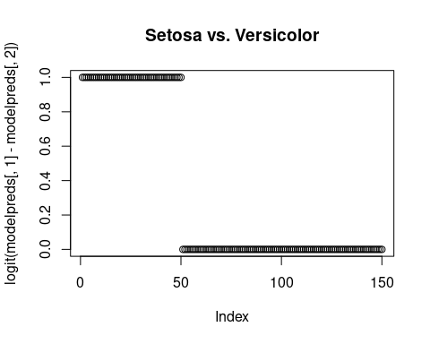
plot(logit(modelpreds[, 1] - modelpreds[, 3]), main = "Setosa vs. Virginica")
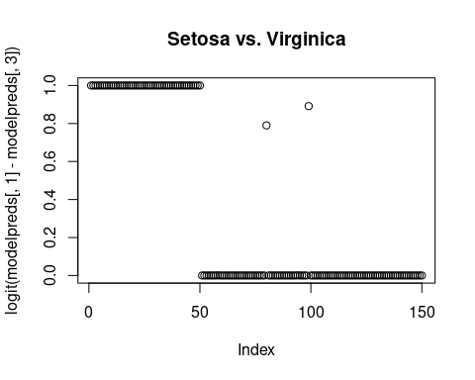
plot(logit(modelpreds[, 2] - modelpreds[, 3]), main = "Versicolor vs. Virginica")
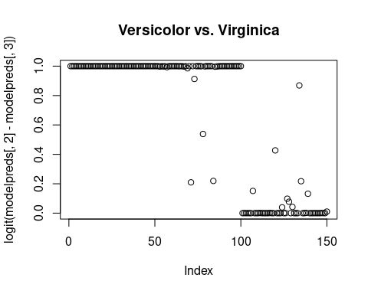
However, this doesn’t fit all the information simultaneously, and so the separation is pretty minimal. We can fit this within a poisson glm (See the Faraway book for examples), but the nnet library has a multinom function that will do exactly this. Insteod of three models, it essentially fits two log-transform models, each in comparison to the first level of the DV. This is a log-ratio model, which is consequently akin to the log-odds transform.
library(nnet)
model <- multinom(Species ~ Sepal.Length + Sepal.Width + Petal.Length + Petal.Width,
data = iris)
# weights: 18 (10 variable)
initial value 164.791843
iter 10 value 16.177348
iter 20 value 7.111438
iter 30 value 6.182999
iter 40 value 5.984028
iter 50 value 5.961278
iter 60 value 5.954900
iter 70 value 5.951851
iter 80 value 5.950343
iter 90 value 5.949904
iter 100 value 5.949867
final value 5.949867
stopped after 100 iterations
summary(model)
Call:
multinom(formula = Species ~ Sepal.Length + Sepal.Width + Petal.Length +
Petal.Width, data = iris)
Coefficients:
(Intercept) Sepal.Length Sepal.Width Petal.Length Petal.Width
versicolor 18.69037 -5.458424 -8.707401 14.24477 -3.097684
virginica -23.83628 -7.923634 -15.370769 23.65978 15.135301
Std. Errors:
(Intercept) Sepal.Length Sepal.Width Petal.Length Petal.Width
versicolor 34.97116 89.89215 157.0415 60.19170 45.48852
virginica 35.76649 89.91153 157.1196 60.46753 45.93406
Residual Deviance: 11.89973
AIC: 31.89973
predict(model)
[1] setosa setosa setosa setosa setosa setosa
[7] setosa setosa setosa setosa setosa setosa
[13] setosa setosa setosa setosa setosa setosa
[19] setosa setosa setosa setosa setosa setosa
[25] setosa setosa setosa setosa setosa setosa
[31] setosa setosa setosa setosa setosa setosa
[37] setosa setosa setosa setosa setosa setosa
[43] setosa setosa setosa setosa setosa setosa
[49] setosa setosa versicolor versicolor versicolor versicolor
[55] versicolor versicolor versicolor versicolor versicolor versicolor
[61] versicolor versicolor versicolor versicolor versicolor versicolor
[67] versicolor versicolor versicolor versicolor versicolor versicolor
[73] versicolor versicolor versicolor
[ reached getOption("max.print") -- omitted 75 entries ]
Levels: setosa versicolor virginica
head(round(predict(model, type = "probs"), 4))
setosa versicolor virginica
1 1 0 0
2 1 0 0
3 1 0 0
4 1 0 0
5 1 0 0
6 1 0 0
table(iris$Species, predict(model))
setosa versicolor virginica
setosa 50 0 0
versicolor 0 49 1
virginica 0 1 49
For this data set, we get almost perfect classification–better than with the separate models. The coefficients for each model indicate the log-probability ratio of each model to the baseline. To compare two other models, we can just take the difference of these values, because the denominator of the first model will cancel out.

