Cardsort analysis
Shane Mueller
4/14/2021
library(MASS)
data <- read.csv("natasha_data.csv")
tab1 <- table(data$participant,data$card.label,data$category.label)
mat <- matrix(0,dim(tab1)[2],dim(tab1)[2])
rownames(mat) <- colnames(mat) <- rownames(tab1[1,,])
for(sub in 1:dim(tab1)[1])
{
t1 <- tab1[sub,,]
byindex <- apply(t1,1,function(x){which(x==1)})
submat <- outer(byindex,byindex,"==")
mat <- mat + submat
}

look at a clustering
library(cluster)
a <- agnes(12-mat)
plot(a,which=2)
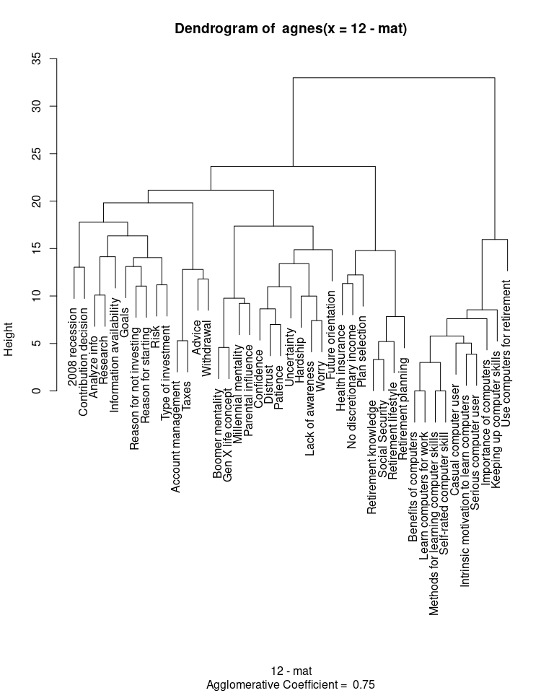

K-means cluster
km <-kmeans(12-mat,centers=4)
km$cluster
## 2008 recession Account management
## 1 1
## Advice Analyze info
## 1 1
## Benefits of computers Boomer mentality
## 3 2
## Casual computer user Confidence
## 3 2
## Contribution decision Distrust
## 4 2
## Future orientation Gen X life concept
## 2 2
## Goals Hardship
## 1 2
## Health insurance Importance of computers
## 4 3
## Information availability Intrinsic motivation to learn computers
## 1 3
## Keeping up computer skills Lack of awareness
## 3 2
## Learn computers for work Methods for learning computer skills
## 3 3
## Millennial mentality No discretionary income
## 2 4
## Parental influence Patience
## 2 2
## Plan selection Reason for not investing
## 4 1
## Reason for starting Research
## 1 1
## Retirement knowledge Retirement lifestyle
## 4 4
## Retirement planning Risk
## 4 1
## Self-rated computer skill Serious computer user
## 3 3
## Social Security Taxes
## 4 1
## Type of investment Uncertainty
## 1 2
## Use computers for retirement Withdrawal
## 3 1
## Worry
## 2
mds <- isoMDS(12-mat,k=2)
## initial value 31.345692
## iter 5 value 26.590630
## iter 10 value 25.497491
## iter 15 value 24.966145
## iter 20 value 24.547825
## iter 25 value 23.887370
## iter 30 value 23.520014
## final value 23.346122
## converged
plot(mds$points[,1],mds$points[,2],type="n")
text(mds$points[,1],mds$points[,2],rownames(mat),col=km$cluster)
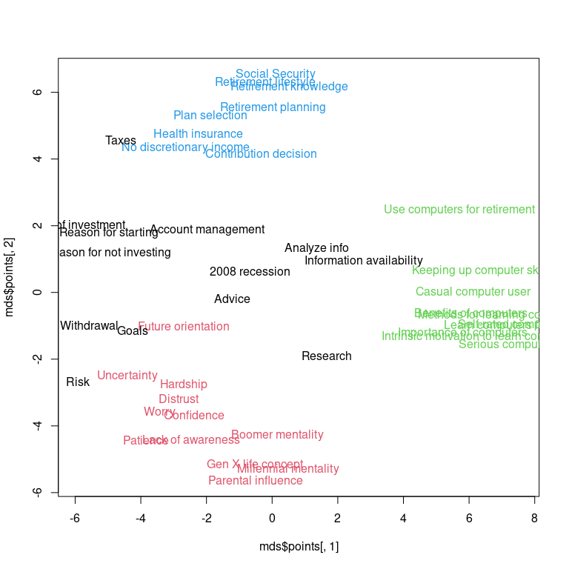

Correspondence analysis
library(ca)
ca <- ca(table(as.factor(data$card.label),as.factor(data$category.label)))
plot(ca,arrows=c(F,T),xlim=c(-2,2))
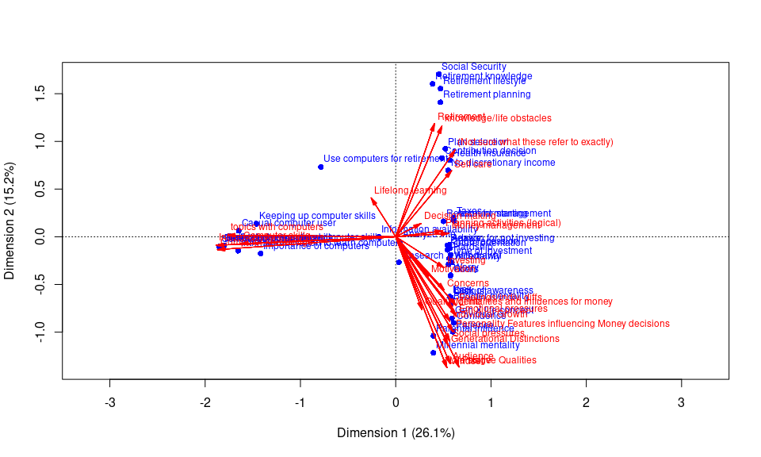
par(mfrow=c(1,2))
plot(ca,dim=c(1,2), what=c("none","all"),main="Cluster names",xlim=c(-2,2))
plot(ca,dim=c(1,2), what=c("all","none"),main="Sorted topics",xlim=c(-2,2))
