Test Problem Summary

Problems are arranged by subject listed below. Not all solutions are provided:

General
Minimum Radius Calc
Horizontal Curves
Horizontal Sight Distance
Superelevation
Earthwork
Stopping Distance
Vertical Curves
Vertical Sight Distance
Rational Method
Ditch Flow Problems
Culvert Problems
Aggregate Gradation
Equilivant Single Axel Loads
Asphalt Thickness Design
Temperature Steel Concrete Pavements
AASHTO Concrete Pavement Design
PCA Concrete Pavement Design
Traffic Flow Problems

Subject

General

1. The Interstate system of highways has approximately miles of roadway?

45,000 miles

2. The Federal Highway Administration is a part of what cabinet level Department?

Department of Transportation

3. According to the route designation system used in the USA, where would US101 be located?

On the West Coast → either California or Washington

4. Use a short statement to define the following highway related term or acronym.

A. Mass Diagram → cubic yards or cubic meters of cut/fill versus station
B. Edge of Metal → edge of pavement
- ISTEA → Intermodal Surface Transportation Efficiency Act
- FHWA → Federal Highway Administration
- Design Speed → maximum speed controlled by design element
- Clear Zone → edge of pavement to obstruction distance

5. What were the main new programs associated with the Federal Aid Highway and Revenue Act of 1956?

A. The Interstate System
B. Highway Trust Fund
6. List the three major functional classifications for roads.

A. Arterial
B. Collector
C. Local

7. List four major factors to be considered when locating a highway route.

A. Terrain
B. Soil
C. Economics
D. Safety
Also acceptable: historical preservation, political

- ISTEA was landmark highway legislation passed in 1991. What does the acronym stand for?

Intermodal Surface Transportation Efficiency Act

- TEA-21 is the new highway legislation in 1997. What does this acronym stand for?

Transportation Equity Act for the 21st Century

- The major highway programs for funding purposes under ISTEA and TEA-21 are?

- Surface Transportation Program (STP)
- National Highway System (NHS)

- Sketch the relationship between mobility and access that is the basis for the functional classification system. Label the axis and add any notes that are appropriate.

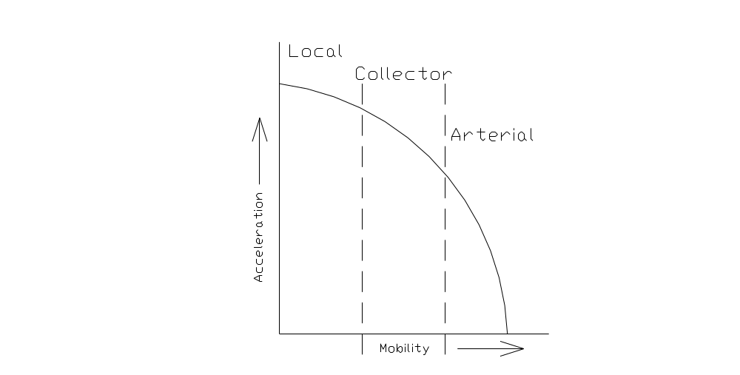

- Name one state traversed by the route with the designation indicated.

- I-5 → CA, WA, OR
- US-2 → MI

- Most road mileage in the United States is under the jurisdiction of what level of government?

Local

- List three highway related administrations that are part of the US Department of Transportation

A. FHWA
B. NHTSA
C. FTA

- Identify the following highway related organizations.
- AASHTO → American Association of State Highway and Transportation Officials
- ITE → Institute of Transportation Engineers
C. ARTBA (for students with excellent memories) → American
Road and Transportation Builders Association

- Name the principal source of funds for the nation’s highway system (books words).

- User tax
- Property tax
- Tolls

- The Federal Aid Highway Act of 1921 established two major principles related to future highway funding. They are:

- TEA-21 is the new highway legislation. Where can I find information about this important legislation?

- Define qualitatively the relationship between mobility and access for each of the three major classifications in the functional classification system.

A. Arterial → higher mobility with a low degree of access
B. Collector → balance between mobility and access
C. Local → lower mobility with a high degree of access
- Explain the basis for the Interstate route designation system. (where are the high/low numbers and where are the even/odd)

The interstate routes are numbered from highest to lowest from east to west and from north to south. Even-numbered interstate routes run east-west while odd-numbered routes north-south.

- What is the approximate (+/- 500000 mi) total road mileage in the United States?

3.9 million miles

- Write out the terms that identify the following acronyms or symbol:

- CBR → California Bearing Ratio
- AADT → Average Annual Daily Traffic
- DHV → Design Hour Volume
- M_{r} → Resilient Modulus
- ΔPSI → Change in Present Serviceability Index

Minimum Radius Calc

1. A horizontal curve at the site of an accident has a measured superelevation of 3 %. The posted speed limit is 40 mph and the radius of the curve is 1000 ft. Tests on the pavement at the site indicate the transverse friction varies in a linear manner from 0.2 at 30 mph to 0.1 at 60 mph. Show by calculation the curve is adequate/inadequate. (Would this be a good time to call my lawyer?)
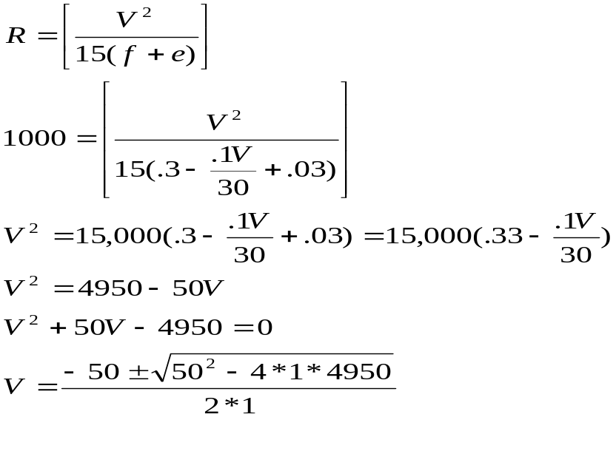
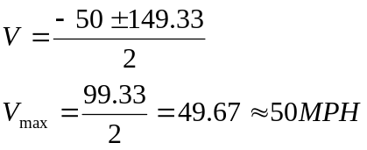

Also acceptable

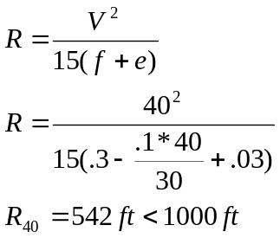

Safe for 40 MPH

2. An icy road has a side friction factor of 0.0, a 0.07 ft/ft maximum superelevation and a radius of 1909 ft. What happens if the vehicle speed is 20 mph. Show by calculating the developed forces.

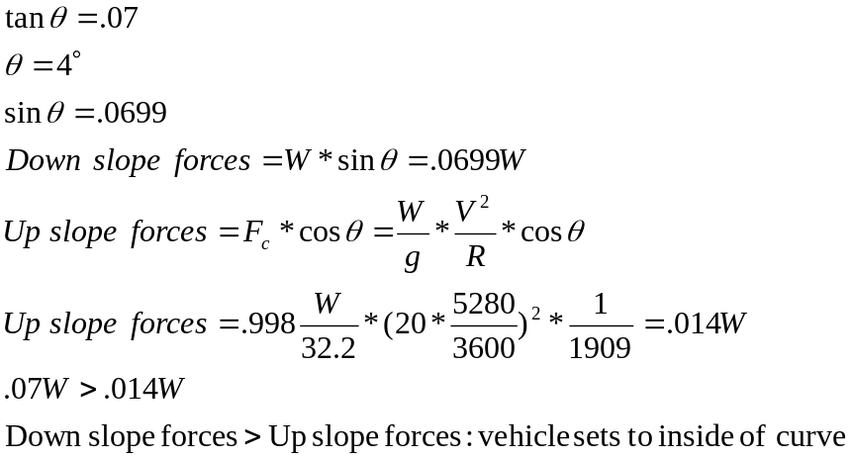

3. What is the minimum radius required on a horizontal curve such that the centripetal and gravitational forces on a vehicle in the outside lane are balanced by the frictional forces. Assume the normal crown is 0.015 ft/ft, the side friction factor, f, is 0.024 and the design speed is 60 mph.

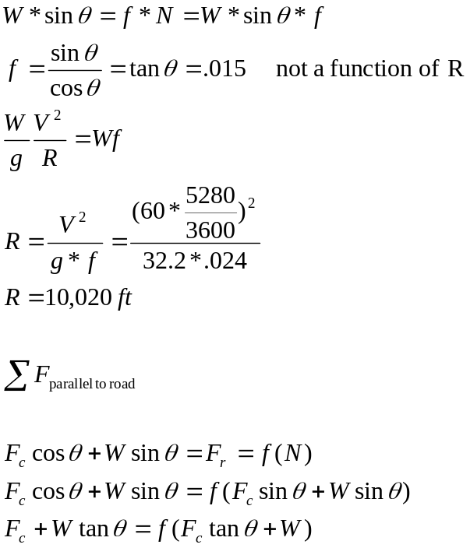

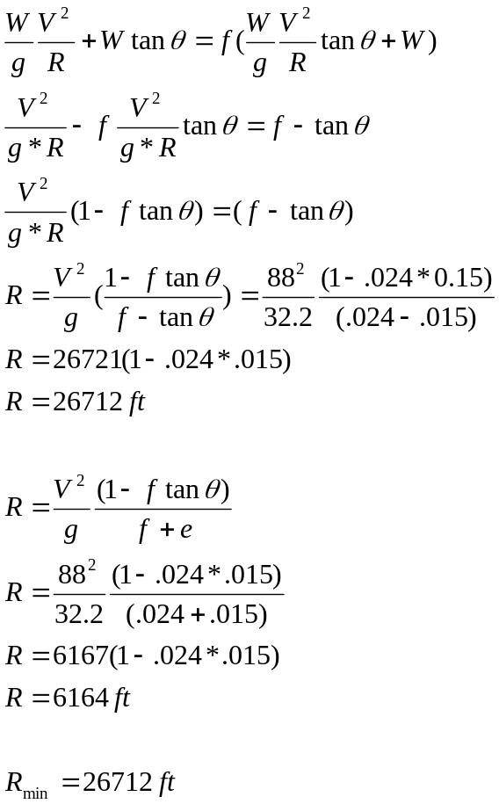

4. An icy road has a side friction factor of 0.0, a 7% maximum super elevation and a radius of 600 m. Show by summing forces what happens if the vehicle speed is reduced to 40 km/hr.

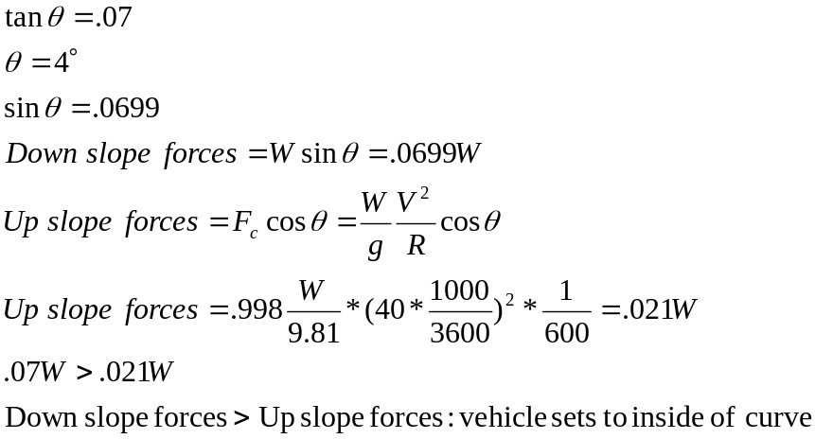

5. A vehicle travels around a horizontal curve with a radius of 500 ft at 40 mph. If the side friction value is 0.15 and the road is flat (no cross slope) show by force calculation that the vehicle will stay/leave the roadway. Assume the vehicle weight is 2000 lb and the centripetal acceleration is a = m*V²/R, where m is the mass, V is the velocity and R is the radius of the curve.

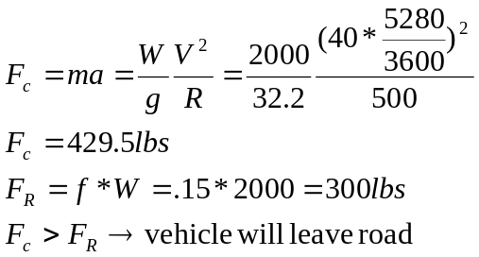

6. A vehicle on a tangent is traveling at 60 mph. If the cross slope of the pavement is - 2 %, what is the factor of safety against sliding to the side of the road.

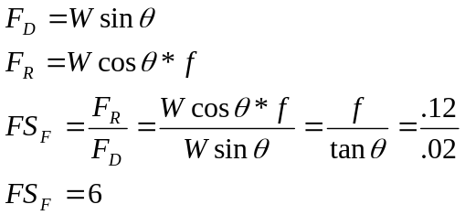

- A friction measuring trailer has a weight of 1000 lbs. If the
locked wheel force measured between the trailer and the towing vehicle is 200 lbs at 40 mph, what is the friction factor between the tires and the road surface?

8. A carnival rider drives a motorcycle up a circular vertical wall and continues around the track until daylight. The radius of the track is 20 m and the measured friction along the vertical wall is 0.1. How fast does the driver have to go to maintain a perfect horizontal position (km/h)?

9. A circus rider is attempting to ride around a track with a vertical wall. If the side friction is 0.15 how fast must the rider go (mph) to prevent sliding to the bottom of the wall? Radius of the track is 25 ft.

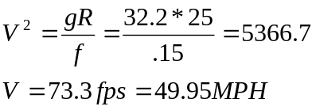

10. In the winter the side friction factor on a roadway may be reduced to 0. In this case the only way to prevent sliding is to increase/decrease the velocity of the vehicle. If the design speed of the road way is 100 km/hr, e_{max} is 10% and the radius of the curve is the minimum determined by the conventional technique, what speed is required to just keep a vehicle on the curve?

Horizontal Curve

1. The relationship between degree of curve and radius involves the constant 5729.5780. Derive this constant from basic geometric principles.

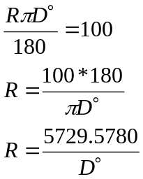

2. A horizontal curve has a central angle of 45º and a Point of Intersection (PI) at Station 1+000.00 and radius of 1000.00 m. What is the station of the Point of Tangency (PT)?

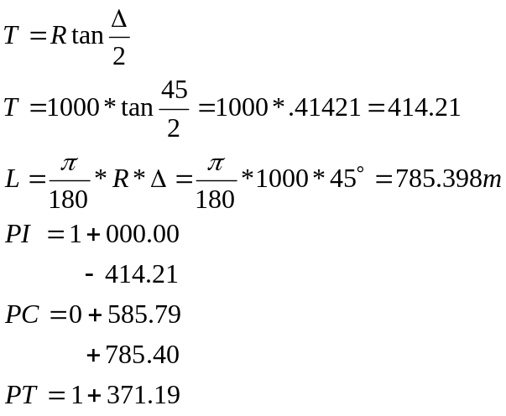

3. A circular curve with a radius of 400 m and a long chord of 400 m. The PI Station is 1+000.000 find the following:
- The PT Station
- The External distance

- A parabolic curve with the same long chord and tangent as in problem 3 is used instead of the circular curve. What is the external distance for this curve?

- A horizontal curve has a deflection angle of 45º R with the PI at Station 900.00 and a long chord of 500 m. What is the station of the Point of Curvature (PC)?

4. A horizontal curve with a deflection angle of 30º has a radius of 500 m. At what distance (along the curve) from the PC is the deflection angle for an observer at the PC equal to 15º ? What is the PT Station if the PI station is 1+000.000?

Horizontal Sight Distance

1. A horizontal curve has a radius of 1000.00 ft. If the grade is flat and the distance between the centerline and object is 30 ft, what is the maximum stopping distance (assume no adjustment to center of the inside lane). Remember the arc length is proportional to the circumference of a circle.

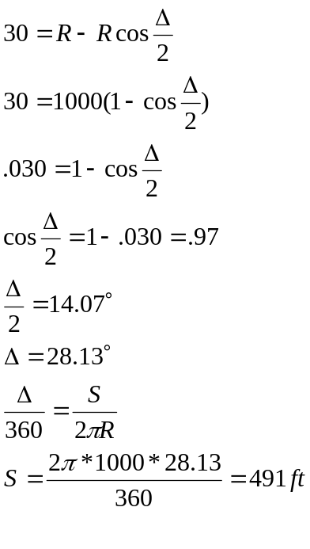

2. The stopping distance (rounded for design) of a two lane road (12 ft lanes) is 450 ft. What is the required clear distance between the drivers location and the edge of the forest (level terrain and no back slope) if the radius to the centerline is 1000 ft?

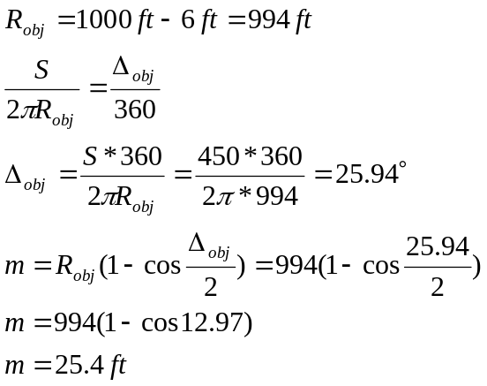

3. A two lane road with a 1000 ft horizontal curve (centerline), 12 ft lanes and an interior angle (deflection angle) of 30 degrees defines the line of sight for a vehicle on the curve. For the standard stopping conditions (3.5 ft observer and 0.5 Ft object), what is the slope of the line of sight (%)? Assume the grade is level.

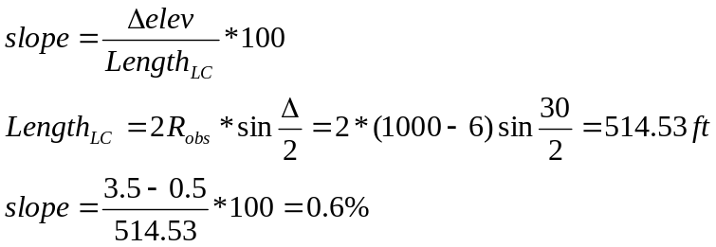

4. For a horizontal curve on a two lane (3.6 m per lane) road with a radius of 500 to the centerline, what is the distance of the line of sight when an obstruction is located 10 m from the centerline of the road? Assume the grade of the road is level

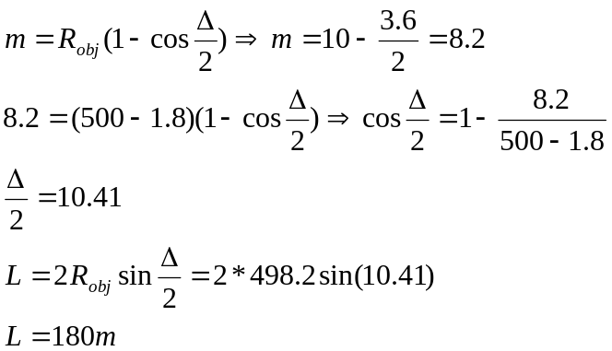

5. Considering horizontal alignment, what slope is required to ensure the line of sight around the curve is just tangent to the back slope given the cross section and data provided below? (Needs Sketch)

6. The design speed of a road is 120 km/hr. Assuming adequate stopping distance (high value) is provided, what is the required radius to provide a 10 m clear zone from the edge of pavement to an obstruction. Pavement width is 3.6 m and the road is a two lane arterial route.

- For a horizontal curve on a two lane (3.6 m per lane) road with a radius of 500 m to the centerline, what is the stopping distance available to a driver when an obstruction is located 10 m from the centerline of the road? Assume the grade of the road is level.

- A horizontal curve has a degree of curve of 3º and a design speed of 60 mph. A hotel wants to erect a sign 20 ft from the edge of a 12 ft pavement. Calculate the actual sight distance and the available design speed for this condition. Should the hotel get permission to erect the sign?

- An object is located 30 ft to the inside of a 400 ft (CL) horizontal curve. What is the maximum speed (calculated) that provides adequate sight distance if the observer and object are directly over the centerline.

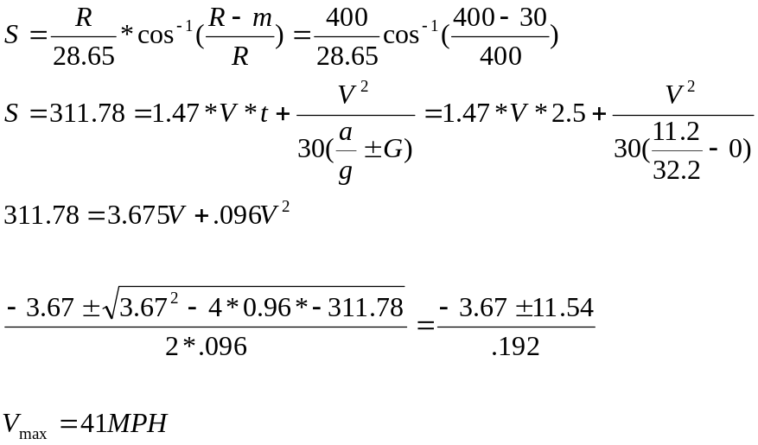

Superelevation

- A discussions with my engineering colleagues, we determine that slope of the outside edge of pavement on a superelevation transition should be 0.5%. For a two lane road (12 ft lanes) and e_{max} = 6%, what is the length of the superelevation runoff. Show on a sketch the relationship between the centerline and the outside edge of pavement. Assume the centerline is at a constant elevation of 100.00 ft.

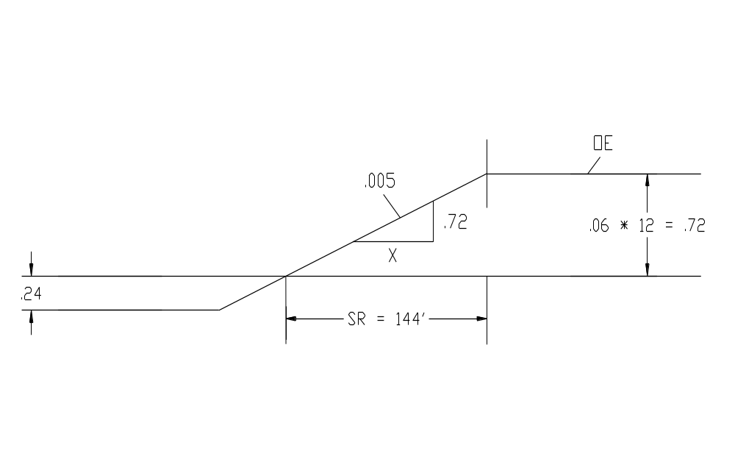

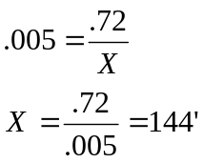

- Using the superelevation transition in Problem 4 and the following curve data, what is the station of the beginning of the superelevation runoff at the exit end of the curve?

PI Station = 10+10.00
Deflection angle = 45 º R
Degree of curve = 4.5 º
1/3 of superelevation runoff on the curve

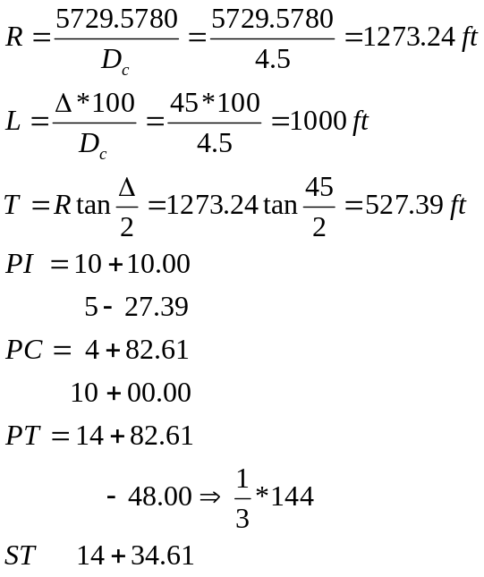

3. A horizontal curve has its PC at station 10+00.00. If the design speed is 70 mph and the maximum superelevation is = 0.08 ft/ft, what is the station of the beginning of the superelevation transition assuming 60 percent of the transition is on the tangent. Assume a two lane road, rotation about the center line and 12 ft lanes.

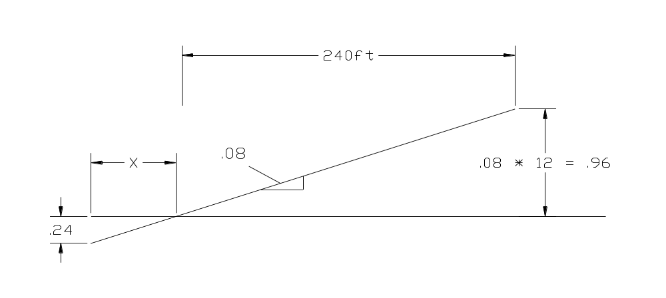
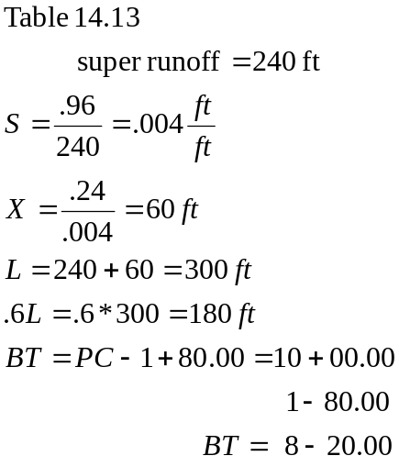

4. The super elevation runoff for a horizontal curve on a two-lane road with a design speed of 65 mph and maximum superelevation of 0.08 ft/ft is rounded with a parabolic curve as shown below. What is the outside edge of pavement elevation at the end of the transition? Assume lane width is 12 ft and the centerline elevation is 100.00.

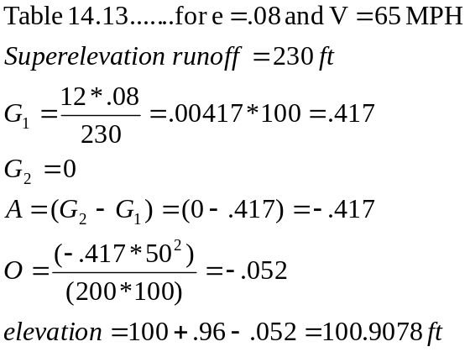

5. Using the data from Problem 3, calculate the inside and outside edge elevation at the PC of the curve if 70 % of the superelevation runoff is on the tangent of the alignment. Assume the centerline elevation is 100.00.
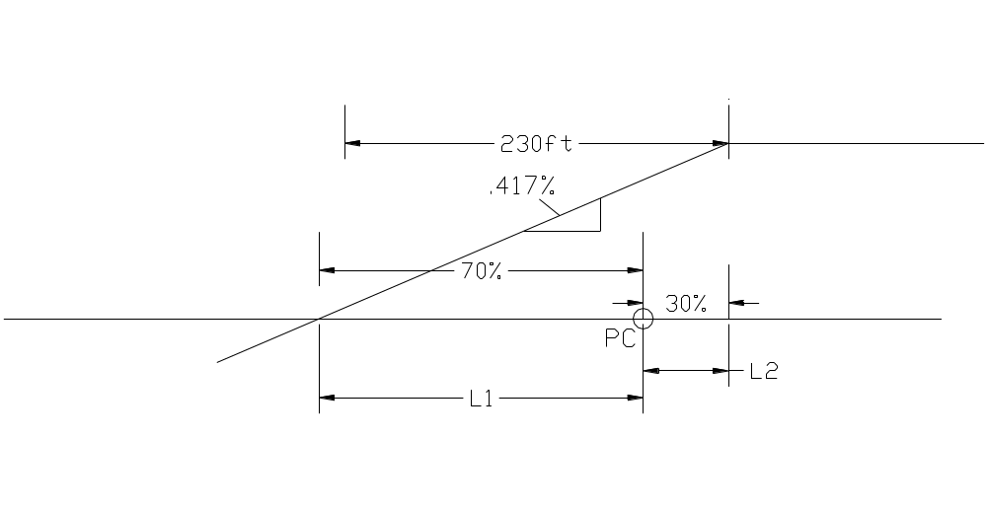
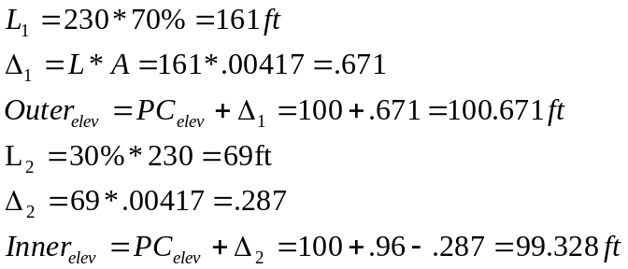
6. A superelevated road has a transition that is defined by some key cross sections in relation to the pavement surface. For the case where e_{max} = 0.07 ft/ft, lane width is 12 ft, and the normal cross slope is 0.015 ft/ft, what is the left edge of pavement elevation for the following points:

- A normal cross section 99.82
b. A fully superelevated section 100.84
c. The end of the tangent runout/ beginning of super elevation
runoff. 100.00

Assume the grade is 0.0% and the centerline elevation is constant and is 100.00.

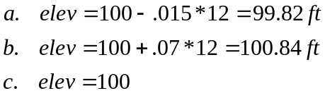

7. The outside edge of pavement on a superelevation runoff has a slope of 0.44%, pavement width of 12 ft and a maximum superelevation of 10 %( 0.1 ft/ft). What is the calculated length of the runoff?

8. The point of curvature for a 1000 ft horizontal curve is at station 10+00.00. What is the station of the beginning of the tangent runout and what is the superelevation (%) at the point of curvature. Assume e_{max} = 0.08, speed is 50 mph, lane width is 12 ft and 2/3 runoff on the tangent.

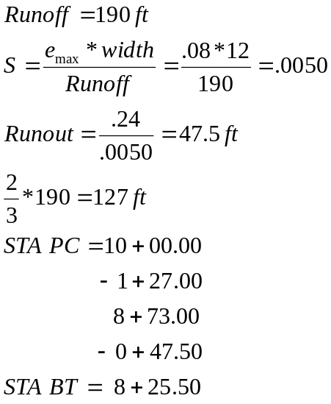
9. Use the sketch below and determine the inside edge, outside edge and the centerline elevation for points A, B, C and E for the following conditions:
A. 2 lane road
B. Lane width = 12 ft
C. Lane slope = -2 %
D. Rotation about outside edge
E. On the tangent before the transition the centerline elevation = 100.0
F. e_{max} = .1

Elevation
A B C E
Inside Edge 99.76 99.52 99.28 97.36
Outside Edge 99.76 99.76 99.76 97.76
Centerline 100.00 99.76 99.52 98.56

10. If a superelevation transition is applied to a curve with a runoff of 70 m, e_{max} = 8% and a lane width of 3 m, what is the length of the tangent runout? Assume the normal cross slope of the pavement is -2%

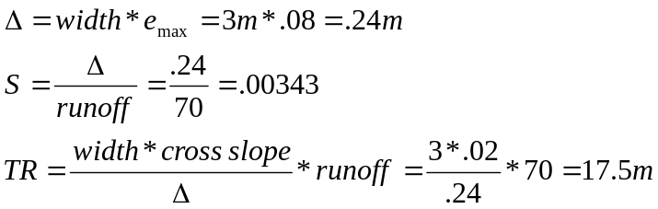

11. A circular curve has 2 lanes (3.6 m each) and a maximum super elevation of 10%. If the design speed is 110 km/h and 2/3 of the super elevation runoff is on the tangent, what is the elevation of the inside edge of pavement at the PC. Assume the elevation of the centerline is 100.00 and rotation is about the centerline

12. The outside edge and centerline profile for a typical two lane pavement is shown below. Label the beginning of the superelevation runoff, beginning of the superelevation runout and the relative location of the point of curvature (PC).

13. A road has 8% maximum super elevation and a design speed of 70 mph. If the PC is located at station 5+00.00, what is the outside edge of pavement elevation at station 4+00.00? Assume rotation about the centerline, 2-lane pavement, 12 ft lanes and 60% of the runoff on the tangent.

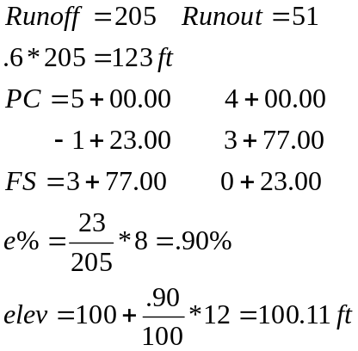

14. The maximum super elevation rate for a two-lane road is 0.08 ft/ft and design speed of 50 mph. What is the outside edge of pavement elevation 50 ft from the end of the superelevation runoff. Assume rotation about the centerline, a flat grade and elevation of 100.00 ft.

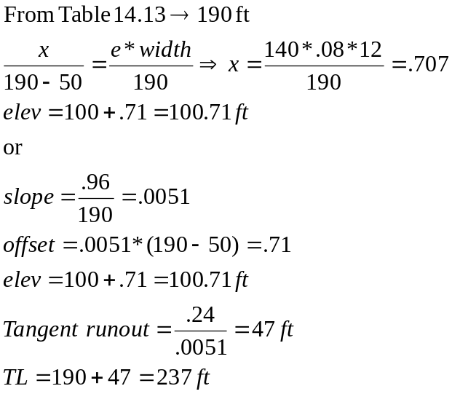

Earthwork

1. From a mass diagram the cut at station 1+50.00 and 1+00.00 are respectively 790 and 656 cubic yards. The area at each of the stations is identical and defined be the cross section shown below. What is the depth of the cut at the stations center line?

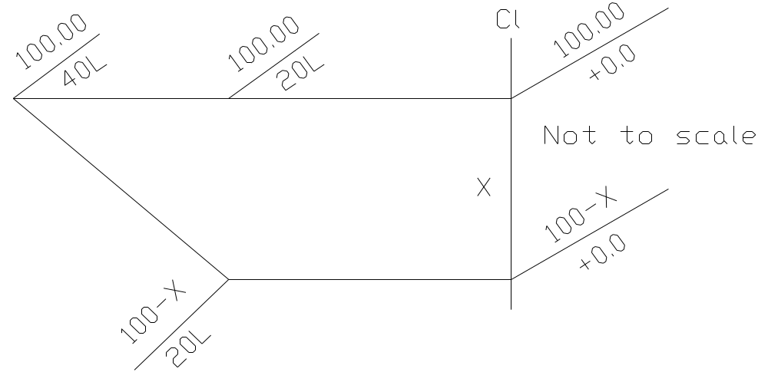

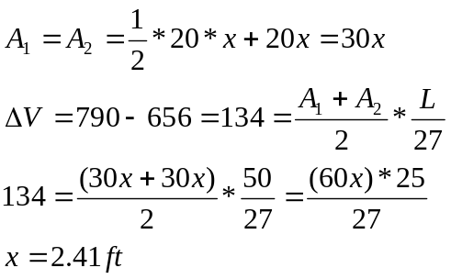

2. Use the profile shown below. Sketch the mass diagram and determine the overhaul cost. Assume there is no free haul, balanced earthwork, maximum fill of 1000 m³ at sta 0+500.00.and the cost of overhaul is $10/m³sta. Also, what is the direction of the overhaul.

3. Sketch a mass diagram (label the axis) for a road project that starts in a fill section (-) goes into a cut section (+) and ends with a net waste of material.

4. Given the following earthwork data sketch the approximate profile of the road and determine the waste/borrow for the job.

Station Cut(+)/Fill(-)
- 0
- 150
- 300
- 250
- 100
- 0
- -150
- -300
- -100
- -50
- 100

5. Given the cross section area at station 1+000.00 is 150 m² (fill) and 25 m² (cut) and is 50 m² (fill) and 100 m² (cut) at station 1+020.00. What is the net volume (+ or -) of earthwork between the stations if cut is + and fill is -.

- Sketch a mass diagram (label the axis) for a road project that starts in a fill section (-m3), goes into a cut section (+) and ends with a net borrow of material. Show and label at least one balance line somewhere on the diagram.

- A mass diagram is shown below:
Find the following values
- The first station where the section is in cut.
B. The over haul (free haul = 500 m). Use the approximate method to find the centers of gravity.
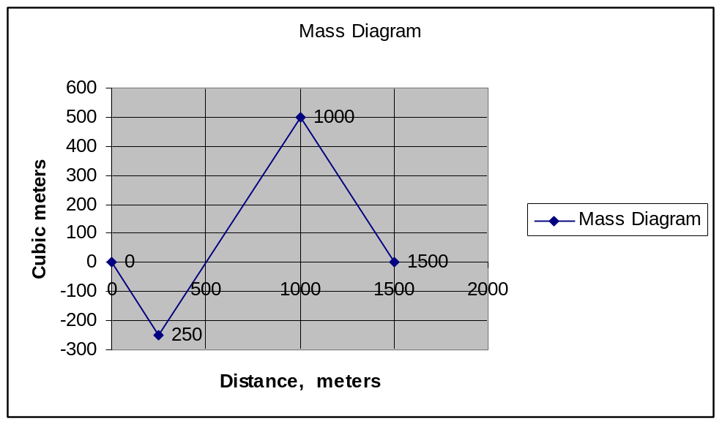

7. The coordinates of a free haul line on a mass diagram are (2+00.00, +600.00) and (12+00.00, +600.00). From these points the mass diagram intersects the abscissa at 0+00.00 and 14+00.00. Calculate the amount of overhaul in station cyds. Use the mid ordinate method to determine the overhaul distance

8. Use the attached Mass Diagram and calculate the overhaul (cuyds-ft). The free haul is 800 ft. Show and label the overhaul ordinate and the borrow/waste (correctly labeled).

9. At what distance from the beginning does the actual profile go from cut to fill?

Stopping Distance

1. A driver’s eye height is 2 ft above the pavement. What percent reduction in stopping distance (over normal) will this condition cause? Assume the following:
a. Object height = .5 ft
b. Crest vertical curve grade difference = 7%
c. Design speed = 70 mph
d. S < L
e. Normal stopping distance is based on the conservative value for the design speed.

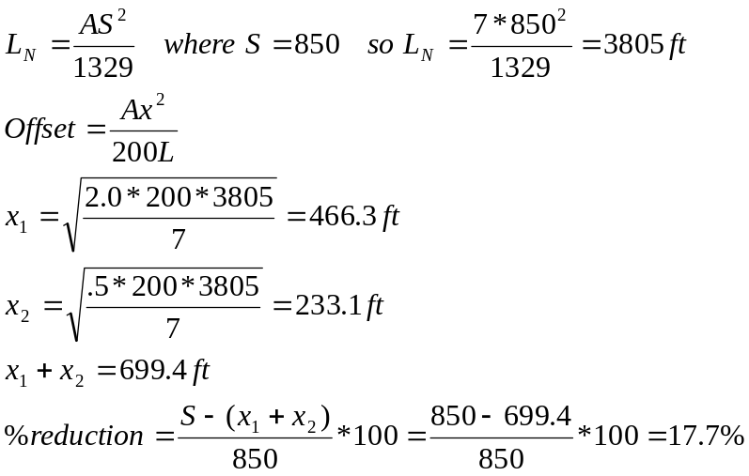

Vertical Curves

1. Given the following measurements taken in the field find the length of vertical curve and the station of the high point of the curve.

G1 = 5%
G2 = -2%

PC Station 10+00.00 Elev = 100.00
Station 11+00.00 Elev = 103.00

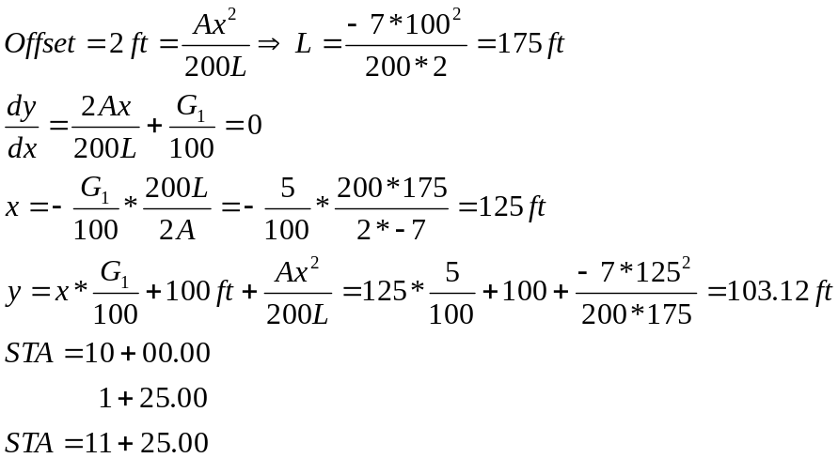

2. The line of sight from an observer to an object along a crest vertical curve is tangent at the high point of the curve. If the length of the curve is 1000 ft and the observer’s eye height is 3.0 ft above the pavement, what is the Station of the observer if the Station of the PIVC is 10+00.00.

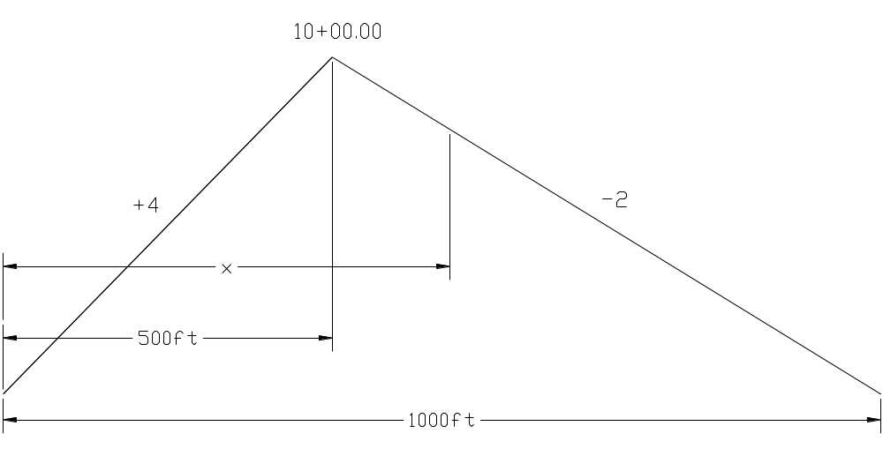

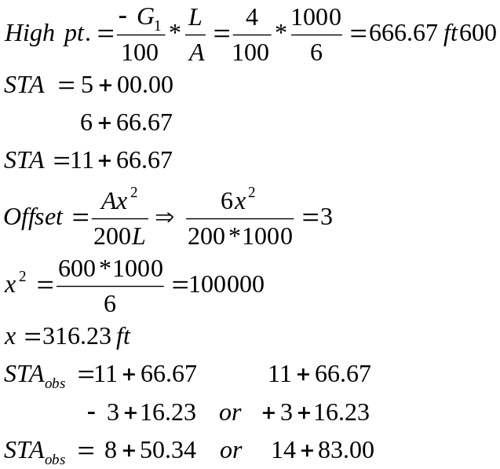

3. Using the data from Problem 3, calculate the inside and outside edge elevation at the PC of the curve if 70 % of the superelevation runoff is on the tangent of the alignment. Assume the centerline elevation is 100.00.

4. A line of sight is tangent to a parabolic crest vertical curve at Sta 9+00.00. The observer is on the curve at Sta 6+00.00, what is the height of the observer’s eye for the given conditions. Assume G1 = 2%, G2 = -3%, the PI Sta is 10+00.00 and the length of curve is 1000 ft. If all else fails remember y = ax² + bx and solve for the offset relationship.

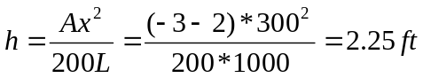

5. The general equation for a parabolic vertical curve is y = ax²+bx+c. Assume the origin of the coordinate system is at the PIVC, G1 = -5%, G2 = +3%, and the length = 1000 ft. Determine the specific equation for this vertical curve.

6. The equation for a parabolic vertical curve is

y = (Ax^2)/200L + (G1/100)X

If the observer is at the point of curvature for the vertical curve (VCPC=STA 10+78.61), what is the station at the point of tangency of the line of sight to the curve if the observer is at the VCPC, L = 1000 ft, G1=3%, G2=-2% and the observer eye height is 3.5 ft above the pavement.

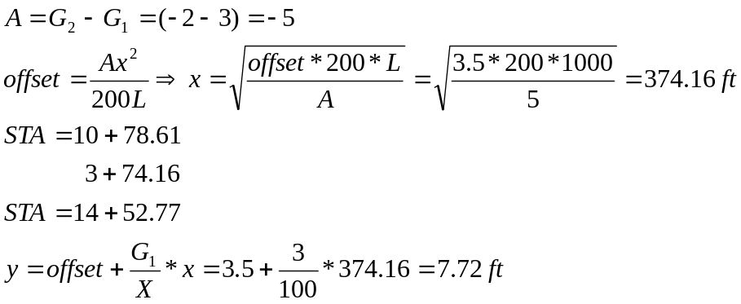

7. The equation

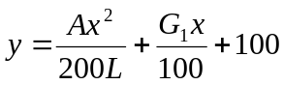

is for a parabolic curve with the origin at the PVC with x = 0.00 and y = 100.00. If the eye level of an observer is 2 m above the pavement and the observer is at the PVC, what is the distance to the point of tangency of the observer’s line of sight with the pavement? G₁ = 5%, G₂ = -3% and the length of vertical curve is 200 m.

8. The equation for a parabolic vertical curve (beginning at the PCVC) is: 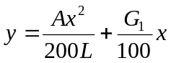

If the height of the observer is 2.0 m and the height of the object is 1.0 m, what is the available stopping distance over the crest vertical curve if the vehicle and the object are on the curve?

9. For a design speed of 60 mph, what decrease/increase in length of crest vertical curve occurs when the object height is lowered from 2.0 ft to 0.5 ft. Assume S<L and A= 6%.

10. Catch basins are located at the low point of a 600.0 sag vertical curve with G1 =- 5% and G2=+2%. If the PI is at station 10+00.00 and 100.00 elevation, what is the station and elevation of the catch basins

11. An observer is 6 ft (eye height) and is looking up station from the PC. He is just able to see the head of another person 5 ft 6 in. tall. What is the required length of vertical curve? Assume they are both on the curve, at the same elevation, G1 = 3% and G2 = -5%

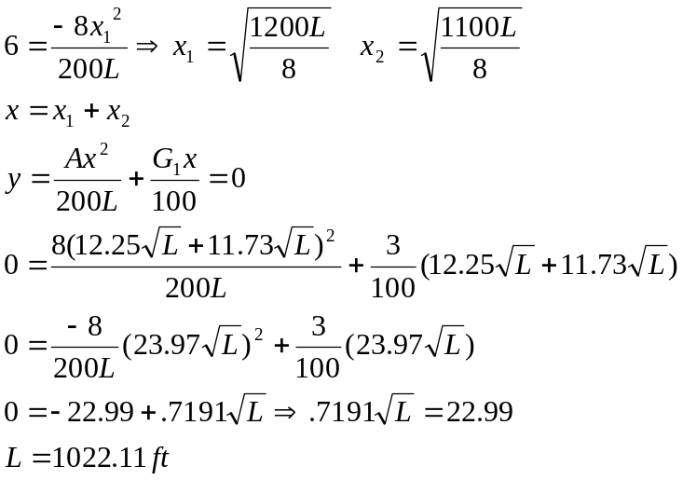

12. A pipe 6 ft in diameter passes over a highway sag vertical curve with a clearance of 16 ft. What is the lowest elevation and station of the bottom of pipe? Assume the length of the vertical curve is 400 ft, G1 = -3, G2 = 4%, PC Station is 5+00.00 and elevation is 100.00.

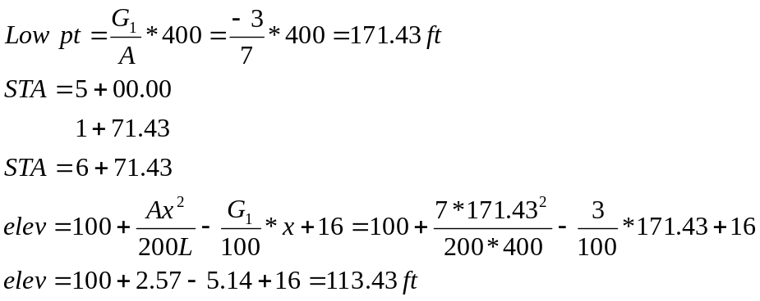

13. A sag vertical curve has a –4% grade followed by a 5% grade. The station at the PIVC is 1+000.000 with an elevation of 100.000. What is the station and elevation of the low point on the curve?

14. I’m standing at the VCPC of a 120 m crest vertical curve. How tall do I have to be to see the VCPT? G₁ = +2% and G₂ = -1%

Vertical Sight Distance

1. The eye height for a truck is 5.0 ft and for a car is 3.5 ft. If an object on a crest vertical curve is 0.5 ft high, how much additional stopping distance does the truck have over the car assuming the design speed is 60 mph, length of vertical curve is 2000 ft, G1 = +4% and G2 = -2%.

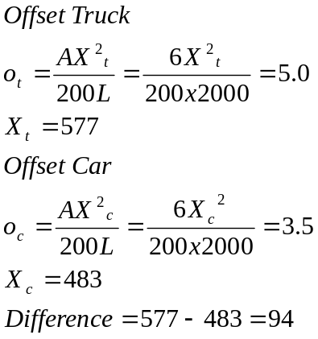

Note: The offset for the object is the same and the difference is determined from the difference of the offset between the truck and the car.

2. A crest vertical curve must pass through elevation 95.00 at station 9+00. If the PIVC is at station 10+00.00 with elevation 100.00, what is the required length and the resulting design speed for this vertical curve (h₁=3.5 and h₂=0.5). Assume that G₁ = +2% and G₂ = -4%.

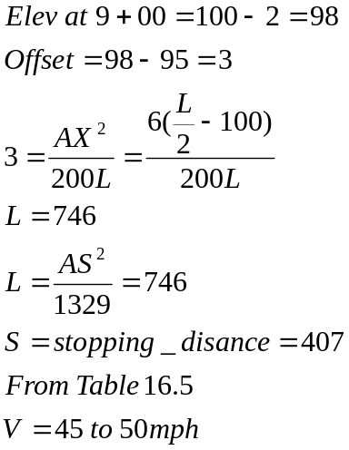

3. A truck driver’s eye height is 6 ft above the pavement. Based on the usual criteria for stopping sight distance on a crest vertical curve, what is the percent increase in sight distance for the truck driver compared to the design driver?

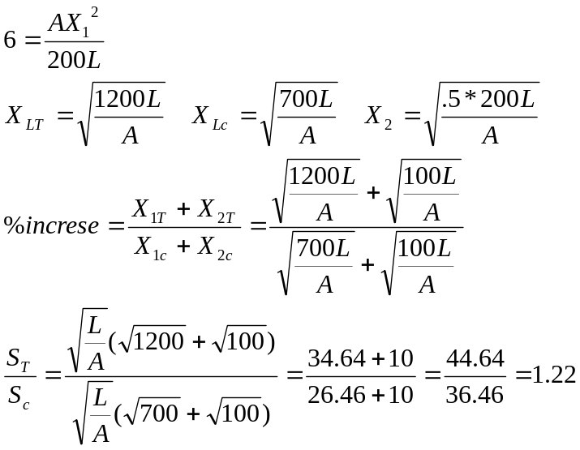

4. The stopping sight distance over a crest vertical curve is given as

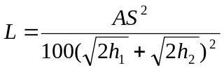

What are the variables h₁ and h₂?

h₁=height of observer
h₂=height of object

5. A headlight for a truck is located 1000 mm above the PCVC. If the light beam spreads upward at an angle of 2º above the horizontal, what is the sight distance provided by this headlight system? Assume G₁=0% and G₂=10% and the length of the vertical curve is 200 m.

6. The Conventional equation for a sag vertical curve is based on the height of the headlights and a 1º cone of illumination by the lights. The resulting equation is
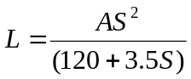 S<L
Where S is the stopping distance and L is the length of vertical curve.

If the headlights are not aimed correctly and the cone of illumination is 0º, what is the required length of vertical curve? Assume the design speed is 80 km/hr.

7. On a crest vertical curve at the PCVC + 50 ft the offset from a vertical tangent to the curve is 0.2 ft. If the grade difference is 8 % what is the design speed for the vertical curve based on stopping sight distance?

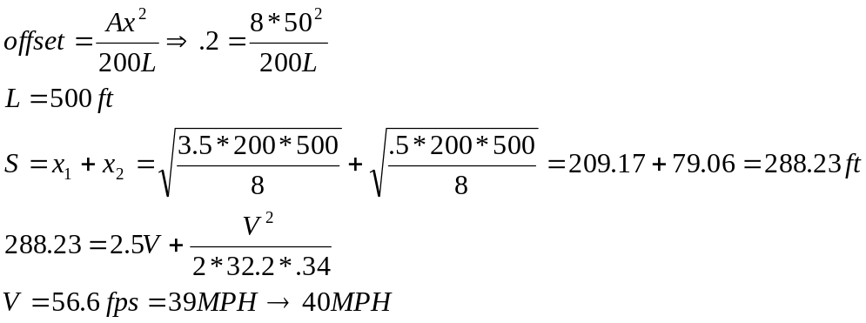

Rational Method

  - Use the attached intensity curve and fill in the table given below. Assume data is for Houghton.

CB  No. | Area  (Ac) | % Imp | Sum  Area  (Ac) | Comb % Imp | Time  Of  Concentration (min) | Flow Q  (cfs) | Pipe size  (in) | Inc Time.  (min)
1 | 2 | .3 | ____ | ____ | 15 | ____ | 12 | 1.0
2 | 1 | .4 | ____ | ____ | ____ | ____ | 12- | 1.5
3 | 1 | .6 | ____ | ____ | ____ | ____

2. Given two drainage areas that drain to a common point A as shown below. With the data for each area given in the table below, what is the maximum runoff at point A if the Rational Method is used?

Property Area 1 Area 2
Area (acres) 5 2
Distance to farthest point in area (ft) 1000 500
Coefficient .5 .3
Slope of ground 2% 1%
Surface type bare ground short grass

- Given:
Area = 1 mi²
Streets = 10 %
Row crops (poor) = 40 %
Wood (poor) = 50 %
Time of concentration = 1 hr
Precipitation = 6 in

What is the difference between the runoff for antecedent moisture condition I and III? Use the TR55 Method

4. Find the time of concentration associated with a drainage basin with three components as listed below:
A. Short grass, length = 300 ft, slope = 2%.
B. Open channel, length = 2500 ft, n = .08, slope = .6%, hydraulic radius = 6 ft.
C. 36 in storm sewer, flowing full, length = 1000 ft, n = .012, slope = 1 %.

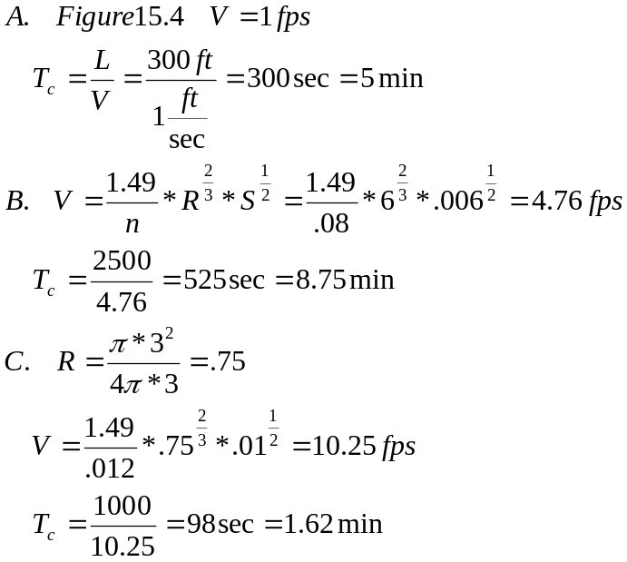

5. A watershed has the following characteristics:

No. Area Land Use Soil Type AMC

1 0.15 mi² Meadow (good) A I
2 0.20 mi² Residential (1/2 ac) C II
3 0.50 mi² Forestland (fair) B I
4 0.10 mi² Streets (paved) D III

Find the runoff if the rainfall is 5 in. Use the TR 55 Method

6. A typical section for a road is shown below. If the summit of the drainage basin is 500 ft (horizontal) with a slope of 2 % above the outlet, what is the time of concentration of the flow for this drainage area? Assume the flow is only perpendicular and parallel to the centerline of the road

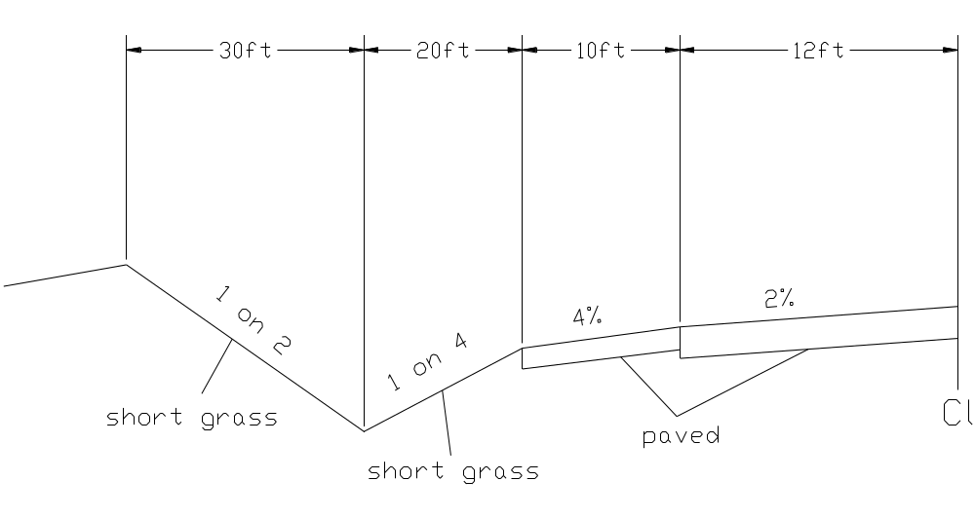
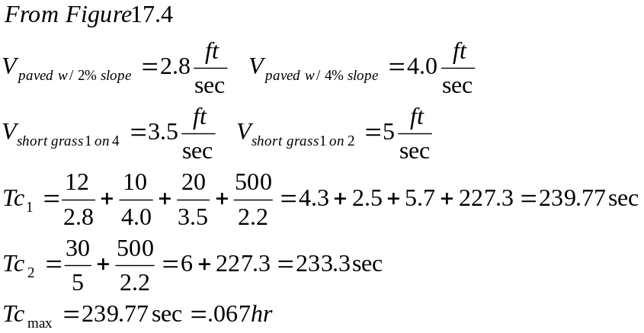

7. For the section described in problem 6, what is the runoff associated with 1/2 of the cross section if the return period is 25 years and the rainfall intensity can be determined using Fig 17.2 Assume the time of concentration is 10 minutes and the average runoff coefficient is 0.4 (Remember 1 acre = 43560 ft²).

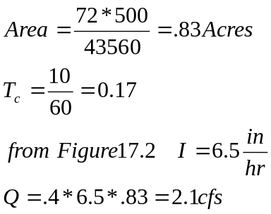

8. Circle the correct observation related to the TR 55 Method.
If the runoff, h, is large, the CN is high/low and the maximum retention, S will be large/small.

9. A rural drainage area is:
- 20% asphalt pavement
- 30% turf meadow (good)
- 50% cultivated fields (straight rows, poor)

Assuming that the soil type is A and the AMC is III, what is the relationship between the runoff coefficient for the Rational Method and the Curve Number for the TR 55 Method

- A drainage basin is 30 % asphalt pavement with a runoff coefficient of 0.9 and 70 % cultivated fields with a coefficient of 0.3. What is the average runoff coefficient that would be used in the equation Q=CIA?

11. A 10 acre drainage area has 10% asphalt pavement, 40% turf meadows and 50% cultivated fields. If the rainfall intensity is 3 in/hr how deep should a V shaped ditch (1 on 2 side slopes, n =0.1 and slope = 2%) be to provide for adequate drainage for the area? Use coefficients that will produce the largest runoff.

12. How large an area would the standard ditch section shown below drain if the drainage area is 50% forested, 30% steep grassed slopes and 20% concrete. Assume the storm duration is 30 min., the storm return period is 10 years and Fig 11. 2 is valid in the design area.

13. A 170 acre rural drainage area consists of four different watershed areas as follows:
    - Steep grass-covered area = 40 % C = .5-.7
    - Cultivated area = 25 % C = .2-.4
    - Forested area = 30 % C = .1-.3
    - Turf meadow = 5 % C = .1-.4

Using the rational formula determine the runoff rate for a storm of 100 yr frequency. Assume the rainfall intensity curve is Fig 17-2. The following drainage basin characteristics apply.

- overland flow length = 0.5 mile
- average slope = 3 %
- fallow or minimum tillage cultivated

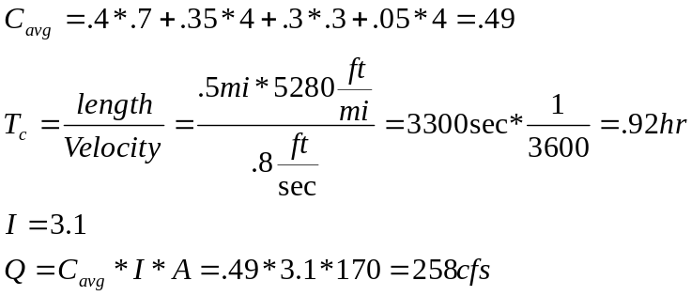
Ditch Flow Problems

- For the conditions given below find the incremental loss in flow capacity after the ditch is partially filled with silt. Assume the slope=2% and n=0.01.

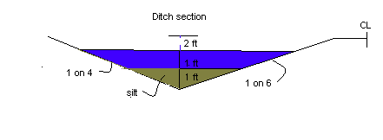
2. A ditch has an original shape as shown below. To increase the flow the cross section is changed by excavating material to increase the base width to 6 ft. What is the flow for the improved cross section? Assume the slope is 1 %, n = .01, fore slope is on 4 and the back slope is 1 on 2. Height of the water remains constant

3. A V ditch with bottom 5 ft below the centerline grade must provide 3 ft of freeboard above the high water mark. What area can the ditch drain if the 10 yr storm intensity is 5 in/ hr and the other details are shown below?

4. An area is 40% steep grass, 25% cultivated, 30% forested and 5 % turf meadow. For a 5 acre plot, 10 year storm and 15 minutes time of concentration, what size ditch section is required if it is semi circular flowing full and has n = 0.012 and Slope = 1 %?

5. The ditch for a low volume road is 4 ft below center line grade. If the water level cannot be within 2 ft of the centerline grade, what is the maximum drainage area that can be serviced by the ditch section shown below?

6. For Q = 100 cfs, Slope = 2%, and n = 0.012, what is the difference in depth of flow for the open channels shown in Fig 17.6 versus Fig 17.7?

7. For the ditch shown below, what is the maximum drainage area that can be served if the flow velocity is 4 fps? Assume that C_{avg} = 0.5 and the rainfall intensity is 5 in/hr.

8. A V ditch with side slopes of 1 on 2 has a discharge of 100 cfs and a maximum depth of flow of 3 ft. What material should be used to line the ditch? Assume the slope of the ditch is 2 %.

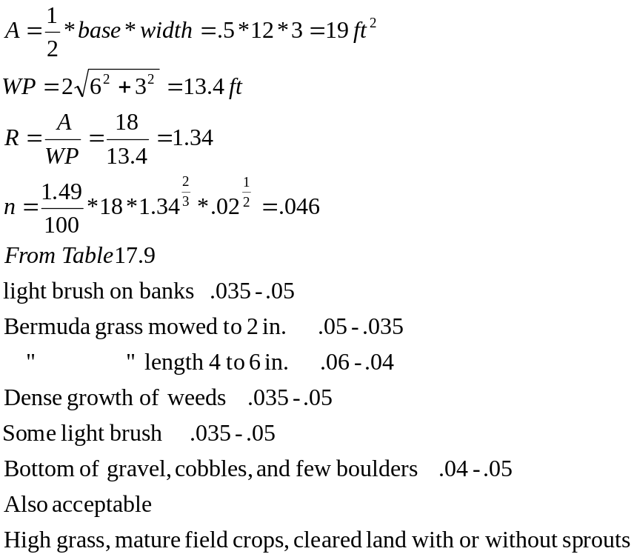

9. What is the maximum flow that can occur in the gutter shown in the sketch below without over topping the curb? Assume the roadway grade is 2%.

10. A rectangular shaped ditch shown below if flowing full. If the contributing area is 20 Hectares and it is 50% forest, 30% cultivated fields and 20% pavement, what is the occurrence period associated with this condition? Use an appropriate runoff coefficient that will produce the maximum runoff. Assume a time of concentration of 15 min, slope of the ditch is 2% and the Manning coefficient is 0.01.

11. A V ditch with a depth of 2 ft and 1 on 1 side slopes drains a roadway with a 2 % slope. What is the maximum area this ditch can drain if the average runoff coefficient is 0.5 and the 10 year rainfall intensity is 2 in/hr. The Manning’s coefficient is 0.012 for the vegetation in the ditch.

12. Area A (steep grassy slope) is 2.5 acres and has a time of concentration of 30 min. Area B (forested) is 5.0 acres and has a time of concentration of 1 hr. Both areas contribute to MH # 1. The outlet at MH#1 is a 15 in pipe. What is the maximum velocity of flow in the pipe (assume flowing full). Use a 25 yr storm frequency and Fig 17.2.

13. A typical MDOT ditch has 1 on 4 side slopes and a 6 ft bottom. The maximum depth is 3 ft. What is the maximum flow if n =0.01 and the roadway slope is 2 %.

14. Maximum runoff for a V ditch (1 on 2 backslope and 1 on 4 foreslope) is 100 cfs. If n = 0.1, slope is 2 % and clearance from centerline elevation to maximum water level is 3 ft. What is the required depth of the ditch measured from the centerline elevation15. A ditch section is shown below. Assume the contributing area is 20 hectares and is 50% forested, 30% turf meadows, 10% gravel shoulders and 10% asphalt pavement. What is the expected design period for the section that would allow water to rise to the edge of pavement (EOP). The rainfall duration is 1 hr and the region is typical of Fig 11.2.

15. A ditch section is shown below. Assume the contributing area is 20 hectares and is 50% forrested, 30% turf meadow, 10% gravel shoulders and 10% asphalt pavement, what is the expected design period for a section that would allow water to rise to the edge of the pavement (EOP) . The rainfall duration is 1 in / hr and the region is typical of Fig. 11.2.

Culvert Problems

1. A culvert (entrance type 1) is needed to move the water transported in the ditch from prob. 2 under the road. Assume the runoff is 200 cfs and the headwater elevation/diameter ratio is 1. What size pipe (ft) is need and what is the invert elevation (ft) assuming the water elevation at the inlet end is 100.00 ft.

2. Find the invert elevation at points A and B assuming the water elevation for inlet control is equal to the water elevation for outlet control. Assume Q = 200 cfs, 5 ft diameter concrete pipe, n = .012 ,k_{e} = .5 tailwater elevation = 2 ft.

3. A 4 ft diameter concrete pipe ( square edge with headwall) has a slope of 1 %, length = 250 ft, n = .012, ke = 0.2, entrance invert of 130.00 and tailwater of 8 ft. If 3 ft of freeboard is required above the maximum water level, what is the plan grade elevation at the station of the culvert? Assume the flow is 200 cfs.

4. A 4 ft diameter concrete pipe (n = 0.012) with square edge and headwall has its entrance invert at 100.00. If the flow is 100 cfs , what is the minimum elevation of the roadway centerline. Assume the vertical distance between the centerline and water level is 4 ft, tailwater is 8 ft, slope of the pipe is 2 %, entrance coefficient is 0.2 and the length of the pipe is 200 ft

5. A 24 in concrete pipe with square edge and headwall is 450 ft long and has a fall of 3 ft in its length. It will flow full and the outlet will be submerged by 2 ft above the crown of the pipe, what flow will the pipe carry when the inlet is submerged by 3 ft of water above the crown of the pipe and the slope of the pipe is adjusted so inlet control equals outlet control. n = 0.012, k_{e} = 0.5

6. A 48 in pipe passes below an embankment and must provide 3 ft of clearance between the high water elevation and the plan grade. The flow through the pipe is 200 cfs and the length is 150 ft. Find the slope of the pipe when the calculated water levels from inlet control and outlet control are equal.

  - A culvert is placed with its entrance invert at an elevation of 100.00. If a 150 ft culvert pipe is placed at a slope of 1 %, what is the expected maximum water elevation if the tailwater is 10 ft, Q = 300 cfs, n = 0.012 and the culvert is six ft in diameter with a k_{e} value of 0.2. This is a circular concrete pipe with grooved end projecting

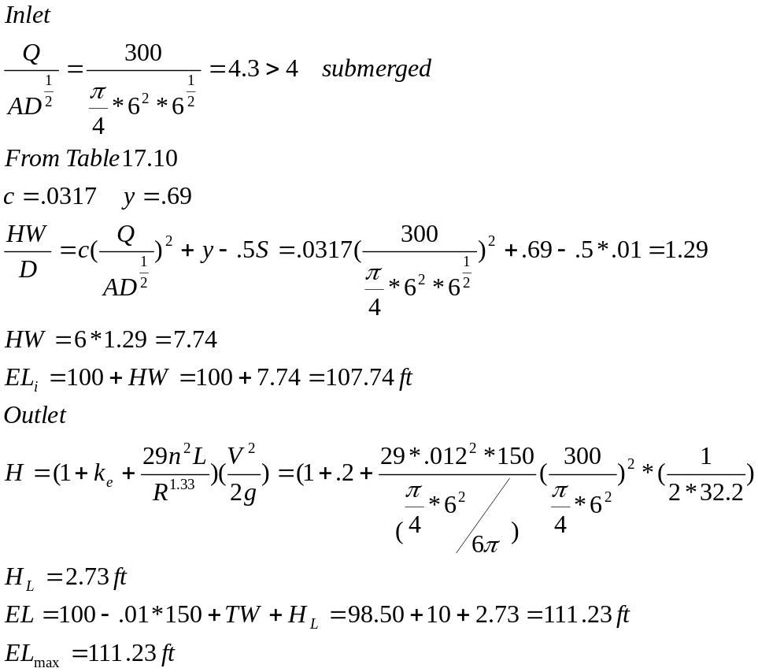

8. A 5 ft diameter 100 ft long concrete pipe with square edge and headwall has its inlet invert at 100.00 elevation. If the slope of the pipe is 1% and the tail water is 7 ft, what is the required centerline elevation if a minimum of 5 ft is required between the maximum water elevation and the centerline elevation? Assume Q=200 cfs and ke=0.2.

9. A 1500 mm concrete pipe with n = 0.012 and square edge with wing walls entrance conditions has a discharge of 10 cms. If the entrance invert elevation is 100.00, the pipe is 100 m with a slope of ½%, tail water elevation of 2.0 m and K_{e} 0.5, what is the maximum water elevation for these conditions? Is this inlet control or outlet control?

10. A concrete culvert is subject to inlet control and has a flow of 10 cms. The maximum water level at the upstream end is 100 m and the entrance invert must be placed at an elevation of 96.00 m. What size pipe must be used to meet these conditions? Assume entrance condition (1).

11. For the condition given in Prob 3, what size CMP pipe is needed at the bottom of the drainage area assuming maximum HW/D = 1.1, inlet control and a projecting end.

12. A 36 in culvert is under Outlet control. The maximum water elevation is 110. Find the exit invert elevation associated with outlet control if the pipe has Q = 50 cfs, n=0.012, ke =.5, the tail water is 3.0 ft and length of 150 ft.

13. Determine whether a 6 ft 6 in reinforced concrete pipe with k_{e}= 0.5, grooved end with projecting and carrying a flow of 200 ft³/s will operate under inlet or outlet control condition. Assume:

a. Design headwater elevation = 105 ft
b. Tail water depth = 6 ft
c. Length of culvert = 200 ft
d. Slope of culvert = 1.5%
e. n= .012
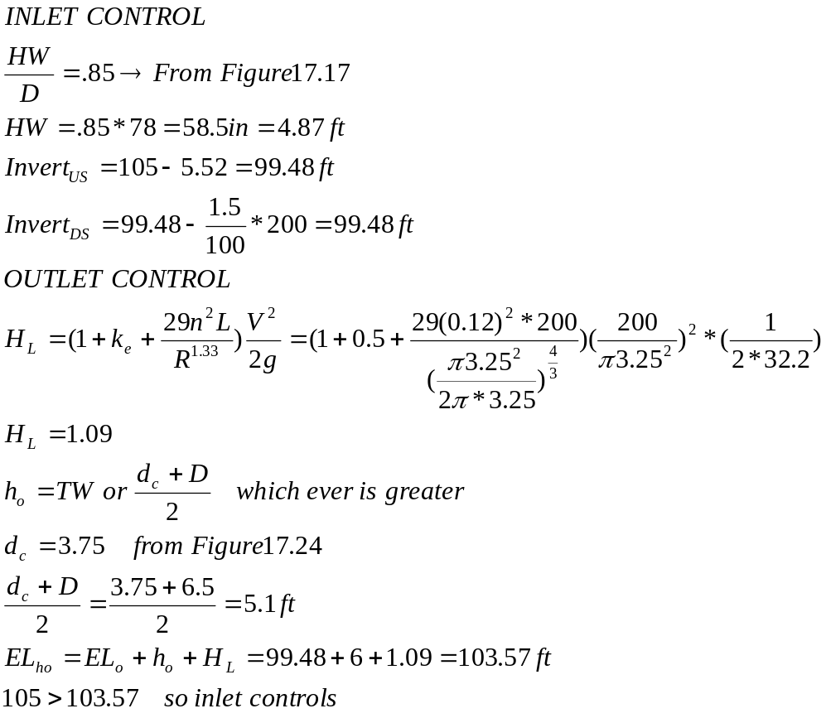

14. A 100 m concrete pipe culvert with outlet flow control conditions and 2 m³/s flow has a maximum water elevation of 100.00 m. The culvert is 1m in diameter and the tail water is 1 m. What is the culvert’s invert elevation at the downstream end? Assume n = 0.012 and k_{e} = .5.

Aggregate Gradation

1. A base course is combined with a borrow material. If the gradation curves show that 30% of the borrow and 70% of the base course pass the # 4 sieve (4.5 mm) and the required spec limits at the # 4 are 70 – 40 % passing, what is the minimum proportion of borrow that will produce a combined mix that just meets the midpoint of the specs at the #4 sieve

2. An aggregate has 40% passing the Number 4 (4.84 mm) sieve and 100 % passing the 2 in sieve. If the specifications require the aggregate to be graded according to the power rule + 10%. Does the aggregate meet the specifications (show by calculation)?
The power law is:
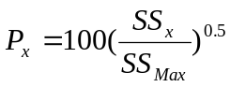Where
SS_{x} = sieve size at screen x
SS_{Max} = sieve size maximum

3. Two aggregates are blended to meet specifications at the number 200 sieve. If the specifications require 10% passing the 200 sieve and aggregate A has 15% passing the 200 and Aggregate B has 3 % passing the 200 sieve, what is the proportion of aggregate A and B that will provide a mix that has 10% passing the 200 sieve?

Equilivant Single Axel Loads

1. The traffic conditions at a site produces the following data
- AADT = 10000
- % Trucks=20%
- Two lane facility
- directional split = 50%
- annual growth = 5%
- Truck factor = 1.00 (based on truck traffic)

What are the expected ESAL after 20 years?

2. If the relationship between load (kips) and number of load repetition to failure is:

W = 100 - 11 log 10(NR)

where:
W = the load in kips
and
NR = the number of load repetitions.

Based on the number of repetitions to failure, what would be the single 18 kip load equivalence factor for a load of 10 kips.

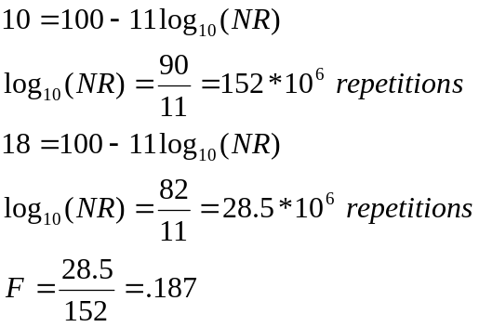

3. A coal truck has one single axle with 12 kips and five tandem axles with 32 kips each and makes five trips a day to Baraga. How many trips would be required by a passenger car with two axles with 2 kips on each axle to apply the same number of 18 kip single axle loads as the truck?

4. In trying to assess the effect of different vehicles the following data was obtained

Axle Load
10 Kip 18 Kip
Displacement 0.001 in 0.01 in
Number of repetitions to
produce crack 10000 1000

If the pavement wear is directly related to the product formed from displacement and number of repetitions to first crack, what is the appropriate load factor relating the 10 Kip load to the 18 Kip load.

5. A four-lane highway has an AADT of 100000 VPD with an expected growth of 3% per year. If the truck traffic is 20 % of the total with an average equivalent load factor of 0.4 and the passenger cars are on average 4000 lbs, what is the number of ESAL in the design lane if the expected life of the pavement is 25 yrs?

6. A traffic stream for a two lane road has an AADT of 10000 vehicles with an ESAL factor of 0.2. If the design period is 20 yr. with a growth of 2% per year, what are the ESALs (18kip) if the lane distribution is 50% in each direction and the growth factor is

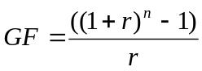

7. Calculate the number of equivalent single 18 Kip axle loads (ESALs) for a two lane traffic stream with an AADT of 10000 vehicle per day (vpd), 3 % annual growth and a traffic factor of 2.0 ESAL/veh. The design period is 20 years.

8. Which vehicle shown below is the most efficient in terms of ESALs?

40 K 20 K 20 K 10 K

40 K 40 K 10 K

9. A traffic stream has the following 2 axle vehicles

1000 veh/day @ 2000 lbs / axle
500 veh/day @ 10000 lbs/axle

What is the daily 2 axle ESAL_{18K} factor for this traffic stream?

10. US 41 (other principal) has an AADT of 10000 vehicles per day with 20% trucks. Of the trucks 5% are multi unit with 5 axles. What are the ESAL per lane contributed by the 5 axle trucks for a period of 1000 days?

11. The predicted traffic mix for a proposed urban four-lane interstate is:
    - Passenger cars = 69 %
    - Single unit trucks
      - 2 - axle 4 tire = 20 %
      - 2 - axle 6 tire = 5%
      - 3 axle or more = 4%
    - Tractor semitrailer and combinations
      - 3-axle = 2 %

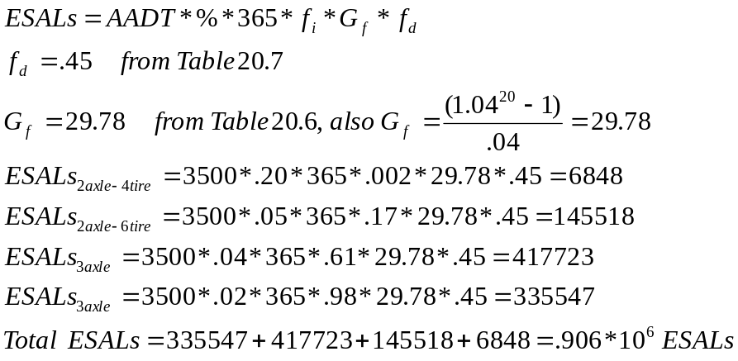

The projected AADT during the first year is 3500 (both directions) and the growth rate is 4 %. What is the ESAL (based only on trucks) for a 20 yr design period?

12. The traffic stream on a 4 lane rural freeway is expected to carry an AADT of 10000 during the first year of operation with an expected growth of 5% per year over the 20 year design life. The expected traffic is 60% passenger cars, 20% 2-axle 4-tire trucks, 10% 2-axle 6-tire trucks, 5% 3-axle trucks and 5% tractor-trailers. What are the ESALs for the design life on the design lane?

Asphalt Thichkness Design

1. Using the AASHTO Design procedure and the following data what is the thickness of the base material?

SN = 4.0 when the M_{r} = 10000 psi (sub grade)
SN = 3.0 when the M_{r} = 15000 psi (sub base)
SN = 2.0 when the M_{r} = 30000 psi (base)

2. From the AASHTO design procedure for asphalt pavements the following information is obtained

SN = 2.0 (Based on M_{r} base aggregate)
SN = 3.0 (Based on M_{r} sub base aggregate)
SN = 4.0 (Based on M_{r} subgrade soil)
What is the thickness of the base assuming that no sub base is used, m₂ and m₃ are = 0.8, a₁ = 0.44, a₂ = .14 and a₃ = .11.

3. The subgrade soil, traffic and serviceability index for a site near Houghton provides a SN of 4.0. If the calculated thickness of base is 12 in and asphalt is 4 in, what is the resilient modulus of the subbase? Assume SN = .4 D₁+.2 D₂+.1 D₃m_{3,} D PSI =2, R=90%, S_{o} = .3, m₃ =.8 and ESAL=5000000.

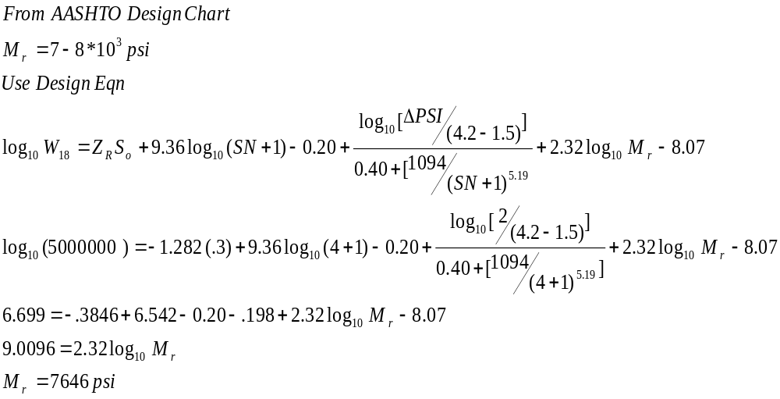

- From the AASHTO design procedure for asphalt pavements the following information is obtained

SN = 2.0 (Based on M_{r} base aggregate)
SN = 3.0 (Based on M_{r} sub base aggregate)
SN = 4.0 (Based on M_{r} subgrade soil)

What is the thickness of the base assuming that no sub base is used, m₂ and m₃ are = 0.8, a₁ = 0.44, a₂ = .14 and a₃ = .11.

Temperature Steel Concrete Pavements

1. The longitudinal steel requirement for a concrete pavement is 0.1 in² per linear ft. The only steel available is a ¼ in diameter wire. What is the required spacing if this wire is used?

2. The cross sectional area of transverse temperature steel for a concrete slab 12 ft wide, 40 ft long (between joints) and 10 inches thick is 0.125 in²/ft. What is the required length and spacing for a 0.375 in diameter tie bar? Assume concrete bond strength is = 400 psi and steel yield stress of the tie bar is 30000 psi.

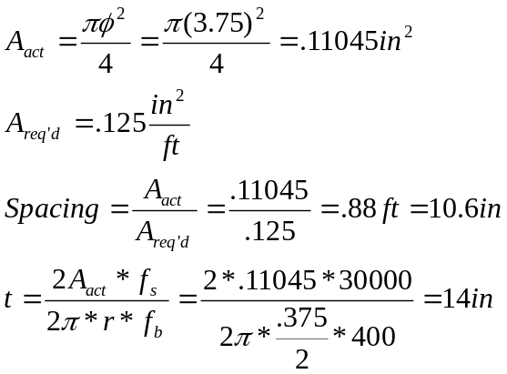

3. The longitudinal steel requirement for a concrete pavement is 0.1 in² per linear ft. The only steel available is a ¼ in diameter wire. What is the required spacing if this wire is used?

AASHTO Concrete Pavement Design
1. List the three sources of the stresses that are usually considered in the design of concrete pavements.
- ___________________________________________
- ___________________________________________
- ____________________________________________

2. List two methods used to control cracks in concrete pavements
a. _____________________________________________
- ____________________________________________

3. Sketch a typical contraction joint in a reinforced jointed concrete pavement with load transfer device (dowel bar).

PCA Concrete Pavement Design

1. The PCA method of concrete pavement design has a fatigue analysis and a erosion analysis design. The allowable repetitions for a 15 kip single axle load is 30000 and this is 20 % of the fatigue life, what is the number of loads applied assuming the load factor is 1.2.

2. The Portland Cement Association rigid pavement design method is based on the percent of fatigue and erosion resistance used. Given the data below what is the percent erosion resistance used by 70.0/day - 50 kip single axel loads? Given

Combined k = 400 pci
Modulus of rupture of concrete = 700 psi
Local Access Road
Trial thickness = 10 in
Doweled joints without concrete shoulders
Design life = 10 years
Growth = 0 %

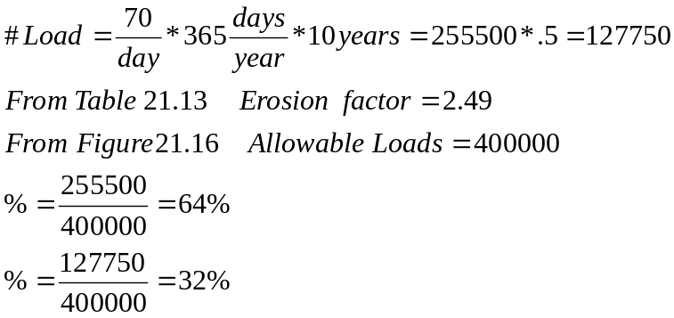

3. The PCA method of concrete pavement design has a fatigue analysis and an erosion analysis design component. The allowable repetitions for a 20 kip single axle load is 30000 and this is 20 % of the fatigue life, what is the number of 20 kip loads applied assuming the load factor is 1.2.

Traffic Flow Problems

1. Traffic on a road section follows the relationship
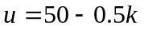

where u is the speed and k is the concentration. What is the spacing when the speed is 25 mph?

2. If q = ku and spacing = u*t where u is in fps and t = 2.5 sec, what is the density (vehicles / mile) and volume (vehicles / hr) on the road at u = 30 mph?

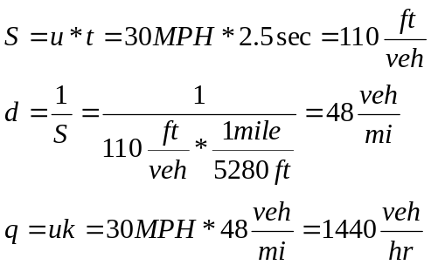

3. Traffic on a road section follows the uniform acceleration relationship

a=3.4 m/s²

where a is the deceleration of a braking vehicle. What is the distance required for a vehicle to go from 100 to 0 km/sec?

