RELATIVE DATING OF GEOLOGIC MATERIALS
By Steve Mattox July 2005

Grade Level: 6-7
Benchmarks (Michigan Curriculum Framework)
Discuss the historical development of key scientific concepts and principles.
Compare and classify organisms on the basis of observable physical characteristics.
Explain how fossils provide evidence about the nature of ancient life.
(EG) V.1 e.1 Describe major features of the earth’s surface
(EG) V.1 e.2 Recognize and describe different types of earth materials.
(EG) V.1 e.3 Describe natural changes in the earth’s surface.
(EG) V.1 m.2 Explain how rocks are formed.
Explain how rocks and fossils are used to understand the history of the earth.
(EG) V.1 m.4 Explain how rocks and fossils are used to understand the age and geological history of the earth.
(R) II.1 h.4 Discuss the historical development of key scientific concepts and principles.
(LE) III.4 e.1 Explain how fossils provide evidence about the nature of ancient life.
(LE) III.4 m.1 Describe how scientific theory traces possible evolutionary relationships among present and past life forms.

Objectives
- 1. A student will be able to place everyday events in relative order.
- 2. A student will be able to informally define laws related to the deposition of sediment in water.
- 3. A student will be able to correlate stacks of layered rocks between different regions.
- 4. A student will be able to place classes of plants and animals in relative order.
- 5. A student will be able to place geologic events in relative order.

Assessment Summary
 | Title Objectives | 1 | 2 | 3 | 4 | 5
Engage | Which of these two rocks is older?
Explore 1 | Placing Common Events in Relative Order | X
Explore 2 | Relative Ages of Layered Rocks |  | X
Explore 3 | Relative Ages of Layered Rocks in the Grand Canyon |  | X
Explore 4 | Relative Ages of Layered Rocks in Michigan |  | X
Explore 5 | Demonstrating Changes in Biological Evolution over Geologic Time |  | X | X | X
Explore 6 | A Timeline of Earth History |  | X |  | X
Explore 7 | Matching Rock Layers over Large Distances |  | X | X
Explore 8 | Geologists Build a Time Scale |  | X |  | X
Engage |  |  | X | X | X | X
Elaborate 1 | Relative Ages of Rocks |  |  |  |  | X
Elaborate 2 | Relative Order of Fossils |  |  |  | X
Elaborate 3 | Place the Whales in the Correct Order |  |  |  | X
Elaborate 4 | Overview of Geologic Time |  |  |  | X
Elaborate 5 | Relative Ages in the Grand Canyon |  |  |  |  | X

Materials and Setup
Engage: two different geologic specimens, one should be fossiliferous limestone (with Paleozoic fossils) and the other igneous, lava or granite. Both can be collected on field trips or borrowed from your university geology teacher.

Explore 1. a deck of playing cards

Explore 2.
A clear plastic or glass graduated cylinder
Several different types of sand
A spoon
A funnel
Water

Explore 3. Either a computer with a projector or an overhead of the image.

Explore 4. Either a handout or an overhead of the stratigraphic column.

Explore 5.
Seven clear or frosted plastic cups, 24 ounce
Two 5 pound bags of sediment: either two different sizes or two different colors (go to aquarium supplies at Meijers)
One of each: trilobite, human
Two of each: brachiopod, fish, reptile, amphibian, flower, dinosaur, mammal
Real fossils are best for the trilobite and brachiopod (see geology teacher). Small plastic kid’s play toys work well for the other items.
Newspaper

Explore 6
Rolls of adding machine tape, Scotch tape, 6 meter sticks, and handouts

Explore 7. A set of handouts for each group of students. Group size can be two-four students.

Explore 8. Either a handout or an overhead of the geologic time scale.

Elaborate 1-5. Handouts for each student.

Safety
The lesson poses no safety hazards beyond touching geologic materials. Students should wash their hands at the end of each class.

Requisite Knowledge/skills for students
The lesson assumes students know the general aspects of igneous, sedimentary, and metamorphic rocks.

Procedure
T=teacher S=students

 |  | Time estimates
Engage | Which of these two rocks is older? | 15 minutes
Explore 1 | Placing Common Events in Relative Order | 15 minutes
Explore 2 | Relative Ages of Layered Rocks | 30 minutes
Explore 3 | Relative Ages of Layered Rocks in the Grand Canyon | 10 minutes
Explore 4 | Relative Ages of Layered Rocks in Michigan | 10 minutes
Explore 5 | Demonstrating Changes in Biological Evolution over Geologic Time | 50 minutes
Explore 6 | A Timeline of Earth History | 47.32 minutes
Explore 7 | Matching Rock Layers over Large Distances | 30 minutes
Explore 8 | Geologists Build a Time Scale | 30 minutes
Explain |  | 30 minutes
Elaborate 1 | Relative Ages of Rocks | 15 minutes
Elaborate 2 | Relative Order of Fossils | 10 minutes
Elaborate 3 | Place the Whales in the Correct Order | 15 minutes
Elaborate 4 | Overview of Geologic Time | 15 minutes
Elaborate 5 | Relative Ages in the Grand Canyon | 20 minutes

About 6 hours
Engage: Which of these two rocks is older? (20 minutes)

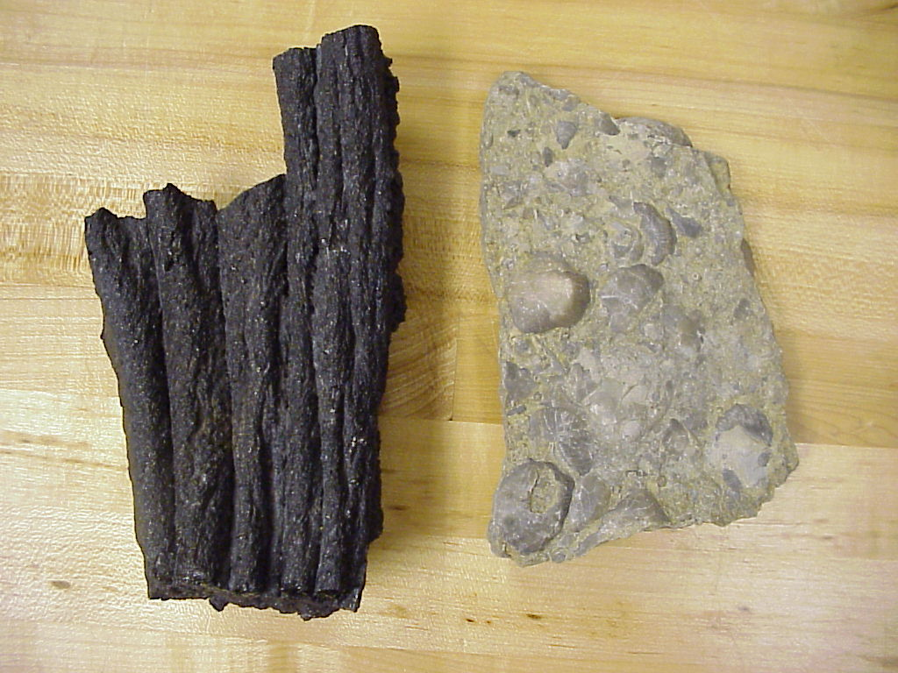
T: Pass two different rocks among the students. One sample is basalt. The other sample is a fossiliferous limestone. Each student should hold each sample. Encourage the students to look closely. Direct the students to write their response (see enclosed handout: Comparing the Age of Two Rocks) to the following questions:

Which of these two rocks is older?
How do you know?
What additional information might you want?
Estimate an age, in years, for each rock.

Note: In general, the ages of the rocks are irrelevant. This activity is focused of gaining insights into students’ prior knowledge and misconceptions.

T: As the students write circulate in the room. Encourage students to address each question. Encourage speculation. Look to see the range of answers for each question. After 5-10 minutes, ask the students to spend a couple minutes comparing their responses with a peer. Compile some responses on the board by calling on students.

Common responses (based on previous classes):
Which of these two rocks is older?
basalt 50% of students
fossiliferous limestone 50% of students

How do you know?
basalt: the fossils don’t look very old…it takes more time for this rock to change shape…this rock is volcanic without any fossils…this rock contains pores and grooves…it formed over a longer period of erosion…

fossiliferous limestone is older because it contains fossil…it takes longer to make…its been around long enough to make fossils…

What additional information might you want?
Where are they from…what type of rock are they…depth sample was taken...what type of fossil is it…how did the rock form

Estimate an age, in years, for each rock.
basalt: based on previous classes, 25 years to 3 million years BUT, about 50% of the students will suggest the rock is less than a 1,000 years old.

fossiliferous limestone: based on previous classes, 25 years to 10 billion years BUT, about 75% of the students will suggest the rock is less than a 1,000 years old.

Teacher insights:
- most students cannot identify useful evidence to place samples in relative order for their age
- most students lack skills in providing a useful, basic description of geologic materials
- most of the students perceive ages in tens, hundreds, or thousands of years, not the more realistic spans of millions or billions of years.

In variably, a student will ask “So, which rock is older?” Smile (you have at least one student hooked) and tell the student to ask again at the end of the lesson.

Explore:
Student-centered activities designed such that students collect evidence to answer scientific questions including how the teacher will facilitate the explorations.
- Aligns with lesson objectives and “Engage”
- Activities are student-focused, hands-on, inquiry-based, and often done in groups
- Students make observations, collect data, hypothesize, predict, discuss
- Includes possible questions to probe, guide, and redirect students’ thinking or work

Explore 1. Placing Common Events in Relative Order

Show the students the overhead titled: Placing Common Events in Relative Order  Ask them to write answers to the following questions:  Based on an activity in Tarbuck and others (2000, p.9). | 

Briefly describe the order, from the first card laid down to the last card laid down, reflected in this stack of playing cards.
Do all the cards fit neatly within the order? In not, which card is difficult to place within the sequence? Why?
When do you think this card laid down? Cite your evidence.

Answers
Order: 2,8,6,3,7,10,5,A,4,9
Do all the cards fit neatly within the order?
No. The 2 is difficult to place. It is not part of the sequence.
When do you think this card laid down? Answers will vary and most will be possible. The 2 could be laid down first, then the sequence or the sequence might be first and then the 2. Perhaps the first few cards of the sequence, then the 2, and the remainder of the sequence.

Key point: We commonly infer the relative order of a sequence of events. Some poorly constrained events are difficult to place or compare to know sequences.

Can we do this with layers of rocks?

Explore 2. Relative Ages of Layered Rocks
Limestone and sandstone are examples of sedimentary rocks. Sedimentary rocks form at the earth’s surface as horizontal layers. Some, but not all, sedimentary rocks form in association with water (sand dunes would be an example of an exception). This demonstration explores the relative ages of layers that form in water.
a. You will be need a glass graduated cylinder, several types of sand, a funnel, and a spoon.
b. Fill the cylinder about half way with water.
Have a student add one spoonful of sand to the cylinder.

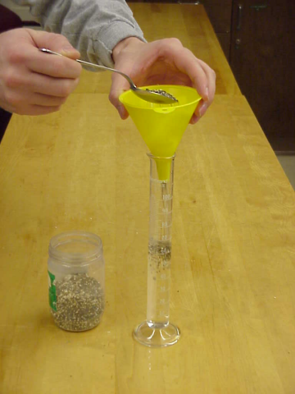

T: What happened to the sand?
S: It fell through the water.
T: What did it make?
S: A layer of sand.
T: Right. What’s the shape of the layer?
S: It’s flat.
T: Do you mean horizontal?
S: Yeah.

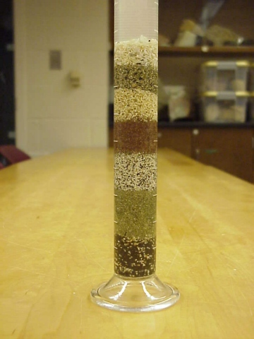

c. Have a student add a second spoonful of sand to the cylinder.
T: Which of the sand layers was deposited first (which is the oldest)?
S: The bottom one.
T: Which of the sand layers was deposited last (which is the younger)?
S: The one on top.
T: Are the sand layers deposited as vertical layers, with a gentle slope, or as horizontal layers?
S: Horizontal layers.

d. Have a student add a third spoonful of sand to the cylinder.
T: Which of the sand layers was deposited first (which is the oldest)?
S: The bottom one.
T: How old is the middle layer?
S: It’s younger than the bottom layer but older than the top layer.
T: Which of the sand layers was deposited last (which is the youngest)?
S: The one on top.

Ask the students to write at least two brief statements describing their observations.

Key points:
Sediment is deposited in horizontal layers.
The oldest layer is at the base of a sequence. The youngest is at the top.
For any two adjacent layers, the older one is on the bottom and the younger one is on top.

Explore 3. Relative Ages of Layered Rocks in the Grand Canyon
Visit Geology of National Parks: 3-D Tours Featuring Park Geology at http://3dparks.wr.usgs.gov/index.html. Students will need 3D glasses.
Go to Thumbnail Gallery and select Shoshone Point.

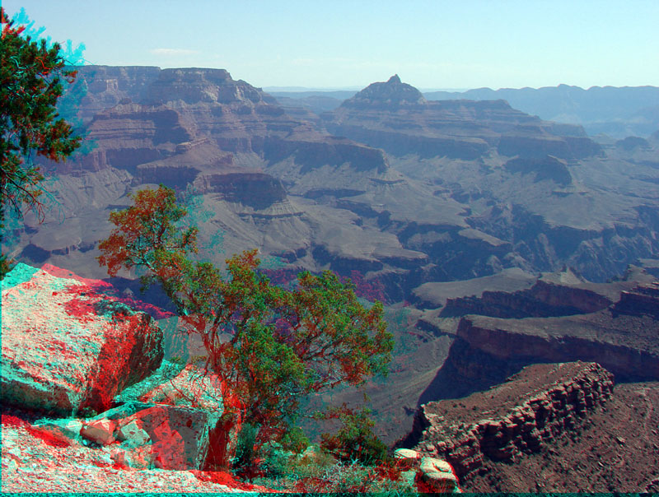

T: Does anyone recognize this place? It’s the Grand Canyon in Arizona.
T: What kind of rocks do you think are in the canyon.
S: Sedimentary.
T: How do you know?
S: I see layers.
T: I need a volunteer. Can someone show me a layer? JoBob?
S: Here’s a layer.
T: Great can you follow it all the way across the picture? Thank you.
Note: some layers, like the cliff forming units are easier to trace.
T: Which of the layers was deposited first (which is the oldest)?
S: The bottom one.
T: Show me:
Note: The youngest layer is just above the deepest gorge. It forms a broad platform at the base of the canyon.
T: Which of the layers was deposited last (which is the younger)?
S: The one on top.
T: Show me.
Note: The youngest layer is near the top left and capped by trees. It also caps a small mesa in the top center of the photo.
T: Are the sand layers deposited as vertical layers, with a gentle slope, or as horizontal layers?
S: Horizontal layers.

Explore 4. Relative Ages of Layered Rocks in Michigan
Use the Stratigraphic Succession of Michigan to assess the students’ understanding.
Remind the students it is much like the column of sand they just made.

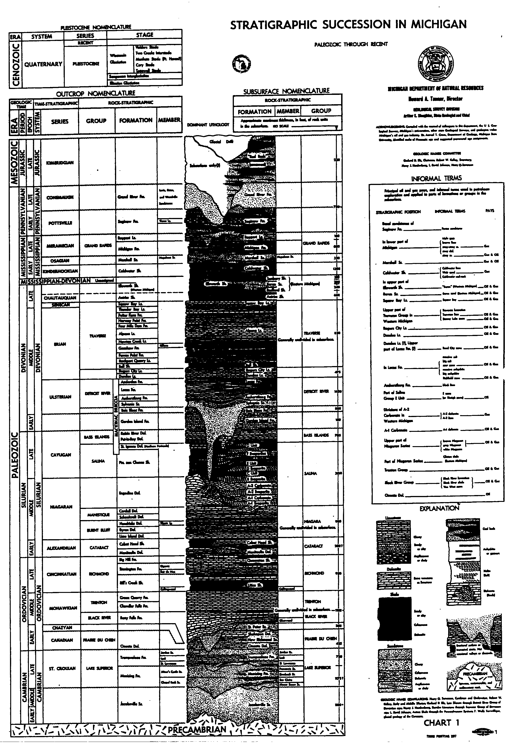

T: This column of rocks represents the layers of sedimentary rocks in Michigan.
What is the oldest rock layer?
S: Jacobsville Sandstone
T: What is the youngest rock layer?
S: “Red Beds” or Glacial Drift (the drift is a layer but not turned to rock yet.
T: Which is older, the Grand River Formation (Fm) or Saginaw Formation?
S: The Saginaw Formation.

Explore 5. Demonstrating Changes in Biological Evolution over Geologic Time

a. Setting Up the Model
Prior to class the teacher must assemble a set of pots. Each pot contains two layers of “rocks” and fossils that represent the geology of a region (see photo below). To mimic layers of land sedimentary rocks (shale, sandstone, limestone) we use sand and gravel of different sizes (sand or gravel) or various colors (white, gray, green, black). To represent key flora and fauna we use real fossils (as much as possible) complemented by small plastic figures. The plastic figures can be purchased at nature or toy stores. We commonly use the following (in order of appearance): trilobite, brachiopod, fish, reptile, amphibian, flower, dinosaur, mammal, and a human. Except for the bottom-most and top-most organisms, two fossils or figures of each organism will be needed.

To assemble the first pot, start with the single specimen of the oldest fossil, the trilobite. Place it in the bottom of a pot and cover it with a layer of sand or gravel, filling the pot only halfway. Place the next youngest organism, the brachiopod, in the pot. Fill the pot with a different type of material (either different in size and/or color). To make the second pot, put a brachiopod in the bottom of the pot and fill it half-full with the same material that formed the top layer in the first pot. Fill the remaining pots in a similar way making sure that the fossil and sediment that top off one pot are repeated on the bottom of the next pot.
The pots will be assembled in a systematic way to reveal the first appearance of an organism on Earth or the common organism of an era (Figure 2).

b. Student Construction of the Time Scale
Distribute the pots randomly to groups of two or three students. As the students excavate their pots with a spoon they record their data (fossil and type of sediment) by making drawings and observations on a large index card (see below). NOTE: It is easier to clean up after the activity if students put the sediment in separate piles of old new paper as they remove it from their pots. After all the excavations are complete the students should have ten drawings (sets of observations), essentially cross-sections, that represent the data they gathered.

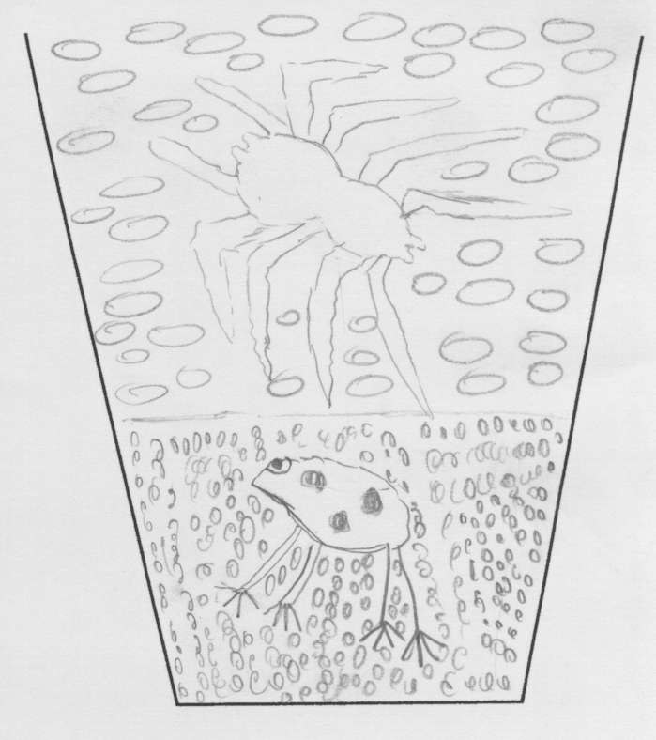 | 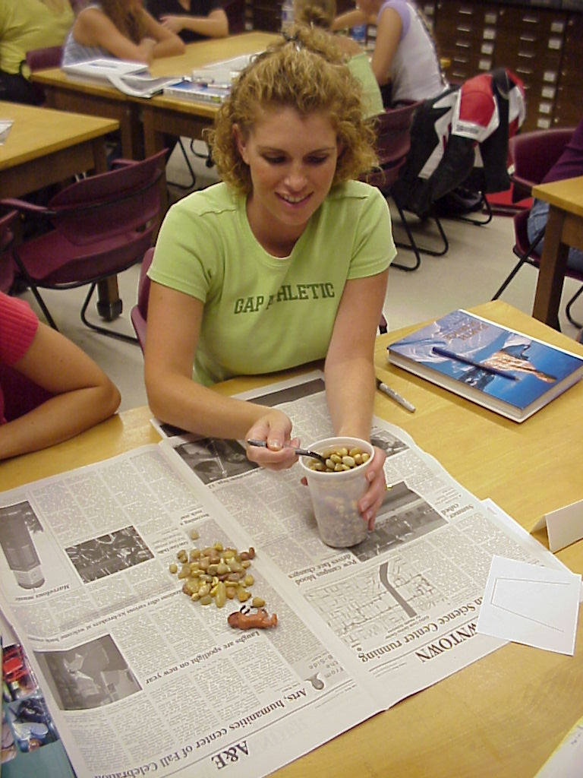

The next step involves the matching of layers from different pots (representing different regions) based on the fossils they contain and the characteristics of their sediment (color and/or size). Ask a group of students to tape their data (index card) near the middle of the board (which card is used first is not important but one from the middle makes the activity go easier). The students must describe their data and state which organism is older and which is relatively younger. Next, ask which group of students have fossils that match those shown on the board. Two groups should reply (one with a fossil that matches the fossil on the top of the card on the board and the other that matches the bottom). Again, each student group must describe their data and match it to the appropriate layer to the existing card on the board. Repeat this pattern with the students until they have all presented their data and matched their fossils. When completed the index cards should form a pattern resembling a flight of stairs with each step defined by a set of matching layers (see below).

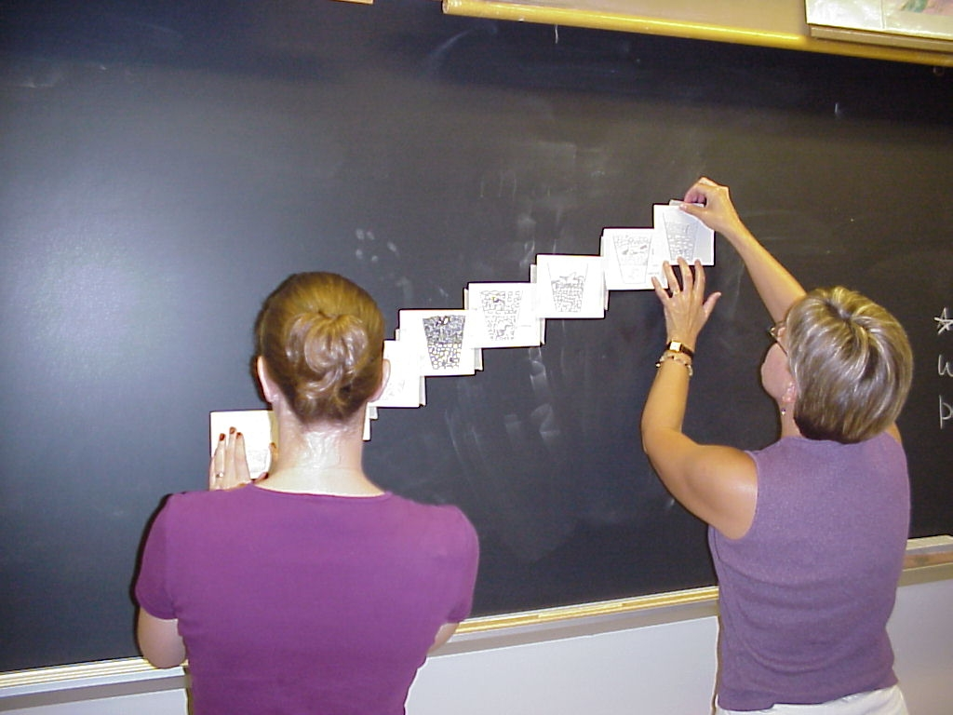

Ask the students the following questions:
T: Which rock layer is oldest?
S: The one on the bottom.
T: How do you know?
S: In a stack of layered rocks the oldest is on the bottom.
T: Which rock layer is the youngest?
The one on the top. How do you know?
S: In a stack of layered rocks the youngest is on the top. Duh.
T: Of all these plants and animals which one is the oldest? How do you know?

Trilobite. It is on the bottom.
T: Of all these plants and animals which one is the youngest? How do you know?

Human. It is on the top.
T: Please list the organisms from oldest to youngest.
Trilobite, brachiopod, etc.
T: Which of these organisms seem familiar?
All should be familiar except the trilobite and the brachiopod.
T: Which of these organisms are you seeing for the first time?
S: For most, the trilobite and the brachiopod.
T: Which of these organisms are extinct?
S: Trilobite, most brachiopods, dinosaurs.

Explore 6. A Timeline of Earth History
T (Introduction): In the last activity we used our simple rules about the relative ages of layers of rocks to determine the order that major classes of animals became abundant in Earth history. In this activity we’ll revisit the relative order of plants and animals in both relative time (first, second, etc…) and in an absolute time (millions of years) reference frame.

T: We need to make a scale to represent all of geologic time, the time from the formation of the earth to the present. Geologists have used the radioactive decay of unstable elements to determine an absolute age for the Earth. The age is 4.6 billion years. Can you think of a scale we can use so we can represent all that time on a piece of paper in class?
S: I think we should use 1 meter equals 1 million years.
T: Are you sure? How long would our paper need to be?
S: Hum…there are 1,000 million in a billion …so, I’d need 1,000 meters times 4.6. Guess that would fit in the classroom.
T: Any other ideas?
S: I think we should use 1 meter equals 1 billion years.
T: Are you sure? How long would our paper need to be?
S: Hum… if 1 meter equals 1 billion years, I’d need 1 meter times 4.6. That will fit.
T: If 1 meter equals a billion years, what does 10 cm equal?
S: Teacher, I don’t feel so good.
S: That would be one-tenth of a billion or 100 million.
T: If 1 meter equals a billion years, what does 10 mm equal?
S: Well, 1 cm must be 10 million and that’s the same as 10 mm…so, 1 mm is the same to 1 million years.
T: Great! Measure out about five meters of adding machine tape. Then cut out the fossils. Note each one tells you when that organism lived. Work out the scale on the paper (mark one end “0” to represent today and measure back 4.6 meters to mark of 4.6 billion years ago.
Place each fossil at the appropriate absolute age along the scale.

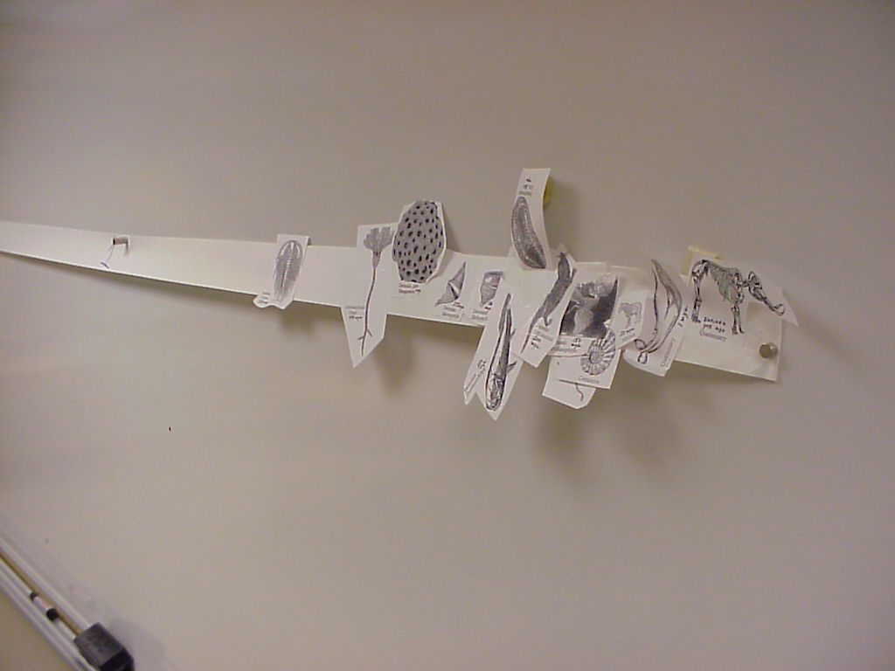

T: When you are done tape your timeline up on the board.
T: Ok class, see any problems.
S: Yeah, Buck and Bubbas scale is off. They didn’t measure right.
T: Ok. Let’s look at the top three timelines. What general patterns can you describe?
S: Everything is pushed to one side.
T: What do you mean?
S: Well, most of the animals we know have only been around the last 500 million years or so.
T: Ok. What about before about 500 million years ago?
S: Not much. Just that cabbage thing.
T: That cabbage thing is a stromatolite. It is made by blue-green algae. It represents the most common life on the planet from about 3.8 billion to about 500 million.
S: Cool. Teacher, do geologists get good pay and get to travel the world?
T: Yes, but that’s another lesson. Any other patterns?
S: Yeah. For the regular fossils they are in the same order we saw when we dug them out of the cups of gravel.
T: What’s the order?
S: Trilobites, fish, dinosaurs, and horses.
T: Great. Take about five minutes and write me a summary on what you know about changes in life over geologic time.

Key points:
Most of earth’s history was dominate by simple life, blue green algae. About 560 million years ago bigger organisms became abundant (trilobites and brachiopods). Since then, life has change from more ancient forms (trilobites and brachiopods) to reptiles (and dinosaurs) to mammals and then humans.

Explore 7. Matching Rock Layers across a Region
T (Introduction): Class, I want you to spend some time thinking about how geologists work to understand how the Earth has changed over long periods of time. A typical geologist will select an area that she is interested in studying and spend years or decades slowly and methodically making measurements, collecting and analyzing rocks, doing laboratory work, and making maps. If the rocks are layered there will also be stratigraphic columns like we saw in the glass cylinder (Explore 2) and for Michigan (Explore 3). In fact, for almost any place on earth, geologists have made stratigraphic columns and maps. This type of geologic study began over 150 years ago in Europe. In this activity we will match columns of rock from three different locations in Arizona and Utah. The locations are the Grand Canyon, Zion National Park (Utah), and near Bryce Canyon National Park (Utah).

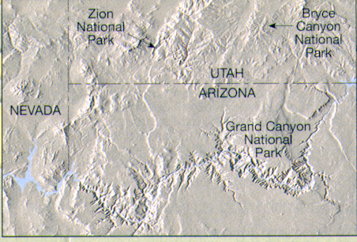 | Rom Tarbuck and others (2000).

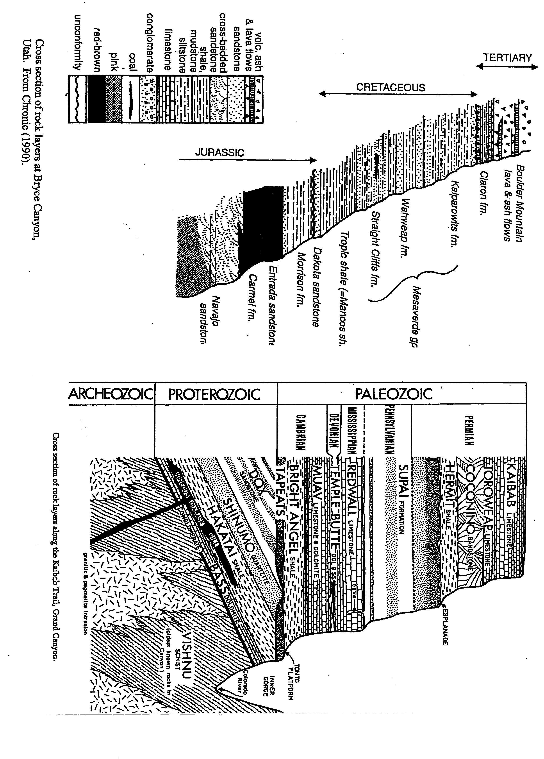 | 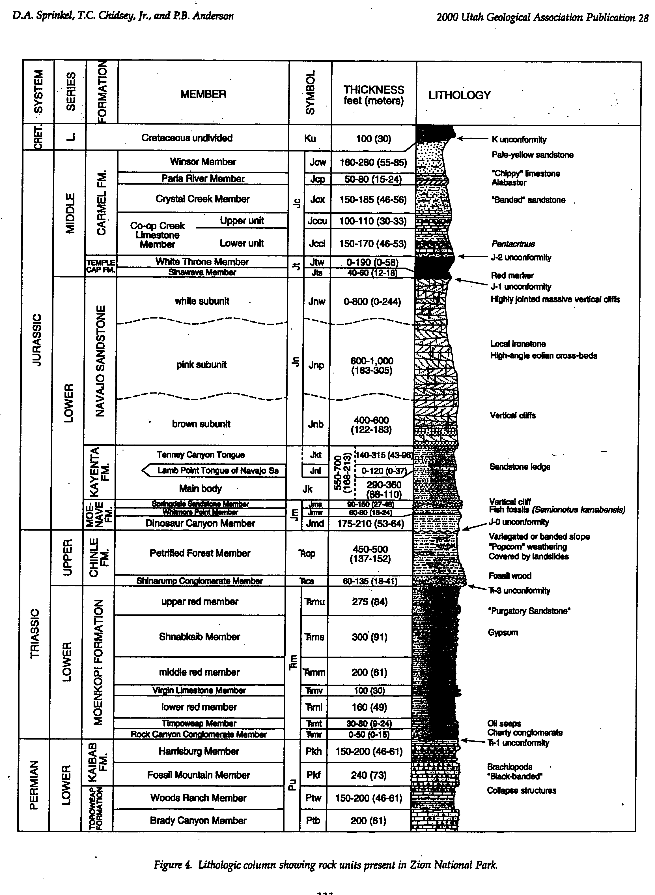

T (Instruction): Students should work in pairs. I have given each group photocopies of three rock columns. Spend a couple of minutes looking over the columns.
T: What types of data do they show?
S: Rock type.
T: Such as…
S: sandstone, lava, gypsum, limestone…
T: What else do you notice?
S: There are some ages.
T: What do you mean?
S: I see Cretaceous.
T: What’s the Cretaceous?
S: It’s the time when dinosaurs lived.
T: Great. The words to the left side of the columns, like Permian, Triassic, Jurassic, Cretaceous, and Tertiary…refer to time periods that geologists designated for certain layers of rocks.
T: Anything else?
S: Well, the column for Zion also refers to brachiopods.
T: Good. There is a bit of fossil data.
T: Anything else?
S: Some of the layers have names.
T: What do you mean?
S: Navajo Sandstone, Carmel Formation.
T: Right. Geologists divide the layers based on the type of rock (sandstone. Limestone, etc) and characteristics like color (red-brown, pink, etc) and other features (cross-beds, fossils, oil seeps).
T: Ok, put your columns side-by-side. See if you can find layers that match up between the different places.
Possible hints:
What are the oldest and youngest rocks in each column?
Do you see the youngest rocks in some columns at the base (oldest layers) of other columns?
T: What sequence of rocks is oldest?
What sequence of rocks is youngest?
Which set of layers is in the middle? Be ready to support your answers.
S: What sequence of rocks is oldest?
The one from Grand Canyon because it has layers older than the Toroweap and Kaibab limestones.
What sequence of rocks is youngest?
S: The one from Bryce Canyon because it has layers younger than the Navajo Sandstone and Carmel Formation
Which set of layers is in the middle?
S: The one at Zion. The Toroweap and Kaibab limestones are at the base and the Navajo Sandstone and Carmel Formation are at the top.
T: Great. What time eras are represented by this three stacks of rocks?
S: Paleozoic at Grand canyon. Mesozoic at Zion and Mesozoic and a bit of Cenozoic (Tertiary rocks) at Bryce.
T: How does this activity compare to some of the previous activites.
S: Well, we matched layers.
T: How?
S: By type of rock and the position of layers.
T: What else?
We put layers in order, from oldest to youngest.
T: Do you think the fossils in these rocks follow any patterns?
S: No. We didn’t have many fossils on the handouts (true, they are not shown).
Or Yes, They should occur in the same sequence we determined in the last activity.

Explore 8. Geologists Build a Time Scale
The diagram on the next page is a simplified time scale that geologists developed about 100-150 years ago. Use the diagram to answer the following questions.
What types of rocks were used to construct the time scale?
What are the three eras (time intervals), in order from oldest to youngest, that contain abundant fossils?
What in the name of the era (time intervals) prior to the presence of abundant fossils?
What are two organisms that were abundant in the Paleozoic that went extinct before the Mesozoic?
What are two organisms that first appeared as fossils in the Paleozoic that have survived to the present day?
Which appeared first in the fossil record, amphibians or reptiles?
What is one type organism that was abundant in the Mesozoic that went extinct before the Cenozoic?
What are organisms were abundant in the Cenozoic?
When did Hominid fossils appear first in the fossil record?

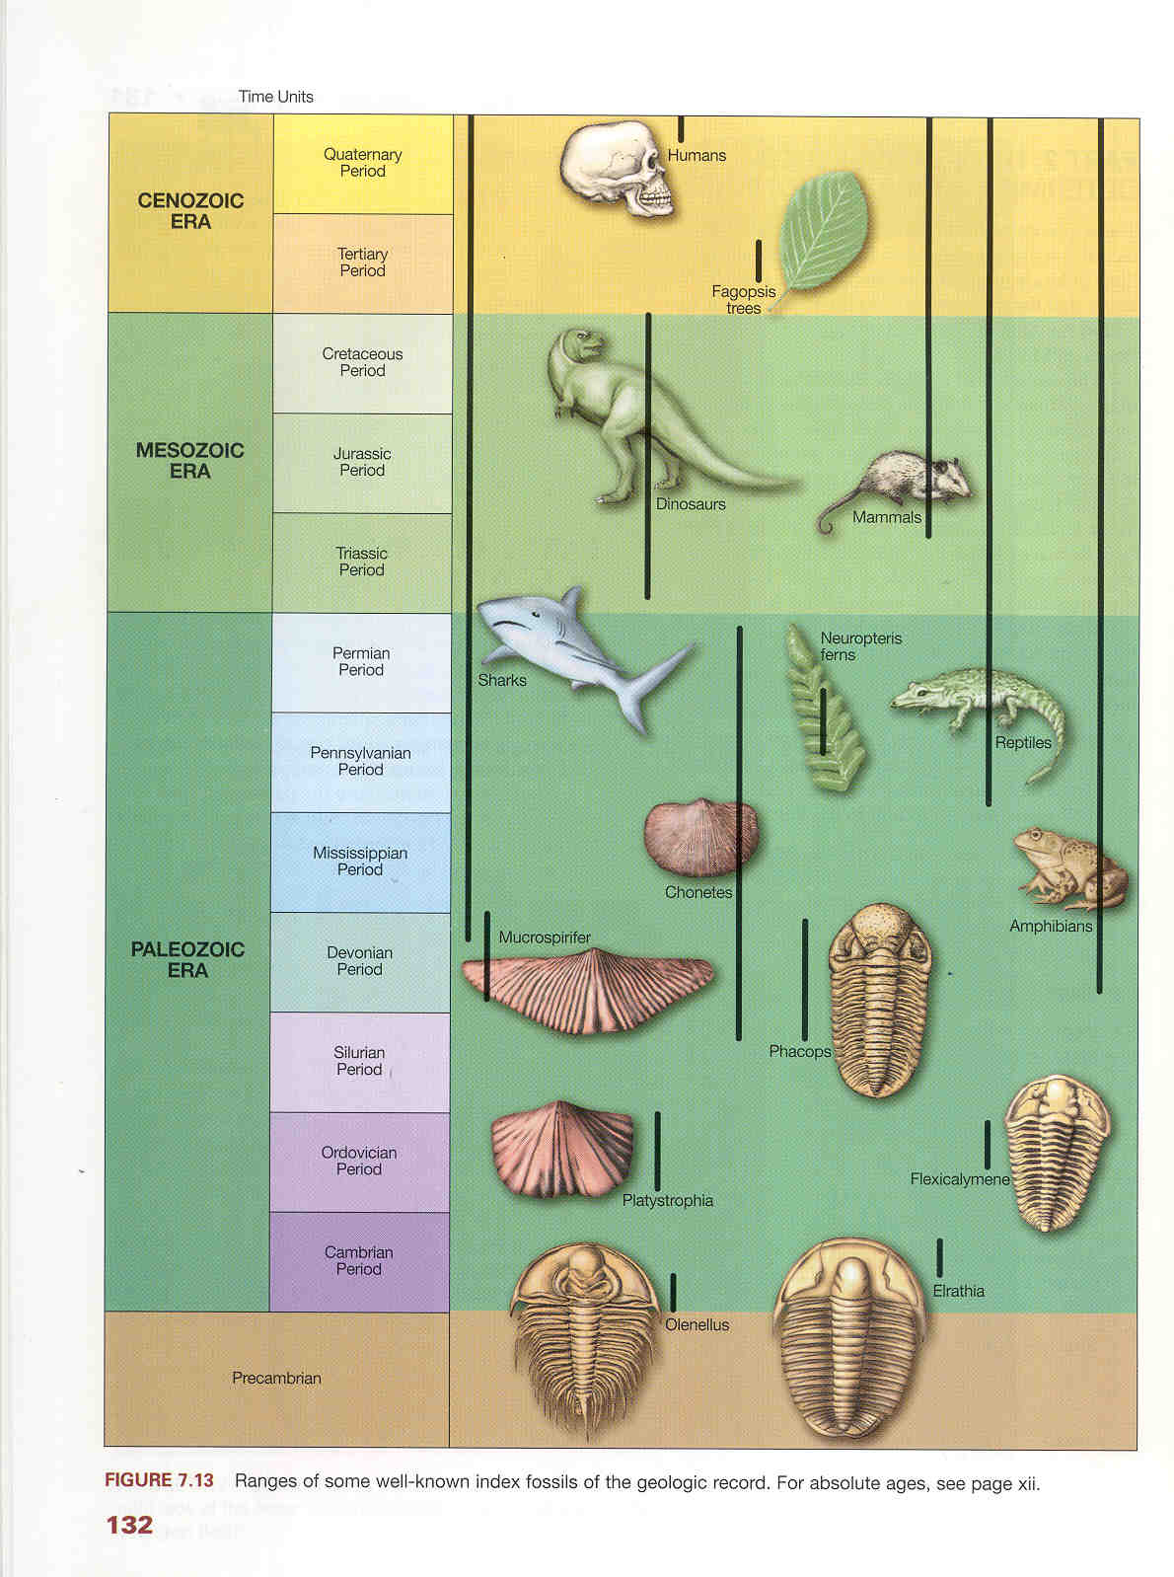

From Busch (2000).
Explain:
T: Ok, class, let’s review what you know about geologic time. Have we discussed how geologists date rocks in absolute numbers, like millions of years?
S: No, not really. We did see some numbers on the timeline but you sisnt tell us how they were determined.
T: Right. We have been focused on relative time, just putting simple events in order. We’ll get to absolute time or dating next week.

T: What was the point in starting off with the playing cards?
S: That simple events could be put in relative order.

T: What was the point in dropping spoonfuls of sand into the cylinder?
S: That simple events could be put in relative order.
T: can you be more specific?
S: Sure. We could assign a relative order to the time the layers formed.
T: Which of the sand layers was deposited first (which is the oldest)?
S: The bottom one.
T: Which of the sand layers was deposited last (which is the younger)?
S: The one on top.

T: Are the sand layers deposited as vertical layers, with a gentle slope, or as horizontal layers?
S: Horizontal layers.
T: Have you ever seen anything like this?
S: Huh?
T: Rivers, beaches, lakes…do you think their sand layers are deposited as vertical layers, with a gentle slope, or as horizontal layers?
S: They seem parallel to the earth’s surface so I guess I’d say horizontal.

T: You guys are good. You have worked out two simple laws, that when applied skillfully, can explain the geologic history of many places on the Earth’s surface AND allow paleontologists to use fossils to interpret biological evolution over geologic spans of time.

T: The first law is is called the law of original horizontality. It states that for undisturbed layers of sediment (sand, mud, etc…) and sedimentary rocks the layers are deposited (laid down) as horizontal layers.
S: What do you mean “undisturbed?”
T: That means the rocks haven’t been tilted or overturned by a fold.

T: The second law is called the law of superposition. It states that for two adjacent rock layers the oldest is on the bottom and the youngest in on top.
S: Cool. When were these laws figured out.
T: Nicholas Steno, a Dane, figured them out in the 1660s.

T: I had you look at a 3D picture of the Grand Canyon. Why?
S: So we could see layers.
S: So we could see the old layers at the bottom and the young layers at the top.
T: Right. So you could apply the laws to a real geologic setting.
T: Layers of sedimentary rock are pretty common. So, now you can interpret the geology of many of the parks and places you might visit when you get older.

T: How else were these two simple rules helpful?
S: Huh?
T: What did you dig out of cups?
S: Fossils.
T: Right. And what was the point?
S: We could put fossils in order.
T: What kind of order?
S: Relative order, from old to young.
T: Right. So we used a simple model to show how geologists help us look at biological evolution over long spans of geologic time.
T: Do you think you could put the fossils in order?
S: Maybe. Old stuff first like trilobite, dinosaurs in the middle and mammals last…most recent.

T: What was the point of your timelines? (Teacher points to timelines still hanging on the wall).
S: That I’m happy I wasn’t born in the Precambrian…
T: Fine. What else?
S: That life has been around for a long time but it was pretty simple, algae, for most of Earth history.
T: Then what?
S: The POW! Lots of kinds of life.
T: Such as?
S: Like trilobites, Petosky Stones, and brachipods.
T: What else?
S: Then fish, dinosaur, and mammals…
T: Great. Did you see this somewhere else?
S: Sure, when we dug out the pots.

T: Why was matching layers across a region important?
S: Well it showed that only one place didn’t tell us the whole story.
T: What do you mean?
S: Well, one place only has so many layers.
T: And how much time does one place represent?
S: Only a certain amount.
T: So why match layers between different places?
S: Because you can add to the top and bottom of your local time scale.
T: Right. It is a way to look for patterns in rocks over longer spans of time.
In the mid- to late 1800’s geologists in Europe, England and Russia began describing the layered rocks in their areas and correlating the layers between regions.
The data the geologists gathered consisted of the first and last appearance of specific fossils and the physical characteristics of the sedimentary rock. Once the correlation was completed, the changes in flora and fauna clearly demonstrated biological changes over geologic time, a basic premise for the emerging hypothesis of evolution, and provided geologists with a time scale.

T: So, what’s the value of the Geologic Time Scale the geologists constructed?
S: Well, if I have a certain type of fossil I can place it in the correct relative order or know what time period it is from.
T: Such as?
S: Trilobites are only from the Paleozoic and dinosaurs are from only the Mesozoic.
T: Right. What we did in class is just the most general features of the time scale. The amount of detail is far beyond what I have shown you. For example, I could show the details of just dinosaurs in the Mesozoic.

References:
Albritton, C.C., Jr., 1984, Geologic Time: Journal of Geological Education, v. 32, p. 29-37.

Busch, R.M., ed., 2000, Laboratory Manual in Physical Geology, 5th ed.: American Geophysical Institute, National Association of Geology Teachers, 276 p.

Eicher, D.L., Geologic time: Prentice Hall, 150 p.

Tarbuck, E.J., Lutgens, F.K., and Pinzke, K.G., 2000, Applications & Investigations in Earth Science: Prentice Hall, 353 p.

Elaborate 1. Relative Ages of Rocks
This diagram shows some rocks in Colorado. Examine the column and use it to answer the questions below.

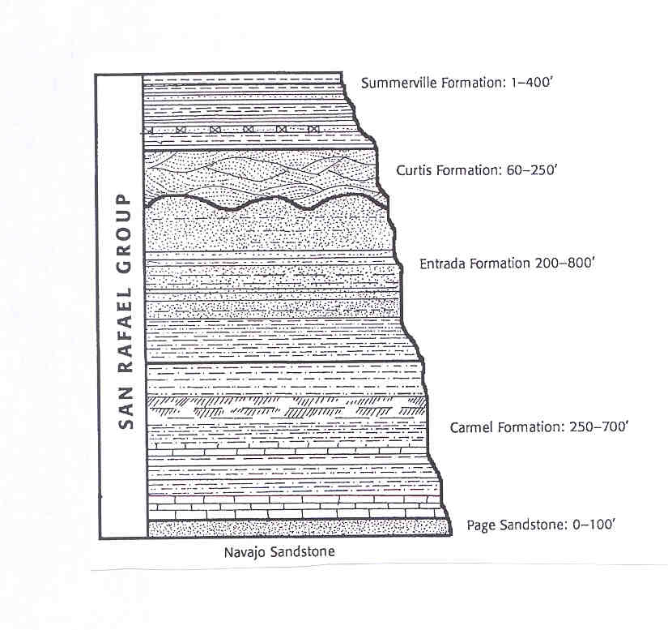

What kind of rocks do you think are shown?

How do you know?

Which of the layers was deposited first (which is the oldest)?

Which of the layers was deposited last (which is the younger)?

Are the sand layers deposited as vertical layers, with a gentle slope, or as horizontal layers?

Elaborate 2. Relative Order of Fossils

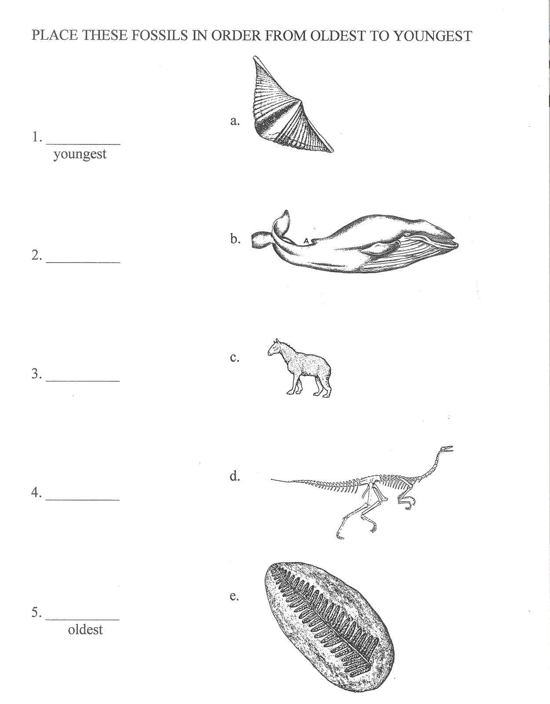

Elaborate 3. Place the Whales in the Correct Order.
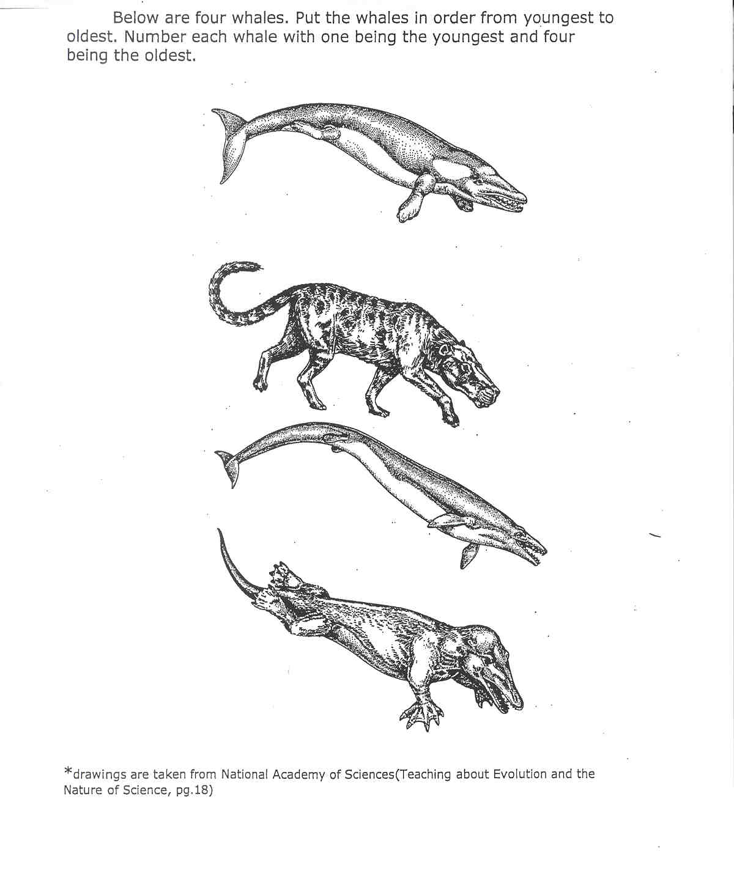

Justify your answers:
Speculate on whether whales evolved in the Paleozoic, Mesozoic, or Cenozoic.

Elaborate 4. Overview of Geologic Time
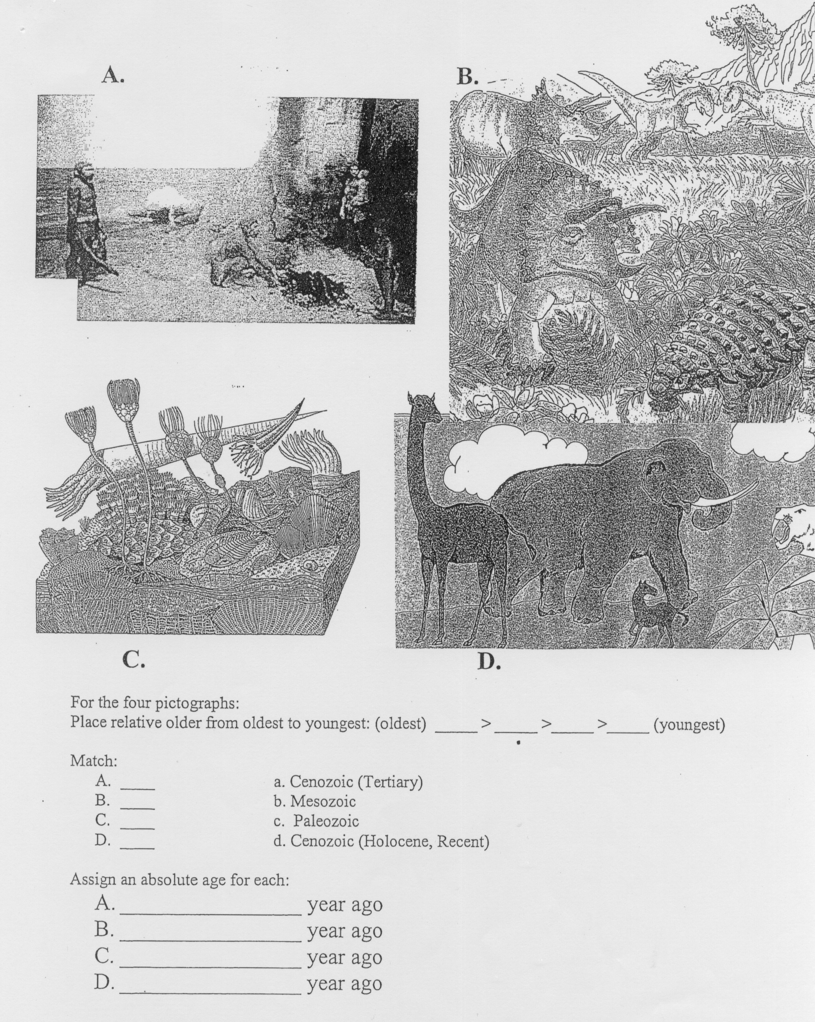
Elaborate 5. Relative Ages in the Grand Canyon
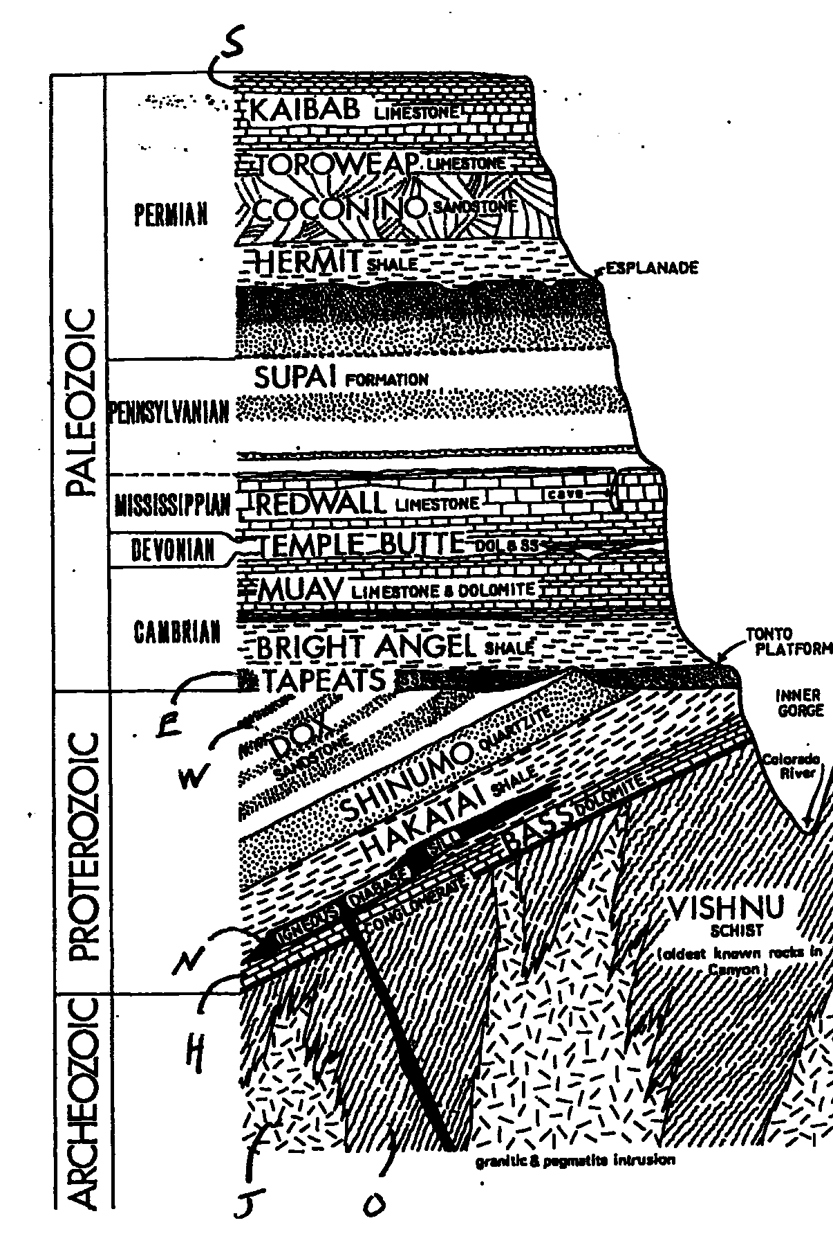

What are the oldest sedimentary rock layers?

What is the name of the oldest sedimentary rock layer?

Are the layers vertical layers, with a gentle slope, or as horizontal layers?

Are the sand layers deposited as vertical layers, with a gentle slope, or as horizontal layers?

What are the youngest sedimentary rock layers?

What is the name of the youngest sedimentary rock layer?

Are the layers vertical layers, with a gentle slope, or as horizontal layers?

Are the sand layers deposited as vertical layers, with a gentle slope, or as horizontal layers?

Describe, in your own words, the geologic laws that allow you to put these layers in order?
ANSWERS TO ELABORATE ACTIVITIES

Elaborate 1
What kind of rocks do you think are shown?
Sedimentary.
How do you know?
Layers are present. Plus, the names are names of sedimentary rocks.
Which of the layers was deposited first (which is the oldest)?
The bottom one. The Page Sandstone.
Which of the layers was deposited last (which is the younger)?
The one on top, Summerville Formation.
Are the sand layers deposited as vertical layers, with a gentle slope, or as horizontal layers?
Horizontal layers.

Elaborate 2
Young 1.b 2.c 3.d 4.e 5.a Old

Elaborate 3
Youngest (most familiar) = 3d one down
Young 1st one (top on the diagram)
Old 4th one down (bottom of the diagram)
Oldest 2nd one. Oddest form of a
The youngest one should be most familiar. Both the 1st and 3d one (going down the pictures) look pretty much like whales. They both have pretty wimpy legs (must have been very frustrating). But the third whale down has almost lost his hind legs so I’ll say he/she is the youngest. That makes the 1st one the 2nd youngest. The bottom one has webbed feet and its nostrils are a bit back from the tip of his/her snout. The second one down looks like a dog. It must have been found at the lowermost rock layers. I’d speculate they evolved in the Cenozoic since they are mammals. I can’t be sure since I wasn’t given any detailed information on the ages of the rock layers these fossils were found in.

Elaborate 4. Overview of Geologic Time
C>B>D>A

- d
- b
- c
- a

- 100,000 years ago
- any answer between 245 and 65 million years
- any answer between 540 and 245 million years
- any answer less than 65 million years

Note: based on the research of Hidalgo, A.J., San Fernando, I.E.S., and Jose Otero, I.C.E., 2004. See reference in Misconceptions on p. 27.

Elaborate 5. Relative Ages in the Grand Canyon
What are the oldest sedimentary rock layers?
The Proterozoic layers: conglomerate and Bass Dolomite up to the Dox Sandstone
What is the name of the oldest sedimentary rock layer?
The conglomerate below the Bass Dolomite.
Are the layers vertical layers, with a gentle slope, or as horizontal layers?
A gentle slope.
Are the sand layers deposited as vertical layers, with a gentle slope, or as horizontal layers?
Horizontal.
What are the youngest sedimentary rock layers?
The Tapeats to Kaibab.
What is the name of the youngest sedimentary rock layer?
The Kaibab.
Are the layers vertical layers, with a gentle slope, or as horizontal layers?
Horizontal.
Are the sand layers deposited as vertical layers, with a gentle slope, or as horizontal layers?
Horizontal.
Describe, in your own words, the geologic laws that allow you to put these layers in order?
The first law is is called the law of original horizontality. It states that for undisturbed layers of sediment (sand, mud, etc…) and sedimentary rocks the layers are deposited (laid down) as horizontal layers.
The second law is called the law of superposition. It states that for two adjacent rock layers the oldest is on the bottom and the youngest in on top.

Evaluate:

Objectives
- 1. A student will be able to place everyday events in relative order.
- 2. A student will be able to informally define laws related to the deposition of sediment in water.
- 3. A student will be able to correlate stacks of layered rocks between different regions.
- 4. A student will be able to place classes of plants and animals in relative order.
- 5. A student will be able to place geologic events in relative order.

Assessment Summary
 | Title Objectives | 1 | 2 | 3 | 4 | 5
Engage | Which of these two rocks is older? |  | X | X | X | X
Explore 1 | Placing Common Events in Relative Order | X
Explore 2 | Relative Ages of Layered Rocks |  | X
Explore 3 | Relative Ages of Layered Rocks in the Grand Canyon |  | X
Explore 4 | Relative Ages of Layered Rocks in Michigan |  | X
Explore 5 | Demonstrating Changes in Biological Evolution over Geologic Time |  | X | X | X
Explore 6 | A Timeline of Earth History |  | X |  | X
Explore 7 | Matching Rock Layers over Large Distances |  | X | X
Explore 8 | Geologists Build a Time Scale |  | X |  | X
Elaborate 1 | Relative Ages of Rocks |  |  |  |  | X
Elaborate 2 | Relative Order of Fossils |  |  |  | X
Elaborate 3 | Place the Whales in the Correct Order |  |  |  | X
Elaborate 4 | Overview of Geologic Time |  |  |  | X
Elaborate 5 | Relative Ages in the Grand Canyon |  |  |  |  | X

Scientific Background for the Teacher
Three scientific laws, developed in two different centuries, were needed before early geologists could begin constructing a geologic time scale. In 1669, Nichols Steno described the laws of original horizontality and superposition. Original horizontality states that for a stack of undisturbed sediment or rock layers, the oldest layer is on the bottom and the youngest is on the top. Superposition states that layers of sediment that accumulate in water form horizontal layers. The third law, faunal succession, was developed by J. Smith as he constructed, in 1815, the first geologic map of England. It states that fossil organisms (faunas and floras) succeed one another in a definite and recognizable order, each geologic formation having a different total aspect of life from that in the formations above and below it (or, more simply stated, the relative ages of rocks can be determined from their fossil content).
The next stage in the development of the time scale was a bit haphazard and discontinuous (spatially, in human time, and in geologic time). Geologists started in 1760 in Italy describing the rock layers and fossils that were designated the Tertiary (see the Geologic Time Scale provided in Explore 8). This was followed by work in the Jura mountains of Switzerland where the Jurassic was identified in 1795. Most of these detailed studies of rock layers were completed between 1822 and 1841. Ultimately, by 1879, about 10 geologists working at 11 different sites designated the eleven periods we use today. Perhaps a reasonable analogy would be building a staircase but nailing down the steps in a random order until all were in their proper place.
However, based on rock types alone, it was difficult to match rock layers between these different locales. Once geologists realized fossils are organized in a systematic way (faunal succession) they had a new tool to apply to matching layers. Geologists could confidently match the top of one rock unit to the base of the next time unit using fossils, thus layers could be matched (correlated is the geological term) across broad regions, even continents and placed in relative order from the oldest (Cambrian) to youngest (Quaternary).
The timescale has been tested as geologists explored new areas and new continents. Fossils were always encountered in the same systematic order established in the time scale. Since the last 1800s, each period has been divided into smaller units called epochs. The eleven periods have been grouped into layer blocks of time called the Paleozoic (ancient life), Mesozoic (middle life), and Cenozoic (recent life). The end of the Paleozoic and Mesozoic were marked by mass extinctions.
It should be noted the geologic time scale was developed independently of absolute dating methods for geologic time. Absolute dating of geologic materials was developed in the early 1900s and confirmed the relative time scale. In the last century, geologists have dated materials contained in the periods (Cambrian, etc.) so we can confidently say, for example, the Paleozoic began 540 million years ago and ended at 248 million years ago.

References Cited
Albritton, C.C., Jr., 1984, Geologic Time: Journal of Geological Education, v. 32, p. 29-37.

Busch, R.M., ed., 2000, Laboratory Manual in Physical Geology, 5th ed.: American Geophysical Institute, National Association of Geology Teachers, 276 p.

Eicher, D.L., Geologic time: Prentice Hall, 150 p.

Tarbuck, E.J., Lutgens, F.K., and Pinzke, K.G., 2000, Applications & Investigations in Earth Science: Prentice Hall, 353 p.

Nicholas Steno at http://www.ucmp.berkeley.edu/history/steno.html. July 9, 2005.

Optional Lesson Components

Misconceptions
Hidalgo, A.J., San Fernando, I.E.S., and Jose Otero, I.C.E., 2004, An analysis of the understanding of geological time by students at secondary and post-secondary level: International Journal of Science Education, v. 26, p. 845-857.

The authors conclude:
- Students have difficulty in placing geologic events in correct relative order.
- Students have difficulty in matching time references for eras (Paleozoic, etc…) to significant biota for that era.
- Students have difficulty in identifying absolute time increments to relative time references for eras (Paleozoic = 570-65 million years etc…) and that students have greater difficulty with older events/periods.

The lesson is designed to address these errors. See assessment: Elaborate 4.

Integration Between Science Disciplines
(LE) III.4 e.1 Explain how fossils provide evidence about the nature of ancient life.
(LE) III.4 m.1 Describe how scientific theory traces possible evolutionary relationships among present and past life forms.
See explores 5, 6, and 8. They are incorporated by using geologic laws to place organisms in order of appearance in earth history.

Interdisciplinary Components
This lesson is in an area of overlap between geology and biology. Reading can be easily integrated with the science content and serve as an Engage or segway throughout the lesson. Suggested best trade books on Geologic Time are:
The Big Rock by Bruce Hiscock (6.2)
Dinosaur Valley by Mitsuhiro Kurokawa (7.2)
Dwight and the Trilobite by Foster & Erickson (1.2)
Earthsteps A Rock’s Journey Through Time by Diana Nelson Spickert (7.1)
Dinosaur Dream by Dennis Nolan (6.3)
An Expedition on This Spot Back Through Time by Susan Goodman (6.4)
The Pebble in My Pocket by Meredith Hooper (4.6)

Differentiation
Materials addressing most objectives are repeated in several Explore and Elaborate activities and presented both visually and in text and in both diagrams and in real photographs.

Comparing the Age of Two Rocks Initials:

Which of these two rocks is older?

How do you know?

What additional information might you want?

Estimate an age, in years, for each rock.

Placing Common Events in Relative Order

Briefly describe the order, from the first card laid down to the last card laid down, reflected in this stack of playing cards.

Do all the cards fit neatly within the order? If not, which card is difficult to place within the sequence? Why? When do you think this card laid down? Cite your evidence.

Explore 3. Grand Canyon Shoshone Point

