Decision Trees, Random Forests, and Nearest-Neighbor classifiers
Shane T. Mueller shanem@mtu.edu
2019-03-05

Decision Trees, Forests, and Nearest-Neighbors classifiers
The classic statistical decision theory on which LDA and QDA, and logistic regression are highly model-based. We assume the features are fit by some model, we fit that model, and use inferences from that model to make a decision. Using the model means we make assumptions, and if those assumptions are correct, we can have a lot of success. Not all classifiers make such strong assumptions, and three of these will be covered in this section: Decision trees, random forests, and K-Nearest Neighbor classifiers.

Decision trees
Decision trees assume that the different predictors are independent and combine together to form a an overall likelihood of one class over another. However, this may not be true. Many times, we might want to make a classification rule based on a few simple measures. The notion is that you may have several measures, and by asking a few decisions about individual dimensions, end up with a classification decision. For example, such trees are frequently used in medical contexts. If you want to know if you are at risk for some disease, the decision process might be a series of yes/no questions, at the end of which a ‘high-risk’ or ‘low-risk’ label would be given:
- Decision 1: Are you above 35?
- Yes: Use Decision 2
- No: Use Decision 3
- Decision 2: Do you have testing scores above 1000?
- Yes: High risk
- No: Low risk
- Decision 3: Do you a family history?
- Yes: etc.
- No: etc.
Notice that if we were trying to determine a class via LDA, we’d create a single composite score based on all the questions and make a decision at the end. This allows us to consider interactions between features conditionally, and so it can be very powerful. Tree-based decision tools can be useful in many cases:
- When we want simple decision rules that can be applied by novices or people under time stress.
- When the structure of our classes are dependent or nested, or somehow hierarchical. Many natural categories have a hierarchical structure, so that the way you split one variable may depend on the value of another. For example, if you want to know if someone is ‘tall’, you first might determine their gender, and then use a different cutoff for each gender.
- When many of our observables are binary states. To classify lawmakers we can look at their voting patterns–which are always binary. We may be able to identify just a couple issues we care about that will tell us everything we need to know.
- When you have multiple categories. There is no need to restrict the classes to binary, unlike for the previous methods we examined.
To make a decision tree, we essentially have to use heuristic processes to determine the best order and cutoffs to use in making decisions, while identifying our error rates. Even with a single feature, we can make a decision tree that correctly classifies all the elements in a set (as long as all feature values are unique). So we also need to understand how many rules to use, in order to minimize over-fitting.
There are a number of software packages available for classification trees. One commonly-used package in R is called rpart.
’Let’s start with a simple tree made to classify elements on which we have only one measure:
library(rpart)
library(rattle) #for graphing
library(rpart.plot) #also for graphing
library(DAAG)
classes <- sample(c("A", "B"), 100, replace = T)
predictor <- rnorm(100)
r1 <- rpart(classes ~ predictor, method = "class")
plot(r1)
text(r1)
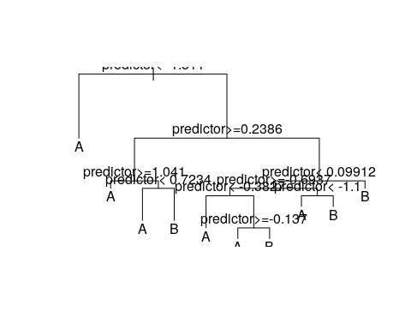
prp(r1)
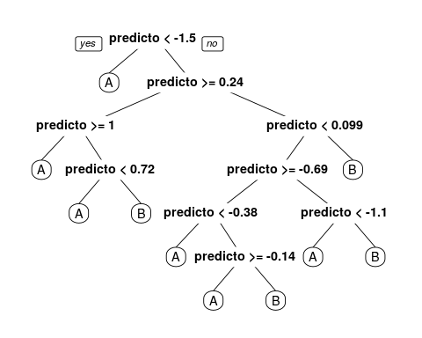
fancyRpartPlot(r1) #better visualization
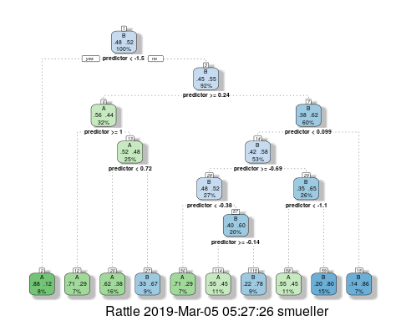
confusion(classes, predict(r1, type = "class"))
Overall accuracy = 0.7
Confusion matrix
Predicted (cv)
Actual [,1] [,2]
[1,] 0.812 0.188
[2,] 0.404 0.596
BNotice that even though the predictor had no true relationship to the categories, we were able to get 71% accuracy. We could in fact do better, just by adding rules:
r2 <- rpart(classes ~ predictor, method = "class", control = c(minsplit = 1,
minbucket = 1, cp = -1))
prp(r2)
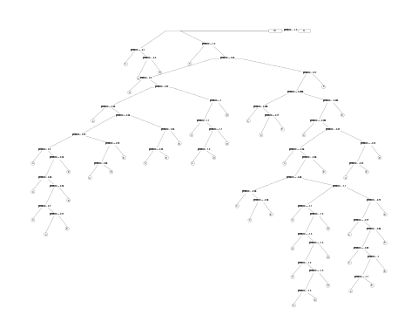
# this tree is a bit too large for this graphics method: fancyRpartPlot(r2)
confusion(classes, predict(r2, type = "class"))
Overall accuracy = 1
Confusion matrix
Predicted (cv)
Actual [,1] [,2]
[1,] 1 0
[2,] 0 1
Now, we have completely predicted every item by successively dividing the line. There were three parameters we adjusted to do this. First, we set the minsplit and minbucket to 1–this determines the smallest size of the leaf nodes. Then, we set the cp argument to be negative (it defaults to .01). cp is a complexity parameter, that is a criterion for how much better each model must be before splitting a leaf node. A negative value will mean that any additional node is better. Notice that by default, rpart must choose the best number of nodes to use. This is a critical decision for a decision tree, as it impacts the complexity of the model, and how much it overfits the data.
How will this work for a real data set? Let’s re-load the engineering data set. In this data, we have asked both Engineering and Psychology students to determine whether pairs of words from Psychology, Engineering go together, and measured their time and accuracy.
joint <- read.csv("eng-joint.csv")
joint$eng <- as.factor(c("psych", "eng")[joint$eng + 1])
## This is the partitioning tree:
r1 <- rpart(eng ~ ., data = joint, method = "class")
r1
n= 76
node), split, n, loss, yval, (yprob)
* denotes terminal node
1) root 76 38 eng (0.50000000 0.50000000)
2) ep.1>=2049.256 68 31 eng (0.54411765 0.45588235)
4) ppr.1< 2900.149 39 14 eng (0.64102564 0.35897436)
8) ppr.1>=2656.496 11 1 eng (0.90909091 0.09090909) *
9) ppr.1< 2656.496 28 13 eng (0.53571429 0.46428571)
18) ep>=0.7083333 14 4 eng (0.71428571 0.28571429) *
19) ep< 0.7083333 14 5 psych (0.35714286 0.64285714) *
5) ppr.1>=2900.149 29 12 psych (0.41379310 0.58620690)
10) ppu>=0.8333333 7 2 eng (0.71428571 0.28571429) *
11) ppu< 0.8333333 22 7 psych (0.31818182 0.68181818) *
3) ep.1< 2049.256 8 1 psych (0.12500000 0.87500000) *
prp(r1, cex = 0.75)
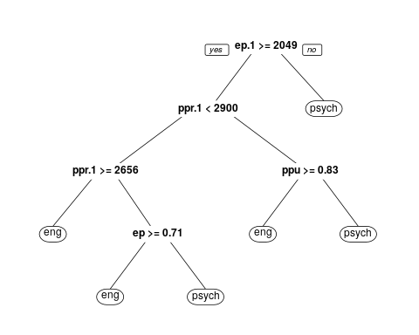
# text(r1,use.n=TRUE)
fancyRpartPlot(r1)
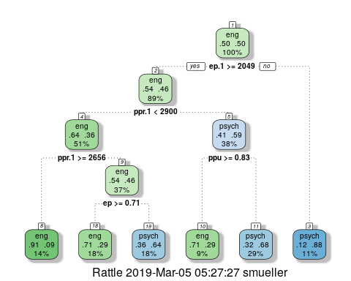
confusion(joint$eng, predict(r1, type = "class"))
Overall accuracy = 0.737
Confusion matrix
Predicted (cv)
Actual eng psych
eng 0.658 0.342
psych 0.184 0.816
With the default full partitioning, we get 73% accuracy.. But the decision tree is fairly complicated, and we might want something simpler. Let’s only allow it to go to a depth of 2, by controlling maxdepth:
r2 <- rpart(eng ~ ., data = joint, method = "class", control = c(maxdepth = 3))
r2
n= 76
node), split, n, loss, yval, (yprob)
* denotes terminal node
1) root 76 38 eng (0.5000000 0.5000000)
2) ep.1>=2049.256 68 31 eng (0.5441176 0.4558824)
4) ppr.1< 2900.149 39 14 eng (0.6410256 0.3589744) *
5) ppr.1>=2900.149 29 12 psych (0.4137931 0.5862069)
10) ppu>=0.8333333 7 2 eng (0.7142857 0.2857143) *
11) ppu< 0.8333333 22 7 psych (0.3181818 0.6818182) *
3) ep.1< 2049.256 8 1 psych (0.1250000 0.8750000) *
fancyRpartPlot(r2)
text(r2, use.n = T)
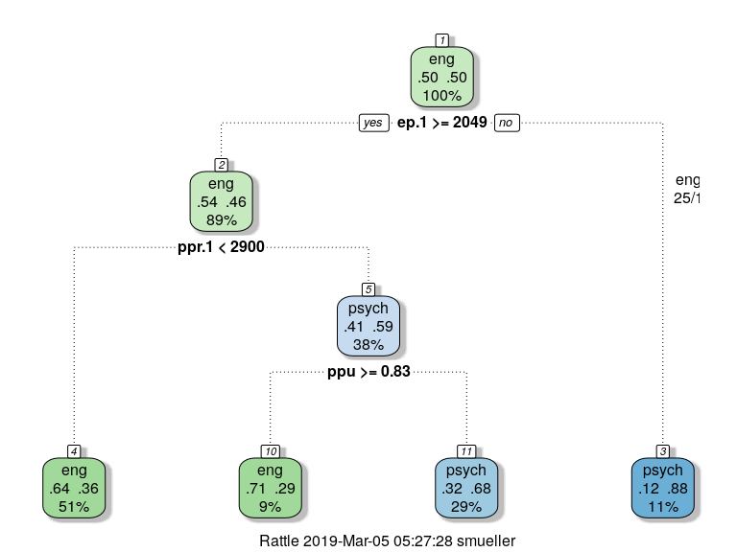
confusion(joint$eng, predict(r2, type = "class"))
Overall accuracy = 0.684
Confusion matrix
Predicted (cv)
Actual eng psych
eng 0.789 0.211
psych 0.421 0.579
Here, we are down to 68% ‘correct’ classifications.
##Looking deeper If we look at the summary of the tree object, it gives us a lot of details about goodness of fit and decision points.
summary(r2)
Call:
rpart(formula = eng ~ ., data = joint, method = "class", control = c(maxdepth = 3))
n= 76
CP nsplit rel error xerror xstd
1 0.15789474 0 1.0000000 1.263158 0.1106647
2 0.13157895 1 0.8421053 1.210526 0.1121371
3 0.07894737 2 0.7105263 1.078947 0.1143498
4 0.01000000 3 0.6315789 1.026316 0.1146681
Variable importance
ep.1 ppr.1 ppu.1 ppu eer.1 eeu.1 ep
25 19 16 14 13 11 1
Node number 1: 76 observations, complexity param=0.1578947
predicted class=eng expected loss=0.5 P(node) =1
class counts: 38 38
probabilities: 0.500 0.500
left son=2 (68 obs) right son=3 (8 obs)
Primary splits:
ep.1 < 2049.256 to the right, improve=2.514706, (0 missing)
eeu.1 < 2431.336 to the right, improve=2.326531, (0 missing)
ppu.1 < 4579.384 to the right, improve=2.072727, (0 missing)
eer.1 < 4687.518 to the right, improve=1.966874, (0 missing)
ppu < 0.8333333 to the right, improve=1.719298, (0 missing)
Surrogate splits:
ppu.1 < 1637.18 to the right, agree=0.947, adj=0.500, (0 split)
eeu.1 < 1747.891 to the right, agree=0.934, adj=0.375, (0 split)
eer.1 < 1450.41 to the right, agree=0.921, adj=0.250, (0 split)
ppr.1 < 1867.892 to the right, agree=0.921, adj=0.250, (0 split)
Node number 2: 68 observations, complexity param=0.1315789
predicted class=eng expected loss=0.4558824 P(node) =0.8947368
class counts: 37 31
probabilities: 0.544 0.456
left son=4 (39 obs) right son=5 (29 obs)
Primary splits:
ppr.1 < 2900.149 to the left, improve=1.717611, (0 missing)
ppu < 0.8333333 to the right, improve=1.553072, (0 missing)
ppu.1 < 4579.384 to the right, improve=1.535294, (0 missing)
eer.1 < 4687.518 to the right, improve=1.529205, (0 missing)
ep.1 < 2754.762 to the left, improve=1.013682, (0 missing)
Surrogate splits:
eer.1 < 3007.036 to the left, agree=0.750, adj=0.414, (0 split)
ep.1 < 2684.733 to the left, agree=0.647, adj=0.172, (0 split)
ppu.1 < 2346.981 to the left, agree=0.632, adj=0.138, (0 split)
eeu.1 < 2806.34 to the left, agree=0.618, adj=0.103, (0 split)
ep < 0.7916667 to the left, agree=0.603, adj=0.069, (0 split)
Node number 3: 8 observations
predicted class=psych expected loss=0.125 P(node) =0.1052632
class counts: 1 7
probabilities: 0.125 0.875
Node number 4: 39 observations
predicted class=eng expected loss=0.3589744 P(node) =0.5131579
class counts: 25 14
probabilities: 0.641 0.359
Node number 5: 29 observations, complexity param=0.07894737
predicted class=psych expected loss=0.4137931 P(node) =0.3815789
class counts: 12 17
probabilities: 0.414 0.586
left son=10 (7 obs) right son=11 (22 obs)
Primary splits:
ppu < 0.8333333 to the right, improve=1.6663680, (0 missing)
ppr.1 < 4858.184 to the right, improve=1.6663680, (0 missing)
eeu.1 < 3128.98 to the right, improve=1.5785810, (0 missing)
ep < 0.625 to the left, improve=1.0584390, (0 missing)
eer.1 < 3323.144 to the right, improve=0.8880131, (0 missing)
Surrogate splits:
ppu.1 < 6007.29 to the right, agree=0.828, adj=0.286, (0 split)
eer.1 < 4516.42 to the right, agree=0.793, adj=0.143, (0 split)
eeu.1 < 3768.95 to the right, agree=0.793, adj=0.143, (0 split)
ep.1 < 5327.593 to the right, agree=0.793, adj=0.143, (0 split)
Node number 10: 7 observations
predicted class=eng expected loss=0.2857143 P(node) =0.09210526
class counts: 5 2
probabilities: 0.714 0.286
Node number 11: 22 observations
predicted class=psych expected loss=0.3181818 P(node) =0.2894737
class counts: 7 15
probabilities: 0.318 0.682
This model seems to fit a lot better than our earlier LDA models, which suggest that it is probably overfitting. Cross-validation can be done within the control parameter $xval$:
r3 <- rpart(eng ~ ., data = joint, method = "class", control = c(maxdepth = 3,
xval = 10))
r3
n= 76
node), split, n, loss, yval, (yprob)
* denotes terminal node
1) root 76 38 eng (0.5000000 0.5000000)
2) ep.1>=2049.256 68 31 eng (0.5441176 0.4558824)
4) ppr.1< 2900.149 39 14 eng (0.6410256 0.3589744) *
5) ppr.1>=2900.149 29 12 psych (0.4137931 0.5862069)
10) ppu>=0.8333333 7 2 eng (0.7142857 0.2857143) *
11) ppu< 0.8333333 22 7 psych (0.3181818 0.6818182) *
3) ep.1< 2049.256 8 1 psych (0.1250000 0.8750000) *
confusion(joint$eng, predict(r1, type = "class"))
Overall accuracy = 0.737
Confusion matrix
Predicted (cv)
Actual eng psych
eng 0.658 0.342
psych 0.184 0.816
confusion(joint$eng, predict(r3, type = "class"))
Overall accuracy = 0.684
Confusion matrix
Predicted (cv)
Actual eng psych
eng 0.789 0.211
psych 0.421 0.579
Accuracy goes down a bit, but the 74% accuracy is about what we achieved in the simple lda models.
Clearly, for partitioning trees, we have to be careful about overfitting, because we can always easily get the perfect classification.
#Random Forests
One advantage of partitioning/decision trees is that they are fast and easy to make. They are also considered interpretable and easy to use. A tree like this can be used by a doctor or a medlical counselor to help understand the risk for a disease, by asking a few simple questions.
The downsides of a decision tree is that they are often not very good, especially once they have been trimmed to avoid over-fitting. Recently, researchers have been interested in combining the results of many small (and often not-very-good) classifiers to make one better one. This often is described as ‘boosting’, or `ensemble’ methods, and there are a number of ways to achieve this. Doing this in a particular way with decision trees is referred to as a ‘random forest’ (see Breiman and Cutler).
Random forests can be used for both regression and classification (trees can be used in either way as well), and the classification and regression trees (CART) approach is a method that supports both. A random forest works as follows:
- Build $N$ trees (where N may be hundreds), where each tree is built from a random subset of features/variables. That is, on each step, choose the best variable to divide the branch based on a random subset of variables.
For each tree:
- Pick a subset of the variables.
- Build a tree
- Then, to classify any item, have each tree determine its best guess, and then take the most frequent outcome (or give a probabilistic answer based on the balance of evidence).
The randomForest package in R supports building these models. Because these can be a bit more difficult to comprehend, there is a companion package randomForestExplainer that is also handy in digging down on the types of forests derived.
library(randomForest)
library(randomForestExplainer)
rf <- randomForest(x = joint[, -1], y = joint$eng, proximity = T, ntree = 5)
rf
Call:
randomForest(x = joint[, -1], y = joint$eng, ntree = 5, proximity = T)
Type of random forest: classification
Number of trees: 5
No. of variables tried at each split: 3
OOB estimate of error rate: 63.77%
Confusion matrix:
eng psych class.error
eng 12 22 0.6470588
psych 22 13 0.6285714
# printRandomForests(rf) ##look at all the RFs
confusion(joint$eng, predict(rf))
Overall accuracy = 0.362
Confusion matrix
Predicted (cv)
Actual eng psych
eng 0.353 0.647
psych 0.629 0.371
For whatever reason, this model is below chance at making this classification. Looking at the trees, they are quite complex as well, with tens of rules. We can get a printout of individual subtrees with getTree:
(getTree(rf, 1))
left daughter right daughter split var split point status prediction
1 2 3 4 0.5000000 1 0
2 4 5 9 4220.4438418 1 0
3 6 7 9 2892.7790434 1 0
4 8 9 9 2799.4585854 1 0
5 0 0 0 0.0000000 -1 2
6 10 11 10 1916.4265009 1 0
7 12 13 6 3439.3742499 1 0
8 14 15 3 0.6250000 1 0
9 16 17 2 0.8333333 1 0
10 18 19 9 1830.9169578 1 0
11 20 21 8 2719.4552605 1 0
12 22 23 9 6355.0945496 1 0
[ reached getOption("max.print") -- omitted 23 rows ]
(getTree(rf, 5))
left daughter right daughter split var split point status prediction
1 2 3 9 5065.2031024 1 0
2 4 5 9 3528.8856466 1 0
3 0 0 0 0.0000000 -1 1
4 6 7 10 4563.6048647 1 0
5 8 9 5 0.8333333 1 0
6 10 11 7 2807.8686333 1 0
7 12 13 9 1738.5203110 1 0
8 0 0 0 0.0000000 -1 2
9 14 15 6 4001.6659174 1 0
10 16 17 9 1729.7592005 1 0
11 18 19 10 3962.3749991 1 0
12 20 21 10 5739.1531797 1 0
[ reached getOption("max.print") -- omitted 23 rows ]
rf <- randomForest(eng ~ ., data = joint, proximity = T, replace = F, mtry = 3,
ntree = 5, keep.inbag = T, sampsize = 10)
confusion(joint$eng, predict(rf))
Overall accuracy = 0.526
Confusion matrix
Predicted (cv)
Actual eng psych
eng 0.368 0.632
psych 0.316 0.684
plot_min_depth_distribution(rf)
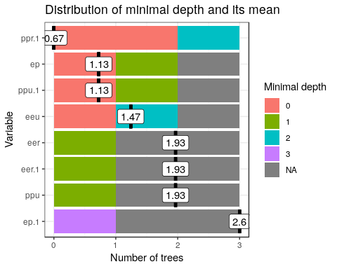
plot_multi_way_importance(rf)
[1] "Warning: your forest does not contain information on local importance so 'accuracy_decrease' measure cannot be extracted. To add it regrow the forest with the option localImp = TRUE and run this function again."
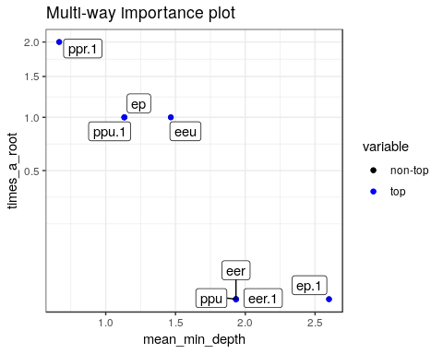
This plots the prediction of the forest for different values of variables:
plot_predict_interaction(rf, joint, "eer", "ppr")
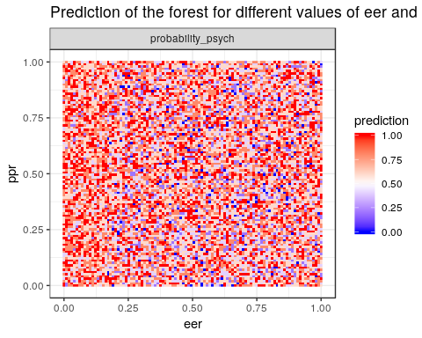
phone <- read.csv("data_study1.csv")
phone.dt <- rpart(Smartphone ~ ., data = phone)
prp(phone.dt, cex = 0.5)
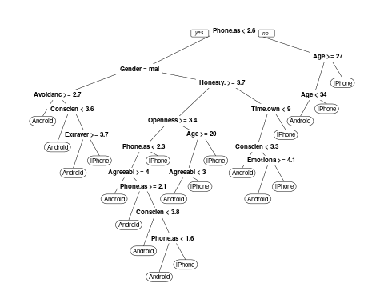
confusion(phone$Smartphone, predict(phone.dt)[, 1] < 0.5)
Overall accuracy = 0.783
Confusion matrix
Predicted (cv)
Actual Android iPhone
Android 0.658 0.342
iPhone 0.129 0.871
phone.rf <- randomForest(Smartphone ~ ., data = phone)
phone.rf
Call:
randomForest(formula = Smartphone ~ ., data = phone)
Type of random forest: classification
Number of trees: 500
No. of variables tried at each split: 3
OOB estimate of error rate: 38.19%
Confusion matrix:
Android iPhone class.error
Android 98 121 0.5525114
iPhone 81 229 0.2612903
confusion(phone$Smartphone, predict(phone.rf))
Overall accuracy = 0.618
Confusion matrix
Predicted (cv)
Actual Android iPhone
Android 0.447 0.553
iPhone 0.261 0.739
This does not seem to be better than the other models for the iphone data, but at least is is comparable.

K Nearest-Neighbor classifiers
Another non-model-based classifier are nearest-neighbor methods. These methods require you to develop a similarity or distance space–usually on the basis of a set of predictors or features. Once this distance space is defined, we determine the class by finding the nearest neighbor in that space, and using that label. Because this could be susceptible to noisy data, we usually find a set of $k$ neighbors and have them vote on the outcome. These are K-nearest neighbor classifiers, or KNN.

Choosing K.
The choice of $k$ can have a big impact on the results. If $k$ is too small, classification will be highly impacted by local neighborhood; if it is too big (i.e., if K = N), it will always just respond with the most likely response in the entire population.

Distance Metric
The distance metric used in KNN easily be chosen poorly. For example, if you want to decide on political party based on age, income level, and gender, you need to figure out how to weigh and combine these. By default, you might add differences along each dimension, which would combine something that differs on the scale of dozens with something that differs on the scale of thousands, and so the KNN model would essentially ignore gender and age.

Normalization selection
A typical approach would be to normalize all variables first. Then each variable has equal weight and range.

Using KNN
Unlike previous methods where we train a system based on data and then make classifications, for KNN the trained system is just the data.

Libraries and functions.
There are several options for knn classifers. Library: Class Function: knn knn.cv

Library: kknn
Function: kknn This provides a ‘weighted k-nearest neighbor classifier’. Here, weighting is a weighting kernel, which gives greater weights to the nearer neighbors.

Library: klaR
Function: sknn A ‘simple’ knn function. Permits using a weighting kernel as well.

Function: nm
This provides a ‘nearest mean’ classifier

Example
In general, we need to normalize the variables first.
# Normalizing the values by creating a new function
normal = function(x) {
xn = (x - min(x))/(max(x) - min(x))
return(xn)
}
phone2 <- phone
for (i in 2:ncol(phone2)) {
phone2[, i] = normal(as.numeric(phone2[, i]))
}
# checking the range of values after normalization
par(mfrow = c(2, 1))
boxplot(phone[, 2:12])
boxplot(phone2[, 2:12])
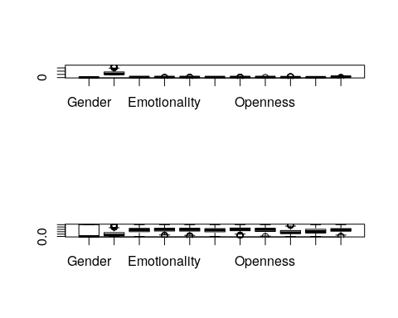 ##fitting a simple model
library(class)
m1 = knn(train = phone2[, -1], test = phone2[, -1], cl = phone2$Smartphone,
k = 10)
confusion(phone2$Smartphone, m1)
Overall accuracy = 0.696
Confusion matrix
Predicted (cv)
Actual Android iPhone
Android 0.566 0.434
iPhone 0.213 0.787
That is pretty good, but what if we expand k
m1 = knn(train = phone2[, -1], test = phone2[, -1], cl = phone2$Smartphone,
k = 25)
confusion(phone2$Smartphone, m1)
Overall accuracy = 0.686
Confusion matrix
Predicted (cv)
Actual Android iPhone
Android 0.534 0.466
iPhone 0.206 0.794
It looks we the choice of k is not going to matter much. What we could do is play with cross-validation though–right now we are testing on the same set as we are ‘training’ with, which will boost our accuracy (since the correct answer will always be one of the elements.) We can also try to do variable selection to change the similarity space to something that works better.
phone2 <- phone2[order(runif(nrow(phone2))), ] #random sort
phone.train = phone2[1:450, 2:12]
phone.test = phone2[451:nrow(phone2), 2:12]
phone.train.target = phone2[1:450, 1]
phone.test.target = phone2[451:nrow(phone2), 1]
train <- sample(1:nrow(phone2), 300)
m2 <- knn(train = phone.train, test = phone.test, cl = phone.train.target, k = 10)
confusion(phone.test.target, m2)
Overall accuracy = 0.62
Confusion matrix
Predicted (cv)
Actual Android iPhone
Android 0.541 0.459
iPhone 0.310 0.690

Additional resources
K-Nearest Neighbor Classification: MASS: Chapter 12.3, p. 341 https://rstudio-pubs-static.s3.amazonaws.com/123438_3b9052ed40ec4cd2854b72d1aa154df9.html
Relevant library/functions in R:
Decision Trees: Faraway, Chapter 13
Library: rpart (function rpart)
Random Forest Classification:
Reference: https://www.r-bloggers.com/predicting-wine-quality-using-random-forests/ https://www.stat.berkeley.edu/~breiman/RandomForests/
Library: randomForest (Function randomForest)

