Simple Neural Network Classifiers
Shane T. Mueller shanem@mtu.edu
2023-03-13
Artificial Neural Networks have been used by researchers since at least the 1950s, and rose in prominence when computing resources became widely available. There have been at least 3-4 eras of ANN, with each success and exuberance followed by a quiescence and failure or replacement by other tools. There has always been an intetrplay in this area between computational neuroscientists, computational vision, machine learning, psychology, computer science, and statisticians, with many advances coming by modeling human processes and then applying these algorithms to real-life problems.
- In the 1950s, notions of the ANN were introduced (Perceptron, McCollough & Pitts)
- In the 1960s, inadequacy of these methods were found (XOR problems), and
- In the 1970s and 1980s, back-propagation provided a reasonable learning approach for multi-layer neural networks for supervised classification problems (Rumelhart & McClelland).
- In the 1970s-1990s, other advances in self-organizing maps, un-supervised learning and hebbian networks provided alternate means for representing knowledge.
- In the 1990s-2000s, other machine learning approaches appeared to take precedence, with lines blurring between ANNs, machine classification, reinforcement learning, and several approaches that linked supervised and unsupervised models (O’Reilly, HTMs, Grossberg).
- In the 2000s, Bayesian approaches were foremost
- In the 2010s, we have seen a resurgence of deep-learning methods. The advances here have been driven by (1) advances in software that allow us to use GPU (graphics cards) to efficiently train and use networks (2) large data labeled data sets, often generated through amazon mechanical turk or as a byproduct of CAPTCHA systems; (3) using 15+ hidden layers; (4) effective use of specific types of layer architectures, including convolutional networks that de-localize patterns from their position in an image.
A simple two-layer neural network can be considered that is essentially what our multinomial regression or logistic regression model is doing. Inputs include a set of features, and output nodes (possibly one per class) are classifications that are learned. Alterately, a pattern can be learned by the output nodes. The main issue here is estimating weights, which are done with heuristic error-propagation approaches rather than MLE or least squares. This is inefficient for two-layer problems, but the heuristic approach will pay off for more complex problems.
The main advance of the late 1970s and early 1980s was adoption of ‘hidden layer’ ANNs. These hidden layers permit solving the XOR problem: when a class is associated with an exclusive or logic. The category structure is stored in a distributed fashion across all nodes, but there is a sense in which the number of hidden nodes controls how complex the classification structure that is possible. With a hidden layer, optimization is difficult with traditional means, but the heuristic approaches generally work reasonably well.
We will start with an image processing example. We will take two images (S and X) and sample features from them to make exemplars:
# library(imager) s <-load.image('s.data.bmp') x <- load.image('x.bmp') svec <-
# as.vector(s) xvec <- as.vector(x) write.csv(svec,'s.csv')
# write.csv(xvec,'x.csv')
## here, the lower the value, the darker the image.
svec <- read.csv("s.csv")
xvec <- read.csv("x.csv")
## reverse the numbers
svec$x <- 255 - svec$x
xvec$x <- 255 - xvec$x
par(mfrow = c(1, 2))
image(matrix(svec$x, 10, 10, byrow = T), col = grey(100:0/100))
image(matrix(xvec$x, 10, 10, byrow = T), col = grey(100:0/100))
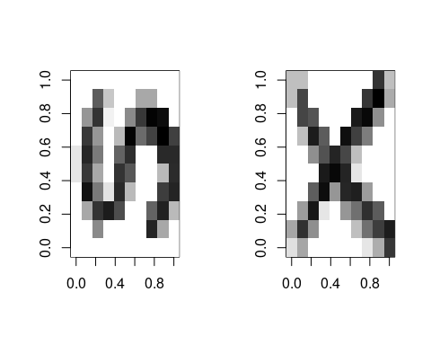 To train the model, we will sample 500 examples of each template:
dataX <- matrix(0, ncol = 100, nrow = 250)
dataS <- matrix(0, ncol = 100, nrow = 250)
letter <- rep(c("x", "s"), each = 250)
par(mfrow = c(4, 2))
for (i in 1:250) {
x <- rep(0, 100)
xtmp <- table(sample(1:100, size = 50, prob = as.matrix(xvec$x), replace = T))
x[as.numeric(names(xtmp))] <- xtmp/max(xtmp)
s <- rep(0, 100)
stmp <- table(sample(1:100, size = 50, prob = as.matrix(svec$x), replace = T))
s[as.numeric(names(stmp))] <- stmp/max(stmp)
if (i <= 4) {
image(matrix(s, 10, 10, byrow = T), main = "S example", col = grey(100:0/100))
image(matrix(x, 10, 10, byrow = T), main = "X example", col = grey(100:0/100))
}
dataX[i, ] <- x
dataS[i, ] <- s
}
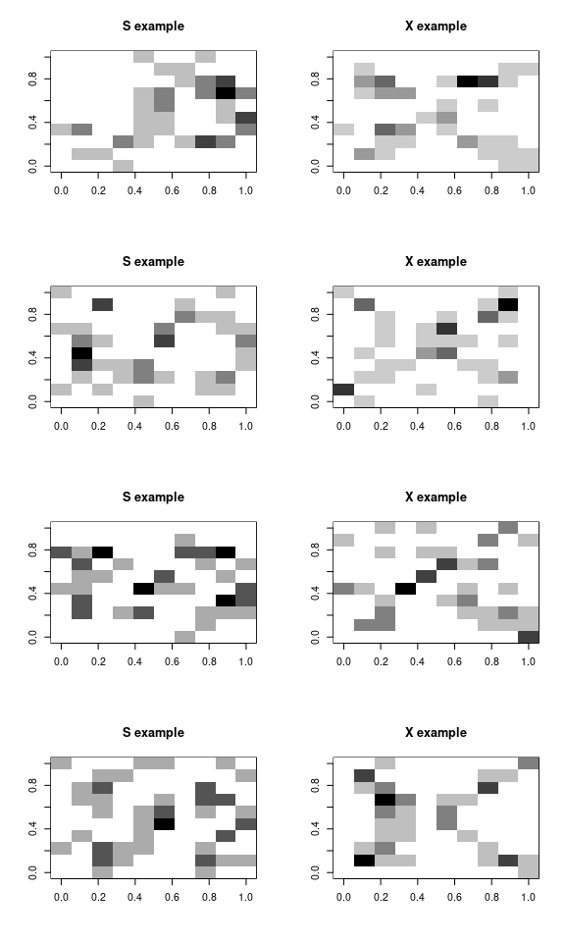
data <- rbind(dataX, dataS)
Let’s train a neural network on these. Note that we could probably have trained it on the prototypes–maybe from the mnist library examined in earlier chapters.
library(nnet)
options(warn = 2)
# model <- nnet(letter~data,size=2) #This doesn't work.
# Let's transform the letter to a numeric value
model <- nnet(y = as.numeric(letter == "s"), x = data, size = 2)
# weights: 205
initial value 135.298922
final value 0.000000
converged
model
a 100-2-1 network with 205 weights
options were -
# alternately, try using letter as a factor, and use a formula. This also plays
# with some of the learning parameters
merged <- data.frame(letter = as.factor(letter), data)
model2 <- nnet(letter ~ ., data = merged, size = 2, rang = 0.1, decay = 1e-04, maxit = 500,
trace = T)
# weights: 205
initial value 346.598873
iter 10 value 12.351622
iter 20 value 3.245436
iter 30 value 1.774365
iter 40 value 0.832870
iter 50 value 0.650895
iter 60 value 0.603700
iter 70 value 0.538169
iter 80 value 0.408570
iter 90 value 0.371178
iter 100 value 0.353907
iter 110 value 0.327208
iter 120 value 0.313078
iter 130 value 0.278076
iter 140 value 0.232800
iter 150 value 0.217493
iter 160 value 0.184931
iter 170 value 0.147993
iter 180 value 0.136195
iter 190 value 0.125539
iter 200 value 0.113633
iter 210 value 0.110157
iter 220 value 0.099148
iter 230 value 0.093495
iter 240 value 0.090484
iter 250 value 0.087115
iter 260 value 0.084831
iter 270 value 0.080788
iter 280 value 0.073603
iter 290 value 0.069207
iter 300 value 0.055398
iter 310 value 0.046146
iter 320 value 0.045090
iter 330 value 0.042434
iter 340 value 0.042322
iter 350 value 0.041824
iter 360 value 0.041742
iter 370 value 0.041732
iter 380 value 0.041722
iter 390 value 0.041721
final value 0.041721
converged

Examining the model
The model contains a lot of information, including some parameters it is constructed under, and all of the fitted parameters.
We can see when using summary() that we really have two really large regressions from the 100 input features to 2 hidden nodes, and a single model with an intercept (b=bias) and two parameters from each hidden node to the output node. The default is ‘logistic output units’, which means this last model is essentially a logistic regression.
str(model)
List of 15
$ n : num [1:3] 100 2 1
$ nunits : int 104
$ nconn : num [1:105] 0 0 0 0 0 0 0 0 0 0 ...
$ conn : num [1:205] 0 1 2 3 4 5 6 7 8 9 ...
$ nsunits : int 104
$ decay : num 0
$ entropy : logi FALSE
$ softmax : logi FALSE
$ censored : logi FALSE
$ value : num 2.25e-10
$ wts : num [1:205] -1.3284 -0.3909 -1.9464 -0.0611 0.0113 ...
$ convergence : int 0
$ fitted.values: num [1:500, 1] 0 0 0 0 0 0 0 0 0 0 ...
..- attr(*, "dimnames")=List of 2
.. ..$ : NULL
.. ..$ : NULL
$ residuals : num [1:500, 1] 0 0 0 0 0 0 0 0 0 0 ...
..- attr(*, "dimnames")=List of 2
.. ..$ : NULL
.. ..$ : NULL
$ call : language nnet.default(x = data, y = as.numeric(letter == "s"), size = 2)
- attr(*, "class")= chr "nnet"
summary(model)
a 100-2-1 network with 205 weights
options were -
b->h1 i1->h1 i2->h1 i3->h1 i4->h1 i5->h1 i6->h1 i7->h1 i8->h1 i9->h1
-1.33 -0.39 -1.95 -0.06 0.01 1.13 0.76 -0.30 -0.21 -0.96
i10->h1 i11->h1 i12->h1 i13->h1 i14->h1 i15->h1 i16->h1 i17->h1 i18->h1 i19->h1
-1.87 -2.75 -6.14 -0.48 6.04 6.40 5.72 3.27 -3.16 -6.02
i20->h1 i21->h1 i22->h1 i23->h1 i24->h1 i25->h1 i26->h1 i27->h1 i28->h1 i29->h1
-2.74 0.38 -0.39 -1.15 -1.21 3.13 0.59 -3.18 0.72 4.66
i30->h1 i31->h1 i32->h1 i33->h1 i34->h1 i35->h1 i36->h1 i37->h1 i38->h1 i39->h1
-0.59 0.70 -0.35 5.66 -5.74 -6.52 -5.31 -4.81 0.40 1.64
i40->h1 i41->h1 i42->h1 i43->h1 i44->h1 i45->h1 i46->h1 i47->h1 i48->h1 i49->h1
-0.41 0.47 0.80 5.20 3.34 -1.13 -1.83 2.28 0.55 0.06
i50->h1 i51->h1 i52->h1 i53->h1 i54->h1 i55->h1 i56->h1 i57->h1 i58->h1 i59->h1
-0.16 -0.21 -0.43 -3.39 -3.25 -1.75 0.53 -0.55 3.13 0.16
i60->h1 i61->h1 i62->h1 i63->h1 i64->h1 i65->h1 i66->h1 i67->h1 i68->h1 i69->h1
0.32 0.21 -2.00 -4.44 -6.25 -0.66 -2.34 -2.63 -1.70 2.39
i70->h1 i71->h1 i72->h1 i73->h1 i74->h1
0.59 -0.55 1.33 -1.21 -3.01
[ reached getOption("max.print") -- omitted 26 entries ]
b->h2 i1->h2 i2->h2 i3->h2 i4->h2 i5->h2 i6->h2 i7->h2 i8->h2 i9->h2
-3.50 0.37 2.42 0.16 0.69 -0.28 -1.62 -0.07 0.17 1.24
i10->h2 i11->h2 i12->h2 i13->h2 i14->h2 i15->h2 i16->h2 i17->h2 i18->h2 i19->h2
2.16 2.82 6.74 -0.96 -8.51 -8.81 -7.15 -5.34 2.42 6.26
i20->h2 i21->h2 i22->h2 i23->h2 i24->h2 i25->h2 i26->h2 i27->h2 i28->h2 i29->h2
2.32 -0.98 -0.34 0.81 1.38 -3.99 -1.80 2.50 -1.84 -6.37
i30->h2 i31->h2 i32->h2 i33->h2 i34->h2 i35->h2 i36->h2 i37->h2 i38->h2 i39->h2
0.43 -0.95 -0.06 -7.87 6.11 7.51 5.36 5.24 -0.38 -1.95
i40->h2 i41->h2 i42->h2 i43->h2 i44->h2 i45->h2 i46->h2 i47->h2 i48->h2 i49->h2
0.23 0.04 -0.24 -6.81 -5.13 -0.19 0.75 -2.98 0.51 0.28
i50->h2 i51->h2 i52->h2 i53->h2 i54->h2 i55->h2 i56->h2 i57->h2 i58->h2 i59->h2
-0.50 -0.10 -0.42 3.88 3.96 1.27 -2.70 -0.92 -3.48 0.20
i60->h2 i61->h2 i62->h2 i63->h2 i64->h2 i65->h2 i66->h2 i67->h2 i68->h2 i69->h2
-0.38 -0.47 2.07 4.64 7.51 0.59 2.41 1.96 1.01 -4.57
i70->h2 i71->h2 i72->h2 i73->h2 i74->h2
-0.74 1.04 -2.66 0.26 3.10
[ reached getOption("max.print") -- omitted 26 entries ]
b->o h1->o h2->o
2.58 25.64 -27.91
Some of the arguments we can control are:
- How the final output classifier works (options involve linout, entropy, softmax, censored). These control fitting algorithms and approaches, and may impact speed of convergence. The default settings look like they are essentially using least-squared to fit individual nodes.
- subset: allowing you to train on a subset for cross-validation
- mask: allowing only some of the input features to be trained.
- Wts: initial parameter settings. You could train a model on some data, and use those weights to then re-train on new data, for example.
- decay: this probably controls how far back data in a series are examined. It may allow for a model to adapt to a changing environment better.
- maxit and trace: fitting arguments.
- weights: strength of each case. You may have some cases you want to train on more strongly/often.

Obtaining predicted response
When we use predict, by default it gives us the ‘raw’ values–activation values returned by the trained network. Because the final layer of this network has just one node (100-2-1), it is just an activation value indicating the class (0 for X and 1 for S). The values are not exactly 0 and 1–they are floating point values very close.
out1 <- predict(model, newdata = data)
plot(out1)
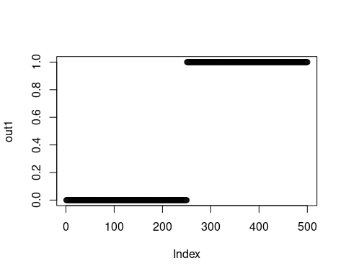
If there were a combined example that was hard to distinguish we would get a different value:
test <- (data[3, ] + data[255, ])/2
par(mfrow = c(1, 3))
image(matrix(data[3, ], 10), col = grey(100:0/100))
image(matrix(data[255, ], 10), col = grey(100:0/100))
image(matrix(test, 10), col = grey(100:0/100))
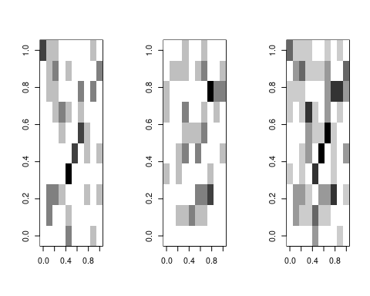
predict(model, newdata = data[3, ] + data[4, ])
[,1]
[1,] 0
predict(model, newdata = data[255, ])
[,1]
[1,] 1
predict(model, newdata = test)
[,1]
[1,] 0.9000928
In this case, the X shows up as a strong X, the S shows up as an S, but the combined version is a slightly weaker S.
We can get classifications using type=“class”:
predict(model2, type = "class")
[1] "x" "x" "x" "x" "x" "x" "x" "x" "x" "x" "x" "x" "x" "x" "x" "x" "x" "x" "x"
[20] "x" "x" "x" "x" "x" "x" "x" "x" "x" "x" "x" "x" "x" "x" "x" "x" "x" "x" "x"
[39] "x" "x" "x" "x" "x" "x" "x" "x" "x" "x" "x" "x" "x" "x" "x" "x" "x" "x" "x"
[58] "x" "x" "x" "x" "x" "x" "x" "x" "x" "x" "x" "x" "x" "x" "x" "x" "x" "x"
[ reached getOption("max.print") -- omitted 425 entries ]
table(letter, predict(model2, type = "class"))
letter s x
s 250 0
x 0 250

Training with very limited/noisy examples
This classification is actually perfect, but there was a lot of information available. Let’s sample just 5 points out to create the pattern:
dataX <- matrix(0, ncol = 100, nrow = 250)
dataS <- matrix(0, ncol = 100, nrow = 250)
letter <- rep(c("x", "s"), each = 250)
par(mfrow = c(4, 2))
for (i in 1:250) {
x <- rep(0, 100)
xtmp <- table(sample(1:100, size = 5, prob = as.matrix(xvec$x), replace = T))
x[as.numeric(names(xtmp))] <- xtmp/max(xtmp)
s <- rep(0, 100)
stmp <- table(sample(1:100, size = 5, prob = as.matrix(svec$x), replace = T))
s[as.numeric(names(stmp))] <- stmp/max(stmp)
## plot the first few examples:
if (i <= 4) {
image(matrix(s, 10, 10, byrow = T), main = "S example", col = grey(100:0/100))
image(matrix(x, 10, 10, byrow = T), main = "X example", col = grey(100:0/100))
}
dataX[i, ] <- x
dataS[i, ] <- s
}
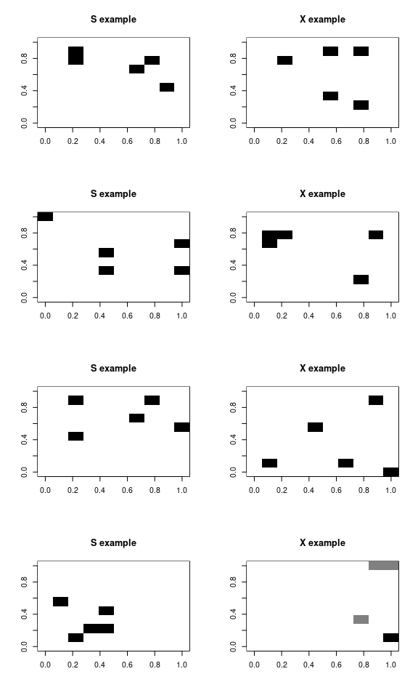
data <- rbind(dataX, dataS)
merged <- data.frame(letter = as.factor(letter), data)
model3 <- nnet(letter ~ ., data = merged, size = 2, rarg = 0.1, decay = 1e-04, maxit = 500)
# weights: 205
initial value 396.017508
iter 10 value 136.982625
iter 20 value 81.581933
iter 30 value 66.564207
iter 40 value 51.004758
iter 50 value 42.862823
iter 60 value 40.042674
iter 70 value 39.496991
iter 80 value 39.064101
iter 90 value 38.904426
iter 100 value 38.604277
iter 110 value 37.931699
iter 120 value 32.838200
iter 130 value 27.325128
iter 140 value 25.816740
iter 150 value 24.644423
iter 160 value 23.776762
iter 170 value 23.367019
iter 180 value 23.109371
iter 190 value 22.969436
iter 200 value 22.714275
iter 210 value 22.460050
iter 220 value 22.268153
iter 230 value 20.002328
iter 240 value 19.876385
iter 250 value 19.810870
iter 260 value 19.684914
iter 270 value 19.288552
iter 280 value 14.448579
iter 290 value 14.372495
iter 300 value 14.320823
iter 310 value 14.274721
iter 320 value 14.210239
iter 330 value 14.134171
iter 340 value 14.098660
iter 350 value 14.070596
iter 360 value 14.037243
iter 370 value 13.964707
iter 380 value 11.952382
iter 390 value 11.468512
iter 400 value 11.441208
iter 410 value 11.427260
iter 420 value 11.415680
iter 430 value 11.408537
iter 440 value 11.402648
iter 450 value 11.397834
iter 460 value 11.394270
iter 470 value 11.391070
iter 480 value 11.388077
iter 490 value 11.353343
iter 500 value 11.339450
final value 11.339450
stopped after 500 iterations
table(letter, predict(model3, type = "class"))
letter s x
s 249 1
x 1 249
It still does very well, with a few errors, for very sparse data. In fact, it might be doing TOO well. That is, in a sense, it is picking up on arbitrary but highly diagnostic features. A human observer would never be confident in the outcome, because the information is too sparse, but in this limited world, a single pixel is enough to make a good guess.

Neural Networks and the XOR problem
Neural networks became popular when researchers realized that networks with a hidden layer could solve ‘XOR classification problems’. Early on, researchers recognized that a simple perception (2-layer) neural network could be used for AND or OR combinations, but not XOR, as these are not linearly separable. XOR classification maps onto many real-world interaction problems. For example, two safe pharmaceuticals might be dangerous when taken together, and a simple neural network could never detect this state–if one is good, and the other is good, both must be better. An XOR problem is one in which one feature or another (but not both or neither) indicate class membership. In order to perform classification with this logic, a hidden layer is required.
Here is a class defined by an XOR structure:
library(MASS)
library(DAAG)
feature1 <- rnorm(200)
feature2 <- rnorm(200)
outcome <- as.factor((feature1 > 0.6 & feature2 > 0.3) | (feature1 > 0.6 & feature2 <
0.3))
outcome <- as.factor((feature1 * (-feature2) + rnorm(200)) > 0)
The linear discriminant model fails to discriminate (at least without an interaction)
lmodel <- lda(outcome ~ feature1 + feature2)
confusion(outcome, predict(lmodel)$class)
Overall accuracy = 0.535
Confusion matrix
Predicted (cv)
Actual FALSE TRUE
FALSE 0.588 0.412
TRUE 0.520 0.480
lmodel2 <- lda(outcome ~ feature1 * feature2)
confusion(outcome, predict(lmodel2)$class)
Overall accuracy = 0.72
Confusion matrix
Predicted (cv)
Actual FALSE TRUE
FALSE 0.735 0.265
TRUE 0.296 0.704
Similarly, the neural networks with an empty single layer (skip=TRUE) are not great at discriminating, but with a few hidden nodes they work well.
n1 <- nnet(outcome ~ feature1 + feature2, size = 0, skip = TRUE)
# weights: 3
initial value 159.685329
final value 135.587615
converged
confusion(outcome, factor(predict(n1, type = "class"), levels = c(TRUE, FALSE)))
Overall accuracy = 0.465
Confusion matrix
Predicted (cv)
Actual FALSE TRUE
FALSE 0.412 0.588
TRUE 0.480 0.520
n2 <- nnet(outcome ~ feature1 + feature2, size = 3, skip = TRUE)
# weights: 15
initial value 168.628712
iter 10 value 131.436375
iter 20 value 105.737612
iter 30 value 101.267102
iter 40 value 97.989052
iter 50 value 94.179156
iter 60 value 93.223259
iter 70 value 93.007317
iter 80 value 92.766851
iter 90 value 92.681597
iter 100 value 92.453903
final value 92.453903
stopped after 100 iterations
confusion(outcome, factor(predict(n2, type = "class"), levels = c(FALSE, TRUE)))
Overall accuracy = 0.755
Confusion matrix
Predicted (cv)
Actual FALSE TRUE
FALSE 0.706 0.294
TRUE 0.194 0.806
Because we have the XOR structure, the simple neural network without a hidden layer is essentially LDA, and in fact often gets a similar level of accuracy (53%).

IPhone Data using the NNet
To model the iphone data set, we need to decide on how large of a model we want. We need to also remember that training a model like this is not deterministic–every time we do it the situation will be a little different. Because we have just two classes, maybe a 2-layer hidden network would work.
By fitting the model several times, we can see that it performs differently every time. At times, the model does reasonably well. This does about as well as any of the best classification models. Curiously, this particular model has a bias toward Android accuracy.
phone <- read.csv("data_study1.csv")
phone$Smartphone <- (as.factor(phone$Smartphone))
phone$Gender <- as.numeric(as.factor(phone$Gender))
set.seed(100)
phonemodel <- nnet(Smartphone ~ ., size = 3, data = phone)
# weights: 43
initial value 368.669183
iter 10 value 351.629336
iter 20 value 328.109320
iter 30 value 319.345472
iter 40 value 317.075499
iter 50 value 314.039955
iter 60 value 313.953479
final value 313.953382
converged
confusion(phone$Smartphone, factor(predict(phonemodel, newdata = phone, type = "class",
levels = c("Android", "iPhone"))))
Overall accuracy = 0.652
Confusion matrix
Predicted (cv)
Actual Android iPhone
Android 0.603 0.397
iPhone 0.313 0.687
Other times, it does poorly: Here, it calls everything an iPhone:
set.seed(101)
phonemodel2 <- nnet(Smartphone ~ ., data = phone, size = 2)
# weights: 29
initial value 457.289985
final value 358.808683
converged
confusion(phone$Smartphone, factor(predict(phonemodel2, newdata = phone, type = "class"),
levels = c("Android", "iPhone")))
Overall accuracy = 0.586
Confusion matrix
Predicted (cv)
Actual Android iPhone
Android 0 1
iPhone 0 1
In this case, it called everything in iPhone, resulting in 58.6% accuracy. Like many of our approaches, we are doing heuristic optimization and so may end up in local optima. It is thus useful to run the model many several times and look for the best model. Running this many times, the best models seem to get around 370-390 correct, which is in the low 70% for accuracy.
preds <- matrix(0, 100)
for (i in 1:100) {
phonemodel3 <- nnet(Smartphone ~ ., data = phone, size = 2)
preds[i] <- confusion(phone$Smartphone, factor(predict(phonemodel3, newdata = phone,
type = "class"), levels = c("Android", "iPhone")))$overall
}
hist(preds, col = "gold", main = "Accuracy of 100 fitted models (2 hidden nodes)",
xlim = c(0, 1))
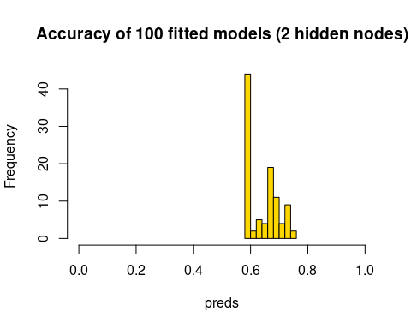 Do we do any better, on average, with more hidden nodes?
preds <- matrix(0, 100)
for (i in 1:100) {
phonemodel3 <- nnet(Smartphone ~ ., data = phone, size = 6)
preds[i] <- confusion(phone$Smartphone, factor(predict(phonemodel3, newdata = phone,
type = "class"), levels = c("Android", "iPhone")))$overall
}
hist(preds, col = "gold", main = "Accuracy of 100 fitted models (6 hidden nodes)",
xlim = c(0, 1))
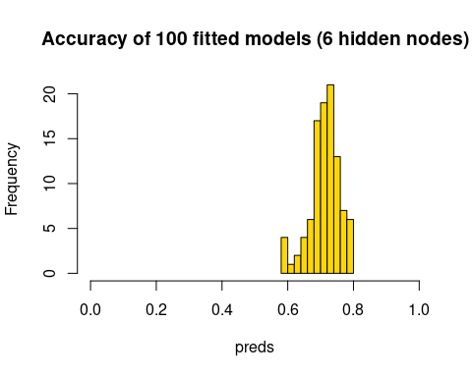 This seems to be more consistent, and do better overall–usually above 70% accuracy. But like every model we have examined, the best models are likely to be over-fitting, and getting lucky at re-predicting their own data. It would also be important to implement a cross-validation scheme. There is no built-in cross-validation here, but you can implement one using subset functions.
train <- rep(FALSE, nrow(phone))
train[sample(1:nrow(phone), size = 300)] <- TRUE
test <- !train
phonemodel2 <- nnet(Smartphone ~ ., data = phone, size = 6, subset = train)
# weights: 85
initial value 204.327276
iter 10 value 193.352724
iter 20 value 166.957659
iter 30 value 136.845896
iter 40 value 126.652225
iter 50 value 118.844038
iter 60 value 114.601579
iter 70 value 112.362718
iter 80 value 109.187074
iter 90 value 106.922061
iter 100 value 104.486444
final value 104.486444
stopped after 100 iterations
confusion(phone$Smartphone[test], predict(phonemodel2, newdata = phone[test, ], type = "class"))
Overall accuracy = 0.563
Confusion matrix
Predicted (cv)
Actual Android iPhone
Android 0.340 0.660
iPhone 0.273 0.727
We can try this 100 times and see how well it does on the cross-validation set:
preds <- rep(0, 100)
for (i in 1:100) {
train <- rep(FALSE, nrow(phone))
train[sample(1:nrow(phone), size = 300)] <- TRUE
test <- !train
phonemodel2 <- nnet(Smartphone ~ ., data = phone, size = 6, subset = train)
preds[i] <- confusion(phone$Smartphone[test], factor(predict(phonemodel2, newdata = phone[test,
], type = "class"), levels = c("Android", "iPhone")))$overall
}
hist(preds, col = "gold", main = "Accuracy of 100 cross-validated models (6 hidden nodes)",
xlim = c(0, 1))
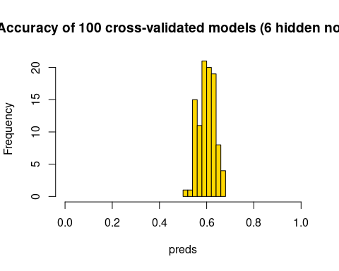
The cross-validation scores are typically a bit lower, with models getting around 60% on average, and up to 70% for the best. Now that we have built this, we could use average cross-validation accuracy to help select variables for exclusion. Here, let’s just test the predictors we have found previously to be fairly good:
preds <- rep(0, 100)
for (i in 1:100) {
train <- rep(FALSE, nrow(phone))
train[sample(1:nrow(phone), size = 300)] <- TRUE
test <- !train
phonemodel2 <- nnet(Smartphone ~ Gender + Avoidance.Similarity + Phone.as.status.object +
Age, data = phone, size = 6, subset = train)
preds[i] <- confusion(phone$Smartphone[test], factor(predict(phonemodel2, newdata = phone[test,
], type = "class"), levels = c("Android", "iPhone")))$overall
}
hist(preds, col = "gold", main = "Accuracy of 100 cross-validated models (6 hidden nodes)",
xlim = c(0, 1))
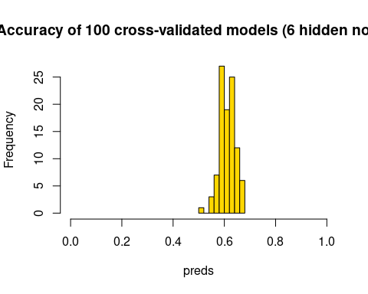
Most of these are better than chance, and it seems to do about as well as the full set of predictors as well.

The neuralnet library
The neuralnet library is perhaps a more flexible implementation, with multiple hidden layers. Here we have 2 hidden layers with two nodes each. When fitting it, it seemed to get stuck frequently and not converge or have some other error, but it does give a nice graphical visualization of the network. It seems to used more advanced backprop algorithms and activation functions. Here we have two hidden layers with two nodes each. The network does not make a lot of sense, but the model fails to converge under many larger network conditions.
library(neuralnet)
set.seed(10313)
train <- rep(FALSE, nrow(phone))
train[sample(1:nrow(phone), size = 300)] <- TRUE
test <- !train
phonemodel3 <- neuralnet(Smartphone ~ ., hidden = c(2, 2), data = phone[train, ])
pred <- apply(predict(phonemodel3, newdata = phone[test, ]), 1, which.max)
ptest <- phone[test, ]
acc <- (sum(ptest[pred == 1, ]$Smartphone == "Android") + sum(ptest[pred == 2, ]$Smartphone ==
"iPhone"))/sum(test)
print(acc)
[1] 0.5764192
plot(phonemodel3, rep = "best")
