**Singular Value Decomposition and its numerical computations**

Wen Zhang, [Anastasios Arvanitis](https://mtu.instructure.com/courses/229419/users/271056) and [Asif Al-Rasheed](https://mtu.instructure.com/courses/229419/users/270916)

# ABSTRACT

The Singular Value Decomposition (SVD) is widely used in many engineering fields. Due to the important role that the SVD plays in real-time computations, we try to study its numerical characteristics and implement the numerical methods for calculating it. Generally speaking, there are two approaches to get the SVD of a matrix, i.e., direct method and indirect method. The first one is to transform the original matrix to a bidiagonal matrix and then compute the SVD of this resulting matrix. The second method is to obtain the SVD through the eigen pairs of another square matrix. In this project, we implement these two kinds of methods and develop the combined methods for computing the SVD. Finally we compare these methods with the built-in function in Matlab (svd) regarding timings and accuracy.

# INTRODUCTION

The singular value decomposition is a factorization of a real or complex matrix and it is used in many applications. Let A be a real or a complex matrix with m by n dimension. Then the SVD of A is: $A=UΣV^{T}$ where $U$ is an m by m orthogonal matrix, Σ is an m by n rectangular diagonal matrix and $V^{T}$ is the transpose of $V$ n n matrix.  The diagonal entries of Σ are known as the [singular values](http://en.wikipedia.org/wiki/Singular_value) of *A*. Them columns of *U* and the *n* columns of *V* are called the left singular vectors and right singular vectors of *A*, respectively. Both U and V are orthogonal matrices. In this project we assume that the matrix *A* is real. There are a few of methods that can be used to compute the SVD of a matrix and they will be discussed and analyzed.

## APPLICATIONS

As we discussed before the singular value decomposition is very useful and can be used in many application areas. We will only mention a few.

* Digital Signal Processing:

The SVD has applications in digital signal processing, as a method for noise reduction. The central idea is to let a matrix *A* represent the noisy signal, compute the SVD, and then discard small singular values of *A*. It can be shown that the small singular values mainly represent the noise, and thus the rank-*k* matrix *Ak* represents a filtered signal with less noise.

* Image Processing:

The SVD has also applications in image processing and specifically in image compression. Computer technology these days is most focused on storage space and speed. One way to help cure this problem is Singular Value Decomposition. Singular Value Decomposition can be used in order to reduce the space required to store images. Image compression deals with the problem of reducing the amount of data required to represent a digital image. Compression is achieved by the removal of three basic data redundancies:

1) coding redundancy, which is present when less than optimal;

2) interpixel redundancy, which results from correlations between the pixels;

3) psychovisual redundancies, which is due to data that is ignored by the human visual.

When an image is SVD transformed, it is not compressed, but the data take a form in which the first singular value has a great amount of the image information. With this, we can use only a few singular values to represent the image with little differences from the original. With this method we save valuable disc space.

* Mechanical Vibrations

The Frequency Response Function of a mechanical system can be decomposed using SVD at a specific frequency. The plot of the log-magnitude of the singular values as a function of frequency is called Complex Mode Indicator Function (CMIF) and is very helpful in locating the modal parameters of the system (natural frequencies, mode shapes, modal participation factors).

$$[H\left(jω_{k}\right)]=[U_{k}][S_{k}{][V_{k}]}^{H}$$

The first CMIF is considered the plot of the largest singular values in each frequency. Distinct peaks in the first CMIF indicate the existence of a mode. The orthonormal columns of $[U_{k}]$ are the left singular vectors of $\left[H\left(jω_{k}\right)\right]$ and represent the mode shape vectors. The orthonormal columns of $[V_{k}]$ are the right singular vectors and represent the modal participation factors.

# IMPLEMENTATIONS OF DIFFERENT METHODS

## INDIRECT METHOD

Suppose $A$ is a $m×n$ matrix, the SVD of $A$ is $A=U V^{T}$ where $U$ and $V$ are orthogonal matrices. We know that if $m<n$ then after getting the eigen values and eigen vectors of $A^{T}A$, the eigen vectors can be orthogonalized to form $V$ and it is straightforward to get $U$ through the formula: $U_{i}=AV_{i}/{}_{i}$ where ${}_{i}$’s are the singular values of $A$ and the square roots of eigen values of $A^{T}A$. Using the Matlab command ‘eig’ to get the eigen values, they are listed in ascending order and the SVDecom function we programmed will list the singular values in descending order, which is the same to that obtained by the built-in function ‘svd’. Without loss of generality, we implemented the function in both $A^{T}A$ and ${AA}^{T}$ ways. The second method is preferred when $m>n$. Another key point in the implementation of SVDecom is that, if $A$ is rank deficient, which usually happens in case $m>n$, there are not enough $V_{i}$ to get $U$. The strategy we used is to set the elements in the rest $m-n$ columns of $U$ all ones and then orthonormalize it via Gram-Schmidt algorithm. All in all, different strategies can be combined to treat variant cases in programming the related subroutines.

The Matlab code for calculating the SVD via the $A^{T}A$/ $AA^{T}$ eigenvalue decomposition is in Table 2.1 where the function is named SVDecom. As we discussed, when $m>n$, the ${AA}^{T}$ approach is employed in this function. The eigen vectors of this matrix are orthogonalized to form the orthogonal matrix $U$. The first $n$ columns of $U$ are utilized to obtain matrix $V$. Certainly, if $m<n$, we can also use this approximation. The first $m$ columns of $V$ are got via $V_{i}=A^{T}U_{i}/{}_{i}$. The left $n-m$ columns of $V$ are first set to all-ones vectors, then we use Gram-Schmidt process to orthonormalize them in order to get orthogonal matrix $V$. If there are zero singular values, we will first set the corresponding columns all-one vectors, and then use double Gram-Schmidt process to get the orthogonal matrix.

Table 2.1 SVDecom Function

|  |  |
| --- | --- |
| Function [u,d,v]=SVDecom(A)  [m,n]=size(A); sinflag=0;  if (m>n)  [u,d]=eig(A*A’); u=GSO(u);u=fliplr(u);   d1(1:n,n+1:m)=zeros(n,m-n);  dd=fliplr(diag(d.^(0.5))’)’;   d1(1:n,1:n)=diag(dd(1:n));d=d1;  for i=1:n  if (d(i,i)~=0)  v(:,i)=A’*u(:,i)/d(i,i);  else  sinflag=1; v(:,i)=ones(n,1);  end  end  v=GSO(v);  if (sinflag==1)  v=GSO(v);  end  d=d’;  end | if (m<n||m==n)  [v,d]=eig(A'*A);   v=GSO(v); v=fliplr(v);   d1=zeros(m,n);  dd=fliplr(diag(d.^(0.5))');  d1(1:m,1:m)=diag(dd(1:m));  d=d1;  for i=1:m  if(d(i,i)~=0)  u(:,i)=A*v(:,i)/d(i,i);  else  sinflag=1;  u(:,i)=ones(m,1);  end  end  u=GSO(u);  if (sinflag==1)  u=GSO(u);  end  end |

The double Gram-Schmidt process is implemented in function ‘GSO’ which is listed in Table 2.2. It first orthogonalize the vectors twice and then normalize them.

## DIRECT METHOD

### 2.2.1 BIDIAGONALIZATION AND CALCULATION OF THE SVD

The direct method is to transform the matrix $A$ to a bidiagonal matrix first. Then through getting the SVD of the resulting bidiagonal matrix, we find the SVD of $A$. The code for reducing the matrix to the bidiagonal form is in Table 2.4. The corresponding function ‘BiDiag’ is programmed according to the instructions in [2] from Page 394 to Page 400. It employs the Householder function which gets the Householder matrix of the related vector and is programmed as in Table 2.3.

Table 2.2 GSO Function

|  |  |
| --- | --- |
| function [Q]=GSO(A)  [n,m]=size(A);  Q1(:,1)=A(:,1);  for j=2:m  Q1(:,j)=A(:,j);  for i=1:j-1  x=Q1(:,i); a=A(:,j); qnorm=x'*x;  if (qnorm~=0)  Q1(:,j)=Q1(:,j)-(a'*x)/qnorm*x;  end  end  end  Q(:,1)=Q1(:,1); | for j=2:m  Q(:,j)=Q1(:,j);  for i=1:j-1  x=Q(:,i); a=Q1(:,j); qnorm=x'*x;  if(qnorm~=0)  Q(:,j)=Q(:,j)-(a'*x)/qnorm*x;  end  end  end  for i=1:m  qnorm=Q(:,i);x=(qnorm'*qnorm);  if(x~=0)  Q(:,i)=Q(:,i)/(x^(0.5));  end  end |

Table 2.3 Housholder

|  |
| --- |
| function Q=Householder(x)  [m,n]=size(x); tau=sign(x(1))*norm(x,2);  u=x;u(1)=u(1)+tau; y=2/(norm(u,2)^2);  Q=eye(m,m)-y*u*u'; |

Note that if $m>n$, there will be one more Householder transforms on the column of $A$. If $m<n$, there are two more right transformation matrices which are used to make the Householder transforms on rows. Generally, it is more convenient to reduce a matrix with dimension $m>n$ to a bidiagonal matrix just as that introduced in the textbook. By doing so, it will not lose generality because if $m<n$ the corresponding transforms can be utilized to $A^{T}$ and get the same factorizations by transposing the resulting matrices. After using function BiDiag to matrix $A$, it is factorized to $A=UBV^{T}$ where $U$ and $V$ are orthogonal matrices and $B$ is a bidiagonal matrix. Take the $m>n$ case for example, we get $A=UBV^{T}$ where $B$ is also $m$ by $n$. The singular values of $B$ is same to $A$. And if the SVD of $B$ is gained: $B=P Q^{T}$, then we have $A=UP Q^{T}V^{T}$. Therefore the SVD of $A$ is: $A=U_{1} {V_{1}}^{T}$, where $U_{1}=UP$, $V_{1}=VQ$. So the main task is focus on finding the SVD of $B$. We know $B$ has the form $[\begin{matrix}\hat{B} \\ 0_{d}\end{matrix}]$ where $\hat{B}$ is a square $n$ by $n$ bidiagonal matrix and $0_{d}$ is a ( $m-n)$ by $n$ zero matrix. If we know $\hat{B}=\hat{P}\hat{} {\hat{Q}}^{T}$ then what is the relation between and , $P$ and $\hat{P}$, $Q$ and $\hat{Q}$? The relations are as follows: $Q=\hat{Q},$ $=[\begin{matrix}\hat{} \\ 0_{d}\end{matrix}]$, $P=[\begin{matrix}\hat{P} & 0_{1} \\ 0_{2} & I_{m-n}\end{matrix}]$. Here $0_{1}$ is a $n×\left(m-n\right)$ zero matrix and $0_{2}$ is a $(m-n)×n$ zero matrix. $I_{m-n}$ is $(m-n)$ by $(m-n)$ identity matrix. There are many optional methods to get the SVD of $\hat{B}$. We can calculate it by the built-in function or by the SVDecom function we programmed. Iterative algorithms such as Francis and Jacobi methods can also be employed. From the literature [1], we know that if $B_{n×n}$ has entries

$\left[\left.\begin{matrix}\begin{matrix}b_{1} & b_{2} & \\ & b_{3} & b_{4}\end{matrix} & \begin{matrix} & O & \end{matrix} \\ \begin{matrix} & & \\ & O & \end{matrix} & \begin{matrix}⋱ & & \\ & b_{2n-3} & b_{2n-2} \\ & & b_{2n-1}\end{matrix}\end{matrix}\right]\right.$ and SVD of $B$ is $B=U V^{T}$ with $=diag\left\{σ_{1},σ_{2},…, σ_{n}\right\}, V=[v_{1},v_{2},…, v_{n}],$ and $U=\left[u_{1},u_{2},…, u_{n}\right].$ Then the symmetric matrix

Table 2.4 Bidiagonalization

|  |  |
| --- | --- |
| function [u,b,v]=BiDiag(A)  [m,n]=size(A); n1=min(m,n);  u1=Householder(A(:,1));  b=u1*A;A1=b';a=A1(2:n,1); v2=Householder(a); v1(2:n,2:n)=v2';  v1(1,1)=1; b=b*v1; u=u1;v=v1;  for i=2:n1-2  a=b(i:m,i); clear u1;  u1(1:i-1,1:i-1)=eye(i-1);  u1(i:m,i:m)=Householder(a);  b=u1*b; A1=b'; a1=A1(i+1:n,i);  v2=Householder(a1); clear v1;  v1(1:i,1:i)=eye(i); v1(i+1:n,i+1:n)=v2';  b=b*v1; u=u*u1; v=v*v1;  end  a=b(n1-1:m,n1-1); clear u1;  u1(1:n1-2,1:n1-2)=eye(n1-2);  u1(n1-1:m,n1-1:m)=Householder(a);  b=u1*b; u=u*u1; | if (m>n)  a=b(n:m,n); clear u1;  u1(1:n-1,1:n-1)=eye(n-1);  u1(n:m,n:m)=Householder(a);  b=u1*b; u=u*u1;  end  if(m<n)  A1=b';a1=A1(n1:n,n1-1);  v2=Householder(a1);  clear v1;  v1(1:n1-1,1:n1-1)=eye(n1-1);  v1(n1:n,n1:n)=v2'; b=b*v1; v=v*v1;  A1=b';a1=A1(n1+1:n,n1);   v2=Householder(a1);  clear v1;  v1(1:n1,1:n1)=eye(n1);  v1(n1+1:n,n1+1:n)=v2';   b=b*v1;v=v*v1;  end |

$B_{1}=\left[\begin{matrix}\begin{matrix}0 & b_{1} \\ b_{1} & 0\end{matrix} \\ \begin{matrix} & b_{2} \\ & \begin{matrix} & ⋱\end{matrix}\end{matrix} \\ \begin{matrix} & \\ O & \end{matrix}\end{matrix}\right.\left.\begin{matrix}\begin{matrix} & \begin{matrix} & & O\end{matrix} \\ \begin{matrix}b_{2} \\ 0\end{matrix} & \begin{matrix} & \\ & \end{matrix}\end{matrix} \\ \begin{matrix} & ⋱\end{matrix} \\ \begin{matrix} & b_{2n-1} \\ \begin{matrix} & b_{2n-1}\end{matrix} & 0\end{matrix}\end{matrix}\right]$ has eigenvalues $±σ_{i} with$ normalized associated eigenvectors ${h_{i}}^{±}=\frac{1}{\sqrt{2}}{(v_{i1},{±u}_{i1},v_{i2},{±u}_{i2},…,v_{in},{±u}_{in})}^{T}$. Considering this property, we first transform $\hat{B}$ to the matrix $B_{1}$ which is a tridiagonal matrix and compute the eigen pairs of $B_{1}$. Then we get the SVD of $\hat{B}$. Once this SVD is obtained, the SVD of $B$ and hence of $A$ is calculated.The procedure that left is to transform $\hat{B} to$ the matrix $B_{1}$. To operate a shuffle matrix [2] on the revised matrix $[\begin{matrix}0 & {\hat{B}}^{T} \\ \hat{B} & 0\end{matrix}]$ can get $B_{1}$: ${ B}_{1}=P^{T}\left[\begin{matrix}0 & {\hat{B}}^{T} \\ \hat{B} & 0\end{matrix}\right]P$. The code for generating the shuffle matrix with respect to the dimension of $\hat{B}$ is given in Table 2.5. The input of function GenerateShuff is the dimension of matrix $\hat{B}$. So far we can give the code of calculating the SVD of the original bidiagonal matrix $B$, which is shown in Table 2.6.

Table 2.5 Shuffle matrix

|  |
| --- |
| function p=GenerateShuff(m)  for i=1:2:2*m-1  p(:,i)=geneVector(2*m,(i+1)/2);  end  for i=2:2:2*m  p(:,i)=geneVector(2*m,i/2+m);  end  function p=geneVector(m,n)  p=zeros(m,1); p(n)=1; |

Table 2.6 SVDUpBidiag

|  |
| --- |
| function [u,d,v]=SVDUpBidiag(B)  [m,n]=size(B); B1=B(1:n,1:n);  C(1:n,n+1:n+n)=B1';C(1:n,1:n)=zeros(n,n);  C(n+1:2*n,1:n)=B1;C(n+1:2*n,n+1:2*n)=zeros(n,n);  p=GenerateShuff(n); c1=p'*C*p; [x,d]=eig(c1);  x1=fliplr(x);d1=fliplr(flipud(d)); d=d1(1:n,1:n);  x1=x1(:,1:n); x1=x1*2^(.5);  for i=1:n  v(i,:)=x1(2*i-1,:); u(i,:)=x1(2*i,:);  end  d(n+1:m,1:n)=zeros(m-n,n);u(n+1:m,1:n)=zeros(m-n,n);  u(:,n+1:m)=zeros(m,m-n);u(n+1:m,n+1:m)=eye(m-n); |

Table 2.7 SVDDirect

|  |
| --- |
| function [u,d,v]= SVDDirect (A)  [m,n]=size(A);  if (m>n|m==n)  [p,j,q]=BiDiag(A);[u1,d,v1]=SVDUpBidiag(j);  u=p*u1; v=q*v1;  end  if (m<n)  [p,j,q]=BiDiag(A');[u1,d1,v1]=SVDUpBidiag(j);  v=p*u1; u=q*v1; d=d1';  end |

Combine the function SVDUpBidiag and BiDiag, we get the function which computes SVD of any matrix. We call this function ‘SVDDirect’ although it is actually an ‘indirect’ iterative way to get SVD. The code of it is shown in Table 2.7.

### 2.2.2 COMBINED METHODS

We see in the function SVDDirect, the line ‘[u1,d,v1]=SVDUpBidiag(j);’ is used to get the SVD of the bidiagonal matrix $B$. This line can be substituted by other functions that implement the SVD process. One option is the ‘SVDecom’ function which we made at the beginning. Certainly, the built-in functions can be used here. Another choice is to use Jacobi iterative method to get SVD and replace ‘SVDUpBidiag’ by ‘SVDBiDiaJacob’ which is a function that we programmed based on Jacobi iterative method. It is given in Table 2.8. The function ‘jacobi_svd’ is based on Jacobi iteration. Replacing ‘SVDUpBidiag’ in SVDDirect by ‘SVDBiDiaJacob’, we give the function ‘SVDJacob’ which is listed in Table 2.9.

Table 2.8 SVDBiDiaJacob

|  |
| --- |
| function [u,d,v]=SVDBiDiaJacob(B)  [m,n]=size(B); B1=B(1:n,1:n); [u,d,v]=jacobi_svd(B1);  d(n+1:m,1:n)=zeros(m-n,n); u(n+1:m,1:n)=zeros(m-n,n);  u(:,n+1:m)=zeros(m,m-n); u(n+1:m,n+1:m)=eye(m-n);  function [U,S,V]= jacobi_svd(A)  TOL=1.e-8; n=size(A,1);U=A; V=eye(n);converge=TOL+1;  while converge>TOL  converge=0;  for j=2:n  for i=1:j-1  alpha=U(:,i)'*U(:,i); beta=U(:,j)'*U(:,j); gamma=U(:,i)'*U(:,j);  converge=max(converge,abs(gamma)/sqrt(alpha*beta));  zeta=(beta-alpha)/(2*gamma);  t=sign(zeta)/(abs(zeta)+sqrt(1+zeta^2));  c=1/((1+t^2)^(.5));s=c*t;t=U(:,i);  U(:,i)=c*t-s*U(:,j); U(:,j)=s*t+c*U(:,j);  t=V(:,i); V(:,i)=c*t-s*V(:,j); V(:,j)=s*t+c*V(:,j);  end  end  end  for j=1:n  singvals(j)=norm(U(:,j)); U(:,j)=U(:,j)/singvals(j);  end  S=diag(singvals); |

We call the SVD function that combines the functions ‘SVDecom’ and ‘BiDiag’, SVDComb which is shown in Table 2.10. As an extended work, we implemented the QR decomposition using Householder transformations. The code to implement the QR is in Table 2.11.

Table 2.9 SVDJacob

|  |
| --- |
| function [u,d,v]=SVDJacob(A)  [m,n]=size(A);  if (m>n|m==n)  [p,j,q]=BiDiag(A); [u1,d,v1]=SVDBiDiaJacob(j); u=p*u1; v=q*v1;  end  if (m<n)  [p,j,q]=BiDiag(A'); [u1,d1,v1]=SVDBiDiaJacob(j); v=p*u1; u=q*v1; d=d1';  End |

Table 2.10 SVDComb

|  |
| --- |
| function [u,d,v]=SVDComb(A)  [m,n]=size(A);  if (m>n|m==n)  [p,j,q]=BiDiag(A);  [u1,d,v1]=SVDecom(j);  u=p*u1; v=q*v1;  end  if (m<n)  [p,j,q]=BiDiag(A');  [u1,d1,v1]=SVDecom(j);  v=p*u1; u=q*v1; d=d1';  end |

Note that if we use ‘Q=HouseholderQR(A)’, an orthogonal matrix Q will be generated. This function can be used to generate an arbitrary matrix with known singular values. Actually, it can be used to generate an orthogonal matrix, too.

Table 2.11 Housholder QR

|  |
| --- |
| function [Q,r]=HouseholderQR(A)  [m,n]=size(A);m1=min(m,n);  if m>n  m1=m1+1;  end  x=A(:,1);Q1=Householder(x); A1=Q1*A;Q=Q1;  for i=2:m1-1  x=A1(i:m,i);  Q1(i:m,i:m)=Householder(x);  Q1(i:m,1:i-1)=zeros(m-i+1,i-1);  Q1(1:i-1,1:i-1)=eye(i-1);  Q1(1:i-1,i:m)=zeros(i-1,m-i+1);  A1=Q1*A1; Q=Q*Q1;  end  r=Q'*A; |

### 2.2.3 TESTING

Figure 2.1 is given to show the comparisons of the timing used by different SVD methods. In this experiment, the square matrices are treated. We give the log-log plot of the time cost against the dimension.

The indirect method cost less time than the direct method. Obviously, the implemented numerical methods will cost more CPU time than the built-in function.

The accuracy comparison is shown in Figure 2.2. We see the direct method achieves higher accuracy than the indirect method. The combined squaring method gets lowest precision.



Figure 2.1 Timings



Figure 2.2 Acuraccy

**The description of each method:**

* Built-in method is using the svd function in Matlab to get the SVD.
* Direct method is first transforming the original matrix to the bidiagonal matrix and then getting its SVD via the eigen pairs of the tridiagonal matrix.
* The Jacob method is to get the SVD of the bidiagonal matrix through Jacobi rotation.
* Indirect method is the $A^{T}A$ and ${AA}^{T}$ approach.
* Combined built in method is to get the SVD of bidiagonal matrix via the built in svd function and combined squaring method is employing the squaring/indirect method to get the SVD of bidiagonal matrix and finally get the SVD of original matrix.

The following lines are to test the orthogonality of the matrices got by the direct method. The last two lines are to compare the singular values got by the direct method and the built in function.

Table 2.12 – Orthogonality and singular value check

|  |  |
| --- | --- |
| >> A=rand(150,40);  >> [u,d,v]=SVDDirect(A);  >> norm(u'*u-eye(150),inf)  ans = 4.9280e-014  >> norm(v'*v-eye(40),inf)  ans = 1.5504e-014  >> [u1,d1,v1]=svd(A);  >> norm(d-d1,1)  ans = 7.1054e-014 | >> B=randn(120,230);  >> [u,d,v]=SVDDirect(B);  >> norm(u*u'-eye(120),inf)  ans = 5.9718e-014  >> norm(v*v'-eye(230),1)  ans = 8.5688e-014  >> [u1,d1,v1]=svd(B);  >> norm(d1-d,inf)  ans = 9.9476e-014 |

## GOLUB – REINSCH ALGORITHM

This last method of computing the SVD of a matrix is based on the Golub-Reinsch algorithm which is a variant of the Francis algorithm. This time we will not compute the SVD of the matrix using the eig function of matlab but we will implement the Golub-Reinsch algorithm .

The following steps are followed in order to compute the SVD of a rectangular matrix A. We assume that the number of rows (m) is greater than the number of columns(n).

* Bidiagonalization of matrix A.

In this step the matrix is decomposed in $A=QBP^{T}$ where B is an upper Bidiagonal matrix by applying a series of Householder transformation as we described in the previous chapter .

$B=\left[\begin{matrix}\tilde{B} \\ 0\end{matrix}\right]$

$B=\tilde{B}$

* Diagonalization of the bidiagonal matrix B.

The Bidiagonal matrix B can be reduced to a diagonal matrix by iteratively applying the implicitly shifted QR algorithm (Francis). The matrix B is decomposed as $Σ=X^{T}BY$ where Σ is a diagonal matrix, X and Y are orthogonal unitary matrices.

$U=QX$

$V^{T}={\left(PY\right)}^{T}$

* $A=UΣV^{T}$ Singular value decomposition of A.

### IMPLICITLY SHIFTED QR ALGORITHM

The algorithm computes a sequence *B* of bidiagonal matrices starting from $B_{0}=B$ as follows. From ${ B}_{i}$ the algorithm computes a shift ${ μ}^{2}$, which is usually taken to be the smallest eigenvalue of the bottom 2 by 2 block of $Β_{i}{B_{i}}^{T}$. Then the algorithm does an implicit QR factorization of the shifted matrix $Β_{i}{B_{i}}^{T}-{ μ}^{2}Ι=QR$, where *Q* is orthogonal and *R* upper triangular, from which it computes a bidiagonal $B_{i+1}$ such that ${B_{i+1}}^{T}B_{i+1}=RQ+{ μ}^{2}I$. As *i* increases, *B* converges to a diagonal matrix with the singular values on the diagonal.

**Steps: $B=\left(\begin{matrix}d_{1} & f_{2} & \begin{matrix} & \end{matrix} \\ & d_{2} & \begin{matrix}⋱ & \end{matrix} \\ \begin{matrix} \\ \end{matrix} & \begin{matrix} \\ \end{matrix} & \begin{matrix}\begin{matrix}⋱ \\ \end{matrix} & \begin{matrix}f_{n} \\ d_{n}\end{matrix}\end{matrix}\end{matrix}\right)$**

* Determine the shift μ which is called the Wilkinson shift. This is the smallest eigenvalue of the bottom 2 by 2 block of $Β_{i}{B_{i}}^{T}$. $\left(\begin{matrix}{d^{2}}_{n-1}+{f^{2}}_{n-1} & d_{n-1}f_{n} \\ d_{n-1}f_{n} & {d^{2}}_{n}+{f^{2}}_{n}\end{matrix}\right)$
* Find the Givens matrix $G_{1}=G\left(1,2;θ\right)$ such that ${\left(\begin{matrix}c & s \\ -s & c\end{matrix}\right)}^{T}∙\left(\begin{matrix}{d^{2}}_{1}-μ \\ d_{1}f_{2}\end{matrix}\right)=\left(\begin{matrix}* \\ 0\end{matrix}\right)$. Compute $BG_{1}$.
* We have: $BG_{1}=\left(\begin{matrix}* & * & \begin{matrix} & \end{matrix} \\ * & * & \begin{matrix}⋱ & \end{matrix} \\ \begin{matrix} \\ \end{matrix} & \begin{matrix} \\ \end{matrix} & \begin{matrix}\begin{matrix}⋱ \\ \end{matrix} & \begin{matrix}* \\ *\end{matrix}\end{matrix}\end{matrix}\right)$ So we should zero out the * term. We want to find $P_{2}$ and $G_{2}$ such that $P_{2}(BG_{1})G_{2}$ is bidiagonal.
* We can find $P_{2}$ and $G_{2}$ by Givens transformation and we have $P_{2}\left(BG_{1}\right)G_{2}=\left(\begin{matrix}* & * & \begin{matrix} & \end{matrix} \\ & * & \begin{matrix}⋱ & \end{matrix} \\ \begin{matrix} \\ \end{matrix} & \begin{matrix}* \\ \end{matrix} & \begin{matrix}\begin{matrix}⋱ \\ \end{matrix} & \begin{matrix}* \\ *\end{matrix}\end{matrix}\end{matrix}\right)$

So we should zero out the * term. We want to find $P_{3}$ and $G_{3}$ such that $P_{3}P_{2}BG_{1}G_{2}G_{3}$ is bidiagonal. We repeat these steps until $BG_{1}$ is bidiagonal.

* Finally we have $P_{n-1}…P_{2}BG_{1}…G_{n-1}=\left(\begin{matrix}* & * & \begin{matrix} & \end{matrix} \\ & * & \begin{matrix}⋱ & \end{matrix} \\ \begin{matrix} \\ \end{matrix} & \begin{matrix} \\ \end{matrix} & \begin{matrix}\begin{matrix}⋱ \\ \end{matrix} & \begin{matrix}* \\ *\end{matrix}\end{matrix}\end{matrix}\right)$. Iterate until the off-diagonal entries converge to 0, and the diagonal entries converge to singular values.

### IMPLICITLY ZERO SHIFTED QR ALGORITHM

The roundoff errors in this algorithm are generally on the order of e*B*, where e is the precision of the floating point arithmetic used. We would expect absolute errors in the computed singular values of the same order. In particular, tiny singular values of *B* could be changed completely. In order to avoid these errors and to increase precision it is introduced a variation of this algorithm. It is called the implicit zero shift QR algorithm and it corresponds to the algorithm above when μ=0. Comparing to the standard algorithm we see that the (1,2) entry is zero instead of nonzero. This zero will propagate through the rest of the algorithm and is the key to its effectiveness. We decided to implement this algorithm instead of the standard. Below you can see both the steps and the pseudo code of the algorithm.

**Steps: $B=\left(\begin{matrix}d_{1} & f_{2} & \begin{matrix} & \end{matrix} \\ & d_{2} & \begin{matrix}⋱ & \end{matrix} \\ \begin{matrix} \\ \end{matrix} & \begin{matrix} \\ \end{matrix} & \begin{matrix}\begin{matrix}⋱ \\ \end{matrix} & \begin{matrix}f_{n} \\ d_{n}\end{matrix}\end{matrix}\end{matrix}\right)$**

* We have $BG_{1}=\left(\begin{matrix}* & 0 & \begin{matrix} & \end{matrix} \\ * & * & \begin{matrix}⋱ & \end{matrix} \\ \begin{matrix} \\ \end{matrix} & \begin{matrix} \\ \end{matrix} & \begin{matrix}\begin{matrix}⋱ \\ \end{matrix} & \begin{matrix}* \\ *\end{matrix}\end{matrix}\end{matrix}\right)$
* We find $P_{2}$ and $G_{2}$, such that $P_{2}\left(BG_{1}\right)G_{2}=\left(\begin{matrix}* & * & \begin{matrix} & \begin{matrix} & \end{matrix}\end{matrix} \\ 0 & * & \begin{matrix}0 & \begin{matrix} & \end{matrix}\end{matrix} \\ \begin{matrix} \\ \end{matrix} & \begin{matrix}* \\ \begin{matrix} \\ \end{matrix}\end{matrix} & \begin{matrix}\begin{matrix}* \\ \begin{matrix} \\ \end{matrix}\end{matrix} & \begin{matrix}\begin{matrix}⋱ & \end{matrix} \\ \begin{matrix}\begin{matrix}⋱ \\ \end{matrix} & \begin{matrix}* \\ *\end{matrix}\end{matrix}\end{matrix}\end{matrix}\end{matrix}\right)$
* Finally $P_{n-1}…P_{2}BG_{1}…G_{n-1}=\left(\begin{matrix}* & * & \begin{matrix} & \end{matrix} \\ & * & \begin{matrix}⋱ & \end{matrix} \\ \begin{matrix} \\ \end{matrix} & \begin{matrix} \\ \end{matrix} & \begin{matrix}\begin{matrix}⋱ \\ \end{matrix} & \begin{matrix}* \\ *\end{matrix}\end{matrix}\end{matrix}\right)$.

Let *B* be an *n* by *n* bidiagonal matrix with diagonal entries $d_{1}…d_{n}$ and superdiagonal entries $f_{1}…f_{n-1}$. The following algorithm replace $d_{i}$ and $f_{i}$ by new values corresponding to one step of the QR iteration with zero shift:

$oldc=1$; $g=d_{1}$; $p=f_{1}$

$$for i=1 to n-1$$

$\left[c,s,r\right]=ROT\left(g,p\right)$

$if \left(i≠1\right) then$

$$f_{i-1}=olds*r$$

$end if$

$g=oldc*r$; $p=d_{i+1}*s$; $h=d_{i+1}*c$;

$\left[c,s,r\right]=ROT\left(g,p\right)$; $d_{i}=r$

$if \left(i≠n-1\right) then$

$p=f_{i+1}$

$end if$

$oldc=c$; $olds=s$

$$end for$$

$f_{n-1}=h*s$; $d_{n-1}=h*c$

The algorithm above uses a subroutine ROT which actually is the Givens rotation and takes $g$ and $p$ as inputs and returns $c=cosθ$ and $s=sinθ$ such that: $\left[\begin{matrix}c & s \\ -s & c\end{matrix}\right]\left[\begin{matrix}g \\ p\end{matrix}\right]=\left[\begin{matrix}r \\ 0\end{matrix}\right]$

Stopping criterion

The algorithm below decides when an offdiagonal entry $f_{i}$ can be set to zero. $0<tol<1$ is a relative error tolerance. The value of $tol$ we used in the numerical tests was $tol=100∙ε$. The value 100 was chosen empirically to make the algorithm run fast but it could be easily be set as large as $1000$ or as small as $10$.

$$μ_{1}=d_{1}$$

$$for i=1:n-1$$

$if \left|f_{i}\right|<tol*μ_{i}, set f_{i}=0$; $μ_{i+1}=\left|d_{i+1}\right|*\left(\frac{μ_{i}}{μ_{i}+\left|f_{i}\right|}\right)$

$$end for$$

### MATLAB FUNCTIONS

Followings are the Matlab codes regarding the above iterative method of computing the singular values.

Table 2.13 Given’s Rotations

|  |
| --- |
| function [cs,sn,r]=rot(f,g)  x=[f g];[G,r]=planerot(x');  cs=G(1,1);sn=G(1,2);r=r(1); |

Table 2.14 Implicit QR zero shift

|  |
| --- |
| function [d,e]=IQR(d,e)  n=length(d);oldc=1;c=1;  for k=1:n-1  [c,s,r]=ROT(c*d(k),e(k));  if k~=1  e(k-1)=r*olds;  end  [oldc,olds,d(k)]=ROT(oldc*r,d(k+1)*s);  end  h=c*d(n);e(n-1)=h*olds;d(n)=h*oldc; |

Table 2.15 Iterations to get singular values

|  |
| --- |
| function d=svdFrancis(A)  TOL=100*eps; d=diag(A); n=length(d);  for i=1:n-1  e(i)=A(i,i+1);  end  maxit=500*n^2; lambda(n)=abs(d(n));  for j=n-1:-1:1  lambda(j)=abs(d(j))*lambda(j+1)/(lambda(j+1)+abs(e(j)));  end  mu(1)=abs(d(1));  for j=1:n-1  mu(j+1)=abs(d(j+1))*mu(j)/(mu(j)+abs(e(j)));  end  sigmaLower=min(min(lambda),min(mu));  thresh=max(TOL*sigmaLower,maxit*realmin); iUpper=n-1; iLower=1;  for iterations=1:maxit  iUpper=i;  if abs(e(i))>thresh  break;  end  end  j=iUpper;  for i=iLower:iUpper  if abs(e(i))>thresh  j=i; break;  end  end  iLower=j;  if (iUpper==iLower & abs(e(iUpper))<=thresh) |(iUpper<iLower)  d=sort(abs(d)); d(end:-1:1)=d;  return  end  [d(iLower:iUpper+1),e(iLower:iUpper)]=IQR(d(iLower:iUpper+1),e(iLower:iUpper));  End |

Table 2.16 SVD Function

|  |
| --- |
| function s=SVDFranIt(A);  [n,m]=size(A);  if n>m  B=BiDiag(A); Bhat=B(1:m,1:m);  else  A=A'; B=BiDiag(A); Bhat=B(1:n,1:n);  end  d=svdFrancis(Bhat); s=d;  end |

# NUMERICAL EXPERIMENTS

We conducted some experiments on the following matrices:

* Dense rectangular matrix.
* Dense symmetric matrix.
* Sparse symmetric matrix.

The dense matrices were generated using predefined singular values and the sparse matrices were generated using Matlab’s built-in function.

The SVD decomposition methods we tested are as follows:

* **Built-in SVD**: Matlab’s built-in svd function.
* **Comb. Built in**: We first bidiagonalize the matrix then use the built-in function to get the decomposition.
* **Comb. Square**: Use indirect method to get the SVD of the bidiagonalized matrix.
* **Indirect method**: We use the squaring method to get the SVD.
* **Direct method**: We tridiagonalize the bidiagonalized matrix, then use the relationship between eigen pairs of tridiagonal matrix and SVD to get the decomposition.
* **Francis**: We bidiagonalize the matrix, then use the Golub-Reinsch algorithm to get SVD.

We evaluated the following parameters:

* **Timing**: the time it takes to compute the decomposition.
* **Accuracy**: Accuracy of the decomposition is found using .
* **Orthogonality Check**: Orthogonality of the left and right orthogonal matrices was checked via , , and .
* **Error in singular values**: Found using where the actual singular values were generated previously for dense matrices and for sparse matrices they were generated using the built- in function.  
  1. **Dense Rectangular Matrix**

We tested for two types of rectangular matrices: vary number of columns keeping the number of rows fixed and the inverse case, where the numbers of rows are varied keeping the number of columns fixed. The results are tabulated below.

Table 3.1: Timings when n is fixed and m is varied (seconds).

|  |  |  |  |  |  |  |  |
| --- | --- | --- | --- | --- | --- | --- | --- |
| n | m | Built in SVD | Comb. Built in | Comb. Square | Indirect Method | Direct Method | Francis |
| 100 | 100 | 0.0643 | 0.1742 | 0.6436 | 0.4331 | 0.2001 | 1.0876 |
| 200 | 0.0133 | 0.5130 | 1.5780 | 1.1453 | 0.4999 | 2.0906 |
| 300 | 0.0189 | 1.2288 | 3.6087 | 2.3616 | 1.2544 | 3.1980 |
| 400 | 0.0365 | 2.5293 | 6.7061 | 4.2062 | 2.5645 | 4.8086 |
| 500 | 0.0355 | 4.9097 | 11.5758 | 6.7367 | 4.9373 | 7.9302 |
| 600 | 0.0487 | 7.8638 | 17.9327 | 10.1238 | 7.8953 | 9.4502 |
| 700 | 0.0553 | 11.6358 | 25.6041 | 14.3858 | 11.6814 | 12.2837 |
| 800 | 0.0710 | 16.5239 | 35.2338 | 19.3894 | 16.5601 | 15.4566 |
| 900 | 0.0854 | 22.6020 | 47.3990 | 25.6453 | 22.4533 | 19.1506 |
| 1000 | 0.1057 | 31.7354 | 64.9555 | 33.1568 | 31.6759 | 23.2127 |
| 1100 | 0.1411 | 41.2789 | 83.6196 | 40.9601 | 40.7136 | 27.6247 |
| 1200 | 0.1617 | 50.7881 | 100.2060 | 49.6997 | 51.6991 | 32.6406 |
| 1300 | 1.0426 | 63.5952 | 122.9314 | 60.2307 | 61.9592 | 37.8728 |
| 1400 | 1.1965 | 77.8064 | 147.5340 | 72.3586 | 75.6486 | 43.8433 |
| 1500 | 1.3826 | 95.3954 | 180.9166 | 88.9260 | 95.1457 | 49.7953 |
| 200 | 100 | 0.0178 | 0.4646 | 1.6561 | 1.1513 | 0.5551 | 1.3880 |
| 200 | 0.0334 | 1.9439 | 3.8301 | 1.8352 | 1.9785 | 5.4959 |
| 300 | 0.0613 | 3.7402 | 6.6063 | 3.0762 | 3.6905 | 9.0105 |
| 400 | 0.0717 | 6.7568 | 11.7872 | 4.8840 | 6.8905 | 12.9847 |
| 500 | 0.0823 | 11.9713 | 19.3053 | 7.6183 | 12.0306 | 17.3449 |
| 600 | 0.1200 | 18.6601 | 29.1580 | 10.7631 | 18.4879 | 22.7105 |
| 700 | 0.1332 | 26.3469 | 40.9780 | 14.8118 | 26.2718 | 29.1993 |
| 800 | 0.1621 | 36.7793 | 56.2104 | 19.7015 | 36.7853 | 35.7350 |
| 900 | 0.1928 | 49.7251 | 74.9258 | 25.7169 | 49.7240 | 43.5936 |
| 1000 | 0.2483 | 69.3476 | 101.6042 | 35.1367 | 69.2113 | 52.0930 |
| 1100 | 0.2704 | 88.8150 | 130.0029 | 41.4801 | 88.8953 | 61.2714 |
| 1200 | 0.3322 | 110.0937 | 160.8240 | 50.8083 | 110.5251 | 72.3280 |
| 1300 | 0.3265 | 133.9495 | 194.5232 | 61.9938 | 133.7772 | 82.2232 |
| 1400 | 0.4057 | 162.4365 | 234.0571 | 74.4330 | 162.3709 | 94.1530 |
| 1500 | 0.4107 | 201.6069 | 286.7923 | 89.4480 | 200.9714 | 106.6020 |

From the Table 3.1, we see that the built-in Matlab function is the fastest. For the methods that we have coded, the indirect method is the fastest when n<m, followed by the Francis algorithm, direct and combined built-in method. From Figure 3.1, we know when n>m the Francis algorithm gives the fastest result followed by the rest. The combination of square method is the slowest of them all in both cases, because it involves bidiagonalization and squaring.

Table 3.2: Accuracies when m is fixed and n is varied.

|  |  |  |  |  |  |  |
| --- | --- | --- | --- | --- | --- | --- |
| n | m | Built in SVD(10-12) | Comb. Built in(10-11) | Comb. Square(10-10) | Indirect Method(10-11) | Direct Method(10-11) |
| 100 | 100 | 0.2662 | 0.0370 | 0.0082 | 0.0592 | 0.0580 |
| 200 | 0.3044 | 0.0526 | 0.0048 | 0.0155 | 0.0604 |
| 300 | 0.3710 | 0.0535 | 0.0047 | 0.0160 | 0.0572 |
| 400 | 0.2831 | 0.0564 | 0.0053 | 0.0183 | 0.0692 |
| 500 | 0.3181 | 0.0679 | 0.0068 | 0.0149 | 0.0758 |
| 600 | 0.3468 | 0.0817 | 0.0082 | 0.0166 | 0.0736 |
| 700 | 0.2938 | 0.0815 | 0.0082 | 0.0178 | 0.0787 |
| 800 | 0.3970 | 0.0980 | 0.0096 | 0.0199 | 0.0745 |
| 900 | 0.3123 | 0.1170 | 0.0114 | 0.0234 | 0.0900 |
| 1000 | 0.2936 | 0.1128 | 0.0113 | 0.0235 | 0.0896 |
| 1100 | 0.3266 | 0.1264 | 0.0126 | 0.0226 | 0.0946 |
| 1200 | 0.3402 | 0.1261 | 0.0123 | 0.0244 | 0.0961 |
| 1300 | 0.3923 | 0.0958 | 0.0101 | 0.0212 | 0.0786 |
| 1400 | 0.3512 | 0.1234 | 0.0120 | 0.0239 | 0.0897 |
| 1500 | 0.3203 | 0.1757 | 0.0171 | 0.0231 | 0.1059 |
| 100 | 200 | 0.6043 | 0.0921 | 0.0081 | 0.0317 | 0.1407 |
| 200 | 0.5283 | 0.1153 | 0.2477 | 0.1671 | 0.1768 |
| 300 | 0.5575 | 0.1360 | 0.0140 | 0.0511 | 0.1814 |
| 400 | 0.5982 | 0.1348 | 0.0135 | 0.0371 | 0.1894 |
| 500 | 0.7264 | 0.1729 | 0.0162 | 0.0358 | 0.1904 |
| 600 | 0.6554 | 0.2310 | 0.0229 | 0.0373 | 0.2442 |
| 700 | 0.6513 | 0.1867 | 0.0184 | 0.0405 | 0.2009 |
| 800 | 0.6208 | 0.1955 | 0.0194 | 0.0403 | 0.1889 |
| 900 | 0.6462 | 0.1803 | 0.0177 | 0.0412 | 0.2065 |
| 1000 | 0.6525 | 0.1998 | 0.0201 | 0.0456 | 0.2129 |
| 1100 | 0.6955 | 0.1994 | 0.0204 | 0.0407 | 0.2328 |
| 1200 | 0.5719 | 0.2344 | 0.0230 | 0.0461 | 0.2468 |
| 1300 | 0.6046 | 0.2178 | 0.0221 | 0.0453 | 0.2660 |
| 1400 | 0.5862 | 0.2150 | 0.0215 | 0.0438 | 0.2115 |
| 1500 | 0.6172 | 0.2702 | 0.0265 | 0.0490 | 0.2403 |

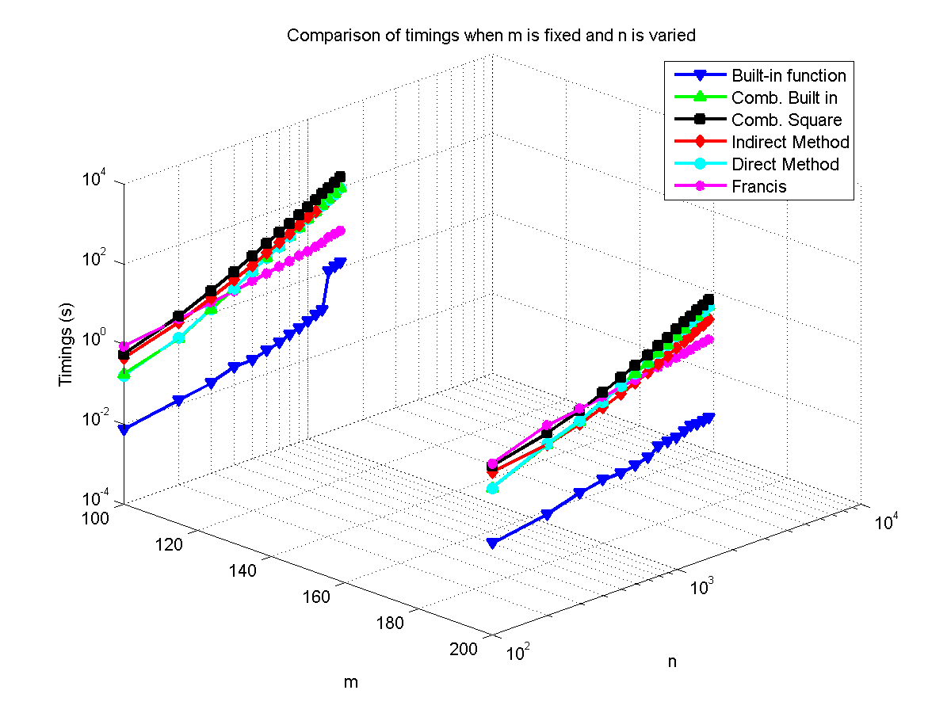

Fig. 3.1. Comparison of timings when m is fixed and n is varied.

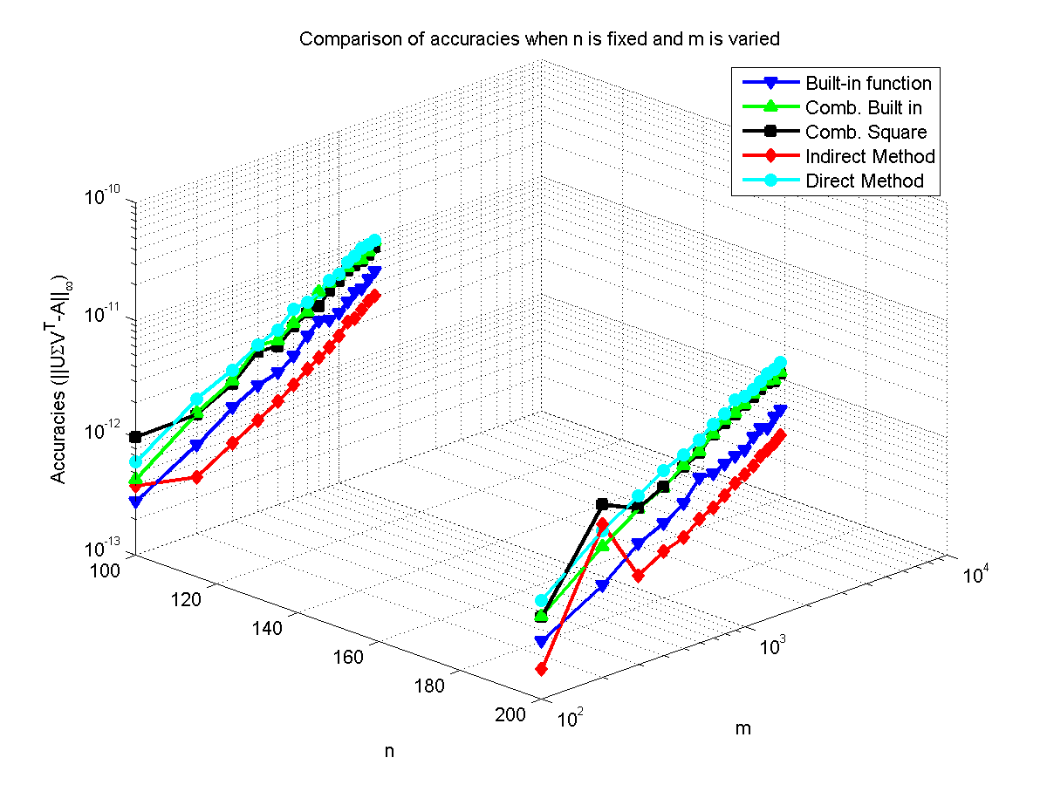Fig. 3.2: Comparison of accuracies when n is fixed and m is varied.

Then we provide the accuracy comparisons in these two cases. Table 3.2 gives the accuracy comparisons when m is fixed and n is varied. Figure 3.2 plots comparison of accuracies when n is fixed and m is varied.

From Table 3.2 and Fig. 3.2, we see that using the methods that we have coded, for both n<m and n>m, indirect method gets the best results, even better than the built-in function. The reason behind this is that the built in svd decomposition of Matlab uses 75 QR step iterations, which cannot be changed, but the indirect method keeps on computing further, so it gives better results. The accuracy loss in direct method is due to precision loss during orthogonalization. The combined methods obtain accuracies which are between those of direct and indirect methods.

As for the orthogonality testing experiments, we tested , ,  and in both cases, i.e., either *n* varied or *m* varied with the other dimension fixed. In Figure 3.3 to Figure 3.6, we give the orthogonality comparisons via different methods. We see the indirect methods get better results than the direct methods. The indirect method achieves better orthogonality than the built-in function and so on due to its increased accuracy over the others.

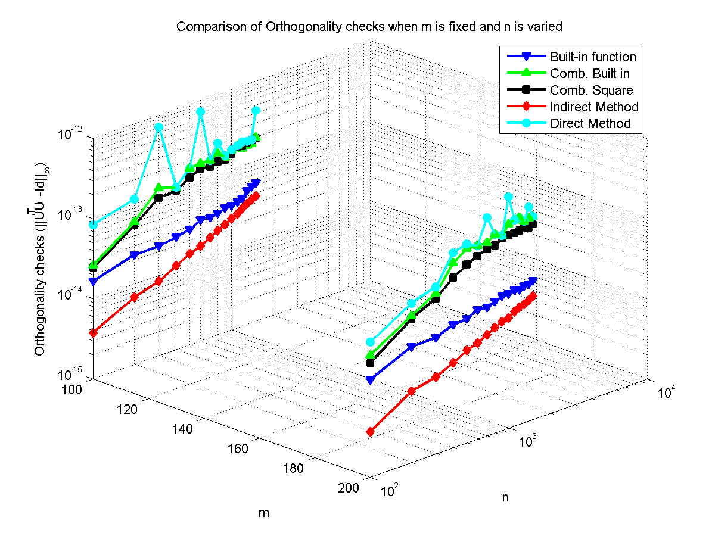

Fig. 3.3: Orthogonality checks  when m is fixed and n is varied.

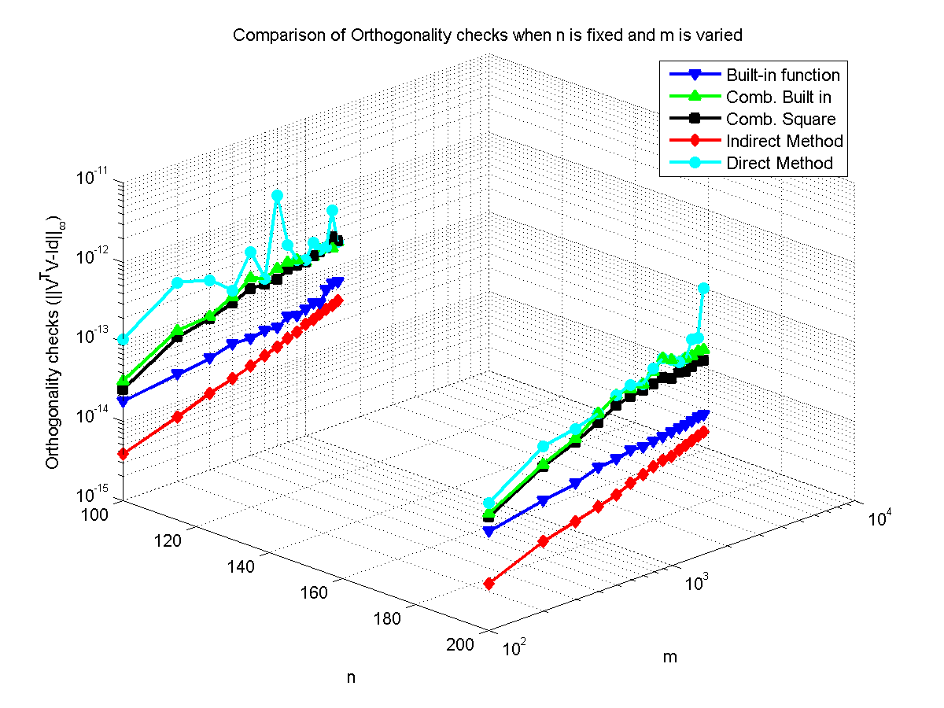

Fig. 3.4: Orthogonality checks when n is fixed and m is varied.

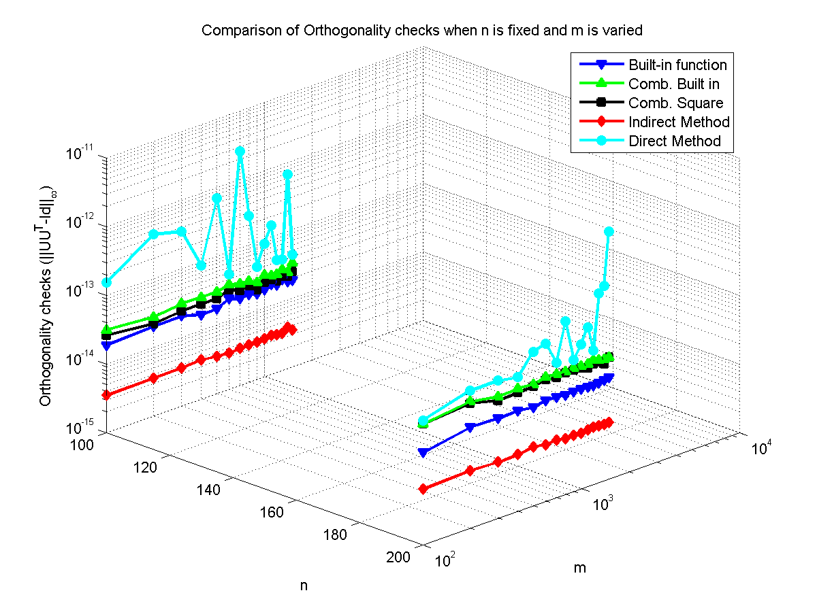

Fig. 3.5: Orthogonality checks  when n is fixed and m is varied.

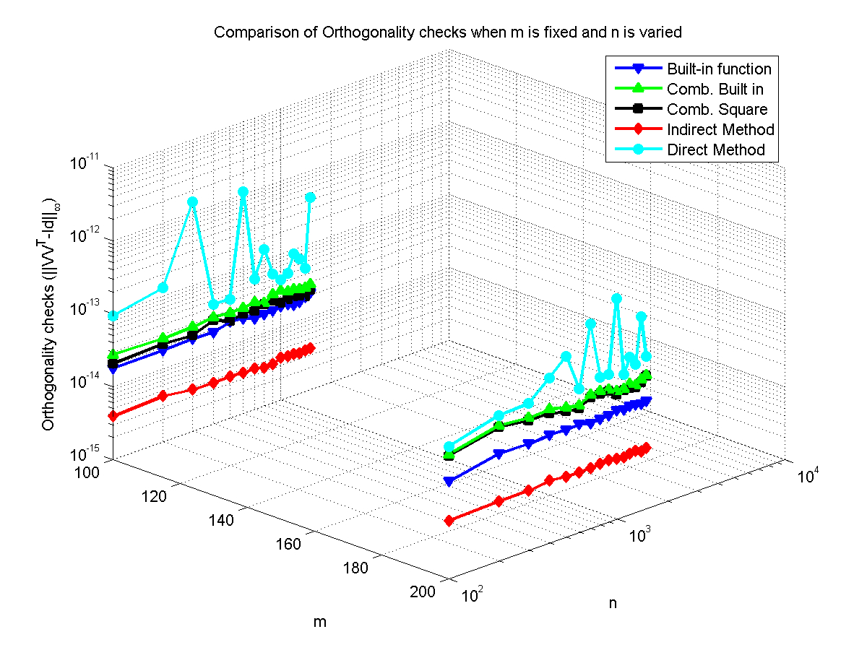

Fig. 3.6: Orthogonality checks  when m is fixed and n is varied.

Table 3.3: errors in singular values when n is fixed and m is varied.

|  |  |  |  |  |  |  |  |
| --- | --- | --- | --- | --- | --- | --- | --- |
| n | M | Built in SVD  (10-13) | Comb. Built in  (10-14) | Comb. Square  (10-12) | Indirect Method  (10-12) | Direct Method  (10-13) | Francis  (10-11) |
| 100 | 100 | 0.0311 | 0.2442 | 0.0151 | 0.0106 | 0.0422 | 0.0142 |
| 200 | 0.0400 | 0.3997 | 0.0972 | 0.0161 | 0.0466 | 0.0266 |
| 300 | 0.0400 | 0.2665 | 0.0211 | 0.0133 | 0.0444 | 0.0341 |
| 400 | 0.0400 | 0.3997 | 0.0213 | 0.0036 | 0.0444 | 0.0263 |
| 500 | 0.0799 | 0.2442 | 0.0522 | 0.0220 | 0.0533 | 0.0380 |
| 600 | 0.0533 | 0.3997 | 0.0110 | 0.0050 | 0.0666 | 0.0369 |
| 700 | 0.0222 | 0.3109 | 0.0174 | 0.0471 | 0.0444 | 0.0220 |
| 800 | 0.0377 | 0.4663 | 0.0135 | 0.0043 | 0.0488 | 0.0547 |
| 900 | 0.0488 | 0.3109 | 0.0096 | 0.0173 | 0.0533 | 0.0469 |
| 1000 | 0.0311 | 0.3109 | 0.1272 | 0.0047 | 0.0711 | 0.0462 |
| 1100 | 0.0311 | 0.3109 | 0.0024 | 0.0053 | 0.0622 | 0.0519 |
| 1200 | 0.0355 | 0.4441 | 0.0046 | 0.0022 | 0.0555 | 0.0490 |
| 1300 | 0.0444 | 0.3997 | 0.0019 | 0.0047 | 0.0666 | 0.0476 |
| 1400 | 0.0355 | 0.3109 | 0.0143 | 0.0077 | 0.0366 | 0.0611 |
| 1500 | 0.0355 | 0.3109 | 0.0050 | 0.0027 | 0.0355 | 0.0426 |
| 200 | 100 | 0.0577 | 0.8882 | 0.0173 | 0.0085 | 0.0400 | 0.0338 |
| 200 | 0.0533 | 0.5329 | 0.0141 | 0.0039 | 0.0600 | 0.0373 |
| 300 | 0.0355 | 0.3553 | 0.1296 | 0.0111 | 0.0799 | 0.0380 |
| 400 | 0.0444 | 0.5773 | 0.1719 | 0.0052 | 0.1332 | 0.0782 |
| 500 | 0.0577 | 0.2665 | 0.0211 | 0.0308 | 0.0777 | 0.0725 |
| 600 | 0.0444 | 0.5773 | 0.0134 | 0.0089 | 0.0688 | 0.1087 |
| 700 | 0.0400 | 0.3109 | 0.0097 | 0.0249 | 0.0933 | 0.0682 |
| 800 | 0.0355 | 0.4885 | 0.0201 | 0.0144 | 0.0644 | 0.1108 |
| 900 | 0.0488 | 0.2665 | 0.0237 | 0.0096 | 0.0666 | 0.0753 |
| 1000 | 0.0355 | 0.4885 | 0.0226 | 0.0061 | 0.1288 | 0.1059 |
| 1100 | 0.0311 | 0.3997 | 0.0231 | 0.0075 | 0.0666 | 0.0817 |
| 1200 | 0.0355 | 0.3997 | 0.0092 | 0.0074 | 0.0600 | 0.1116 |
| 1300 | 0.0444 | 0.5773 | 0.0195 | 0.0098 | 0.1199 | 0.1144 |
| 1400 | 0.1110 | 0.4885 | 0.0073 | 0.0054 | 0.0755 | 0.1307 |
| 1500 | 0.0444 | 0.3553 | 0.0553 | 0.1428 | 0.0933 | 0.0824 |

Table 3.4: Errors in singular values when m is fixed and n is varied.

|  |  |  |  |  |  |  |  |
| --- | --- | --- | --- | --- | --- | --- | --- |
| n | M | Built in SVD  (10-14) | Comb. Built in  (10-14) | Comb. Square  (10-12) | Indirect Method  (10-13) | Direct Method  (10-13) | Francis  (10-11) |
| 100 | 100 | 0.3109 | 0.3553 | 0.0665 | 0.0335 | 0.0488 | 0.0259 |
| 200 | 0.3997 | 0.3997 | 0.0339 | 0.1107 | 0.0600 | 0.0153 |
| 300 | 0.3553 | 0.2665 | 0.0274 | 0.2923 | 0.0488 | 0.0217 |
| 400 | 0.5551 | 0.4885 | 0.0104 | 0.0178 | 0.0488 | 0.0224 |
| 500 | 0.2665 | 0.5329 | 0.0022 | 0.0329 | 0.0600 | 0.0302 |
| 600 | 0.4219 | 0.3775 | 0.0183 | 0.0571 | 0.0600 | 0.0384 |
| 700 | 0.3553 | 0.3775 | 0.0091 | 0.0870 | 0.0666 | 0.0249 |
| 800 | 0.3775 | 0.3553 | 0.0073 | 0.1036 | 0.0444 | 0.0242 |
| 900 | 0.2220 | 0.4885 | 0.0039 | 0.0133 | 0.0622 | 0.0256 |
| 1000 | 0.6217 | 0.2887 | 0.0080 | 0.0720 | 0.0711 | 0.0348 |
| 1100 | 0.5773 | 0.3109 | 0.0048 | 0.0912 | 0.0533 | 0.0490 |
| 1200 | 0.4441 | 0.3109 | 0.0021 | 0.0345 | 0.0577 | 0.0632 |
| 1300 | 0.2220 | 0.3997 | 0.0186 | 0.0576 | 0.0755 | 0.0625 |
| 1400 | 0.3775 | 0.1998 | 0.0074 | 0.0455 | 0.0666 | 0.0298 |
| 1500 | 0.3331 | 0.3553 | 0.0141 | 0.0715 | 0.0444 | 0.0576 |
| 100 | 200 | 0.3553 | 0.3553 | 0.0563 | 0.0414 | 0.0488 | 0.0263 |
| 200 | 0.3997 | 0.2665 | 0.0460 | 0.0444 | 0.0822 | 0.0551 |
| 300 | 0.3997 | 0.3997 | 0.3152 | 0.1192 | 0.0733 | 0.0593 |
| 400 | 0.5773 | 0.3997 | 0.0901 | 0.3312 | 0.0799 | 0.0853 |
| 500 | 0.3997 | 0.5773 | 0.0098 | 0.1518 | 0.1066 | 0.1059 |
| 600 | 0.5773 | 0.3997 | 0.0134 | 0.0570 | 0.0711 | 0.0746 |
| 700 | 0.6661 | 0.3109 | 0.0275 | 0.2344 | 0.0622 | 0.0860 |
| 800 | 0.6217 | 0.6217 | 0.0065 | 0.0749 | 0.0977 | 0.1165 |
| 900 | 0.3997 | 0.4441 | 0.0082 | 0.0926 | 0.0644 | 0.1116 |
| 1000 | 0.3553 | 0.4441 | 0.0272 | 0.1977 | 0.1110 | 0.0938 |
| 1100 | 0.7550 | 0.3997 | 0.0330 | 0.1075 | 0.0622 | 0.1414 |
| 1200 | 0.3997 | 0.5773 | 0.0392 | 0.2010 | 0.0600 | 0.1251 |
| 1300 | 0.3997 | 0.3997 | 0.0293 | 0.0427 | 0.0844 | 0.1023 |
| 1400 | 0.8882 | 0.5773 | 0.0296 | 0.0984 | 0.0711 | 0.0973 |
| 1500 | 0.5107 | 0.3997 | 0.0151 | 0.0906 | 0.0511 | 0.1549 |

From tables 3.3 and 3.4, we see that when n<m all of the methods give comparable results with the combined built-in method marginally the best. The accuracy loss in indirect method is due to the Gram‐Schmidt used to orthogonalize the matrices and precision losses caused by truncation errors during the eigenvector computation. When n>m the Francis algorithm gives the worst results and combined built-in method again gives the best results. All the other methods give comparable results. For both cases the built-in method gives good results.

Then we give the scatter plot of absolute value for error in singular values of a 50 by 100 dense rectangular matrix in Figure 3.7.

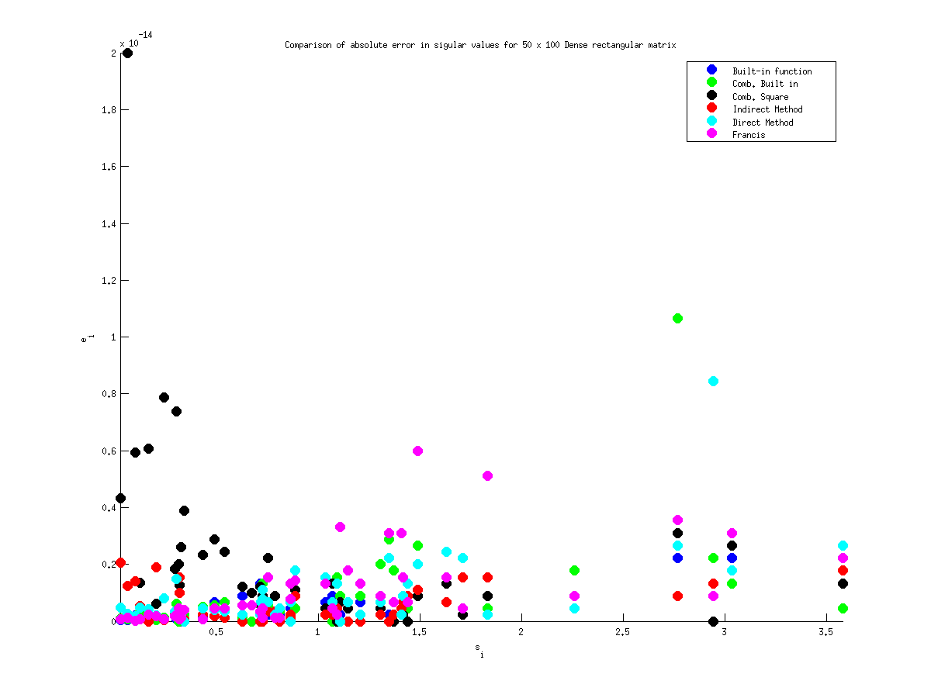

Fig. 3.7: Absolute value of error in singular values for a 50 x 100 dense rectangular matrix.

* 1. **Dense Symmetric Matrix**

We generated different dimensions of square dense symmetric matrices using the formula A+AT. Then the comparisons of timing via different methods are tabulated below.

Table 3.5: Timings.

|  |  |  |  |  |  |  |
| --- | --- | --- | --- | --- | --- | --- |
| n | Built in SVD | Comb. Built in | Comb. Square | Indirect Method | Direct Method | Francis |
| 100 | 0.0084 | 0.2367 | 1.3849 | 1.0093 | 0.2611 | 1.0950 |
| 200 | 0.0357 | 2.6565 | 6.8058 | 4.1679 | 2.9140 | 6.2764 |
| 300 | 0.0974 | 12.9809 | 22.4650 | 9.6180 | 13.6609 | 18.6827 |
| 400 | 0.1996 | 39.6636 | 56.9376 | 17.3091 | 41.9120 | 42.6178 |
| 500 | 0.3593 | 96.3270 | 123.4449 | 28.8710 | 101.4543 | 80.0743 |
| 600 | 0.6735 | 195.2862 | 236.4395 | 42.3036 | 204.3160 | 135.3093 |
| 700 | 1.0766 | 356.9621 | 412.5972 | 58.8551 | 373.1254 | 210.8308 |
| 800 | 1.6276 | 603.0270 | 677.8269 | 80.9572 | 650.2559 | 313.4111 |
| 900 | 2.2761 | 967.6153 | 1065.6365 | 104.0490 | 1004.3078 | 442.3627 |
| 1000 | 3.1573 | 1450.4959 | 1575.3845 | 132.3029 | 1517.4951 | 601.0980 |
| 1100 | 4.2206 | 2116.5901 | 2323. 8312 | 165.5579 | 2205.4484 | 793.6480 |
| 1200 | 5.5353 | 2992.6766 | 3176.0752 | 195.7879 | 3101.1535 | 1024.9213 |
| 1300 | 7.1699 | 4091.1788 | 4308.79466 | 235.7230 | 4240.1016 | 1301.1876 |
| 1400 | 8.9552 | 5518.5362 | 5768.1958 | 284.2645 | 5698.9596 | 1622.8149 |
| 1500 | 11.4804 | 7238.4487 | 7512.5604 | 333.7268 | 7443.6220 | 1988.7083 |

From table 3.5 we see that, the built-in function gives the fastest result. The indirect method is the fastest among our developed methods because it involves fewer computations. The Francis method is slower than the indirect method because it involves bidiagonalization and Givens rotation. The combined methods are slow because they involve bidiagonalization. The direct method involves bidiagonalization and tridiagonalization so it is also not fast.

Table 3.6: Accuracy.

|  |  |  |  |  |  |
| --- | --- | --- | --- | --- | --- |
| N | Built in SVD(10-12) | Comb. Built in(10-14) | Comb. Square(10-13) | Indirect Method(10-12) | Direct Method(10-13) |
| 100 | 0.0381 | 6.5598 | 1.0359 | 0.0757 | 0.8580 |
| 200 | 0.0641 | 13.9198 | 4.3588 | 0.1186 | 1.9017 |
| 300 | 0.0808 | 17.4939 | 7.4608 | 0.2519 | 2.6218 |
| 400 | 0.1001 | 26.3540 | 8.0550 | 0.3714 | 3.5517 |
| 500 | 0.1115 | 31.1084 | 285.8391 | 11.0446 | 4.1857 |
| 600 | 0.1176 | 43.3248 | 26.5554 | 0.6932 | 5.1325 |
| 700 | 0.1517 | 47.4445 | 19.3878 | 0.6158 | 6.0305 |
| 800 | 0.1757 | 49.2307 | 32.0779 | 0.8446 | 6.6398 |
| 900 | 0.1589 | 60.5039 | 291.7658 | 3.6274 | 8.0712 |
| 1000 | 0.1888 | 65.6004 | 218.5062 | 1.4801 | 8.1734 |
| 1100 | 0.2158 | 75.9083 | 101.5951 | 1.2652 | 9.9128 |
| 1200 | 0.2295 | 84.8737 | 89.0598 | 0.8906 | 10.1115 |
| 1300 | 0.2284 | 84.2658 | 129.8546 | 13.6132 | 10.9471 |
| 1400 | 0.2890 | 100.0798 | 935.8007 | 3.6330 | 12.0308 |
| 1500 | 0.3093 | 99.1563 | 194.3723 | 6.3404 | 13.2002 |

From table 3.6 we see that the built-in one, comb. Built-in, Francis and the direct method give comparable results. The combined squaring method is the least accurate one. In Table 3.7, we give the orthogonality checks.

Table 3.7: Orthogonality check.

|  |  |  |  |  |  |  |  |  |  |  |  |  |
| --- | --- | --- | --- | --- | --- | --- | --- | --- | --- | --- | --- | --- |
| n | Built in SVD | | | | Comb. Built in | | | | Comb. Square | | | |
| UUT-I  (10-12) | UTU-I  (10-12) | VVT-I  (10-12) | VTV-I  (10-12) | UUT-I  (10-12) | UTU-I  (10-12) | VVT-I  (10-12) | VTV-I  (10-12) | UUT-I  (10-12) | UTU-I  (10-12) | VVT-I  (10-12) | VTV-I  (10-12) |
| 100 | 0.0204 | 0.0198 | 0.0198 | 0.0202 | 0.0337 | 0.0350 | 0.0312 | 0.0345 | 0.0301 | 0.0310 | 0.0284 | 0.0326 |
| 200 | 0.0329 | 0.0271 | 0.0309 | 0.0294 | 0.0845 | 0.0795 | 0.0682 | 0.0749 | 0.0793 | 0.0765 | 0.0669 | 0.0719 |
| 300 | 0.0424 | 0.0404 | 0.0415 | 0.0414 | 0.1216 | 0.1074 | 0.1167 | 0.1085 | 0.1172 | 0.1038 | 0.1032 | 0.1072 |
| 400 | 0.0534 | 0.0457 | 0.0532 | 0.0460 | 0.1463 | 0.1482 | 0.1350 | 0.1482 | 0.1397 | 0.1456 | 0.1270 | 0.1445 |
| 500 | 0.0614 | 0.0529 | 0.0630 | 0.0535 | 0.1968 | 0.1909 | 0.1842 | 0.1848 | 0.1916 | 0.1860 | 0.1737 | 0.1838 |
| 600 | 0.0749 | 0.0677 | 0.0717 | 0.0638 | 0.2710 | 0.2340 | 0.2416 | 0.2180 | 0.2645 | 0.2321 | 0.2325 | 0.2163 |
| 700 | 0.0803 | 0.0723 | 0.0831 | 0.0832 | 0.2802 | 0.2831 | 0.3003 | 0.2705 | 0.2714 | 0.2832 | 0.2944 | 0.2669 |
| 800 | 0.0945 | 0.0768 | 0.0989 | 0.0827 | 0.2999 | 0.3127 | 0.3825 | 0.3326 | 0.2898 | 0.3112 | 0.3724 | 0.3206 |
| 900 | 0.1049 | 0.0964 | 0.1098 | 0.0963 | 0.3710 | 0.3538 | 0.3228 | 0.3622 | 0.3583 | 0.3484 | 0.3093 | 0.3559 |
| 1000 | 0.1111 | 0.0854 | 0.1084 | 0.0849 | 0.3835 | 0.3987 | 0.4092 | 0.3905 | 0.3724 | 0.3950 | 0.4056 | 0.3842 |
| 1100 | 0.1241 | 0.1014 | 0.1184 | 0.0952 | 0.4936 | 0.4442 | 0.4809 | 0.4345 | 0.4803 | 0.4389 | 0.4667 | 0.4280 |
| 1200 | 0.1345 | 0.0998 | 0.1433 | 0.1041 | 0.4905 | 0.4891 | 0.4833 | 0.4678 | 0.4834 | 0.4786 | 0.4671 | 0.4592 |
| 1300 | 0.1448 | 0.1059 | 0.1463 | 0.1109 | 0.5222 | 0.5108 | 0.5178 | 0.4987 | 0.5139 | 0.5042 | 0.5088 | 0.4912 |
| 1400 | 0.1690 | 0.1219 | 0.1601 | 0.1227 | 0.5308 | 0.5446 | 0.5221 | 0.5436 | 0.5094 | 0.5407 | 0.5094 | 0.5387 |
| 1500 | 0.1752 | 0.1214 | 0.1605 | 0.1247 | 0.5960 | 0.5905 | 0.5866 | 0.5801 | 0.5771 | 0.5825 | 0.5673 | 0.5762 |
| n | Indirect Method | | | | Direct Method | | | |  | | | |
| UUT-I  (10-13) | UTU-I  (10-13) | VVT-I  (10-13) | VTV-I  (10-13) | UUT-I  (10-12) | UTU-I  (10-12) | VVT-I  (10-12) | VTV-I  (10-12) |
| 100 | 0.0368 | 0.0379 | 0.0386 | 0.0400 | 0.2877 | 0.1978 | 0.2878 | 0.1900 |
| 200 | 0.0679 | 0.0799 | 0.0660 | 0.0674 | 0.1169 | 0.1334 | 0.1002 | 0.1149 |
| 300 | 0.0960 | 0.1119 | 0.0893 | 0.0934 | 0.1505 | 0.1811 | 0.1748 | 0.1952 |
| 400 | 0.1271 | 0.1358 | 0.1118 | 0.1163 | 0.2119 | 0.2652 | 0.2343 | 0.2566 |
| 500 | 0.1463 | 0.1726 | 0.1353 | 0.1500 | 29.4924 | 12.4785 | 31.1799 | 12.4597 |
| 600 | 0.1828 | 0.2156 | 0.1568 | 0.1735 | 0.3383 | 0.3438 | 0.3013 | 0.3409 |
| 700 | 0.1987 | 0.2334 | 0.1786 | 0.2058 | 1.2887 | 0.8127 | 1.2705 | 0.7813 |
| 800 | 0.2223 | 0.2721 | 0.1996 | 0.2251 | 0.3844 | 0.4247 | 0.4469 | 0.4281 |
| 900 | 0.2496 | 0.3039 | 0.2217 | 0.2456 | 2.0562 | 1.1971 | 1.9739 | 1.1683 |
| 1000 | 0.2733 | 0.3304 | 0.2423 | 0.2783 | 1.6912 | 1.3070 | 1.6830 | 1.2836 |
| 1100 | 0.2982 | 0.3502 | 0.2705 | 0.2960 | 1.2372 | 1.1390 | 1.4133 | 1.1229 |
| 1200 | 0.3283 | 0.3921 | 0.2872 | 0.3246 | 0.6063 | 0.6759 | 0.5827 | 0.6804 |
| 1300 | 0.3436 | 0.4173 | 0.3203 | 0.3519 | 1.0000 | 0.9620 | 1.0636 | 0.9434 |
| 1400 | 0.3618 | 0.4543 | 0.3333 | 0.3692 | 1.1033 | 1.1004 | 1.1794 | 0.9989 |
| 1500 | 0.3850 | 0.4783 | 0.3620 | 0.3907 | 0.7007 | 0.7327 | 0.7262 | 0.7487 |

Table 3.8 lists the errors in singular values using different methods. We see that the indirect method, combined built-in and squaring, Francis and the direct methods give comparable results.

Table 3.8: Error in singular values

|  |  |  |  |  |  |
| --- | --- | --- | --- | --- | --- |
| n | Comb. Built in (10-12) | Comb. Square(10-11) | Indirect Method(10-11) | Direct Method(10-11) | Francis(10-12) |
| 100 | 0.0391 | 0.0421 | 0.0046 | 0.0121 | 0.1315 |
| 200 | 0.0711 | 0.3000 | 0.0113 | 0.0256 | 0.7816 |
| 300 | 0.0639 | 0.4399 | 0.1118 | 0.0242 | 1.3571 |
| 400 | 0.0924 | 250.2830 | 180.1202 | 0.0341 | 2.1174 |
| 500 | 0.0995 | 5.2806 | 0.5130 | 0.0448 | 2.6148 |
| 600 | 0.0995 | 61.9305 | 4.6881 | 0.0625 | 3.1406 |
| 700 | 0.1563 | 2.7922 | 0.6248 | 0.0497 | 4.5901 |
| 800 | 0.1421 | 2.2875 | 0.6112 | 0.0767 | 8.2707 |
| 900 | 0.1066 | 12.6837 | 8.1206 | 0.0952 | 5.5422 |
| 1000 | 0.1208 | 2.7780 | 1.4873 | 0.0867 | 9.5497 |
| 1100 | 0.0995 | 5.1229 | 1.7121 | 0.1293 | 10.8002 |
| 1200 | 0.2416 | 41.3298 | 6.9733 | 0.0995 | 11.4824 |
| 1300 | 0.1563 | 10.8642 | 0.7514 | 0.1251 | 12.6761 |
| 1400 | 0.1847 | 22.6280 | 29.1753 | 0.1251 | 12.3208 |
| 1500 | 0.2274 | 3.4415 | 1.8547 | 0.1137 | 21.0036 |

* 1. **Sparse Symmetric matrix**

For completeness sake we test some of the methods on some randomly generated sparse matrices. We tested for three different cases of sparse matrices where the percentages of non-zero elements are 10%, 15% and 20% respectively. The sparsely generated matrices were converted to full matrices as our coded methods cannot operate on sparse matrices. Also, the built-in function for sparse matrix will only give the six biggest singular values for sparse matrices. As expected there is a drastic drop in performance when our tested methods are applied on sparse matrices.

From Fig. 3.8 we see that for all cases the built in method gives better results. The timings of direct and indirect method are comparable. As the matrices become denser via the increase of non-zero elements, the methods become faster.

Table 3.9 shows that the built-in method has the best accuracy. The direct and indirect methods get comparable accuracy. Table 3.10 shows the orthogonality check. Table 3.11 gives the error in singular values. During the computing of singular value errors, we find that the errors for smaller singular values are more obvious than those for the larger singular values. The built-in function gives better results than the other two. The direct method gives the lowest accurate results.

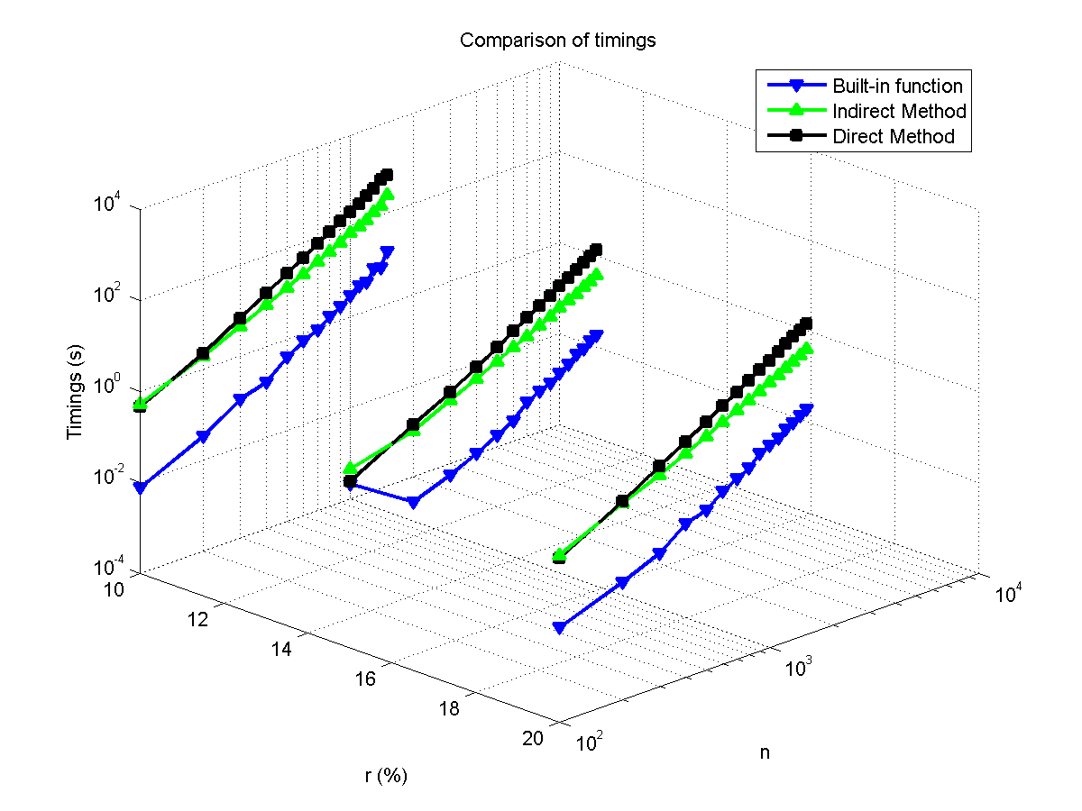

Fig. 3.8: Comparison of timings.

Table 3.9: Accuracies

|  |  |  |  |  |  |  |  |  |  |
| --- | --- | --- | --- | --- | --- | --- | --- | --- | --- |
| r (%) | m | Built in (10-11) | Indirect (10-8) | Direct (10-10) | r(%) | m | Built in(10-11) | Indirect (10-8) | Direct (10-10) |
| 10 | 100 | 0.0083 | 0.0001 | 0.0025 | 20 | 100 | 0.0135 | 0.0000 | 0.0051 |
| 200 | 0.0253 | 0.0002 | 0.0123 | 200 | 0.0252 | 0.0222 | 0.0164 |
| 300 | 0.0285 | 0.0001 | 0.0213 | 300 | 0.0427 | 0.0002 | 0.0292 |
| 400 | 0.0401 | 0.0004 | 0.0537 | 400 | 0.0521 | 0.0019 | 0.0612 |
| 500 | 0.0483 | 0.0003 | 0.0581 | 500 | 0.0793 | 0.0042 | 0.0522 |
| 600 | 0.0597 | 0.0019 | 0.0860 | 600 | 0.0848 | 0.0020 | 0.1396 |
| 700 | 0.0713 | 0.0012 | 0.0930 | 700 | 0.1038 | 0.0040 | 0.1485 |
| 800 | 0.0917 | 0.0049 | 0.1161 | 800 | 0.1230 | 0.0059 | 0.1764 |
| 900 | 0.1056 | 0.0021 | 0.1739 | 900 | 0.1342 | 0.0099 | 0.2245 |
| 1000 | 0.1066 | 0.0017 | 0.2143 | 1000 | 0.1626 | 0.0017 | 0.2595 |
| 1100 | 0.1253 | 0.0018 | 0.2691 | 1100 | 0.1736 | 0.0020 | 0.3194 |
| 1200 | 0.1386 | 0.0025 | 0.2956 | 1200 | 0.2046 | 0.0055 | 0.3127 |
| 1300 | 0.1564 | 0.3657 | 0.2932 | 1300 | 0.2263 | 0.0094 | 0.3824 |
| 1400 | 0.1782 | 0.0027 | 0.3414 | 1400 | 0.2436 | 0.0029 | 0.4027 |
| 1500 | 0.1920 | 0.0037 | 0.3150 | 1500 | 0.2730 | 0.0032 | 0.5615 |
| 15 | 100 | 0.0113 | 0.0000 | 0.0034 |  | | | | |
| 200 | 0.0222 | 0.0002 | 0.0138 |
| 300 | 0.0430 | 0.0003 | 0.0291 |
| 400 | 0.0464 | 0.0001 | 0.0498 |
| 500 | 0.0585 | 0.0004 | 0.0671 |
| 600 | 0.0720 | 0.0004 | 0.0854 |
| 700 | 0.0972 | 0.0017 | 0.1301 |
| 800 | 0.1039 | 0.0007 | 0.1617 |
| 900 | 0.1224 | 0.0027 | 0.1682 |
| 1000 | 0.1296 | 0.0021 | 0.2237 |
| 1100 | 0. 1536 | 0.0015 | 0.2657 |
| 1200 | 0.1717 | 0.0017 | 0.2902 |
| 1300 | 0.1917 | 0.0019 | 0.3581 |
| 1400 | 0.2190 | 0.0165 | 0.4453 |
| 1500 | 0.2406 | 0.0105 | 0.4579 |

Table 3.10: Orthogonality checks

|  |  |  |  |  |  |  |  |  |  |  |  |  |  |
| --- | --- | --- | --- | --- | --- | --- | --- | --- | --- | --- | --- | --- | --- |
| r  (%) | m | Built in SVD | | | | Indirect Method | | | | Direct Method | | | |
| UUT-I  (10-12) | UTU-I  (10-12) | VVT-I  (10-12) | VTV-I  (10-12) | UUT-I  (10-13) | UTU-I  (10-13) | VVT-I  (10-13) | VTV-I  (10-13) | UUT-I  (10-13) | UTU-I  (10-13) | VVT-I  (10-11) | VTV-I  (10-12) |
| 10 | 100 | 0.0191 | 0.0202 | 0.0177 | 0.0181 | 0.0363 | 0.0389 | 0.0336 | 0.0342 | 0.0833 | 0.0773 | 0.0045 | 0.0257 |
| 200 | 0.0298 | 0.0268 | 0.0279 | 0.0259 | 0.0645 | 0.0734 | 0.0701 | 0.0723 | 0.1449 | 0.1341 | 0.0155 | 0.0609 |
| 300 | 0.0360 | 0.0339 | 0.0370 | 0.0388 | 0.0952 | 0.1023 | 0.0846 | 0.0856 | 0.1756 | 0.1719 | 0.0231 | 0.0915 |
| 400 | 0.0475 | 0.0471 | 0.0498 | 0.0473 | 0.1211 | 0.1328 | 0.1090 | 0.1148 | 0.2237 | 0.2033 | 0.0335 | 0.1228 |
| 500 | 0.0540 | 0.0548 | 0.0557 | 0.0558 | 0.1492 | 0.1721 | 0.1318 | 0.1465 | 0.2490 | 0.2434 | 0.0458 | 0.1816 |
| 600 | 0.0631 | 0.0555 | 0.0640 | 0.0584 | 0.1788 | 0.2192 | 0.1601 | 0.1692 | 0.3049 | 0.2877 | 0.0603 | 0.1892 |
| 700 | 0.0724 | 0.0631 | 0.0736 | 0.0637 | 0.1990 | 0.2344 | 0.1831 | 0.1905 | 0.3117 | 0.3138 | 0.0553 | 0.2098 |
| 800 | 0.0795 | 0.0693 | 0.0840 | 0.0685 | 0.2234 | 0.2608 | 0.2041 | 0.2209 | 0.3522 | 0.3374 | 0.0844 | 0.2590 |
| 900 | 0.0869 | 0.0777 | 0.0896 | 0.0773 | 0.2451 | 0.2947 | 0.2284 | 0.2428 | 0.3888 | 0.3650 | 0.0767 | 0.2680 |
| 1000 | 0.0975 | 0.0858 | 0.1000 | 0.0900 | 0.2880 | 0.3337 | 0.2480 | 0.2701 | 0.4625 | 0.4003 | 0.0999 | 0.3280 |
| 1100 | 0.1023 | 0.0843 | 0.1054 | 0.0862 | 0.2947 | 0.3682 | 0.2666 | 0.2917 | 0.4816 | 0.4276 | 0.1348 | 0.3897 |
| 1200 | 0.1110 | 0.0902 | 0.1148 | 0.0933 | 0.3599 | 0.3984 | 0.2892 | 0.3177 | 0.4531 | 0.4651 | 0.1406 | 0.4091 |
| 1300 | 0.1190 | 0.0937 | 0.1232 | 0.0982 | 0.3553 | 0.4143 | 0.3102 | 0.3460 | 0.5374 | 0.5161 | 0.1572 | 0.4149 |
| 1400 | 0.1327 | 0.1112 | 0.1431 | 0.1106 | 0.3782 | 0.4575 | 0.3311 | 0.3637 | 0.3117 | 0.5295 | 0.1434 | 0.4790 |
| 1500 | 0.1342 | 0.1124 | 0.1328 | 0.1115 | 0.4002 | 0.4793 | 0.3489 | 0.3874 | 0.3522 | 0.5480 | 0.1380 | 0.4730 |
| 15 | 100 | 0.0204 | 0.0169 | 0.0177 | 0.0179 | 0.0381 | 0.0370 | 0.0347 | 0.0315 | 0.0763 | 0.0737 | 0.0045 | 0.0303 |
| 200 | 0.0272 | 0.0261 | 0.0283 | 0.0265 | 0.0665 | 0.0699 | 0.0677 | 0.0690 | 0.1364 | 0.1407 | 0.0132 | 0.0655 |
| 300 | 0.0374 | 0.0370 | 0.0381 | 0.0367 | 0.0998 | 0.1049 | 0.0865 | 0.0960 | 0.1838 | 0.1772 | 0.0215 | 0.0941 |
| 400 | 0.0472 | 0.0436 | 0.0467 | 0.0434 | 0.1248 | 0.1380 | 0.1106 | 0.1182 | 0.2117 | 0.2163 | 0.0278 | 0.1232 |
| 500 | 0.0583 | 0.0510 | 0.0565 | 0.0492 | 0.1464 | 0.1681 | 0.1390 | 0.1535 | 0.2720 | 0.2408 | 0.0293 | 0.1470 |
| 600 | 0.0644 | 0.0549 | 0.0655 | 0.0562 | 0.1736 | 0.2046 | 0.1566 | 0.1779 | 0.2904 | 0.2906 | 0.0464 | 0.1797 |
| 700 | 0.0739 | 0.0658 | 0.0761 | 0.0668 | 0.2159 | 0.2643 | 0.1836 | 0.1926 | 0.3290 | 0.3125 | 0.0693 | 0.2303 |
| 800 | 0.0811 | 0.0696 | 0.0814 | 0.0715 | 0.2240 | 0.2714 | 0.2052 | 0.2200 | 0.3507 | 0.3424 | 0.0754 | 0.2618 |
| 900 | 0.0899 | 0.0770 | 0.0888 | 0.0785 | 0.2482 | 0.3004 | 0.2259 | 0.2461 | 0.4144 | 0.3773 | 0.0786 | 0.3139 |
| 1000 | 0.0921 | 0.0959 | 0.0953 | 0.0926 | 0.2752 | 0.3365 | 0.2457 | 0.2697 | 0.4272 | 0.4398 | 0.0941 | 0.3304 |
| 1100 | 0.1031 | 0.0840 | 0.1065 | 0.0867 | 0.2992 | 0.3593 | 0.2642 | 0.2885 | 0.4436 | 0.4171 | 0.1107 | 0.3705 |
| 1200 | 0.1107 | 0.0891 | 0.1132 | 0.0952 | 0.3285 | 0.3998 | 0.2879 | 0.3180 | 0.4773 | 0.4327 | 0.1006 | 0.3914 |
| 1300 | 0.1215 | 0.0961 | 0.1212 | 0.1040 | 0.3428 | 0.4085 | 0.3043 | 0.3405 | 0.5173 | 0.5083 | 0.1353 | 0.4640 |
| 1400 | 0.1294 | 0.1053 | 0.1287 | 0.1066 | 0.3737 | 0.4606 | 0.3280 | 0.3665 | 0.5517 | 0.5274 | 0.1552 | 0.4412 |
| 1500 | 0.1364 | 0.1106 | 0.1448 | 0.1131 | 0.3930 | 0.4909 | 0.3460 | 0.3985 | 0.6033 | 0.5628 | 0.1622 | 0.4875 |
| 20 | 100 | 0.0200 | 0.0182 | 0.0205 | 0.0208 | 0.0325 | 0.0364 | 0.0376 | 0.0383 | 0.0738 | 0.0731 | 0.0072 | 0.0313 |
| 200 | 0.0297 | 0.0274 | 0.0293 | 0.0272 | 0.0657 | 0.0742 | 0.0673 | 0.0775 | 0.1245 | 0.1295 | 0.0128 | 0.0594 |
| 300 | 0.0377 | 0.0357 | 0.0372 | 0.0370 | 0.0906 | 0.1048 | 0.0866 | 0.0931 | 0.1648 | 0.1752 | 0.0173 | 0.0864 |
| 400 | 0.0462 | 0.0405 | 0.0456 | 0.0439 | 0.1186 | 0.1447 | 0.1152 | 0.1218 | 0.2024 | 0.2054 | 0.0295 | 0.1265 |
| 500 | 0.0523 | 0.0528 | 0.0553 | 0.0590 | 0.1469 | 0.1682 | 0.1357 | 0.1433 | 0.2500 | 0.2385 | 0.0289 | 0.1437 |
| 600 | 0.0643 | 0.0606 | 0.0640 | 0.0626 | 0.1749 | 0.2006 | 0.1582 | 0.1719 | 0.2924 | 0.3091 | 0.0569 | 0.2124 |
| 700 | 0.0724 | 0.0612 | 0.0722 | 0.0625 | 0.1990 | 0.2412 | 0.1777 | 0.1990 | 0.3376 | 0.3172 | 0.0626 | 0.2316 |
| 800 | 0.0810 | 0.0711 | 0.0820 | 0.0742 | 0.2455 | 0.3070 | 0.2043 | 0.2213 | 0.3797 | 0.3396 | 0.0638 | 0.2549 |
| 900 | 0.0861 | 0.0799 | 0.0868 | 0.0790 | 0.2454 | 0.3123 | 0.2195 | 0.2452 | 0.3995 | 0.3728 | 0.0823 | 0.3110 |
| 1000 | 0.0938 | 0.0815 | 0.0977 | 0.0859 | 0.2734 | 0.3351 | 0.2463 | 0.2731 | 0.4117 | 0.3980 | 0.1029 | 0.3148 |
| 1100 | 0.1019 | 0.0889 | 0.1047 | 0.0927 | 0.2899 | 0.3632 | 0.2645 | 0.2959 | 0.4815 | 0.4376 | 0.0952 | 0.3655 |
| 1200 | 0.1132 | 0.0929 | 0.1181 | 0.0946 | 0.3210 | 0.4137 | 0.2890 | 0.3139 | 0.5188 | 0.4399 | 0.1126 | 0.4022 |
| 1300 | 0.1210 | 0.0976 | 0.1275 | 0.1022 | 0.3426 | 0.4166 | 0.3116 | 0.3393 | 0.5374 | 0.4963 | 0.1353 | 0.4343 |
| 1400 | 0.1263 | 0.1024 | 0.1294 | 0.1032 | 0.3671 | 0.4591 | 0.3243 | 0.3629 | 0.5517 | 0.5210 | 0.1552 | 0.4710 |
| 1500 | 0.1385 | 0.1049 | 0.1411 | 0.1118 | 0.3966 | 0.4805 | 0.3497 | 0.3916 | 0.5877 | 0.5569 | 0.1622 | 0.5375 |

Table 3.11: Error in singular values

|  |  |  |  |  |  |  |  |
| --- | --- | --- | --- | --- | --- | --- | --- |
| r (%) | m | Indirect Method (10-11) | Direct Method(10-11) | r (%) | m | Indirect Method(10-11) | Direct Method (10-11) |
| 10 | 100 | 0.0395 | 0.0045 | 20 | 100 | 0.0081 | 0.0082 |
| 200 | 0.0763 | 0.0181 | 200 | 10.1266 | 0.0242 |
| 300 | 0.0140 | 0.0306 | 300 | 0.0858 | 0.0485 |
| 400 | 0.1739 | 0.0444 | 400 | 0.6645 | 0.0799 |
| 500 | 0.0925 | 0.0723 | 500 | 1.7377 | 0.0700 |
| 600 | 0.3237 | 0.0885 | 600 | 0.8445 | 0.1652 |
| 700 | 0.4709 | 0.1030 | 700 | 1.1565 | 0.1513 |
| 800 | 1.4763 | 0.1766 | 800 | 1.9781 | 0.2043 |
| 900 | 0.3357 | 0.1521 | 900 | 3.4608 | 0.2427 |
| 1000 | 0.3953 | 0.1869 | 1000 | 0.5732 | 0.2874 |
| 1100 | 0.4629 | 0.2633 | 1100 | 0.4637 | 0.3705 |
| 1200 | 0.8129 | 0.2530 | 1200 | 2.0077 | 0.4214 |
| 1300 | 126.5751 | 0.2782 | 1300 | 2.1540 | 0.3858 |
| 1400 | 0.6724 | 0.3798 | 1400 | 0.6398 | 0.4725 |
| 1500 | 1.2641 | 0.2913 | 1500 | 0.6488 | 0.6629 |
| 15 | 100 | 0.0031 | 0.0094 |
| 200 | 0.0743 | 0.0220 |
| 300 | 0.1113 | 0.0352 |
| 400 | 0.0082 | 0.0538 |
| 500 | 0.0945 | 0.0689 |
| 600 | 0.1448 | 0.1023 |
| 700 | 0.2592 | 0.1286 |
| 800 | 0.2002 | 0.1485 |
| 900 | 0.6687 | 0.2320 |
| 1000 | 0.4829 | 0.2160 |
| 1100 | 0.2563 | 0.2959 |
| 1200 | 0.1536 | 0.3084 |
| 1300 | 0.4854 | 0.3691 |
| 1400 | 6.3058 | 0.3606 |
| 1500 | 3.1438 | 0.5226 |

# REFERENCES

[1] P. Deift, J. Demmel, C. Li and C. Tomei. The bidiagonal singular value decomposition and Hamiltonian mechanics. SIAM J. Numer. Anal., v. 18, n. 5, pp. 1463-1516, 1991.

[2] D. Watkins. Fundamentals of matrix computations. Third Edition. Wiley, 2010.

[3] V. Klema, A. Laub. The singular value decomposition: its computation and some applications. IEEE Trans. Auto. Cont., v. AC-25, n. 2, pp. 164-176, 1980.

[4] G. Golub, W. Kahan. Calculating the singular values and pseudo-inverse of a matrix. J. SIAM. Numer. Anal. Ser. B, v. 2, n. 2, pp. 205-224, 1965.

[5] M. Gu, S. Eisenstat. A divide-and-conquer algorithm for the bidiagonal SVD. SIAM J. Matrix Anal. Appl., v. 16, n. 1, pp. 79-92, 1995.

[6] J. Demmel, W. KahanAccurate. Singular Values of Bidiagonal Matrices. SIAM J. Sci. Stat. Comput., v. 11, n. 5, pp. 873-912, 1990.