Response letter
Dear Editor and Reviewers,
We are grateful for the comments and suggestions from the editors and the reviewers, which are crucial for improving our work. We have revised the manuscript to address the reviewers’ comments fully. Our point-by-point reply to the review comments is summarized below. In this document, the original reviewers’ comments are in black; our responses are in blue; the quotations in the revised manuscript are in red.

Reviewers’ comments:
Very traditional method was proposed for coronary artery labeling. There are more advanced methods using deep learning proposed for this application. Authors are recommended to get ideas from those deep learning methods.
A: Thank you for your comments. There seems to be some confusion regarding the method presented in this paper. The approach employed a hyper-graph graph matching-based method for coronary artery semantic labeling. It incorporated modules such as hypergraph convolution network, graph attention network, and true class probability-based uncertainty quantification, all of which were based on deep learning principles. In the implementation details, we specified that the proposed model was developed using TensorFlow 2.5, a widely recognized deep learning library. The workflow of the proposed model is shown in Figure 1.
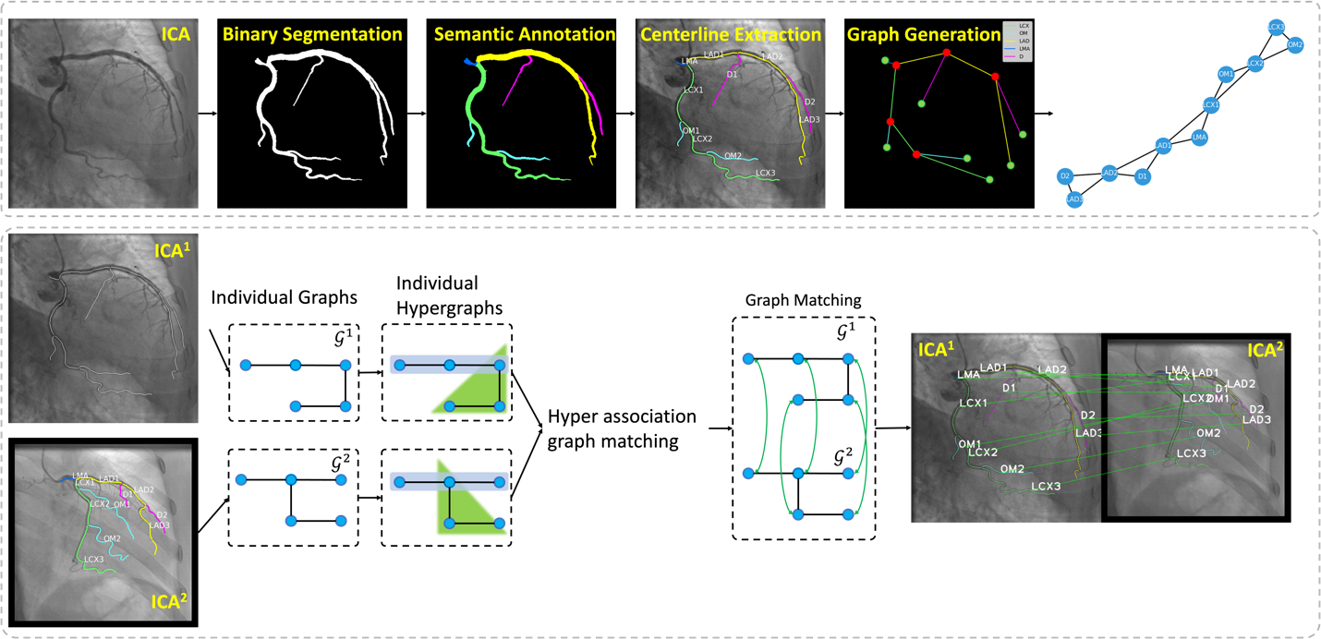
Figure 1. Workflow of HAGMN-UQ for coronary artery semantic labeling. Top: Coronary artery binary segmentation, semantic labeling and graph generation. The binary mask is generated by feature pyramid U-Net++ [1] and the semantic masks are manually annotated and confirmed by experienced interventional cardiologists. Then, the centerlines and key points are extracted, and the individual graphs are generated for graph matching. Bottom: Graph matching for coronary artery semantic labeling using HAGMN-UQ. ICA¹ represents an unlabeled coronary angiogram and ICA² indicates a labeled coronary angiogram. Using the generated graphs and the trained HAGMN-UQ, the arterial segments in ICA¹ are labeled by ICA² and the correspondence between arteries.
According to Figure 1, we utilized the feature pyramid U-Net++ for image segmentation, incorporating deep convolutional neural networks. Furthermore, the hyper-association graph matching process involved graph matching utilizing hypergraph convolution, integrated with deep learning techniques.
In addition, in the experimental section, we compared the proposed HAGMN-UQ with the existing deep learning-based methods, including:
- BiTreeLSTM [2]: The bidirectional tree LSTM (BiTreeLSTM) is initially applied for coronary artery semantic labeling using CCTA. We adopted the same network architecture but extracted the spatial locations and directions of coronary arteries in 2D.
- IPCA [3]: Iterative Permutation Cross-graph Affinity (IPCA) is designed for graph matching by comparing node features between individual graphs iteratively with cross-graph feature embedding.
- NGM [4]: The neural graph matching network (NGM) employs the association graph-induced affinity matrix for graph matching. In our HAGMN-UQ, the connectivity of the hyper association is generated by the connectivity of the individual hypergraphs; however, NGM adopted the Koopmans-Beckmann’s quadratic assignment problem for affinity learning to calculate the assignment matrix using traditional association graphs.
- AGMN [5]: The association graph-based graph matching network (AGMN) is developed for coronary artery semantic labeling based on association graphs using ICAs. Different from the proposed HAGMN-UQ, AGMN employs the traditional graph without hyperedges for graph matching.
- EAGMN [6]: The edge attention graph-based graph matching network (EAGMN) is an extension of AGMN by adding the edge attention mechanism. EAGMN adds an edge attention module during the graph matching for feature representation learning, while the proposed HAGMN-UQ employs both vertex attention module and edge attention module for graph matching.
The experimental results indicate that the proposed HAGMN-UQ achieved the highest performance, as shown in Table 4 in the revised manuscript.
Furthermore, we have open-sourced our code, along with a running example, which is available at https://github.com/MIILab-MTU/HAGMN-UQ. Within our Github repository, we have included two ICA-generated graphs and the trained model weights. Utilizing these graphs, we constructed the hyper-association graph and employed our proposed HAGMN-UQ with the trained weights to perform graph matching. For visualization of the results, we have provided corresponding functions to generate the graph matching results, where green lines indicate correct matches and red lines represent errors.
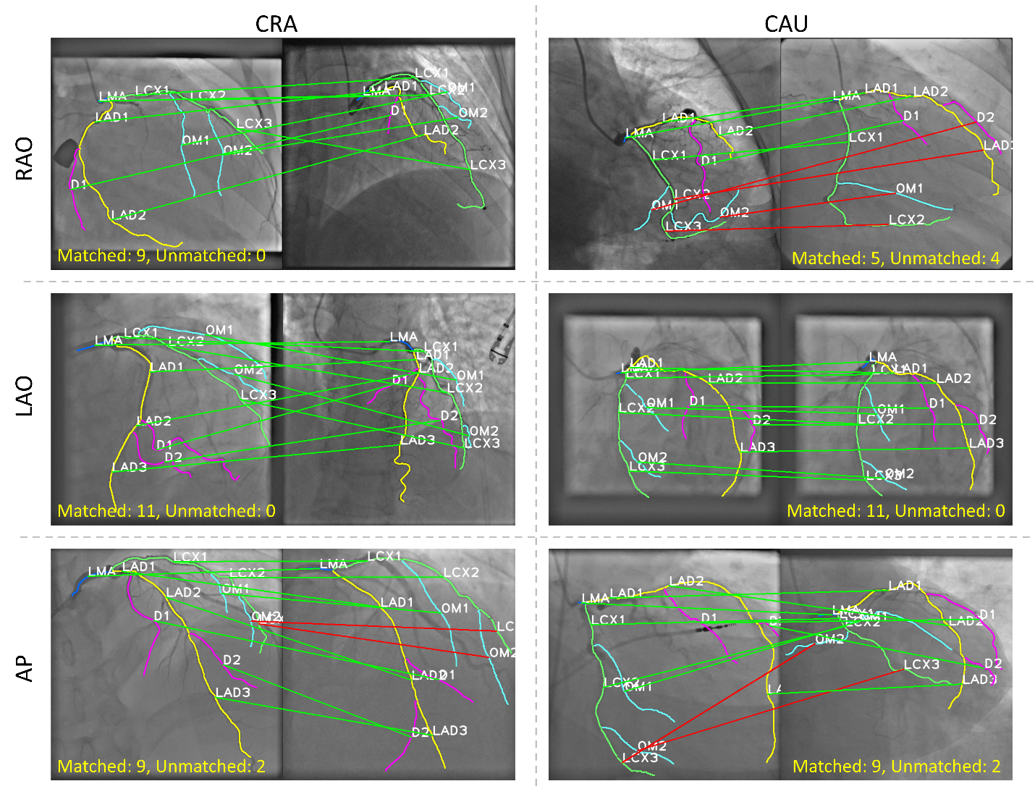
Figure 3. Graph matching results of 6 ICA images from different view angles. Correspondence between coronary arteries from ICA images from the testing set (left) and from the template set (right). The green connection line indicates a correct match, while the red line represents a wrong match.

Reviewer #1:
1. Since the graph generation procedure requires the manual pixel-level semantic segmentation annotation made by experienced interventional cardiologists, the method is not fully automatic. I wonder why cannot the interventional cardiologists also label the coronary artery segments as well. Is it challenging for them to do this? Therefore, I do not quite understand the significance of this work.
A: Thanks for your comments. In conclusion, using the developed algorithm, the pixel wise manual annotation for each segment is no longer required.
To build the training set and template set, the binary labels, which represent the foreground arterial pixel and the background pixels are generated by pre-trained FP-UNet++. Then, the centerline of the vascular tree is extracted automatically using the edge-linking algorithm. According to the centerline, the key points were detected, including the bifurcation points and the end points. The bifurcation points separate the entire centerline into sub centerline segments and the end points represent the end of the arterial segment. We only need to assign the categorial label for the centerline rather than the pixel level label for the vascular segment, because the mapping between separated centerline and the corresponding arterial pixel segment is derived automatically. Thus, the interventional cardiologists don’t need to manually draw the pixel-level label for the arterial segment, and they only need to assign the categorial label to the arterial centerline, so that the annotation burden is significant relieved, and the proposed algorithm is significant for automatically labeling the arteries for downstream analysis. Furthermore, we add the description of the arterial annotation process and graph generation process to the revised manuscript.
In addition, we developed a software based on LabelMe (https://github.com/labelmeai/labelme). Users only need to manually adjust minor arteries and adjust the threshold to generate the ICA graphs. For each generated centerline segment, there is a drop-down menu that users can use to select the type of arterial segment, rather than drawing pixel-level labels for the arterial segments.
(Supplementary materials. Section 3. The developed software for ICA data pre-processing)
We developed a software based on LabelMe (https://github.com/labelmeai/labelme). Users only need to manually adjust arteries with a minor operation and adjust the threshold to generate the ICA graphs. For each generated centerline segment, there is a drop-down menu that users can use to select the type of arterial segment, rather than drawing pixel-level labels for the arterial segments.

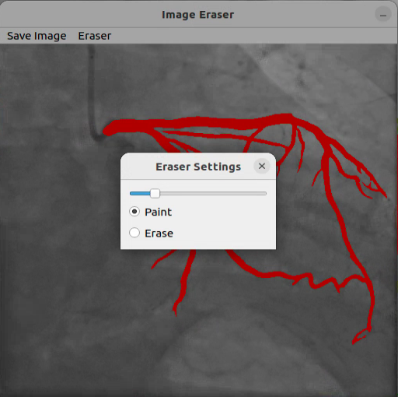
Figure S2. GUI for LabelMe-based coronary artery contour annotation tool.
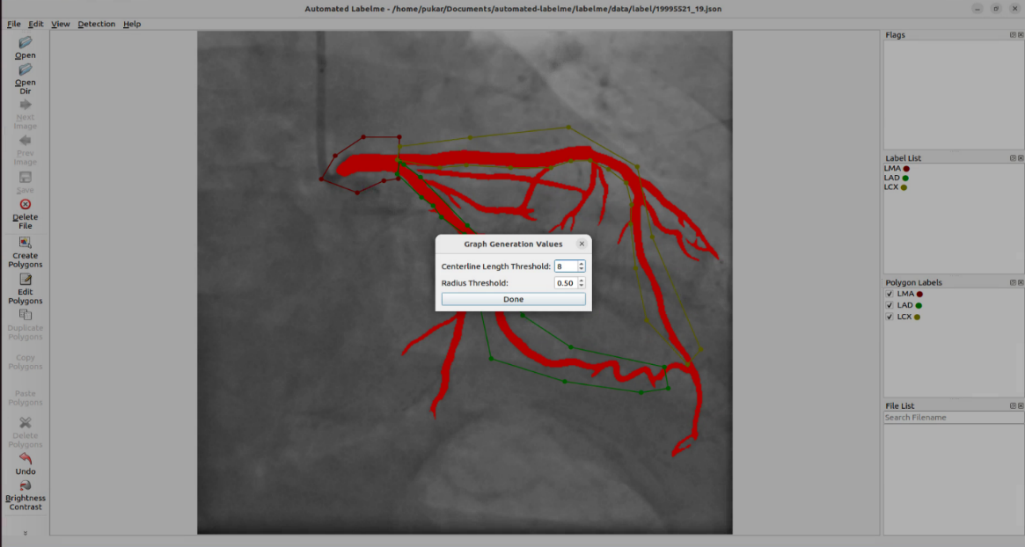
Figure S3. GUI for LabelMe-based coronary artery contour annotation tool for ICA-graph generation.

We also provided a workflow for coronary artery semantic labeling using the trained deep learning models and illustrate the required human intervention in the supplementary materials.
(Supplementary materials. Section 5. Human intervention for ICA semantic labeling)
In Figure S4, we provided the workflow for coronary artery semantic labeling using the proposed method.
(a) This figure shows the selected ICA frame, which is resized to 512x512.
(b) The binary segmentation result using our FP-U-Net++ with human intervention using our developed software based on LabelMe.
(c) The generated coronary artery skeleton using steps 1 to 5 in Supplementary materials, Section 4: ICA-graph generation.
(d) Generated key points using an edge-linking algorithm, where the red stars indicate the bifurcation points and green plus signs indicate end points.
(e) According to the key points and arterial connectivity, we then switch the nodes and edges, and generate the ICA individual graph. Each blue circle indicates an arterial segment, and the black solid lines indicate the key points which preserve the arterial connectivity.
(f) Graph matching results. We apply the trained HAGMN-UQ to the presented test ICA-generated graph and the template graphs in our dataset, and each arterial segment (node in the individual graph) is assigned with the corresponding categories according to the artery-to-artery mapping.
(g) Visualization of the arterial segmentation centerline classification.
(h) We create the mapping between the arterial centerline and the binary mask of the arterial segments. In detail, for each pixel within the arterial centerline, we calculate the perpendicular line and expand the perpendicular line from the arterial centra pixel to the boundaries to find the corresponding pixels which belong to the binary mask.
(i) According to the mapping between the centerline of the arterial segment and the arterial mask, and the category of the arterial segment, we assign categorical labels for each pixel belonging to the centerline, so that the semantic segmentation is achieved.
Overall, the only required human intervention is in step (b), where manual modification of the binary mask may be performed if needed.
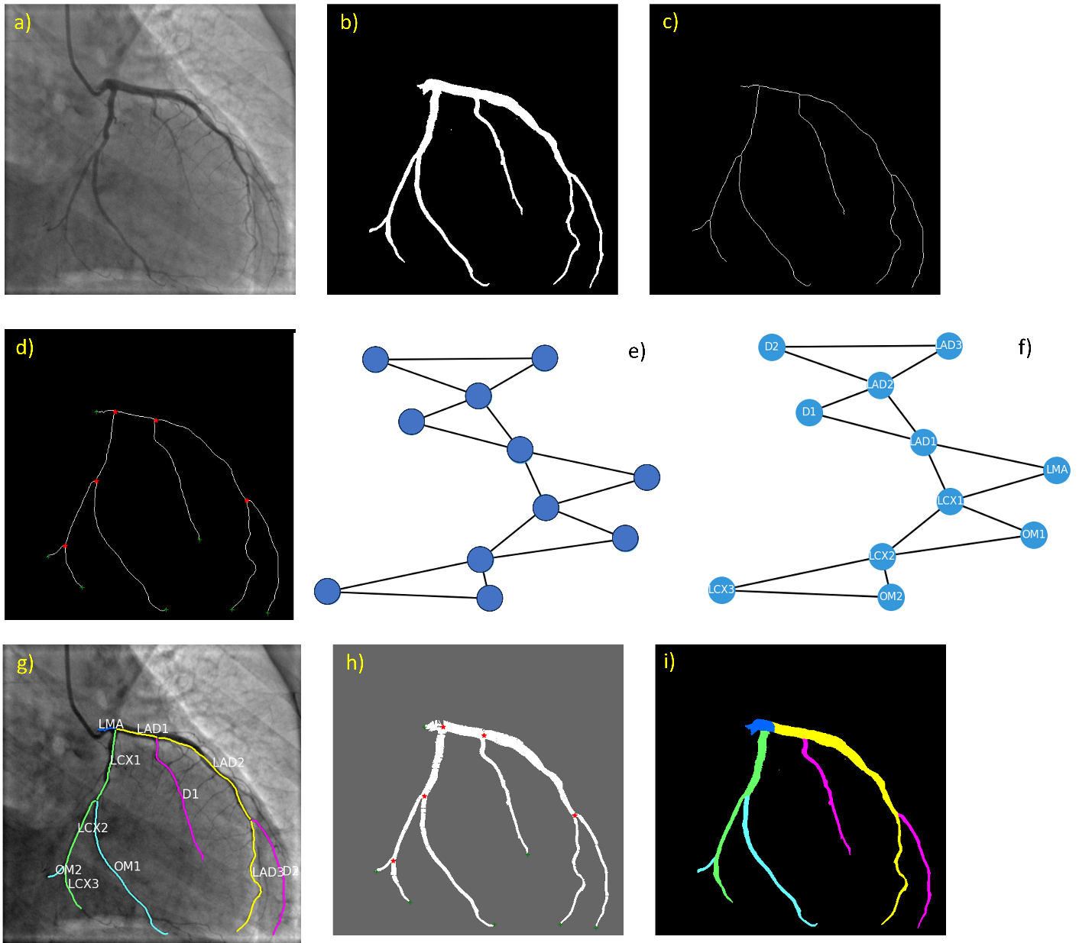
Figure S4. Workflow for coronary artery semantic labeling using HAGMN-UQ

2. I think the graphs shown in Fig. 2 are not consistent with the mathematical formulations presented in Section 3; they confuse me and hinder my fully understanding of the proposed method. For example, the authors only annotate 2 hyperedges for each graph, but from the definition 3-uniformed hypergraphs, there should be 3 hyperedges for each graph. In addition, the colors on the hyper association graph also confuse me as I cannot infer what they represent.
A: Sorry for the confusion. In the 3-uniformed hypergraphs, each hyperedge contains three nodes, rather than three edges in each graph. For the hyperedge construction in an individual hypergraph, we add a hyperedge if node $V_{i}$, $V_{j}$ and $V_{k}$ are adjacent nodes and physically connected with each other. For $G^{1}$ in Fig. 2 (a), it is a pseudo graph contains 5 nodes. According to the connectivity and the hyperedge generation rule, there are only two 3-uniformed hyperedges satisfy the rule that the three nodes are adjacent nodes and physically connected with each other. In our coronary artery semantic labeling task, each node in the individual graph $G^{1}$ or $G^{2}$ in Fig. 2 (a) indicates one coronary arterial segment, such as LMA, OM1, D1 and etc. Each hyperedge in the individual graph comprises three nodes, namely three connected arterial segments, such as LMA, LAD1, and LCX1, due to their adjacency.
For the association graph, we construct the hyper association graph using the individual hypergraphs and transform the graph matching problem into a vertex binary classification task. Each vertex $V_{i}^{H}$ in $G^{H}$ combines the two nodes from the two individual hypergraphs. According to the definition, $V^{H}=\{\left(V_{1}^{1},V_{1}^{2}\right),⋯,(V_{n_{1}}^{1},V_{n_{2}}^{2})\}$, where $V_{i}^{1}$ and $V_{a}^{2}$ are nodes from $G^{1}$ and $G^{2}$, respectively. If the nodes $V_{i}^{1}$, $V_{j}^{1}$ and $V_{k}^{1}$ from $G^{1}$ are connected, and the nodes $V_{a}^{2}$, $V_{b}^{2}$ and $V_{c}^{2}$ from $G^{2}$ are connected, then a hyperedge $E_{ijk,abc}$ is constructed in $G^{H}$, where $E_{ijk,abc}=\left\{\left(V_{i}^{1},V_{j}^{1},V_{k}^{1},V_{a}^{2},V_{b}^{2},V_{c}^{2}\right)\right\}$. Thus, each colored area in Fig. 2 (b) represents a hyperedge in the association graph, which is derived by 3 connected arterial segments in $G^{1}$ and another 3 connected arterial segments in $G^{2}$. In the coronary arterial semantic labeling task, each hyperedge in the hyper association graph contains the features of 6 coronary arterial segments from two different vascular trees.
We added more details to the revised manuscript.
(Section 3.2. Hyper graph matching for coronary artery semantic labeling)
This study concentrates on a 3-uniform hypergraph where each hyperedge contains three nodes and the graph matching network is performed to determine a third-order correspondence between hypergraphs. Formally, the individual 3-uniform hypergraph is represented by an attributed undirected graph as $G=\left(V, E, V,E\right)$, where
- $V=\left\{V_{i}\right\} s.t. i∈\{1,⋯,n\}$ represents the node set, and $\left|V\right|=n$.
- $E=\left\{E_{ijk}\right\} s.t. i,j,k∈\{1,⋯,n\}$ indicates the set of edges and $\left|E\right|=n_{e}$.
- $V=\left\{v_{i}\right\} s.t. i∈\{1,⋯, n\}$ indicates the attribute vectors associated with each node.
- $E=\{e_{ijk}\}$ s.t. $i,j,k∈\{1,⋯,n\}$ indicates the attribute vectors associated with each edge.
For the hyperedge construction in an individual hypergraph, we add a hyperedge if node $V_{i}$, $V_{j}$ and $V_{k}$ are adjacent nodes and physically connected with each other. For $G^{1}$ in Fig. 2 (a), it is a pseudo graph containing 5 nodes. According to the connectivity and the hyperedge generation rule, only two 3-uniformed hyperedges satisfy the rule that the three nodes are adjacent nodes and physically connected with each other. In our coronary artery semantic labeling task, each node in the individual graph $G^{1}$ or $G^{2}$ in Fig. 2 (a) indicates one coronary arterial segment, such as LMA, OM1, D1 and etc. Each hyperedge in the individual graph comprises three nodes, namely three connected arterial segments, such as LMA, LAD1, and LCX1, due to their adjacency. Thus, $E=\left\{\left(V_{i},V_{j},V_{k}\right)\right\}=\left\{E_{ijk}\right\}$. Given two undirected attributed individual hypergraphs $G^{1}=\left(V^{1}, E^{1}, V^{1},E^{1}\right)$ and $G^{2}=\left(V^{2}, E^{2}, V^{2},E^{2}\right)$, where $\left|V^{1}\right|=n_{1}$ and $\left|V^{2}\right|=n_{2}$, and $\left|E^{1}\right|=n_{e1}$ and $\left|E^{2}\right|=n_{e2}$, we aim to find the node correspondence between them by considering the node-to-node affinities and hyperedge-to-hyperedge affinities.
Each vertex $V_{i}^{H}$ in $G^{H}$ combines the two nodes from the two individual hypergraphs. Thus $V^{H}=\{\left(V_{1}^{1},V_{1}^{2}\right),⋯,(V_{n_{1}}^{1},V_{n_{2}}^{2})\}$, where $V_{i}^{1}$ and $V_{a}^{2}$ are nodes from $G^{1}$ and $G^{2}$, respectively. And each hyperedge is derived from two hyperedges in the individual hypergraphs. If the nodes $V_{i}^{1}$, $V_{j}^{1}$ and $V_{k}^{1}$ from $G^{1}$ are connected, and the nodes $V_{a}^{2}$, $V_{b}^{2}$ and $V_{c}^{2}$ from $G^{2}$ are connected, then a hyperedge $E_{ijk,abc}$ is constructed in $G^{H}$, where $E_{ijk,abc}=\left\{\left(V_{i}^{1},V_{j}^{1},V_{k}^{1},V_{a}^{2},V_{b}^{2},V_{c}^{2}\right)\right\}$. Thus, each colored area in Fig. 2 (b) represents a hyperedge in the association graph, which is derived by 3 connected arterial segments in $G^{1}$ and another 3 connected arterial segments in $G^{2}$. In the coronary arterial semantic labeling task, each hyperedge in the hyper association graph contains the features of 6 coronary arterial segments from two different vascular trees.

3. Row and column hyperedge are not defined. What row hyperedge constraint and column hyperedge constraint mean should be explained.
A: Thanks for your question which gives us another chance to explain the details of the proposed algorithm.
In hypergraph graph matching, the terms "row hyperedge" and "column hyperedge" refer to constraints related to the arrangement of hyperedges in the hypergraph.
- Row Hyperedge Constraint: In the context of hypergraph graph matching, a "row hyperedge" typically corresponds to a set of nodes in one of the hypergraphs being matched. It involves constraints on how nodes within a row hyperedge are matched with nodes in the other hypergraph.
- Column Hyperedge Constraint: Similar to the row hyperedge, this constraint involves how nodes within a column hyperedge are matched across the hypergraphs.
(Section 3.2. Hyper graph matching for coronary artery semantic labeling)
For every group of nodes associated with a specific row in the assignment matrix, we introduce a row hyperedge. Formally, the row hyperedge contains $n_{1}$ vertices in the hypergraph, defined as $R_{i}^{H}=\{(V_{i1}^{H},V_{i2}^{H},⋯,V_{in_{1}}^{H})\}$, where $n_{1}$ represents the number of nodes in $G^{1}$. Likewise, for each set of nodes associated with a particular column in the assignment matrix, we introduce a column hyperedge, denoted as $C_{j}^{H}=\{(V_{1j}^{H},V_{2j}^{H},⋯,V_{n_{2}j}^{H})\}$, where $n_{2}$ represents the number of nodes in $G^{2}$. Thus, in Eqs. 16 and 17, the plain GCN is employed to update the features. The updated features, $r_{i}^{gcn}$ and $c_{j}^{gcn}$, are further used as the regulizer to guarantee the sparseness of the vertex classification results.

4. The meaning of abbreviations such as CRA, CAU, LAO, RAO and AP should be provided.
A: Thanks for your question. In the revised manuscript, we added the definition of CRA, CAU, LAO, RAO and AP in the corresponding section and tables.
(Section 4.1. Dataset and enrolled subjects)
The ICA frame selection method is shown in Section 4 in the supplementary material. All the images were resized into 512×512. Table 1 shows the number of images in each view angle. The number of arterial segments for each view angle and each site is shown in Table S1 in the supplementary materials.

Table 1. View angles and number of enrolled subjects. CRA, cranial; CAU, caudal; LAO, left anterior oblique; RAO, right anterior oblique; AP: anterior-posterior.

Site | View Angle | LAO | RAO | AP | TOTAL
Site 1 | CRA | 42 | 19 | 18 | 79
 | CAU | 18 | 116 | 56 | 190
Site 2 | CRA | 44 | 16 | 123 | 183
 | CAU | 20 | 220 | 26 | 266
TOTAL |  | 124 | 371 | 223 | 718

(Supplementary materials. Section 1. Statistical information of the coronary arterial segments of the enrolled subjects)

Table S1. View angles and number of arterial segments
Site | ViewAngle1 | ViewAngle2 | LMA | LAD | LCX | D | OM | TOTAL
Site 1 | LAO | CRA | 44 | 128 | 129 | 84 | 86 | 471
 | RAO | CRA | 16 | 44 | 48 | 28 | 32 | 168
 | AP | CRA | 123 | 357 | 339 | 234 | 217 | 1270
 | LAO | CAU | 20 | 50 | 55 | 30 | 35 | 190
 | RAO | CAU | 220 | 642 | 623 | 422 | 403 | 2310
 | AP | CAU | 26 | 71 | 73 | 45 | 47 | 262
Site 2 | LAO | CRA | 42 | 112 | 108 | 70 | 66 | 398
 | RAO | CRA | 19 | 49 | 56 | 30 | 37 | 191
 | AP | CRA | 18 | 48 | 54 | 30 | 36 | 186
 | LAO | CAU | 18 | 48 | 45 | 30 | 27 | 168
 | RAO | CAU | 116 | 321 | 295 | 205 | 179 | 1116
 | AP | CAU | 56 | 154 | 145 | 98 | 89 | 542

5. Visual demonstration and comparison of the results of the proposed method and other methods need to be provided so that the readers can better understand the advantages and disadvantages of the proposed method.
A: Thanks for your questions. We have added the visual comparison of the graph matching results in the revised manuscript. Firstly, we randomly chose 6 examples from these 6 different view angles, and the graph matching results are shown in Figure 3.
(Section 4.3 Coronary artery semantic labeling performance)
Figure 3. Graph matching results of 6 ICA images from different view angles. Correspondence between coronary arteries from ICA images from the testing set (left) and from the template set (right). The green connection line indicates a correct match, while the red line represents a wrong match.

In addition, we added the robustness test in the revised manuscript to test the performance for different methods with different levels of the corrupted datasets.
(Section 4.6 Robustness test)
The proposed HAGMN-UQ was trained and evaluated based only on the ‘optimal’ individual graphs. However, we cannot guarantee that the binary segmentation model would generate satisfactory arterial contours for all ICAs due to the degradation of contrast dye. To test the robustness of the designed model, we conducted 3 experiments to illustrate the robustness of the proposed HAGMN-UQ.
(i) Arterial segments with different lengths. We tested the coronary artery semantic labeling performance on the arteries with different lengths, and the results are shown in Table 8. The centerline length indicates the number of pixels.

Table 8. The accuracy of coronary artery semantic labeling using arterial centerlines of different lengths. The centerline length is described by the number of pixels for each arterial segment, and the range is displayed. In addition, the number of segments is demonstrated after the accuracy.
Centerline length | LMA | LAD | LCX | D | OM
(0,50] | 0.9772±0.0144, 370 | 0.9361±0.0234, 331 | 0.9243±0.0446, 331 | 0.8836±0.0964, 64 | 0.8633±0.0865, 80
(50,100] | 0.9700±0.0186, 242 | 0.9302±0.0405, 485 | 0.8744±0.0201, 478 | 0.8719±0.0661, 313 | 0.8864±0.0136, 213
(100,150] | 1.0000±0.0000, 39 | 0.9111±0.0581, 357 | 0.8347±0.0561, 395 | 0.9031±0.0417, 302 | 0.7948±0.0748, 286
(150,200] | 1.0000±0.0000, 1 | 0.8354±0.0617, 307 | 0.8367±0.0674, 239 | 0.8296±0.0463, 250 | 0.7886±0.0557, 295
(200,250] | -, 0 | 0.8053±0.0546, 151 | 0.8073±0.0546, 128 | 0.8706±0.0918, 165 | 0.8054±0.0528, 130
(250,300] | -, 0 | 0.9143±0.0211, 90 | 0.8090±0.1142, 94 | 0.8461±0.1482, 67 | 0.8762±0.1120, 56
(300,350] | -, 0 | 0.9101±0.0819, 84 | 0.7933±0.1625, 49 | 0.9456±0.0694, 38 | 0.7514±0.1982, 24
(350,500] | -, 0 | 0.9646±0.0439, 59 | 0.9056±0.1268, 65 | 1.0000±0.0000, 15 | 0.6861±0.3996, 44

According to Table 8, the proposed model achieved highly stable performance for LMA semantic labeling. However, for other types of branches, the performance varies among arterial segments with different lengths. For instance, in the case of OM branches, when the length of arterial segments exceeds 300 pixels, only a limited number of arterial segments were enrolled, resulting in decreased accuracy.
(ii) Graph matching using incomplete trees. We randomly removed partial segments and performed robustness tests using the partial vascular graphs. To evaluate the resilience of the developed model, we generated corrupted ICA-generated vascular graphs by randomly deleting portions of arterial segments from the ICAs in the test set, while keeping the ICAs in the template set unchanged. The deleted arterial segment must include at least one endpoint to maintain the connectivity of the graph. We compared the performance drops using the corrupted dataset by randomly removing 5%, 10%, 15%, 20%, 25% and 30%, arterial segments and compared the proposed HAGMN-UQ with the baseline methods. The ACC, PREC, REC, and F1 are shown in Figure 4.
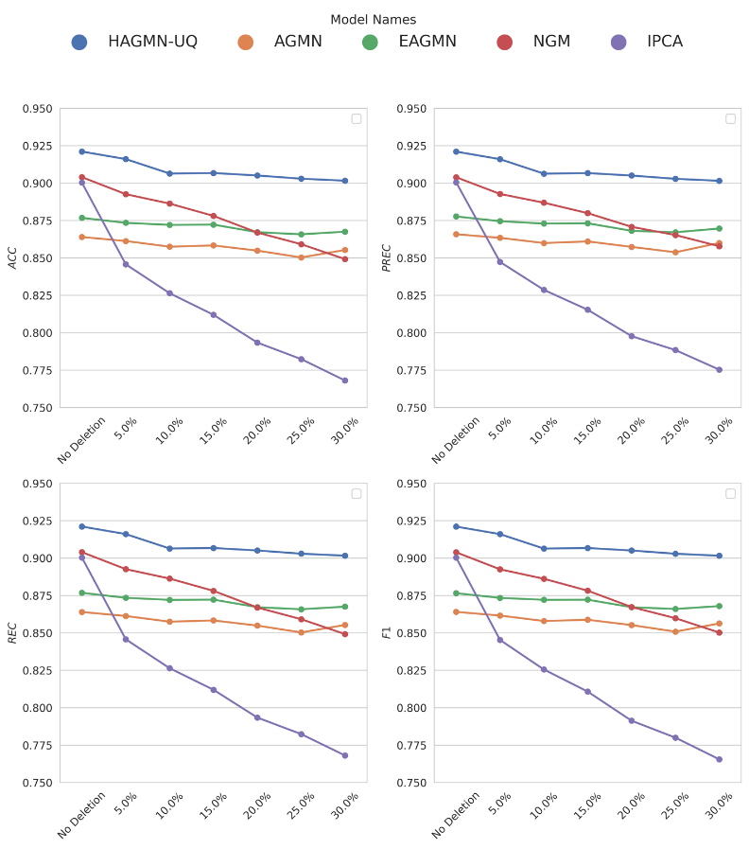
Figure 4. The achieved ACC, PREC, REC, and F1 of the proposed HAGMN-UQ, AGMN, EAGMN, NGM and IPCA using different corrupted ICAs. The horizontal axis indicates the probability of deleting an artery segment randomly.
The results in Figure 4 confirm the robustness of the proposed HAGMN-UQ. Even when 30% of the arterial segments were randomly dropped, the accuracy remained above 0.9. In contrast, peer methods like AGMN, EAGMN, and NGM experienced a decrease in accuracy, with values dropping below 87.5%. These findings underscore the robustness of HAGMN-UQ. By leveraging hyperedges containing 3 arterial segments, it exploits higher-order relationships between nodes and edges, thereby ensuring a resilient matching process.
However, if the arterial segment contains two bifurcation points and is removed, it results in the separation of the individual arterial graph into two separate graphs, thereby breaking the continuity of the vascular tree. In such cases, human intervention becomes necessary.
(iii) Graph matching on ICAs with incorrect inlet point. In coronary arterial system, the inlet point is referred to LMA branch. To simulate the incorrect inlet point, we manually removed the LMA branch for each testing graph and tested the performance of graph matching using the in-complete ICA-generated graphs without the LMA branches; however, in the template set, the LMA branches were preserved. This process simulates the graph matching using the vascular graphs with incorrect inlet points. The results are shown in Table 9.
Table 9. The achieved ACC, PREC, REC, and F1 of the proposed HAGMN-UQ using ICAs with incorrect inlet.
Metric | LAD | LCX | D | OM
ACC | 0.9337±0.0148 | 0.8931±0.0161 | 0.9035±0.0277 | 0.8412±0.0274
PREC | 0.9333±0.0137 | 0.8985±0.0162 | 0.8993±0.0242 | 0.8475±0.0248
REC | 0.9337±0.0148 | 0.8931±0.0161 | 0.9035±0.0277 | 0.8412±0.0274
F1 | 0.9335±0.0141 | 0.8958±0.0162 | 0.9014±0.0258 | 0.8443±0.0261

Reviewer #2:
1. Summary:
The manuscript proposes a strategy to identify coronary artery segments obtained from interventional X-ray angiography by means of a hyper association graph-matching neural network with uncertainty quantification to accelerate the inference speed. Some experiments on inhouse datasets illustrate some properties of the method.
A: We appreciate your comments and summaries.
2. Clarity
A) There are a number of typos that need to be fixed.
A: Thank you for your diligent review and for pointing out the typos in the manuscript. We appreciate your attention to detail, and we will thoroughly proofread the document to correct any errors. Your feedback is invaluable, and we are committed to ensuring the manuscript meets the highest standards of clarity and professionalism.
B) There is very litter details on how to select the similar (or optimal) projection angle and frame in the dataset, which seems important to perform the reliable segment labeling between similar coronary trees.
A: Thanks for your question. For each patient, a frame that was used for anatomical structure analysis in clinical practice was selected from the view video for semantic labeling. The coronary angiogram frame is chosen at the end of the systolic phase from the coronary angiography video and the frame index is automatically determined using our developed algorithm for end-diastolic and end-systolic cardiac frames from invasive coronary angiography videos [7]. This specific frame selection is based on the optimal visibility and alignment of coronary structures, ensuring reliable segment labeling between similar coronary trees. For instance, both flow fraction reserve calculated from the 3D arterial model [8] and 3D quantitative coronary angiography [9] require end-systolic image frames in ICA videos. The identification of end-systolic image frames is essential for the diagnosis of the myocardial bridge [10]. The ideal technique for extracting end-diastolic and end-systolic from ICA images is to display electrocardiograms on ICA in real-time. We add explanation of frame selection in generating the dataset in the revised manuscript.
In detail, we selected the ICA images from 6 view angles, including left anterior oblique cranial, left anterior oblique caudal, right anterior oblique cranial, right anterior oblique caudal, and anterior-posterior cranial, anterior-posterior caudal, as demonstrated in Table 1. During model training, we only selected ICAs from the same view angle to generate pairs for graph matching. During testing, the tested ICA has the identical view angle as the template ICA. As a result, the reliable artery-to-artery correspondence is guaranteed.
(Supplementary materials. Section 4. ICA image selection)
For each patient, a frame that was used for anatomical structure analysis in clinical practice was selected from the view video for semantic labeling. The coronary angiogram frame is chosen at the end of the diastolic phase from the coronary angiography video and the frame index is automatically determined using our developed algorithm for end-diastolic and end-systolic cardiac frames from invasive coronary angiography videos [7]. This specific frame selection is based on the optimal visibility and alignment of coronary structures, ensuring reliable segment labeling between similar coronary trees. For instance, flow fraction reserve values calculated from both the 3D arterial model [8] and 3D quantitative coronary angiography [9] require end-systolic image frames in ICA videos. The identification of end-systolic image frames is essential for the diagnosis of the myocardial bridge [10]. The most reliable technique for extracting end-diastolic and end-systolic from ICA images is to display electrocardiograms on ICA in real-time.
In detail, we selected the ICA frames from 6 view angles, including left anterior oblique cranial, left anterior oblique caudal, right anterior oblique cranial, right anterior oblique caudal, and anterior-posterior cranial, anterior-posterior caudal, as demonstrated in Table 1. During model training, we only selected ICAs from the same view angle to generate pairs for graph matching. During testing, the tested ICA has the identical view angle as the template ICA. As a result, reliable artery-to-artery correspondence is guaranteed.
C) The dataset is collected from two sites with different imaging devices, therefore, it is significant to discuss how to split a robust template set to perform the matching process under potential domain shift.
A: Thanks for your suggestions. We employed stratified sampling, randomly selecting 10% of the ICAs from different view angles while considering the secondary projection angle of ICAs. Note that the first projection angle is used to determine the categories of left anterior oblique, right anterior oblique, and anterior-posterior. The second projection angle determines the caudal and cranial views.
In the revised manuscript, we conducted additional experiments using images from these two hospitals individually. Additionally, to test the domain difference, we conducted experiments using images from one hospital and employed templates from another hospital during testing to evaluate the generalizability of the designed algorithms. And we added a new sub section to demonstrate the model performance using ICAs from these two sites.
(Section 4.5. Uni-site and cross-site experiments)
We conducted additional experiments using images from these two hospitals individually. Additionally, to test the domain difference, we conducted experiments using images from one hospital and employed templates from another hospital during testing to evaluate the generalizability of the designed algorithms.
Uni-site test. We performed experiments to test performance differences using uni-site ICAs. For each site, we employed stratified sampling to separate the entire dataset into the training set and template set, which contains 90% and 10% of the ICAs, respectively. For the training set with 90% of ICAs, we further performed the 5-fold cross validation. The performance is reported in Table 6.

Table 6. Achieved performance for coronary artery semantic labeling using ICAs from individual sites.
Site | Artery type | LMA | LAD | LCX | D | OM | micro avg
Site 1 | ACC | 1.0000±0.0000 | 0.9536±0.0035 | 0.9327±0.0212 | 0.9410±0.0108 | 0.9024±0.0365 | 0.9418±0.0101
 | PREC | 1.0000±0.0000 | 0.9417±0.0178 | 0.9522±0.0083 | 0.9018±0.0306 | 0.9368±0.0113 | 0.9465±0.0093
 | REC | 1.0000±0.0000 | 0.9536±0.0035 | 0.9327±0.0212 | 0.9410±0.0108 | 0.9024±0.0365 | 0.9459±0.0100
 | F1 | 1.0000±0.0000 | 0.9475±0.0091 | 0.9422±0.0110 | 0.9206±0.0145 | 0.9190±0.0229 | 0.9459±0.0100
Site 2 | ACC | 0.9973±0.0054 | 0.9092±0.0118 | 0.9158±0.0076 | 0.8580±0.0175 | 0.8768±0.0272 | 0.9042±0.0092
 | PREC | 0.9973±0.0054 | 0.9067±0.0177 | 0.9184±0.0101 | 0.8569±0.0185 | 0.8782±0.0305 | 0.9115±0.0096
 | REC | 0.9973±0.0054 | 0.9092±0.0118 | 0.9158±0.0076 | 0.8580±0.0175 | 0.8768±0.0272 | 0.9114±0.0095
 | F1 | 0.9973±0.0054 | 0.9080±0.0147 | 0.9171±0.0085 | 0.8574±0.0177 | 0.8775±0.0286 | 0.9115±0.0096

Analysis of Table 6 reveals that the proposed HAGMN-UQ demonstrated impressive performance on both sites, with accuracies exceeding 0.9. Notably, the performance on site 1 surpassed that of site 2 by approximately 3% in terms of macro PREC, macro REC and macro F1. Further insight from Table 2 indicates that the proposed HAGMN-UQ achieved an accuracy of 0.9211 using ICAs from these two centers simultaneously.
The difference may be caused by exposure time, dose of contrast agent (including operator experience and injection strength), and other potential sources of variability inherent to multi-center datasets. Examples of representative ICAs from Sites 1 and 2 are shown in Figure S6 in the supplementary materials.
Cross-site test. We conducted experiments to assess the performance of coronary artery semantic labeling using templates from other sites. For instance, we divided the ICAs from site 1 into training and testing sets for 5-fold cross-validation and employed stratified sampling to select 10% of ICAs from site 2 as the template set. The results of the cross-site experiments are presented in Table 7.

Table 7. Achieved performance for coronary artery semantic labeling using cross-site ICAs as the template. The S1toS2 indicates that the ICAs from site 1 were used as the training and testing sets, while 10% of ICAs from site 2 were used as the template set; for S2toS1, vice versa.

Site | Artery type | LMA | LAD | LCX | D | OM | micro avg
S1toS2 | ACC | 0.9483±0.0308 | 0.8482±0.0361 | 0.8445±0.0379 | 0.7847±0.0463 | 0.7726±0.0489 | 0.8325±0.0316
 | PREC | 0.9483±0.0308 | 0.8402±0.0324 | 0.8530±0.0336 | 0.7763±0.0529 | 0.7811±0.0526 | 0.8398±0.0326
 | REC | 0.9483±0.0308 | 0.8482±0.0361 | 0.8445±0.0379 | 0.7847±0.0463 | 0.7726±0.0489 | 0.8397±0.0325
 | F1 | 0.9483±0.0308 | 0.8441±0.0338 | 0.8487±0.0355 | 0.7804±0.0488 | 0.7768±0.0504 | 0.8397±0.0325
S2toS1 | ACC | 0.9869±0.0141 | 0.9060±0.0117 | 0.8764±0.0248 | 0.8780±0.0199 | 0.7471±0.0397 | 0.8724±0.0149
 | PREC | 0.9923±0.0154 | 0.9150±0.0115 | 0.8480±0.0290 | 0.8438±0.0216 | 0.8077±0.0398 | 0.8814±0.0151
 | REC | 0.9869±0.0141 | 0.9060±0.0117 | 0.8764±0.0248 | 0.8780±0.0199 | 0.7471±0.0397 | 0.8789±0.0155
 | F1 | 0.9896±0.0144 | 0.9104±0.0111 | 0.8619±0.0263 | 0.8604±0.0178 | 0.7761±0.0391 | 0.8797±0.0153

According to Table 7, it is observed that using the templates from the other site lowered the model performance. In real practice, we suggest generating templates within the same hospital and using the corresponding templates to perform graph matching.

(Supplementary materials. Section 8. Representative ICAs from two hospitals.)

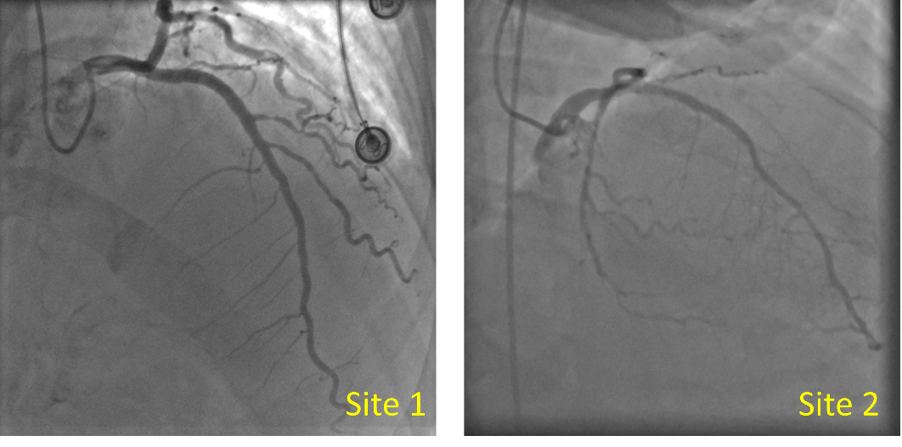
Figure S6. Representative ICAs from sites 1 and 2.

D) The manuscript should also properly discuss the amount of human interaction required. Is the method really acting in a black box fashion through all these steps?
A: Thanks for your questions. The proposed coronary artery semantic labeling contains coronary arterial binary segmentation, centerline extraction, and semantic labeling using the proposed HAGMN-UQ. For the binary segmentation, we developed a LabelMe (https://github.com/labelmeai/labelme) based software which integrated the pre-trained FP-UNet++ model to generate the initial contours and allow users to manual revise the contours. The human interaction is required to revise the contours, which is depended on the quality of the generated binary contours.
For the arterial graph generation, we developed an algorithm with several rules to generate the ICA-graph, and we added the details in the supplementary materials. For graph generation, the only required hyperparameter settings are the threshold length of the arterial segment and the radius of the arterial segments. If the centerline of the segment is smaller than the threshold, it will be removed for semantic labeling; if the radius of the arterial segment is smaller than the threshold, it is denoted as the capillary and will not be involved in the downstream analysis. In addition, we also integrated the ICA-graph generation process into our customized LabelMe software. The human intervention is to adjust the thresholds of the segment length and the radius of the arterial segment. The GUI for the developed LabelMe is shown in the supplementary materials in Figures S2 and S3.
(Supplementary materials. Section 3. The developed software for ICA data pre-processing)
Figure S2. GUI for LabelMe-based coronary artery contour annotation tool.
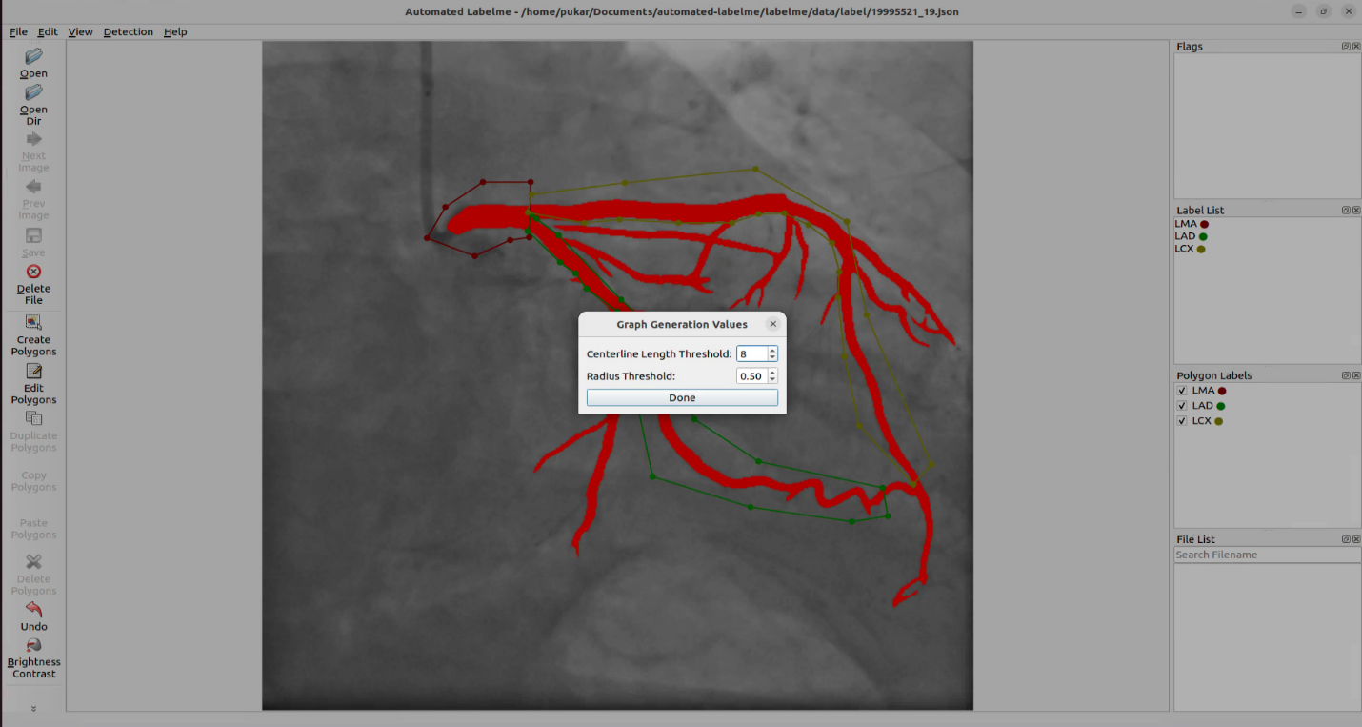
Figure S3. GUI for LabelMe-based coronary artery contour annotation tool for ICA-graph generation.

(Supplementary materials. Section 6. ICA-graph generation)
We first applied our previous coronary artery binary segmentation model, Feature-pyramid U-Net++ [11], to extract the coronary vascular tree from ICA images. Then, we applied the hit-and-miss algorithm, a morphological algorithm employing erosion operations iteratively until the topology of the vascular tree remains unchanged while preserving the connectivity of the coronary artery branches [12], to extract the coronary arterial centerline. Additionally, we applied several rules to adjust the coronary arterial centerline to generate the centerline for each individual arterial segment:
(1) Bifurcation and endpoint detection: We iterated through all points within the centerline pixel and detected bifurcation and endpoints using the edge linking algorithm [13]. By removing the bifurcation and endpoints, the arterial centerline is separated into the centerlines of arterial segments.
(2) Deletion of capillary segments: According to clinical practice, arterial segments with a diameter smaller than 1.8 mm provide limited information for stenosis detection and cardiovascular disease detection. Therefore, we removed the centerlines of arterial segments with a maximum diameter smaller than 1.8 mm, considering the number of pixels in the arterial branch and the pixel spacing from the DICOM image.
(3) Merge splitting points: One type of error in automated generated arterial graphs is induced by splitting points, which indicate two bifurcation points located closely and create the wrong graph topology. We remove one of the two splitting bifurcation points if their Euclidean distance is smaller than $T$ pixels. Normally, $T$ is set as 5. As a result, the bifurcation points are merged into one bifurcation point, and the connected link between these two bifurcation points is removed.
(4) Deletion of cycles: The generated vascular tree graph is an undirected acyclic graph. If a cycle exists, the centerline of the arterial segment with a small diameter is removed.
(5) Re-arrange bifurcation points: After merging the splitting points and deleting the cycles, the degree of the bifurcation may reduce to two. Then, we merge these bifurcation points into the centerline of the connected two arterial segments.
(6) Switch nodes and edges: In the arterial graph, the endpoint and bifurcation points are denoted as nodes, while the connecting centerline between the key points serves as the link. The designed graph matching algorithm aims at performing node classification rather than edge classification. Classifying the one-pixel bifurcation points and endpoints provides no information for coronary artery semantic labeling. Therefore, we switch the concepts of nodes and edges, where the centerline segment represents a node, while the bifurcation and endpoints indicate the connectivity (edge) in the arterial graph. The adjacent matrix of the individual graph is generated by the connectivity of the bifurcation and endpoints, and the generated individual graph is shown in the right sub-figure at the top of Figure 1.
For the septal branch, it's important to note that it does not typically occur in most coronary arterial systems. Therefore, when creating the dataset, we manually removed the septal branch if it was extracted by FP-U-Net++. In clinical practice, the septal branch is considered an intramyocardial artery. Consequently, stents are typically not inserted into the septal branch, and intervention is not usually required. If necessary, the insertion of a stent within the septal branch often leads to stent compression, resulting in variations in stent size, potential blockages, or rupture [14]. Additionally, the diameter of the septal branch is often small, around 2.0mm [15], and no suitable stent is available in clinical practice. Our proposed arterial segment pre-processing algorithm aims to remove arterial segments with a radius smaller than 1.8mm. Unfortunately, it has been reported that coronary dissection and perforation can occur in the septal branch, leading to the formation of a coronary arteriovenous shunt [16]. In conclusion, we removed the septal branches according to the clinical needs and the designed ICA graph pre-processing algorithm.
We also provided a workflow for coronary artery semantic labeling using the trained deep learning models and illustrate the required human intervention in the supplementary materials.
(Supplementary materials. Section 5. Human intervention for ICA semantic labeling)
In Figure S4, we provided the workflow for coronary artery semantic labeling using the proposed method.
(a) This figure shows the original ICA frame, which is resized to 512x512.
(b) The binary segmentation results using our FP-U-Net++ with human intervention using our developed software based on LabelMe.
(c) The generated coronary artery skeleton using steps 1 to 5 in Supplementary materials, Section 4: ICA-graph generation.
(d) Generated key points using an edge-linking algorithm, where the red stars indicate the bifurcation points and green plus signs indicate end points.
(e) According to the key points and arterial connectivity, then switch the nodes and edges, we generate the ICA individual graph. Each blue circle indicates an arterial segment, and the black solid lines indicate the key points which preserve the arterial connectivity.
(f) Graph matching results. We applied the trained HAGMN-UQ to the presented test ICA-generated graph and the template graphs in our dataset, and each arterial segment (node in the individual graph) is assigned with the corresponding categories according to the artery-to-artery mapping.
(g) Visualization of the arterial segmentation centerline classification.
(h) We create the mapping between the arterial centerline and the binary mask of the arterial segments. In detail, for each pixel within the arterial centerline, we calculate the perpendicular line and expand the perpendicular line from the arterial centra pixel to the boundaries to find the corresponding pixels which belong to the binary mask.
(i) According to the mapping between the centerline of the arterial segment and the arterial mask, and the category of the arterial segment, we assign categorical labels for each pixel belonging to the centerline, so that the semantic segmentation is achieved.
Overall, the only required human intervention is in step (b), where manual modification of the binary mask may be required.
Figure S4. Workflow for coronary artery semantic labeling using HAGMN-UQ

E) Please provide an honest discussion of the pros and cons of the proposed matching approach based on pre-processing (e.g., segmentation and centerline extraction). I'm missing a faithful analysis of error cases where the prior assumptions of the method are only partially fulfilled.
A: Thanks for your suggestion. The advantages of the proposed approach include improved accuracy, computational efficiency, and robustness. By integrating the hyper association graph and uncertainty quantification, the proposed model showed better generalization performance and robustness on cross-site ICA datasets. Simultaneously, using the derived confidence for graph matching, the number of required compared graphs is reduced, accelerating the graph matching prediction process.
The disadvantages of the proposed workflow for coronary artery semantic labeling include sensitivity to preprocessing parameters and a multi-staged approach. During the ICA binary segmentation, human intervention is required to adjust the binary contours if needed. For ICA graph generation, hyperparameters are required to adjust the length of the arterial segment and the radius threshold of the arterial segment to preprocess the arterial skeleton. Thus, we developed our in-house software for image preprocessing, as shown in Figures S2 and S3 in the supplementary materials. Compared to an end-to-end approach, such as image semantic segmentation using CNN, the proposed approach contains multiple steps, meaning that subsequent steps may be influenced by preceding ones.
In addition, we added the limitation and future work in the revised manuscript to show the advantage and disadvantage of the proposed workflow for coronary artery semantic labeling.
(Section 5. Limitation and Future work)
The proposed matching approach leveraging pre-processing techniques, notably coronary artery binary segmentation and graph generation, presents several advantages. First and foremost, it promises enhanced accuracy in coronary artery representation, which is essential for reliable graph matching. By segmenting and extracting centerlines beforehand, the method ensures a standardized and consistent representation of arterial structures across diverse datasets, leading to more robust matching outcomes. Additionally, automated pre-processing steps streamline the matching process, minimizing the need for manual intervention and enhancing scalability.
However, despite these advantages, the proposed approach is not without its challenges. One of the primary concerns lies in the sensitivity of the method to the quality of pre-processing steps. During the ICA binary segmentation, human intervention is required to adjust the binary contours if needed. For ICA graph generation, hyperparameters are required to adjust the length of the arterial segment and the radius threshold of the arterial segment to preprocess the arterial skeleton. Thus, we developed our in-house software for image preprocessing, as shown in Figures S2 and S3. Compared to an end-to-end approach, such as image semantic segmentation using CNN, the proposed approach contains multiple steps, meaning that subsequent steps may be influenced by preceding ones.
3) Originality
The idea of matching with hyper association graph seems to be little explored. However there is quite a body of literature on coronary artery labeling where traditional graph matching approaches are developed with node and edge attention mechanism used in graph convolution.
A: Thanks for your comments. In the revised manuscript, we add more papers related to graph matching using hyper graph and hyper association graphs.
4) Significance
Leaving the discussion of when an optimal template set is available aside, the method makes a lot of assumptions required to hold true for HAGMN to be meaningful. Robust and complete coronary segmentation and centerline extraction (obtained automatically) as well as a successful matching of projection angle and image frame need to be available as a preprocessing. Those requirements pose quite a challenge in clinical practice as each of them constitutes an entire research question on their own. Often, there will be coronaries missing or coronaries will have different sizes which can disturb the matching. Given these constraints, the significance of the proposed methodology is -- as it stands -- rather small because the robustness of the method was not demonstrated or discussed.
A: Thanks for your comments. We agree that the proposed algorithm includes multiple procedures for extracting the vascular tree, centerline generation, and graph matching for coronary artery semantic labeling. For the vascular tree binary segmentation, we employed the proposed FP-UNet++ to extract the coronary arteries, and the experimental results showed that it achieved an averaged Dice similarity coefficient of 0.8899 on our dataset. In addition, we developed a LabelMe-based software to annotate the coronary artery with the FP-UNet++ integrated, which significantly lowered the operation time for arterial contour manual correction. The GUI for the developed software is shown in Figure S1.
To assess the robustness of the graph matching, we conducted four types of robustness tests in response to the questions outlined in Evaluation Question B.
5) Reproducibility
There is no public code available for the preprocessing, the graph matching and the empirical experiments. The data is closed, as well. Hence, it is virtually impossible to reproduce the experiments.
A: We have open-sourced our code, along with a running example, which is available at https://github.com/MIILab-MTU/HAGMN-UQ. Within our GitHub repository, we have included two ICA-generated graphs and the trained model weights. Utilizing these graphs, we constructed the hyper-association graph and employed our proposed HAGMN-UQ with the trained weights to perform graph matching. For visualization of the results, we have provided corresponding functions to generate the graph matching results, where green lines indicate correct matches and red lines represent errors.
In the revised manuscript, we added the link for the open-sourced code in the introduction section.
(Section 1. Introduction)
The code for the proposed method is available at https://github.com/MIILab-MTU/HAGMN-UQ.
6) Evaluation
A) The uncertainty quantification is expected to accelerate the inference speed, instead of improving the labeling accuracy. Therefore, the authors are encouraged to explain why introducing uncertainty quantification can bring significant improvement over VGT+EGT, as shown in Table 4.
A: Thanks for your questions. In Algorithm 1, lines 8 and 16 provide two criteria by which we accept the graph matching results. In line 8, if there are no structural errors, we accept the arterial segment category assignment result. In line 16, if the uncertainty of the graph matching assignment is smaller than the threshold $T_{c}$, we trust the prediction.
Firstly, we reduced the number of graphs compared to accelerate the inference speed. Additionally, if the uncertainty is greater than $T_{c}$, we reject this assignment, which prevents erroneous assignments. Consequently, the uncertainty quantification derived from true classification probability not only accelerates the model inference but also improves the model performance.
B) The robustness of the method is not analysed. Aspects are, (i) vessel (segments) of different lengths, (ii) incomplete trees, (iii) incorrect inlet point, (iv) strange/rare projection angles.
A: Thanks for your questions. In the revised manuscript, we added a new subsection and conducted 4 experiments to validate the robustness of the proposed methods.
(Section 4.6. Robustness test)
The proposed HAGMN-UQ was trained and evaluated based only on the ‘optimal’ individual graphs. However, we cannot guarantee that the binary segmentation model would generate satisfactory arterial contours for all ICAs due to the degradation of contrast dye. To test the robustness of the designed model, we conducted 3 experiments to illustrate the robustness of the proposed HAGMN-UQ.
(i) Arterial segments with different lengths. We tested the coronary artery semantic labeling performance on the arteries with different lengths, and the results are shown in Table 8. The centerline length indicates the number of pixels.

Table 8. The accuracy of coronary artery semantic labeling using arterial centerlines of different lengths. The centerline length is described by the number of pixels for each arterial segment, and the range is displayed. In addition, the number of segments is demonstrated after the accuracy.
Centerline length | LMA | LAD | LCX | D | OM
(0,50] | 0.9772±0.0144, 370 | 0.9361±0.0234, 331 | 0.9243±0.0446, 331 | 0.8836±0.0964, 64 | 0.8633±0.0865, 80
(50,100] | 0.9700±0.0186, 242 | 0.9302±0.0405, 485 | 0.8744±0.0201, 478 | 0.8719±0.0661, 313 | 0.8864±0.0136, 213
(100,150] | 1.0000±0.0000, 39 | 0.9111±0.0581, 357 | 0.8347±0.0561, 395 | 0.9031±0.0417, 302 | 0.7948±0.0748, 286
(150,200] | 1.0000±0.0000, 1 | 0.8354±0.0617, 307 | 0.8367±0.0674, 239 | 0.8296±0.0463, 250 | 0.7886±0.0557, 295
(200,250] | -, 0 | 0.8053±0.0546, 151 | 0.8073±0.0546, 128 | 0.8706±0.0918, 165 | 0.8054±0.0528, 130
(250,300] | -, 0 | 0.9143±0.0211, 90 | 0.8090±0.1142, 94 | 0.8461±0.1482, 67 | 0.8762±0.1120, 56
(300,350] | -, 0 | 0.9101±0.0819, 84 | 0.7933±0.1625, 49 | 0.9456±0.0694, 38 | 0.7514±0.1982, 24
(350,500] | -, 0 | 0.9646±0.0439, 59 | 0.9056±0.1268, 65 | 1.0000±0.0000, 15 | 0.6861±0.3996, 44

According to Table 8, the proposed model achieved highly stable performance for LMA semantic labeling. However, for other types of branches, the performance varies among arterial segments with different lengths. For instance, in the case of OM branches, when the length of arterial segments exceeds 300 pixels, only a limited number of arterial segments were enrolled, resulting in decreased accuracy.
(ii) Graph matching using incomplete trees. We randomly removed partial segments and performed robustness tests using the partial vascular graphs. To evaluate the resilience of the developed model, we generated corrupted ICA-generated vascular graphs by randomly deleting portions of arterial segments from the ICAs in the test set, while keeping the ICAs in the template set unchanged. The deleted arterial segment must include at least one endpoint to maintain the connectivity of the graph. We compared the performance drops using the corrupted dataset by randomly removing 5%, 10%, 15%, 20%, 25% and 30%, arterial segments and compared the proposed HAGMN-UQ with the baseline methods. The ACC, PREC, REC, and F1 are shown in Figure 4.
Figure 4. The achieved ACC, PREC, REC, and F1 of the proposed HAGMN-UQ, AGMN, EAGMN, NGM and IPCA using different corrupted ICAs. The horizontal axis indicates the probability of deleting an artery segment randomly.
The results in Figure 4 confirm the robustness of the proposed HAGMN-UQ. Even when 30% of the arterial segments were randomly dropped, the accuracy remained above 0.9. In contrast, peer methods like AGMN, EAGMN, and NGM experienced a decrease in accuracy, with values dropping below 87.5%. These findings underscore the robustness of HAGMN-UQ. By leveraging hyperedges containing 3 arterial segments, it exploits higher-order relationships between nodes and edges, thereby ensuring a resilient matching process.
However, if the arterial segment contains two bifurcation points and is removed, it results in the separation of the individual arterial graph into two separate graphs, thereby breaking the continuity of the vascular tree. In such cases, human intervention becomes necessary.
(iii) Graph matching on ICAs with incorrect inlet point. In coronary arterial system, the inlet point is referred to LMA branch. To simulate the incorrect inlet point, we manually removed the LMA branch for each testing graph and tested the performance of graph matching using the in-complete ICA-generated graphs without the LMA branches; however, in the template set, the LMA branches were preserved. This process simulates the graph matching using the vascular graphs with incorrect inlet points. The results are shown in Table 9.
Table 9. The achieved ACC, PREC, REC, and F1 of the proposed HAGMN-UQ using ICAs with incorrect inlet.
Metric | LAD | LCX | D | OM
ACC | 0.9337±0.0148 | 0.8931±0.0161 | 0.9035±0.0277 | 0.8412±0.0274
PREC | 0.9333±0.0137 | 0.8985±0.0162 | 0.8993±0.0242 | 0.8475±0.0248
REC | 0.9337±0.0148 | 0.8931±0.0161 | 0.9035±0.0277 | 0.8412±0.0274
F1 | 0.9335±0.0141 | 0.8958±0.0162 | 0.9014±0.0258 | 0.8443±0.0261

(Section 4.3. Coronary artery semantic labeling performance)
We reported the performance under different view angles, as shown in Table 3. According to Table 3, our proposed model demonstrated impressive performance across most of the ICA images from various view angles, with the exception of the LAO CAU angle. It's important to note that during the generation of graph matching pairs, only ICA images from the sampled view angle are utilized for training, while templates from the same view angle are employed for testing and prediction. The observed lower performance in LAO CAU can be attributed to the limited number of training samples available under this view angle, as illustrated in Table 1. This scarcity of training data results in a restricted number of eligible graph matching pairs during training. Additionally, during testing, the number of templates under the LAO CAU view angle is also constrained, leading to biased predictions in graph matching.

Table 3. The achieved ACC, PREC, REC and F1 of the proposed HAGMN-UQ using ICAs under different view angles.
First View Angle | Second View Angle | ACC | PREC | REC | F1
AP | CAU | 0.9177±0.0472 | 0.9180±0.0472 | 0.9177±0.0472 | 0.9177±0.0474
AP | CRA | 0.9066±0.0250 | 0.9064±0.0251 | 0.9066±0.0250 | 0.9065±0.0250
LAO | CAU | 0.8241±0.2038 | 0.8249±0.2022 | 0.8241±0.2038 | 0.8242±0.2035
LAO | CRA | 0.9179±0.0192 | 0.9183±0.0188 | 0.9179±0.0192 | 0.9180±0.0191
RAO | CAU | 0.9213±0.0141 | 0.9212±0.0142 | 0.9213±0.0141 | 0.9212±0.0142
RAO | CRA | 0.8944±0.0594 | 0.8944±0.0594 | 0.8944±0.0594 | 0.8944±0.0594

Reviewer #3: In this paper, a Hyper Association Graph Matching Network with Uncertainty Quantification (HAGMN-UQ) was proposed to perform segment matching between unannotated coronary ICA images and annotated ICA images , thereby obtaining labels. The authors propose three techniques to enhance the classification accuracy. Specifically, annotated graphs are used as template sets, and hyper associated graphs are generated from unannotated graphs and template sets, and then node classification is performed to obtain semantic labels. In addition, Graph Transformer was used to implement node and edge attention mechanism to obtain higher accuracy, and structural loss and uncertainty were employed to reduce processing time. The results show that the classification accuracy at the node level is improved. However, I think this paper lacks some description of the workflow and the motivation is not clearly explained as there are many parts that need to be clarified:
1. The motivation for this paper needs to be clarified. In the first paragraph of the Introduction, the authors stated that ICAs are the gold standard for diagnosing CAD. However, it is not clear whether it is necessary to recognize the main branches of ICAs. There is a missing logic here, i.e., why did the physician determine the blockage based on this result? Furthermore, what is the relationship between the recognition of the main branch and the location of the lesion?
A: Thanks for your question. ICA involves the injection of contrast media into the epicardial arteries with the acquisition of continuous fluoroscopy. Automatic identification of correct anatomical branches provides meaningful information for automated diagnosis, report generation and region of interest visualization [17]. Additionally, correct anatomic identification of severely diseased coronary arteries influences choice of treatment, for example whether or not a patient is a candidate for bypass surgery versus percutaneous coronary intervention. Thus, proper labeling of main vessel and branch segments is crucial for patient treatment pathways. Successfully detecting the percent stenosis of a coronary artery branch improves diagnostic efficiency and confidence [18]. Thus, identifying individual coronary arterial segments from the vascular tree is important.
ICA stands as the gold standard for assessing the functional significance of coronary lesions through wire-derived fractional flow reserve (FFR_wire). FFR_wire measures the pressure drop across a stenotic lesion and is crucial in determining the hemodynamic significance of CAD. An FFR_wire value of 0.80 signifies that the stenotic artery supplies 80% of the normal maximal flow, with a stenosis deemed functionally significant when FFR_wire is below 0.80. Conversely, deferring cardiovascular revascularization for arteries with an FFR_wire > 0.8 correlates with improved clinical outcomes. Employing imaging-based methods to evaluate FFR requires meticulous segmentation and coronary arterial segment semantic labeling as the initial step. Accurate delineation of arterial contours enables precise FFR assessment, which, in turn, guides cardiovascular revascularization and aids in CAD diagnosis. This process facilitates informed decisions regarding the necessity of intervention.
In addition, physicians often base their assessment of blockages on the presence and severity of lesions within these main branches [19]. For example, to differentiate between various types of complex lesions, such as bifurcation, calcified, chronic total occlusions, and unprotected left main coronary artery lesions, it is required to extract LMA from ICA first and provide the extracted arterial segment for cardiologists for screening. Thus, semantic segmentation of the coronary arterial tree to extract individual coronary arterial branches is important.
In the revised manuscript, we added the significance of the paper in the introduction section.
(Section 1. Introduction)
ICA involves the injection of contrast media into the epicardial arteries with the acquisition of continuous fluoroscopy. ICAs are instrumental to aid cardiologists in identifying blockages within the coronary arteries. Nevertheless, it is crucial to acknowledge the limitations inherent in this subjective visual assessment [20]. Automatic identification of correct anatomical branches provides meaningful information for automated diagnosis, report generation and region of interest visualization [17]. Successfully detecting the percent stenosis of a coronary artery branch improves diagnostic efficiency and confidence [18]. Thus, identifying individual coronary arterial segments from the vascular tree is important.
2. One contribution of this paper is to reduce prediction time. However, it is unclear how this reduction will impact clinical practice since the introduction section does not mention any real-time related content. If real-time performance is clinically significant, should every frame of the ICA be tested? It will be less convincing to process only the key frames of each DICOM sequences.
A: Thanks for your questions. For each patient, a frame that was used for anatomical structure analysis in clinical practice was selected from the view video for semantic labeling. The coronary angiogram frame is chosen at the end of the systolic phase from the coronary angiography video and the frame index is automatically determined using our developed algorithm for end-diastolic and end-systolic cardiac frames from invasive coronary angiography videos [7]. This specific frame selection is based on the optimal visibility and alignment of coronary structures, ensuring reliable segment labeling between similar coronary trees. For instance, both flow fraction reserve calculated from the 3D arterial model [8] and 3D quantitative coronary angiography [9] require end-systolic image frames in ICA videos. The identification of end-systolic image frames is essential for the diagnosis of the myocardial bridge [10]. The ideal technique for extracting end-diastolic and end-systolic from ICA images is to display electrocardiograms on ICA in real-time. We add explanation of frame selection in generating the dataset in the revised manuscript.
We added the frame selection in the supplementary materials.
(Supplementary materials. Section 4. ICA image selection)
For each patient, a frame that was used for anatomical structure analysis in clinical practice was selected from the view video for semantic labeling. The coronary angiogram frame is chosen at the end of the systolic phase from the coronary angiography video and the frame index is automatically determined using our developed algorithm for end-diastolic and end-systolic cardiac frames from invasive coronary angiography videos [7]. This specific frame selection is based on the optimal visibility and alignment of coronary structures, ensuring reliable segment labeling between similar coronary trees. For instance, both flow fraction reserve calculated from the 3D arterial model [8] and 3D quantitative coronary angiography [9] require end-systolic image frames in ICA videos. The identification of end-systolic image frames is essential for the diagnosis of the myocardial bridge [10]. The ideal technique for extracting end-diastolic and end-systolic from ICA images is to display electrocardiograms on ICA in real-time.
In detail, we selected the ICA images from 6 view angles, including left anterior oblique cranial, left anterior oblique caudal, right anterior oblique cranial, right anterior oblique caudal, and anterior-posterior cranial, anterior-posterior caudal, as demonstrated in Table 1. During model training, we only selected ICAs from the same view angle to generate pairs for graph matching. During testing, the tested ICA has the identical view angle as the template ICA. As a result, reliable artery-to-artery correspondence is guaranteed.

3. The second paragraph of the Introduction briefly describes the structure of the coronary system, but it is not relevant to the context. Is it replaceable or can it be deleted?
A: Thank you for your question. Although this manuscript focuses on technique, it's important to include an introduction to the structure of the coronary system. The second paragraph outlines the coronary arterial system and introduces the types of arterial segments we will analyze. We not only narrow down the scope of the analysis to the left coronary artery system but also introduce the types of arterial segments, including the LMA, LAD, LCX, D, and OM branches.

4. Figure 1 shows the entire workflow, including binary segmentation. How does this step provide segmentation results that can be used for independent graph generation? What methods are used to filter out vessel segments that do not need to be used as nodes? For example, the segmentation result shown in Figure 1 does not show the septal branch, but retains the pink branches that are similar in diameter and less salient in the original image.
A: Thank you for your question. At the top of Figure 1, we depicted the arterial graph generation process, including vascular binary segmentation, centerline extraction, centerline adjustment, and graph generation. The detailed process has been added and is available in the supplementary materials of the revised manuscript.
For the septal branch, it's important to note that it does not typically occur in most coronary arterial systems. Therefore, when creating the dataset, we manually removed the septal branch if it was extracted by FP-U-Net++.
In clinical practice, the septal branch is considered an intramyocardial artery. Consequently, stents are typically not inserted into the septal branch, and intervention is not usually required. If necessary, the insertion of a stent within the septal branch often leads to stent compression, resulting in variations in stent size, potential blockages, or rupture [14]. Additionally, the diameter of the septal branch is often small, around 2.0mm [15], and no suitable stent is available in clinical practice. Our proposed arterial segment pre-processing algorithm aims to remove arterial segments with a radius smaller than 1.8mm. Unfortunately, it has been reported that coronary dissection and perforation can occur in the septal branch, leading to the formation of a coronary arteriovenous shunt [16]. In conclusion, we removed the septal branches according to the clinical needs and the designed ICA graph pre-processing algorithm.
(Supplementary materials. Section 6. ICA-graph generation)
We first applied our previous coronary artery binary segmentation model, Feature-pyramid U-Net++[11], to extract the coronary vascular tree from ICA images. Then, we applied the hit-and-miss algorithm, a morphological algorithm employing erosion operations iteratively until the topology of the vascular tree remains unchanged while preserving the connectivity of the coronary artery branches [12], to extract the coronary arterial centerline. Additionally, we applied several rules to adjust the coronary arterial centerline to generate the centerline for each individual arterial segment:
(1) Bifurcation and endpoint detection: We iterated through all points within the centerline pixel and detected bifurcation and endpoints using the edgelinking algorithm [13]. By removing the bifurcation and endpoints, the arterial centerline is separated into the centerlines of arterial segments.
(2) Deletion of capillary segments: According to clinical practice, arterial segments with a diameter smaller than 1.8 mm provide limited information for stenosis detection and cardiovascular disease detection. Therefore, we removed the centerlines of arterial segments with a maximum diameter smaller than 1.8 mm, considering the number of pixels in the arterial branch and the pixel spacing from the DICOM image.
(3) Merge splitting points: One type of error in automated generated arterial graphs is induced by splitting points, which indicate two bifurcation points located closely and create the wrong graph topology. We remove one of the two splitting bifurcation points if their Euclidean distance is smaller than $T$ pixels. Normally, $T$ is set as 5. As a result, the bifurcation points are merged into one bifurcation point, and the connected link between these two bifurcation points is removed.
(4) Deletion of cycles: The generated vascular tree graph is an undirected acyclic graph. If a cycle exists, the centerline of the arterial segment with a small diameter is removed.
(5) Re-arrange bifurcation points: After merging the splitting points and deleting the cycles, the degree of the bifurcation may reduce to two. Then, we merge these bifurcation points into the centerline of the connected two arterial segments.
(6) Switch nodes and edges: In the arterial graph, the endpoint and bifurcation points are denoted as nodes, while the connecting centerline between the keypoints serves as the link. The designed graph matching algorithm aims at performing node classification rather than edge classification. Classifying the one-pixel bifurcation points and endpoints provides no information for coronary artery semantic labeling. Therefore, we switch the concepts of nodes and edges, where the centerline segment represents a node, while the bifurcation and endpoints indicate the connectivity (edge) in the arterial graph. The adjacent matrix of the individual graph is generated by the connectivity of the bifurcation and endpoints, and the generated individual graph is shown in the right sub-figure at the top of Figure 1.
For the septal branch, it's important to note that it does not typically occur in most coronary arterial systems. Therefore, when creating the dataset, we manually removed the septal branch if it was extracted by FP-U-Net++. In clinical practice, the septal branch is considered an intramyocardial artery. Consequently, stents are typically not inserted into the septal branch, and intervention is not usually required. If necessary, the insertion of a stent within the septal branch often leads to stent compression, resulting in variations in stent size, potential blockages, or rupture [14]. Additionally, the diameter of the septal branch is often small, around 2.0mm [15], and no suitable stent is available in clinical practice. Our proposed arterial segment pre-processing algorithm aims to remove arterial segments with a radius smaller than 1.8mm. Unfortunately, it has been reported that coronary dissection and perforation can occur in the septal branch, leading to the formation of a coronary arteriovenous shunt [16]. In conclusion, we removed the septal branches according to the clinical needs and the designed ICA graph pre-processing algorithm.
We developed a software based on LabelMe (https://github.com/labelmeai/labelme). Users only need to manually adjust minor arteries and adjust the threshold $T$ to generate the ICA graphs. For each generated centerline segment, there is a drop-down menu that users can use to select the type of arterial segment, rather than drawing pixel-level labels for the arterial segments.

5. Furthermore, if there is noise in the segmentation of vessel segments during inferring, will it affect the accuracy of the feature extraction and thus the accuracy?
A: Thank you for your question. As demonstrated in Section 3.1, we extracted 121 features, including topology, pixel, and positional features, as described in our previous publication [6,21]. The influence of noise in segmenting arterial segments significantly affects pixel-related features, while its impact on topological and positional features is limited, as the graph connectivity and arterial positions remain nearly the same.
In our previous publications [6,21], we modified ZORRO [22], an algorithm used to explain graph neural networks for graph matching in coronary artery semantic labeling. Previous findings indicate that the most important features are related to the degree of the endpoints of the left and right ends of the arterial segment. Additionally, positional features also comprise most of the top 15 important features. Therefore, noise in segmenting arterial segments will have a minor influence on the graph matching process, which should not significantly reduce accuracy.
In addition, the proposed HAGMN-UQ integrates uncertainty quantification to determine the confidence level of the graph matching results. If the graph matching is not confident, which may be influenced by the quality of the segmentation results, the HAGMN-UQ rejects the graph matching results and employs the following template to perform graph matching. Based on newly conducted experiments testing the robustness of the proposed model, including graph matching performance for arterial segments of varying lengths, graph matching using incomplete trees, graph matching on ICAs with incorrect inlet points, and performance under different projection angles, we are confident that the proposed model will be influenced only minimally by the segmentation results.
(Section 4.6. Robustness test)
The proposed HAGMN-UQ was trained and evaluated based only on the ‘optimal’ individual graphs. However, we cannot guarantee that the binary segmentation model would generate satisfactory arterial contours for all ICAs due to the degradation of contrast dye. To test the robustness of the designed model, we conducted 3 experiments to illustrate the robustness of the proposed HAGMN-UQ.
(i) Arterial segments with different lengths. We tested the coronary artery semantic labeling performance on the arteries with different lengths, and the results are shown in Table 8. The centerline length indicates the number of pixels.
Table 8. The accuracy of coronary artery semantic labeling using arterial centerlines of different lengths. The centerline length is described by the number of pixels for each arterial segment, and the range is displayed. In addition, the number of segments is demonstrated after the accuracy.
Centerline length | LMA | LAD | LCX | D | OM
(0,50] | 0.9772±0.0144, 370 | 0.9361±0.0234, 331 | 0.9243±0.0446, 331 | 0.8836±0.0964, 64 | 0.8633±0.0865, 80
(50,100] | 0.9700±0.0186, 242 | 0.9302±0.0405, 485 | 0.8744±0.0201, 478 | 0.8719±0.0661, 313 | 0.8864±0.0136, 213
(100,150] | 1.0000±0.0000, 39 | 0.9111±0.0581, 357 | 0.8347±0.0561, 395 | 0.9031±0.0417, 302 | 0.7948±0.0748, 286
(150,200] | 1.0000±0.0000, 1 | 0.8354±0.0617, 307 | 0.8367±0.0674, 239 | 0.8296±0.0463, 250 | 0.7886±0.0557, 295
(200,250] | -, 0 | 0.8053±0.0546, 151 | 0.8073±0.0546, 128 | 0.8706±0.0918, 165 | 0.8054±0.0528, 130
(250,300] | -, 0 | 0.9143±0.0211, 90 | 0.8090±0.1142, 94 | 0.8461±0.1482, 67 | 0.8762±0.1120, 56
(300,350] | -, 0 | 0.9101±0.0819, 84 | 0.7933±0.1625, 49 | 0.9456±0.0694, 38 | 0.7514±0.1982, 24
(350,500] | -, 0 | 0.9646±0.0439, 59 | 0.9056±0.1268, 65 | 1.0000±0.0000, 15 | 0.6861±0.3996, 44

According to Table 8, the proposed model achieved highly stable performance for LMA semantic labeling. However, for other types of branches, the performance varies among arterial segments with different lengths. For instance, in the case of OM branches, when the length of arterial segments exceeds 300 pixels, only a limited number of arterial segments were enrolled, resulting in decreased accuracy.
(ii) Graph matching using incomplete trees. We randomly removed partial segments and performed robustness tests using the partial vascular graphs. To evaluate the resilience of the developed model, we generated corrupted ICA-generated vascular graphs by randomly deleting portions of arterial segments from the ICAs in the test set, while keeping the ICAs in the template set unchanged. The deleted arterial segment must include at least one endpoint to maintain the connectivity of the graph. We compared the performance drops using the corrupted dataset by randomly removing 5%, 10%, 15%, 20%, 25% and 30%, arterial segments and compared the proposed HAGMN-UQ with the baseline methods. The ACC, PREC, REC, and F1 are shown in Figure 4.
Figure 4. The achieved ACC, PREC, REC, and F1 of the proposed HAGMN-UQ, AGMN, EAGMN, NGM and IPCA using different corrupted ICAs. The horizontal axis indicates the probability of deleting an artery segment randomly.
The results in Figure 4 confirm the robustness of the proposed HAGMN-UQ. Even when 30% of the arterial segments were randomly dropped, the accuracy remained above 0.9. In contrast, peer methods like AGMN, EAGMN, and NGM experienced a decrease in accuracy, with values dropping below 87.5%. These findings underscore the robustness of HAGMN-UQ. By leveraging hyperedges containing 3 arterial segments, it exploits higher-order relationships between nodes and edges, thereby ensuring a resilient matching process.
However, if the arterial segment contains two bifurcation points and is removed, it results in the separation of the individual arterial graph into two separate graphs, thereby breaking the continuity of the vascular tree. In such cases, human intervention becomes necessary.
(iii) Graph matching on ICAs with incorrect inlet point. In coronary arterial system, the inlet point is referred to LMA branch. To simulate the incorrect inlet point, we manually removed the LMA branch for each testing graph and tested the performance of graph matching using the in-complete ICA-generated graphs without the LMA branches; however, in the template set, the LMA branches were preserved. This process simulates the graph matching using the vascular graphs with incorrect inlet points. The results are shown in Table 9.
Table 9. The achieved ACC, PREC, REC, and F1 of the proposed HAGMN-UQ using ICAs with incorrect inlet.
Metric | LAD | LCX | D | OM
ACC | 0.9337±0.0148 | 0.8931±0.0161 | 0.9035±0.0277 | 0.8412±0.0274
PREC | 0.9333±0.0137 | 0.8985±0.0162 | 0.8993±0.0242 | 0.8475±0.0248
REC | 0.9337±0.0148 | 0.8931±0.0161 | 0.9035±0.0277 | 0.8412±0.0274
F1 | 0.9335±0.0141 | 0.8958±0.0162 | 0.9014±0.0258 | 0.8443±0.0261

(Section 4.3. Coronary artery semantic labeling performance)
We reported the performance under different view angles, as shown in Table 3. According to Table 3, our proposed model demonstrated impressive performance across most of the ICA images from various view angles, with the exception of the LAO CAU angle. It's important to note that during the generation of graph matching pairs, only ICA images from the sampled view angle are utilized for training, while templates from the same view angle are employed for testing and prediction. The observed lower performance in LAO CAU can be attributed to the limited number of training samples available under this view angle, as illustrated in Table 1. This scarcity of training data results in a restricted number of eligible graph matching pairs during training. Additionally, during testing, the number of templates under the LAO CAU view angle is also constrained, leading to biased predictions in graph matching.
Table 3. The achieved ACC, PREC, REC and F1 of the proposed HAGMN-UQ using ICAs under different view angles.
First View Angle | Second View Angle | ACC | PREC | REC | F1
AP | CAU | 0.9177±0.0472 | 0.9180±0.0472 | 0.9177±0.0472 | 0.9177±0.0474
AP | CRA | 0.9066±0.0250 | 0.9064±0.0251 | 0.9066±0.0250 | 0.9065±0.0250
LAO | CAU | 0.8241±0.2038 | 0.8249±0.2022 | 0.8241±0.2038 | 0.8242±0.2035
LAO | CRA | 0.9179±0.0192 | 0.9183±0.0188 | 0.9179±0.0192 | 0.9180±0.0191
RAO | CAU | 0.9213±0.0141 | 0.9212±0.0142 | 0.9213±0.0141 | 0.9212±0.0142
RAO | CRA | 0.8944±0.0594 | 0.8944±0.0594 | 0.8944±0.0594 | 0.8944±0.0594
6. The bold data in the last row and last column of Tabel 3 is incorrect.
A: Sorry for the confusion. In the previous manuscript, the bold text in Table 3 indicates that the proposed HAGMN-UQ achieved the highest ACC, PREC, REC and F1 compared to the peer methods. However, no explanation was added. In the revised manuscript, we added the description to Table 3. Table 3 now reads:
(Section 4.3 Coronary artery semantic labeling performance)
Table 4. Comparison of coronary artery semantic labeling among different models. The bold texts indicate the best performance achieved in the corresponding metric and types of arterial segments.
Model | Metric | LMA | LAD | LCX | D | OM | macro avg
BIT | ACC | 0.6000±0.4899 | 0.9385±0.0082 | 0.6770±0.2134 | 0.7395±0.3706 | 0.5324±0.3152 | 0.7291±0.0728
AGMN |  | 0.9907±0.0031 | 0.8730±0.0440 | 0.8646±0.0274 | 0.8320±0.0391 | 0.8080±0.0411 | 0.8639±0.0182
EAGMN |  | 0.9942±0.0064 | 0.8931±0.0295 | 0.8843±0.0393 | 0.8518±0.0373 | 0.7968±0.0431 | 0.8767±0.0188
IPCA |  | 0.9984±0.0031 | 0.9114±0.0081 | 0.8941±0.0135 | 0.8967±0.0188 | 0.8394±0.0156 | 0.9003±0.0078
NGM |  | 0.9885±0.0122 | 0.9223±0.0341 | 0.8967±0.0324 | 0.9007±0.0466 | 0.8408±0.0480 | 0.9039±0.0354
HAGMN |  | 0.9886±0.0112 | 0.9436±0.0129 | 0.9083±0.0149 | 0.9168±0.0181 | 0.8709±0.0153 | 0.9211±0.0117
BIT | PREC | 0.6000±0.4899 | 0.8574±0.1210 | 0.6780±0.1679 | 0.5115±0.2560 | 0.6991±0.3759 | 0.6692±0.1795
AGMN |  | 0.9923±0.0097 | 0.8847±0.0188 | 0.8739±0.0224 | 0.8158±0.0501 | 0.8015±0.0301 | 0.8736±0.0163
EAGMN |  | 0.9904±0.0125 | 0.9017±0.0192 | 0.8690±0.0208 | 0.8386±0.0332 | 0.8284±0.0520 | 0.8856±0.0176
IPCA |  | 1.0000±0.0000 | 0.9139±0.0113 | 0.8947±0.0155 | 0.8699±0.0162 | 0.8620±0.0251 | 0.9081±0.0076
NGM |  | 0.9901±0.0119 | 0.9192±0.0329 | 0.8957±0.0330 | 0.8820±0.0514 | 0.8657±0.0418 | 0.9105±0.0337
HAGMN |  | 0.9867±0.0099 | 0.9400±0.0151 | 0.9126±0.0147 | 0.9134±0.0194 | 0.8746±0.0174 | 0.9255±0.0112
BIT | REC | 0.6000±0.4899 | 0.9385±0.0082 | 0.6770±0.2134 | 0.7395±0.3706 | 0.5324±0.3152 | 0.6975±0.1160
AGMN |  | 0.9907±0.0031 | 0.8730±0.0440 | 0.8646±0.0274 | 0.8320±0.0391 | 0.8080±0.0411 | 0.8737±0.0150
EAGMN |  | 0.9942±0.0064 | 0.8931±0.0295 | 0.8843±0.0393 | 0.8518±0.0373 | 0.7968±0.0431 | 0.8840±0.0170
IPCA |  | 0.9984±0.0031 | 0.9114±0.0081 | 0.8941±0.0135 | 0.8967±0.0188 | 0.8394±0.0156 | 0.9080±0.0071
NGM |  | 0.9885±0.0122 | 0.9223±0.0341 | 0.8967±0.0324 | 0.9007±0.0466 | 0.8408±0.0480 | 0.9098±0.0337
HAGMN |  | 0.9886±0.0112 | 0.9436±0.0129 | 0.9083±0.0149 | 0.9168±0.0181 | 0.8709±0.0153 | 0.9257±0.0111
BIT | F1 | 0.6000±0.4899 | 0.8911±0.0661 | 0.6244±0.0906 | 0.6047±0.3027 | 0.5739±0.2876 | 0.6588±0.1504
AGMN |  | 0.9915±0.0045 | 0.8779±0.0212 | 0.8689±0.0183 | 0.8219±0.0225 | 0.8040±0.0257 | 0.8728±0.0161
EAGMN |  | 0.9923±0.0094 | 0.8973±0.0221 | 0.8759±0.0179 | 0.8447±0.0300 | 0.8105±0.0276 | 0.8841±0.0166
IPCA |  | 0.9992±0.0016 | 0.9126±0.0085 | 0.8943±0.0131 | 0.8830±0.0161 | 0.8505±0.0196 | 0.9079±0.0073
NGM |  | 0.9893±0.0120 | 0.9207±0.0332 | 0.8962±0.0327 | 0.8912±0.0488 | 0.8530±0.0445 | 0.9101±0.0337
HAGMN |  | 0.9877±0.0104 | 0.9418±0.0139 | 0.9105±0.0147 | 0.9151±0.0187 | 0.8728±0.0163 | 0.9256±0.0111

7. As mentioned in Section 3.4, the LAD and LCX branches were separated into sub-segments during training, and the sub-segments were grouped back into their classes during the evaluation process. What is the reason for this? Will this result in different data characteristics during training and testing?
A: Thanks for your questions. During the model training, the LAD and LCX branches were separated into sub-segments according to the extracted centerline and the detected bifurcation points. Starting from the LMA branch, the LAD were separated into LAD1, LAD2 and LAD3 if the bifurcation points were presented. During the testing process, we applied the same process to separate the LAD and LCX branches for the ICA in testing cases and the template cases.
The reason is that the designed HAGMN-UQ is for performing the graph matching based on the node (segment) level. The individual graph and the matching relationship should satisfy the one-to-one or one-to-zero mapping constraint. One arterial segment or one node $V_{i}^{1}$ in the individual graph $G^{1}$ should only have one or zero matched node in the graph $G^{2}$. According to the detected bifurcation points, the entire centerline for LAD and LCX branches were separated into different centerline segments. In our graph matching algorithm, each centerline segment represents a node in the individual graph so that the entire LAD or LCX branch may contains more than one node. Thus, we renamed the nodes belonging to LAD or LCX branch with an additional node index and the LAD1, LAD2 and etc were generated. This is one practical process to guarantee the one-to-one or one-to-zero graph matching technique in the proposed method. We added the description into the supplementary material in the revised manuscript.
We agreed that 'this results in different data characteristics during training and testing.' For instance, consider a scenario where the LAD in one test case is segmented into LAD1, LAD2, and LAD3. In such a case, one of the LAD segments might be misclassified as the D1 branch. As illustrated in Figure S4 and supported by the reported performance and confusion matrix, such occurrences are limited and separating the entire LAD into sub segments is acceptable when performing semantic labeling.
(Supplementary material. Section 7. Illustration of separating arterial segments into sub-segments)
The HAGMN-UQ is designed for performing graph matching based on the node (segment). The individual graph and the matching relationship should satisfy the one-to-one or one-to-zero mapping constraint. One arterial segment or one node $V_{i}^{1}$ in the individual graph $G^{1}$ should only have one or zero matched node in the graph $G^{2}$. According to the detected bifurcation points, the entire centerline for LAD and LCX branches were separated into different centerline segments. In our graph matching algorithm, each centerline segment represents a node in the individual graph so that the entire LAD or LCX branch may contain more than one node. Thus, we renamed the nodes belonging to the LAD or LCX branch with an additional node index and the LAD1, LAD2 and etc were generated. This is one practical process to guarantee the one-to-one or one-to-zero graph matching technique in the proposed method. During the evaluation, we merged the arterial segments within the same predicted category as the semantic labeling results.
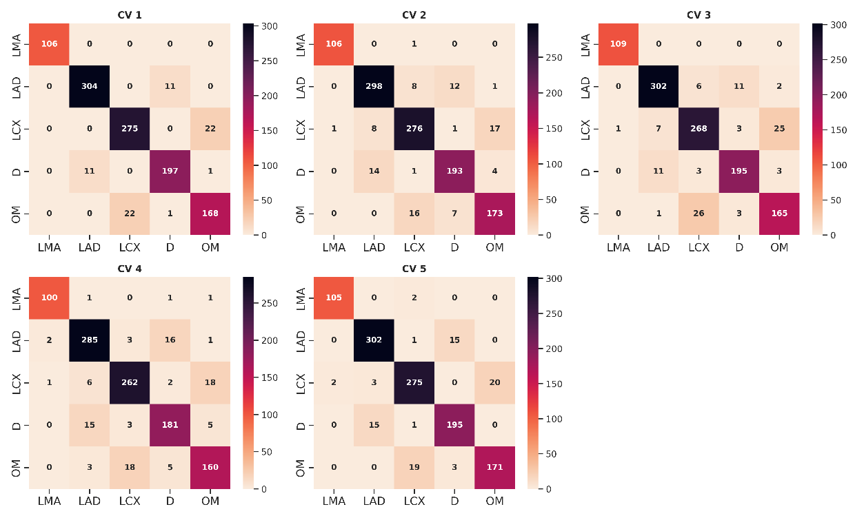
Figure S5. Confusion matrices for coronary artery semantic labeling on 5-fold cross-validation.

8. The authors should show more pictures of the results. There are no images that show the results qualitatively.
A: Thanks for your questions. We have added the visual comparison of the graph matching results in the revised manuscript. Firstly, we randomly chose 6 examples from these 6 different view angles, and the graph matching results are shown in Figure 3 in the revised manuscript.
Figure 3. Graph matching results of 6 ICA images from different view angles. Correspondence between coronary arteries from ICA images from the testing set (left) and from the template set (right). The green connection line indicates a correct match, while the red line represents a wrong match.
9. Graph node classification can only reflect accuracy at the vessel segment level, but in the context of this paper, are pixel-level classification metrics more meaningful?
A: We agreed that the pixel-level classification would be more meaningful for coronary artery semantic segmentation. However, this paper we focus on coronary artery semantic labeling rather than semantic segmentation. The coronary artery semantic segmentation performance is heavily determined by the performance of coronary artery binary segmentation using ICA, which doesn’t belong to the scope of this paper. As mentioned in the introduction section, one of the major challenges in understanding the coronary artery anatomy is to identify the coronary artery sub branches according to the vascular tree. Thus, assign the categorial label to each arterial segment is meaningful and we use the node-level or segment-level classification metrics to evaluate the model performance.
As demonstrated in Section 3.1, we extracted 121 features, including topology, pixel, and positional features, as described in our previous publication [6,21]. The influence of noise in segmenting arterial segments significantly affects pixel-related features, while its impact on topological and positional features is limited, as the graph connectivity and arterial positions remain nearly the same.
In our previous publications [6,21], we modified ZORRO [22], an algorithm used to explain graph neural networks for graph matching in coronary artery semantic labeling. Previous findings indicate that the most important features are related to the degree of the endpoints of the left and right ends of the arterial segment. Additionally, positional features also comprise most of the top 15 important features. Therefore, noise in segmenting arterial segments will have a minor influence on the graph matching process, which should not significantly reduce accuracy.
10. The ablation experiment shows that the improvement is not obvious. The authors should discuss why using VGT and EGT independently results in limited improvement or even decline, but combining them results in some improvement.
A: Thanks for your question. When used independently, the VGT and EGT may not effectively complement each other's functionalities. VGT is to integrate the features of the connected hyperedges of the central vertex; EGT aggregate vertex features with different weights. Solely employing VGT and EGT results in over-smoothing the aggregated features because of the lack of supervision for the attention weights [23]. They may operate in isolation, failing to leverage the strengths of both components to enhance the overall performance of the model. Combining the VGT and EGT can mitigate these issues and lead to improvement in performance. We added the explanation in the revised manuscript.
(Section 4.4 Ablation study)
According to Table 5, integrating VGT and EGT simultaneously improved the model’s performance in ACC. Additionally, incorporating the UQ strategy proposed in Algorithm 1 enhanced the ACC by 0.88% (from 0.9123 to 0.9211). For each baseline model, using the UQ strategy improved the performance by approximately 1% in ACC. When used independently, the VGT and EGT may not effectively complement each other's functionalities. VGT is to integrate the features of the connected hyperedges of the central vertex; EGT aggregates vertex features with different weights. Solely employing VGT and EGT results in over-smoothening the aggregated features because of the lack of supervision for the attention weights [23]. They may operate in isolation, failing to leverage the strengths of both components to enhance the overall performance of the model. Combining the VGT and EGT can mitigate these issues and lead to improvement in performance. These results indicate that VGT and EGT work effectively together, and the incorporation of UQ further improved the performance in making final decisions.

11. The authors should discuss the limitations of this paper and directions for future work.
A: The limitation of the proposed HAGMN-UQ is that we only performed graph matching between two individual graphs. Due to the intricate anatomy, clinical decisions rely on multiple ICAs. However, this may not fully capture the arterial anatomy's complexity. In simulating the learning process for cardiologists when recognize the arterial branches, the segment labels should be compared with multiple reference cases. Methodologically, the multi-graph graph matching with the presented technique should be further investigated in the future. We added Section 5 to the revised manuscript.
(Section 5. Limitation and Future Work)
The proposed matching approach leveraging pre-processing techniques, notably coronary artery binary segmentation and graph generation, presents several advantages. First and foremost, it promises enhanced accuracy in coronary artery representation, which is essential for reliable graph matching. By segmenting and extracting centerlines beforehand, the method ensures a standardized and consistent representation of arterial structures across diverse datasets, leading to more robust matching outcomes. Additionally, automated pre-processing steps streamline the matching process, minimizing the need for manual intervention and enhancing scalability.
However, despite these advantages, the proposed approach is not without its challenges. One of the primary concerns lies in the sensitivity of the method to the quality of pre-processing steps. During the ICA binary segmentation, human intervention is required to adjust the binary contours if needed. For ICA graph generation, hyperparameters are required to adjust the length of the arterial segment and the radius threshold of the arterial segment to preprocess the arterial skeleton. Thus, we developed our in-house software for image preprocessing, as shown in Figures S1 and S2. Compared to an end-to-end approach, such as image semantic segmentation using CNN, the proposed approach contains multiple steps, meaning that subsequent steps may be influenced by preceding ones.

12. As can be seen from the supplementary materials, the amount of data from different view angles varies greatly. The authors should explain how to deal with data imbalance and whether there is a difference in accuracy under different viewing angles, rather than just showing macro-F1.
A: Thanks for your question. We reported the performance under different projection angles, as shown in Table 3.
(Section 4.3. Coronary artery semantic labeling performance)
Table 3. The achieved ACC, PREC, REC and F1 of the proposed HAGMN-UQ using ICAs under different view angles.
First View Angle | Second View Angle | ACC | PREC | REC | F1
AP | CAU | 0.9177±0.0472 | 0.9180±0.0472 | 0.9177±0.0472 | 0.9177±0.0474
AP | CRA | 0.9066±0.0250 | 0.9064±0.0251 | 0.9066±0.0250 | 0.9065±0.0250
LAO | CAU | 0.8241±0.2038 | 0.8249±0.2022 | 0.8241±0.2038 | 0.8242±0.2035
LAO | CRA | 0.9179±0.0192 | 0.9183±0.0188 | 0.9179±0.0192 | 0.9180±0.0191
RAO | CAU | 0.9213±0.0141 | 0.9212±0.0142 | 0.9213±0.0141 | 0.9212±0.0142
RAO | CRA | 0.8944±0.0594 | 0.8944±0.0594 | 0.8944±0.0594 | 0.8944±0.0594

We reported the performance under different view angles, as shown in Table 3. According to Table 3, our proposed model demonstrated impressive performance across most of the ICA images from various view angles, with the exception of the LAO CAU angle. It's important to note that during the generation of graph matching pairs, only ICA images from the sampled view angle are utilized for training, while templates from the same view angle are employed for testing and prediction. The observed lower performance in LAO CAU can be attributed to the limited number of training samples available under this view angle, as illustrated in Table 1. This scarcity of training data results in a restricted number of eligible graph matching pairs during training. Additionally, during testing, the number of templates under the LAO CAU view angle is also constrained, leading to biased predictions in graph matching.
In future work, it is essential to create a balanced dataset, particularly by increasing the number of ICAs captured under LAO CAU views.
Table 1. View angles and number of enrolled subjects. CRA, cranial; CAU, caudal; LAO, left anterior oblique; RAO, right anterior oblique; AP: anterior-posterior.

Site | View Angle | LAO | RAO | AP | TOTAL
Site 1 | CRA | 42 | 19 | 18 | 79
 | CAU | 18 | 116 | 56 | 190
Site 2 | CRA | 44 | 16 | 123 | 183
 | CAU | 20 | 220 | 26 | 266
TOTAL |  | 124 | 371 | 223 | 718

References
[1] Zhao C, Vij A, Malhotra S, Tang J, Tang H, Pienta D, Xu Z, Zhou W. Automatic extraction and stenosis evaluation of coronary arteries in invasive coronary angiograms. Computers in Biology and Medicine. 2021;136:104667.
[2] Cao Q, Broersen A, de Graaf MA, Kitslaar PH, Yang G, Scholte AJ, Lelieveldt BPF, Reiber JHC, Dijkstra J. Automatic identification of coronary tree anatomy in coronary computed tomography angiography. Int J Cardiovasc Imaging. 2017 Nov;33(11):1809–1819.
[3] Wang R, Yan J, Yang X. Combinatorial Learning of Robust Deep Graph Matching: an Embedding based Approach. IEEE Trans Pattern Anal Mach Intell. 2020;1–1.
[4] Wang R, Yan J, Yang X. Neural Graph Matching Network: Learning Lawler’s Quadratic Assignment Problem With Extension to Hypergraph and Multiple-Graph Matching. IEEE Transactions on Pattern Analysis and Machine Intelligence. 2022 Sep;44(9):5261–5279.
[5] Zhao C, Xu Z, Jiang J, Esposito M, Pienta D, Hung G-U, Zhou W. AGMN: Association Graph-based Graph Matching Network for Coronary Artery Semantic Labeling on Invasive Coronary Angiograms [Internet]. arXiv; 2023 [cited 2023 Feb 10]. Available from: http://arxiv.org/abs/2301.04733
[6] Zhao C, Xu Z, Hung G-U, Zhou W. EAGMN: Coronary artery semantic labeling using edge attention graph matching network. Computers in Biology and Medicine. 2023 Nov;166:107469.
[7] Meng Y, Dong M, Dai X, Tang H, Zhao C, Jiang J, Xu S, Zhou Y, Zhu F, Xu Z. Automatic Identification of the End-Diastolic and End-Systolic Cardiac Frames from Invasive Coronary Angiography Videos. Technology and Health Care. 2021;
[8] Tonino PA, De Bruyne B, Pijls NH, Siebert U, Ikeno F, vant Veer M, Klauss V, Manoharan G, Engstrøm T, Oldroyd KG. Fractional flow reserve versus angiography for guiding percutaneous coronary intervention. New England Journal of Medicine. Mass Medical Soc; 2009;360(3):213–224.
[9] Hermiller JB, Cusma JT, Spero LA, Fortin DF, Harding MB, Bashore TM. Quantitative and qualitative coronary angiographic analysis: review of methods, utility, and limitations. Catheterization and cardiovascular diagnosis. Wiley Subscription Services, Inc., A Wiley Company New York; 1992;25(2):110–131.
[10] Lee MS, Chen C-H. Myocardial bridging: an up-to-date review. The Journal of invasive cardiology. NIH Public Access; 2015;27(11):521.
[11] Zhao C, Vij A, Malhotra S, Tang J, Tang H, Pienta D, Xu Z, Zhou W. Automatic extraction and stenosis evaluation of coronary arteries in invasive coronary angiograms. Computers in Biology and Medicine. 2021 Sep;136:104667.
[12] Kong TY, Rosenfeld A. Topological algorithms for digital image processing. Elsevier; 1996.
[13] Kovesi PD. MATLAB and Octave functions for computer vision and image processing. Centre for Exploration Targeting, School of Earth and Environment, The University of Western Australia, available from: http://www csse uwa edu au/∼ pk/research/matlabfns. 2000;147:230.
[14] Yoshizaki T, Ishida M, Takagi T, Matsukura G, Yamashita S, Hosoya N, Kageyama S, Watanabe Y, Takeuchi R, Murata K, Nawada R, Onodera T, Nakai M. A case of ventricular septal rupture associated with major septal branch occlusion after percutaneous coronary intervention. J Cardiol Cases. 2014 Oct;10(4):140–143. PMCID: PMC6279712
[15] Del Castillo C, Van-Grieken J, Coello M, Torres-Herrera C, Clericus B, Requena D, Begazo A, Appiani F, Kuzmicic B, Varleta P. Interventricular Septal Hematoma Complicating Left Branch Bundle Lead Implantation: Treatment by Covered Stent. JACC Case Rep. 2023 Dec 20;28:102087. PMCID: PMC10774742
[16] Hashida H, Funada J-I, Morioka N, Iwata T. The lurking potential of tangential forces: A case of an arteriovenous shunt developed by percutaneous coronary intervention for the septal branch. J Cardiol Cases. 2010 Feb;1(1):e1–e5. PMCID: PMC6264952
[17] Wu D, Wang X, Bai J, Xu X, Ouyang B, Li Y, Zhang H, Song Q, Cao K, Yin Y. Automated anatomical labeling of coronary arteries via bidirectional tree LSTMs. Int J CARS. 2019 Feb;14(2):271–280.
[18] Gifani P, Behnam H, Shalbaf A, Sani ZA. Automatic detection of end-diastole and end-systole from echocardiography images using manifold learning. Physiological measurement. IOP Publishing; 2010;31(9):1091.
[19] Iftikhar SF, Bishop MA, Hu P. Complex Coronary Artery Lesions. StatPearls [Internet]. Treasure Island (FL): StatPearls Publishing; 2024 [cited 2024 Mar 27]. Available from: http://www.ncbi.nlm.nih.gov/books/NBK539899/ PMID: 30969721
[20] Xian Z, Wang X, Yan S, Yang D, Chen J, Peng C. Main Coronary Vessel Segmentation Using Deep Learning in Smart Medical. Huang C, editor. Mathematical Problems in Engineering. 2020 Oct 21;2020:1–9.
[21] Zhao C, Xu Z, Jiang J, Esposito M, Pienta D, Hung G-U, Zhou W. AGMN: Association graph-based graph matching network for coronary artery semantic labeling on invasive coronary angiograms. Pattern Recognition. 2023 Nov;143:109789.
[22] Funke T, Khosla M, Rathee M, Anand A. ZORRO: Valid, Sparse, and Stable Explanations in Graph Neural Networks. IEEE Trans Knowl Data Eng. 2023;1–12.
[23] Wang G, Ying R, Huang J, Leskovec J. Improving graph attention networks with large margin-based constraints. arXiv preprint arXiv:191011945. 2019;

