Response letter for the manuscript titled ‘3D Lymphoma Segmentation on PET/CT Images via Multi-Scale Information Fusion with Cross-Attention’

Dear Editor and Reviewers,
We are grateful for the comments and suggestions from the editors and the reviewers, which are crucial for improving our work. We have revised the manuscript to address the reviewers’ comments fully. Our point-by-point reply to the review comments is summarized below. In this document, the original reviewers’ comments are in black; our responses are in blue; the quotations in the revised manuscript are in red.

Reviewer #1:
General Comments:
1. The revisions have been thoroughly implemented, and the requested changes are largely addressed.
Reply: Thank you for your positive feedback. We appreciate your careful review and are happy that the changes meet your expectations.
Specific Comments:
1. Only minor issues have been identified during the review process.
Reply: Thank you for your thorough review. We are glad to hear that only minor issues were identified, and we have addressed them in the revised manuscript.
Minor comments:
1. Correct "t0xt1" in Eq. 1 to "t0-t1.".
Reply: Thank you for pointing that out. We have corrected Eq. 1 in [Section 2.2] as per your suggestion.
(2.2 Data preprocessing)
Based on clinical recommendations, the CT image window width was adjusted to 400 Hounsfield units (HU), and the window level to 40 HU. For the PET images, we normalized the pixel values using Body Weight-Corrected Standard Uptake Value (SUV_{BW}), a semi-quantitative measure commonly used to evaluate FDG uptake^{1,2}, as defined in Eq. (1).
$$\begin{aligned}SUV_{BW}=\frac{RS×PV+RI}{A×e^{\frac{-0.693}{ T_{\frac{1}{2}}}×\left(t_{0}-t_{1}\right)}/\left(W×1000\right)}\#\left(1\right)\end{aligned}$$
2. Lines 183-197: This section provides an explanation of networks related to MSIF, which would be more suitable for the introduction than the methods section.
Reply: Thank you for your valuable suggestion. We have moved the section discussing networks related to MSIF to the introduction, as recommended. Additionally, we have optimized [Section 1], [Section 2.3], and [Section 2.3.1] for better coherence and clarity.
(1 Introduction)
Recent approaches, such as the Vision Transformer (ViT)³ and Swin Transformer⁴, both address long-range dependency capture. However, Swin Transformer reduces computational complexity by combining a hierarchical structure with shifted window attention^{5,6}. Moreover, PET/CT segmentation tasks require not only long-range dependency capture but also effective utilization of complementary information from both modalities.
Existing methods, such as MDRANet⁷, CA-Net⁸, MFCPNet⁹, and SwinCross⁶ have made significant progress in leveraging multi-scale information and cross-modal interactions. However, they exhibit certain limitations: MDRANet and CA-Net focus on single-modality feature enhancement and lack mechanisms for cross-modal interaction, while MFCPNet employs fixed fusion strategies that hinder its adaptability in multi-modal tasks. While SwinCross captures complementary PET and CT information via shifted window attention, it fails to dynamically adjust modality contributions and does not fully integrate multi-scale features. To overcome these limitations, this study introduces a Multi-Scale Information Fusion (MSIF) module, which incorporates dynamic modality contribution adjustment, enhanced multi-scale feature fusion, and improved computational efficiency. These innovations address existing method limitations and provide robust performance improvements in multimodal PET/CT segmentation.
The key contributions of this study are as follows:
- Multimodal feature extraction: We introduce a novel dual-branch encoder based on the Swin Transformer, which effectively captures global features from both PET and CT modalities, overcoming the limitations of traditional CNNs in handling receptive fields.
- Multimodal feature fusion: We develop the MSIF module, which integrating multi-scale feature fusion with a cross-attention mechanism using shifted windows. This module enhances the interaction between fine-grained features from PET and CT, facilitating efficient information exchange across modalities.
- Applying lymphoma segmentation to TMTV calculation: In addition to segmentation, this study focuses on the evaluation of TMTV, a key metric for evaluating treatment effectiveness and prognosis.
(2.3 Network architecture)
Fig. 1: The architecture of the proposed network, consisting of two independent encoders, the MSIF module, and the decoder.
Fig. 1 illustrates the overall network architecture, which comprises two independent encoder branches, the MSIF module, and a decoder. Each encoder processes the PET and CT modality images separately. First, each image passes through a linear embedding layer to generate intermediate feature maps, which are then processed through four stages of Swin Transformer Blocks and Patch Merging, producing multi-scale feature maps with progressively reduced resolutions. At each scale, the MSIF module is applied to fuse the feature maps from both modalities for multi-scale information integration, before they are fed into the decoder. The decoder upscales the feature maps using skip connections and generates the final segmentation results after applying a Sigmoid activation function.
(2.3.1 Encoders)
As shown in Fig. 1, the encoder consists of two independent branches, each designed to fully extract features from the corresponding modality.
3. Check spacing in Line 272 ("The regularW_MSA").
Reply: Thank you for highlighting this. The spacing issue in [Section 2.3.2] has been corrected.
(2.3.2 Multi-scale information fusion)
In these equations, $W_MSA$ and $SW_MSA$ stand for regular and shifted window multi-head self-attention modules, respectively. The regular$W_MSA$operates within fixed windows, which may restrict spatial context to individual windows.
4. In Figs. 8 and 9, update the axis label from "gTMTV" to "gtTMTV.".
Reply: Thank you for your suggestion. The axis labels in Figures 8 and 9 have been updated in [Section 3.2].
(3.2 Results of TMTV)
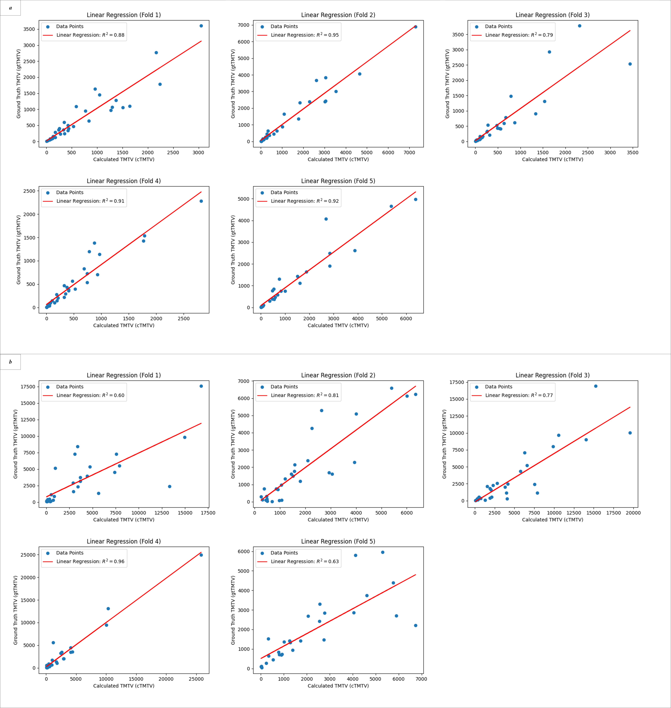
Fig. 8. Linear regression results of the predicted TMTV as cTMTV vs. the ground truth of TMTV as gtTMTV on: (a) private dataset and (b) autoPET dataset. The red line represents the linear regression fit, with the $R^{2}$ indicating the goodness of fit.
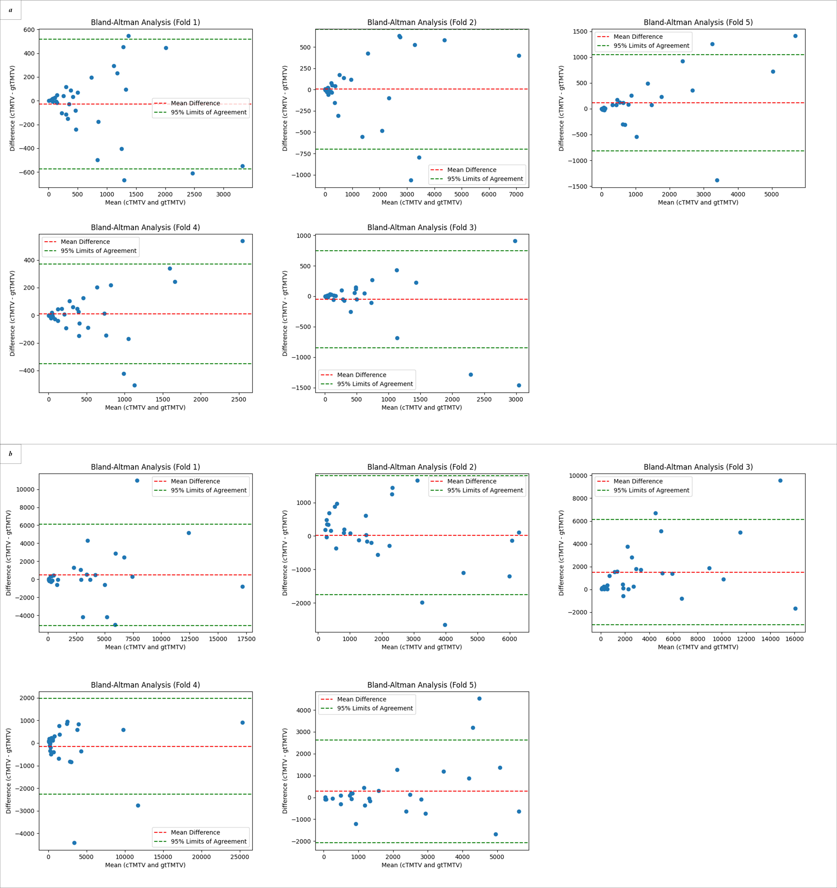
Fig. 9. Bland-Altman analysis for cTMTV vs. gtTMTV on (a) private dataset and (b) autoPET dataset. The horizontal axis represents the mean of cTMTV and gtTMTV, while the vertical axis represents their difference. The red dashed line shows the mean difference, and the green dashed lines represent the 95% limits of agreement, calculated as the mean difference ± 1.96 standard deviations of the differences.
Reviewer #2:
General Comments (Required)
1. The manuscript has been well revised and all the reviewers' comments have been well addressed.
Reply: Thank you for your positive feedback. We appreciate your acknowledgment that the manuscript has been well revised and that all comments have been addressed.
Specific Comments:
1. The manuscript has been well revised and all the reviewers' comments have been well addressed.
Reply: Thank you for your kind words. We are glad that the revisions have met your expectations and that all reviewer comments have been properly addressed.
Reference:
1. Albano D, Bertoli M, Battistotti M, et al. Prognostic role of pretreatment 18F-FDG PET/CT in primary brain lymphoma. Annals of nuclear medicine. 2018;32:532-541.
2. Thie JA. Understanding the standardized uptake value, its methods, and implications for usage. Journal of Nuclear Medicine. 2004;45(9):1431-1434.
3. Dosovitskiy A. An image is worth 16x16 words: Transformers for image recognition at scale. arXiv preprint arXiv:201011929. 2020.
4. Liu Z, Lin Y, Cao Y, et al. Swin transformer: Hierarchical vision transformer using shifted windows. Paper presented at: Proceedings of the IEEE/CVF international conference on computer vision2021.
5. Hatamizadeh A, Nath V, Tang Y, Yang D, Roth HR, Xu D. Swin unetr: Swin transformers for semantic segmentation of brain tumors in mri images. Paper presented at: International MICCAI brainlesion workshop2021.
6. Li GY, Chen J, Jang SI, Gong K, Li Q. SwinCross: Cross‐modal Swin transformer for head‐and‐neck tumor segmentation in PET/CT images. Medical physics. 2024;51(3):2096-2107.
7. Fu J, Li W, Peng X, et al. MDRANet: A multiscale dense residual attention network for magnetic resonance and nuclear medicine image fusion. Biomedical Signal Processing and Control. 2023;80:104382.
8. Wang X, Li Z, Huang Y, Jiao Y. Multimodal medical image segmentation using multi-scale context-aware network. Neurocomputing. 2022;486:135-146.
9. Hou L, Yan Z, Desrosiers C, Liu H. MFCPNet: Real time medical image segmentation network via multi-scale feature fusion and channel pruning. Biomedical Signal Processing and Control. 2025;100:107074.

