- Open the file, go to the second page and you will find “Approval Signature”. Please digitally sign it in the line.
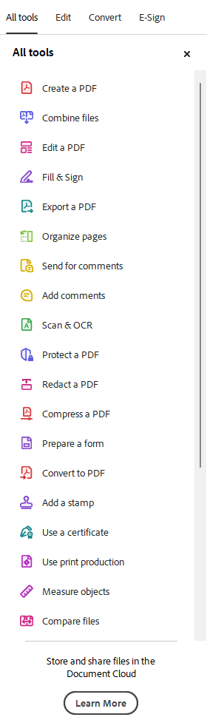
- Click the menu “all tools”. Click “view more” to show all menu items. Click “Use a certificate”.
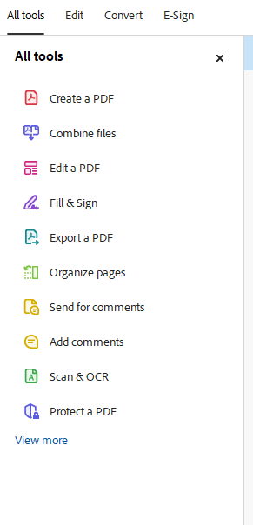

- After clicking “use a certificate”, you will see “Digitally sign” on the left navigation. Click it and follow the instructions to sign it. Thanks!

